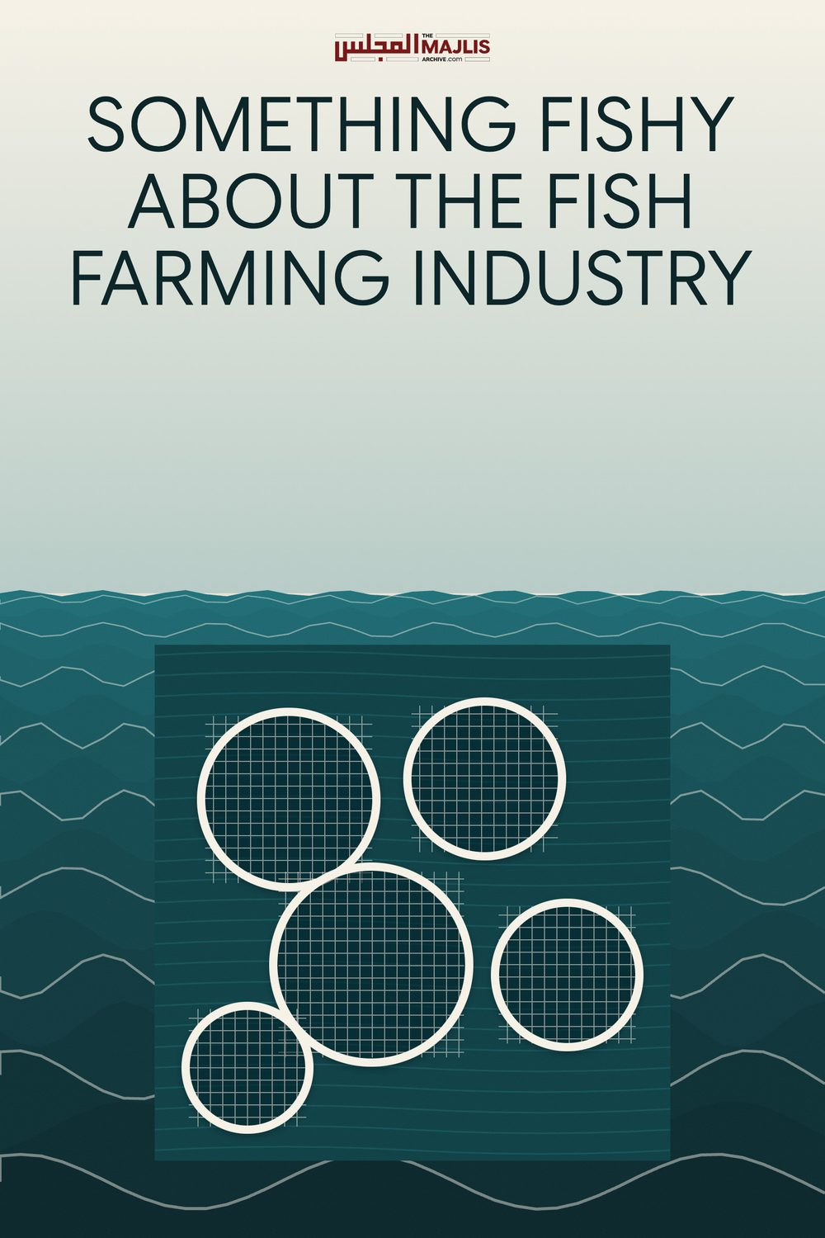

THE FISH FARMING INDUSTRY
The Majlis · Voice of Islam
Mujlisul Ulama of South Africa

About this edition
This is a reproduction by The Majlis Archive (themajlisarchive.com) of a publication of The Majlis, Mujlisul Ulama of South Africa, made and published with their permission.
The PDF as The Majlis issued it is the original. This edition was read from that PDF's own structure and checked against it letter for letter; where the two differ, the PDF is correct.
Checked: 58 paragraphs, 0 differing; a second, independent PDF reader finds 100.0% of the PDF's words here.
Nothing has been reworded, added or removed.

Mujlisul Ulama of South Africa
6056, South Africa

OUR COMMENT
At this stage, without saying that the fish is haraam, our advice is to drastically reduce fish consumption to even less than the levels advised in the articles in this booklet. This applies to fish caught in our seas (South African seas), especially along the Western Cape coast and Kwazulu-Natal coast.
Totally abstain from eating farmed fish and tinned fish. Most of the diseases people are contracting in this era are due to
• Carrion 'foods' such as halaalized broiler chickens, meat sold by the butcheries and restaurant foods.
• Processed foods laden with chemical poisons • White sugar and white flour products • Diseased fish • Flagrant commission of sin – fisq and fujoor.
The deluge of grave diseases which afflicts the community is a form of Athaab (Punishment) from Allah Azza Wa Jal.

THE DISEASED SOUTH AFRICAN FISH
iol.co.za A study by scientists has found that several fish caught off the South African coastline are contaminated with poisonous levels of mercury that could damage the health of people who regularly eat fish.
Several fish caught off Durban, Cape Town and the West Coast have been found to contain mercury levels well above World Health Organisation (WHO) guidelines, prompting fears for the health of subsistence fishing communities and people who eat fish regularly - particularly pregnant women and children. Mercury is a highly toxic heavy metal that can cause brain and nerve system damage, birth defects and other health problems, including fever, tremors, mood swings and insomnia. The study, carried out by researchers from the Council for Scientific and Industrial Research (CSIR) with analytical support from the University of Connecticut in the US, is one of the first attempts to measure mercury pollution in local sea fish and is part of a broader study to measure mercury pollution levels in South African soil, water, animals and the environment.
Several fish were collected and some of the highest mercury levels were found in popular table fish like red romans, silver fish and red panga. The lead author, Durban-based CSIR researcher Mamopeli Matooane, said the results were preliminary and based on a small sample of fish.
Nevertheless, they suggested that fishing communities along the South African coast were "potentially at risk" if they consumed fish every day, she said. People who ate fish often should be told about these risks, and further tests should be carried out to check their health status, she said. The highest levels of mercury were found in samples from False Bay, Cape Town, followed by those from the West Coast and Durban.
The study provides no data for other parts of the KwaZulu-Natal or Eastern Cape coastline. The highest recorded level was 0.486 micrograms of mercury to a million parts of fish tissue, in a red roman caught in False Bay. This is more than double the WHO guideline of 0.2 micrograms for vulnerable people.
In Durban, two of the three red roman samples were above the guideline. In some cases, adults who ate fish daily could be exposed to risks 11 times above guidelines developed by the US Environmental Protection Agency, while the risks were up to 32 times higher among children. Based on some of these risk calculations, Matooane and her fellow CSIR researchers suggested red roman and red panga fish should not be eaten more than twice a month.
Eating cob, yellowtail and silver fish should be restricted to four meals a month, while white stumpnose and hottentot sea bream should not be eaten more than eight to 12 times a month. Although mercury levels in mullet, snoek and blueskin seabream were much lower, these fish should not be eaten more than 16 times a month. Ideally, children should not eat some of these fish more than once a week.
The latest edition of the CSIR journal Sciencescope says mercury contamination in fish is not a problem unique to South Africa and that government agencies in the US have warned that nearly all types of fish and shellfish contain varying levels of methylmercury, a more toxic form of mercury. "Therefore, one should control one's intake and vulnerable groups like young children and pregnant women should be very careful. "The best advice would be for consumers to be aware of these risks and to obtain information from advisory groups if they have questions."
The source of the mercury pollution in South African fish is unclear, as there have been very few published studies on mercury contamination levels in the general environment.

POISONOUS FISH, WHAT THE SCIENTISTS SAY
Cape Town - Mercury, a potent neurotoxin, accumulates naturally in many fish South Africans love to eat - but no one has yet worked out just how much of this toxin is found in local fish.
Now marine scientist Brent Newman, a principal researcher at the Council for Scientific and Industrial Research (CSIR) in Durban, has embarked on a project to do just that.
After 9 months into the three-year project, Newman has come up with a preliminary table of the mercury content in 11 fish South Africans often eat, and made recommendations on the safe amount that can be eaten of each in a month.
Top of the list for high mercury content are swordfish, which Newman recommends should be restricted to just one portion a month. This is followed by kingklip and yellowfin tuna, which should be restricted to two portions a month. Cape Salmon is next, with restrictions of three portions a month, followed by kabeljou and rockcod, (four portions); red roman and dorado (five portions); carpenter and hake (six portions) and yellowtail with nine portions a month Mercury occurs naturally in the air, soil and water. It is also released by human activity, especially from coal-fired power stations and mining for mercury and gold. The World Health Organisations lists it as one of the top 10 chemicals "of major public health concern". Exposure to mercury can damage the nervous system, lungs, kidneys, skin and eyes. It is particularly harmful for unborn babies and very young children.
When fish feed, they absorb mercury which builds up in their flesh over time.
"The amount of mercury depends on the physiology of the fish, and how long they live. It is not necessarily the big fish that have a higher mercury content, although that does tend to be the case. The mercury content in kingklip was quite a surprise for us. It is a fish a lot of us eat quite often."
Newman had coupled the mercury content with the omega-3 fatty acid content of each of the 11 fish. These fats, which the body cannot manufacture but has to get from food, are essential for proper functioning of the body. Fish are high in omega-3 fatty acids. Of those Newman has tested, the fish that scores best on high fatty acid content coupled with low mercury content is yellowtail.
Newman stresses that he does not want his research to make people stop eating fish, as it is an excellent source of high quality protein and one of the best sources of omega-3.
"The point is not to scare people, but to provide them with information so they can make informed choices, so they know to eat some fish sparingly and others more often. People must be encouraged to eat fish, but they need to be able to work out how much. For instance, I eat fish only about three times a month, so at that level of consumption I could eat any of those fish on the list and it would not harm me," Newman said.
Newman buys the fish he tests at shops in Durban, and will move to Cape Town to test species, such as snoek, that do not occur in KwaZula-Natal. Because some shops mis-label fish, he buys whole fish so he can be certain of the species.
He now will also test fish for seasonal differences in mercury content.
Ideally Newman would like to link his mercury results with WWF's Southern African Sustainable Seafood Initiative (Sassi), which helps consumers make the right choice about fish to eat based on environmental considerations. Cape Times

THE POISONS AND HARMS OF FARMED FISH
biznews.com Aquaculture is a rapidly growing sector in South Africa. Although no longer the emerging and secretive industry it was 20 years ago, the consumer is still ignorant of a number of aspects of fish farming. Arguably the biggest misconception is that aquaculture is the environmentally viable answer to dwindling marine fish stocks. As with most things, the way the industry is run determines whether it is a good idea or not. JB By Dave Simon If you eat seafood, unless you catch it yourself or ask the right questions, the odds are pretty good it comes from a fish farm. The aquaculture industry is like a whale on steroids, growing faster than any other animal agriculture segment and now accounting for half the fish eaten in the U.S. As commercial fishing operations continue to strip the world's oceans of life, with one-third of fishing stocks collapsed and the rest headed there by mid-century, fish farming is increasingly seen as a way to meet the world's growing demand.
This article looks at aquaculture and its long-term effects on people, fish, and other animals. With this industry regularly touted as a paragon of food production, whether you eat seafood or not, you should know these nine key facts about farmed fish.
1. Farmed fish have dubious nutritional value. Here's a frustrating paradox for those who eat fish for their health: the nutritional benefits of fish can be greatly decreased when it's farmed. Take omega-3 fatty acids. Wild fish get their omega-3's from aquatic plants. Farmed fish, however, are often fed corn, soy, or other feedstuffs that contain little or no omega-3's. This unnatural, high-corn diet also means some farmed fish accumulate unhealthy levels of the wrong fatty acids.
Further, farmed fish are routinely dosed with antibiotics, which can cause antibiotic-resistant disease in humans. 2. Fish farming robs Peter to pay Paul While some farmed fish can live on diets of corn or soy, others need to eat fish – and lots of it. Tuna and salmon, for example, need to eat up to five pounds of fish for each pound of body weight. The result is that prey (fish like anchovies and herring) are being fished to the brink of extinction to feed the world's fish farms. "We have caught all the big fish and now we are going after their food," says the non-profit Oceana, which blames aquaculture's voracious hunger for declines of whales, dolphins, seals, sea lions, tuna, bass, salmon, albatross, penguins, and other species.
3. Fish experience pain and stress Contrary to the wishful thinking of many a catch-and-release angler, the latest research shows conclusively that fish experience pain and stress. In one study, fish injected with bee venom engaged in rocking behavior linked to pain and, compared to control groups, reduced their swimming activity, waited three times longer to eat, and had higher breathing rates. Farmed fish are subject to the routine stresses of hyperconfinement throughout their lives, and are typically killed in slow, painful ways like evisceration, starvation, or asphyxiation.
4. Farmed fish are loaded with disease, and this spreads to wild fish populations Farmed fish are packed as tightly as coins in a purse, with twenty-seven adult trout, for example, typically scrunched into a bathtub-sized space. These unnatural conditions give rise to diseases and parasites, which often migrate off the farm and infect wild fish populations. On Canada's Pacific coast, for example, sea lice infestations are responsible for mass kill-offs of pink salmon that have destroyed 80% of the fish in some local populations. But the damage doesn't end there, because eagles, bears, orcas, and other predators depend on salmon for their existence. Drops in wild salmon numbers cause these species to decline as well.
5. Fish farms are rife with toxins, which also damage local ecosystems You can't have diseases and parasites infecting your economic units, so operators fight back by dumping concentrated antibiotics and other chemicals into the water. Such toxins damage local ecosystems in ways we're just beginning to understand. One study found that a drug used to combat sea lice kills a variety of nontarget marine invertebrates, travels up to half a mile, and persists in the water for hours.
6. Farmed fish are living in their own feces That's right, fish poop too. Farmed fish waste falls as sediment to the seabed in sufficient quantities to overwhelm and kill marine life in the immediate vicinity and for some distance beyond. It also promotes algal growth, which reduces water's oxygen content and makes it hard to support life. When the Israeli government learned that algal growth driven by two fish farms in the Red Sea was hurting nearby coral reefs, it shut them down.
7. Farmed fish are always trying to escape their unpleasant conditions, and who can blame them? In the North Atlantic region alone, up to two million runaway salmon escape into the wild each year. The result is that at least 20% of supposedly wild salmon caught in the North Atlantic are of farmed origin. Escaped fish breed with wild fish and compromise the gene pool, harming the wild population. Embryonic hybrid salmon, for example, are far less viable than their wild counterparts, and adult hybrid salmon routinely die earlier than their purebred relatives. This pressure on wild populations further hurts predators who rely on fish like bears and orcas.
8. Also at Work: the Twisted "Jevons Paradox" This counterintuitive economic theory says that as production methods grow more efficient, demand for resources actually increases – rather than decreasing, as you might expect. Accordingly, as aquaculture makes fish production increasingly efficient, and fish become more widely available and less expensive, demand increases across the board. This drives more fishing, which hurts wild populations. Thus, as the construction of new salmon hatcheries from 1987 to 1999 drove lower prices and wider availability of salmon, world demand for salmon increased during the period. The net result: fish farming cranks up the pressure on already-depleted populations of wild fish around the world.
9. When the heavy environmental damage they cause is taken into account, fish farming operations often are found to generate more costs than revenues One study found that aquaculture in Sweden's coastal waters "is not only ecologically but also economically unsustainable." Another report concluded that fish farming in a Chinese lake is an "economically irrational choice from the perspective of the whole society, with an unequal tradeoff between environmental costs and economic benefits." Simply put, aquaculture drives heavy ecological harms and these cost society money. In the U.S., fish farming drives hidden costs of roughly $700 million each year – or half the annual production value of fish farming operations.
Now What?
With its long trail of diseases, chemicals, wastes, and suffering, and the heavy pressure it puts on wild populations through parasites, escapes, and higher demand, the sustainability of fish farms emerges as a fish story. And by the way, farmed or wild, fish are only "healthy" when compared to high-fat foods like red meat. But wild fish is no great nutritional treat either:
pound for pound, salmon has just as much cholesterol as ground beef, and virtually all wild fish contains highly-toxic mercury.
Here's one solution to the farmed fish dilemma: vote with your pocketbook and eat less seafood or give it up completely. Get your omega-3's from flax, hemp, soy, or walnuts – all without cholesterol or mercury. And just maybe, as George W. Bush hoped in a moment of unintended comedy, "the human being and fish can coexist peacefully."
For more information and additional solutions visit the Meatonomics.com website or get the book Meatonomics which looks at the latest data on fish farming and explores whether its really the silver bullet to solve the Earth's food needs. Can marine farms reliably satisfy the daily seafood cravings of people around the globe?

