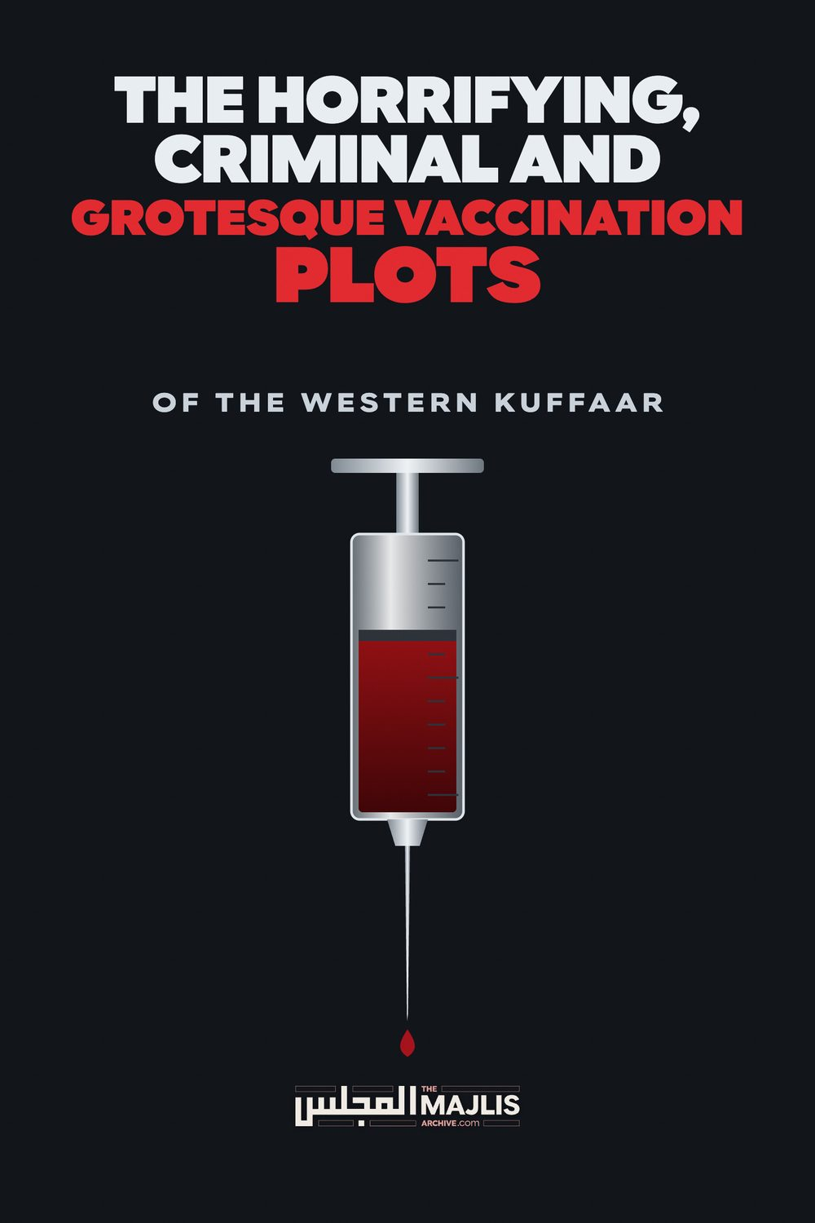

THE HORRIFYING CRIMINAL AND grotesque vaccination plots
The Majlis · Voice of Islam
Mujlisul Ulama of South Africa

About this edition
This is a reproduction by The Majlis Archive (themajlisarchive.com) of a publication of The Majlis, Mujlisul Ulama of South Africa, made and published with their permission.
The PDF as The Majlis issued it is the original. This edition was read from that PDF's own structure and checked against it letter for letter; where the two differ, the PDF is correct.
Checked: 81 paragraphs, 0 differing; a second, independent PDF reader finds 99.9% of the PDF's words here.
Nothing has been reworded, added or removed.

THE HORRIFYING, CRIMINAL AND GROTESQUE VACCINATION

PLOTS

OF THE WESTERN

KUFFAAR
"VERILY, THEY PLOTTED THEIR CONSPIRACY WHILST BY ALLAH
(IN HIS CONTROL) IS THEIR PLOT.
VERILY, THEIR PLOT (IS SO
HORRIFYING AND BIZARRE) THAT EVEN MOUNTAINS MOVE."
(QIR'AAN)
By: Mujlisul Ulama of South Africa PO Box 3393 Port Elizabeth, 6056 South Africa Tetanus vaccines found spiked with sterilization chemical to carry out race-based genocide against Africans Saturday, November 08, 2014 by Mike Adams, the Health Ranger Tags: vaccines, sterilization, genocide
(NaturalNews) Tetanus vaccines given to millions of young women in Kenya have been confirmaed by laboratories to contain a sterilization chemical that causes miscarriages, reports the Kenya Catholic Doctors Association, a pro-vaccine organization.
A whopping 2.3 million young girls and women are in the process of being given the vaccine, pushed by UNICEF and the World Health Organization.
"We sent six samples from around Kenya to laboratories in South Africa. They tested positive for the HCG antigen," Dr. Muhame Ngare of the Mercy Medical Centre in Nairobi told LifeSiteNews. "They were all laced with HCG."
Chemical causes a woman's body to destroy its own fetus with vaccine-induced antibodies HCG is a chemical developed by the World Health Organization for sterilization purposes. When injected into the body of a young woman, it causes a pregnancy to be destroyed by the body's own antibody response to the HCG, resulting in a spontaneous abortion. Its effectiveness lasts for years, causing abortions in women up to three years after the injections.
Dr. Ngare explained "...this WHO campaign is not about eradicating neonatal tetanus but a well-coordinated forceful population control mass sterilization exercise using a proven fertility regulating vaccine."
The Kenyan government, of course, insists the vaccine is perfectly safe. Dr. Tabu of Kenya's Health Ministry even told the media that because some young women are still having babies, the vaccine therefore must not contain any sterilization agent. However, this claim belies the fact that HCG doesn't work 100% of the time. It only sterilizes the majority of those injected with it, not all of them.
More importantly, the Kenyan Catholic Church is a pro-vaccine organization. "What reason do the Catholic doctors have for lying?" asked Dr. Ngare as reported in the LifeSiteNews article linked above. "The Catholic Church has been here in Kenya providing health care and vaccinating for 100 years for longer than Kenya has existed as a country."
In other words, the very group exposing the sterilization agenda of the tetanus vaccines is in fact a pro-vaccination group. Yet even they have now come to realize the horrifying truth:vaccines are the perfect vector for governments to deviously insert covert chemical or viral agents which are never revealed to the public.
The smoking gun: a five-shot course over two years What really raised red flags about this so-called tetanus vaccine was the highly unusual inoculation schedule. This vaccine demanded five shots over two years -- a schedule that isn't used for tetanus.
"The only time tetanus vaccine has been given in five doses is when it is used as a carrier in fertility regulating vaccines laced with the pregnancy hormone, Human Chorionic Gonadotropin (HCG) developed by WHO in 1992." explained Dr. Ngare.
Furthermore, the vaccine was only being given to women of child-bearing years, not men or women beyond the age of fertility.
As Dr. Ngare explains, the same vaccine sterilization campaign was used in 1993 in Mexico and both Nicaragua and the Philippines in 1994. WHO attempted to bring it to Kenya in the 1990's, Ngare says, but the effort was stopped by the Catholic Church.
According to Brian Clowes of Human Life International, the United Nations is not refuting the laboratory testing and confirmation of HCG in the vaccines. Instead, it claims some vaccines were "contaminated" in the manufacturing process -- an absurd claim that no reasonable person would believe because HCG should never even be anywhere near a vaccine manufacturing operation unless someone put it there deliberately.
LifeSiteNews reports that it: has obtained a UN report on an August 1992 meeting at its world headquarters in Geneva of 10 scientists from "Australia, Europe, India and the U.S.A" and 10 "women's health advocates" from around the world, to discuss the use of "fertility regulating vaccines." It describes the "anti-Human Chorionic Gonadotropin vaccine" as the most advanced.
Read the full report from LifeSiteNews at:
http://www.lifesitenews.com/news/a-mass-ster...
United Nations, WHO and UNICEF all engaged in vaccination genocide You will not see this news reported by any mainstream media outlet in the United States. All truth about vaccines is censored, even if the truth is that the United Nations is deliberately engaged in a campaign of vaccine genocide against people of Africa.
What is happening in Kenya is a crime against humanity, and it is a crime committed with deliberate racial discrimination. Normally, the liberal media in the United States would be all over a story involving racial discrimination and genocide -- or even a single police shooting of a black teenager -- but because this genocide is being committed with vaccines, the entire mainstream media excuses it. Apparently, medical crimes against black people are perfectly acceptable to the liberal media as long as vaccines are used as the weapon.
As this story clearly demonstrates, "vaccine violence" is very real in our world. Vaccines are the perfect weapon for population control for several reasons:
1) Nobody really knows what's in them.
2) They can be easily spiked with hidden chemicals.
3) They can be administered under the cover of "public health."
4) All governments and establishment media will deliberately collaborate with the genocide in order to protect vaccines from being recognized as medical weapons against women.
Thus, vaccines can be routinely used to inject populations with birth control chemicals or even stealth cancer viruses. In fact, this is exactly what happened to as many as 98 million Americans during the mass polio vaccinations of the 1960's and 70's. The CDC evendocumented the "accidental" injection of millions of Americans with the cancer-causing SV40 simian virus, but the agency scrubbed all that history from its website in 2013.
In Kenya today, government authorities also claim the sterilization chemical was an "accidental" contamination. That's the excuse that can always be used as a cover story in weaponized vaccination schemes, where governments deliberately taint vaccines with known chemicals that end life, promote cancer or cause spontaneous abortions.
Vaccines as weapons = Medical crimes against humanity The deliberate adding of HCG to vaccines without full disclosure to the population is a heinous violation of human rights and human dignity. Here are just a few of the crimes now being committed against humanity under the guise of vaccinations: CRIME #1) No informed consent. None of these women in Kenya were told the truth that they were being injected with a sterilization chemical designed to cause infertility.
CRIME #2) Race-based genocide. The targeting of Kenyan women with this vaccine is a deliberate selection based on their race. By any reasonable standard, this would be called a racially-motivated hate crime resulting in genocide.
CRIME #3) The deliberate killing of a human being. The spontaneous abortions caused by these HCG-spiked vaccines results in the ending of a human life inside the mother's body. These killings take place without the consent or permission of the mother, nor any opportunity for defense of the life of the unborn child.
CRIME #4) Violation of Geneva Convention limitations on medical experimentation.All these Kenyan women injected with this vaccine are being used as human guinea pigs in a covert, criminal medical experiment. None of these women voluntarily signed up for this medical experiment, nor were they even informed. This is a medical crime against human beings.
CRIME #5) Crimes against women. Only women were selected for this targeted sterilization vaccine effort, proving that this is not only a race-based crime but also a gender-based crime against women.
If you add all this up, you've got weaponized vaccines being intentionally spiked with a known sterilization chemical developed by the WHO, then deployed in a racially-motivated genocidal manner that targets women to be used in an illegal medical experiment administered via vaccine inoculations.
When administered via vaccines, genocide and murder are apparently not news Yet, despite all this, the mainstream media is perfectly okay with this activity. The World Health Organizations endorses it. The United Nations organizes it. Governments help fund it. Vaccine-pushing scientists excuse it. Media outlets cover it up and censor the story, hoping you don't read Natural News or Life Site News to learn the truth. When pharmacies in your neighborhood push flu shots and other vaccines, they don't tell you they are part of a branch of medicine steeped in genocide, racially-motivated hate crimes and a medical war on women. They don't tell you that flu shots still contain toxic mercury at concentrations 100 times the mercury found in ocean fish. They don't tell you anything about what's in those vaccines for the same reason that women in Kenya are never told what's in them, either.
Vaccines are the perfect weapons against women and children The truth is that vaccines are easily deployed as weapons against humanity under the false cover story that they are saving humanity. What better way to pursue deliberate chemically-induced population control than to convince people they are being injected "for their own good?"
This is precisely why Bill Gates famously said:
The world today has 6.8 billion people... that's headed up to about 9 billion. Now if we do a really great job on new vaccines, health care, reproductive health services, we could lower that by perhaps 10 or 15 percent.
Why would Bill Gates be talking about vaccines REDUCING human population if vaccines didn't secretly contain sterilization agents? Remember, Gates is the same person who has funded all sorts of sterilization technologies including one that blasts men's scrotums with high-intensity sound waves to make them infertile.
Top tools for human depopulation Gates is part of a covert medical cabal that believes aggressive human depopulation is urgently necessary to save the planet. This group, which includes many scientists and virologists, believe that the most effective tools for human depopulation are: 1) Vaccines which are covertly spiked with sterilization chemicals. 2) Genetically engineered viruses with a high mortality rate, possibly engineered to target specific races and genetic profiles.
For example, Dr. Charles Arntzen, head of The Biodesign Institute for Infectious Diseases and Vaccinology recently joked about using an engineered virus to cull the human population, saying "That's the answer! Go out and use genetic engineering to create a better virus. (laughter) Twenty-five percent of the population is supposed to go in Contagion."
As I wrote on October 22, 2014, many virologists believe humans are nothing more than a "parasite" to be consumed by viruses which are the planet's "immune response" to human overpopulation. Here's a passage from the book "The Hot Zone" by Richard Preston, summarizing the way these scientists think: ...the earth is mounting an immune response against the human species. It is beginning to react to the human parasite, the flooding infection of people, the dead spots of concrete all over the planet, the cancerous rot-outs in Europe, Japan and the United States, thick with replicating primates [i.e. humans], the colonies enlarging and spreading and threatening to shock the biosphere with mass extinctions.
Perhaps the biosphere does not "like" the idea of five billion humans. Or it could also be said that the extreme amplification of the human race, which has occurred only in the past hundred years or so, has suddenly produced a very large quantity of meat, which is sitting everywhere in the biosphere and may not be able to defend itself against a life form that might want to consume it...
The earth's immune system, so to speak, has recognized the presence of the human species and is starting to kick in. The earth is attempting to rid itself of an infection by the human parasite.
What's extraordinary in all this -- both with vaccines and viruses engineered as weapons -- is how the most influential people in the scientific community have come to view humanity as an enemy to be destroyed via tools of medicine and science.
Frighteningly, modern medical science has the tools to carry out its genocidal assaults on humankind through "accidental"
releases of deadly viruses or "accidental" contamination of vaccines with sterilization chemicals.
The evidence of deliberate sterilization chemicals in United Nations vaccines raises the obvious question: Was the recent Ebola outbreak in West Africa also intentional? And what else might scientists, vaccine pushers, world health authorities and governments have in mind for human depopulation in the years ahead?
Is there already something in the food supply that causes sterilization? The answer is a definite YES, and just like the pandemic viruses, it too is genetically engineered.
The five vectors for destroying humanity These are the vectors for the science-based genocidal assault on humanity:

1) Vaccines

2) Viruses

3) Food

4) Water

5) Chemtrails (i.e. atmospheric deployment of chemicals)
All five of these vectors present "opportunities" for genocidal scientists to achieve their goal of human sterilization and depopulation. That is precisely why anyone who wishes to survive the great human culling now under way must take extraordinary steps to isolate themselves from institutionally-produced food, water and medicine. The only safe food, water and medicine is that which was produced independently and far outside the control of Big Food, Big Ag and Big Pharma.
Don't drink the city water without filtering it first, and read my laboratory testing results for all popular water filters at www.WaterFilterLabs.com
Don't eat factory-produced food. Don't allow yourself to be injected with weaponized vaccines. Don't take Big Pharma's deadly medicines. Be smart by being skeptical about the claimed "safety" of all those things created by institutions and authorities that quite literally want to kill off a significant percentage of the existing world population.
If you're smart and resourceful, you might just survive this great human culling. On the other hand, those who anxiously line up to be injected with the seasonal flu shots are all admitting they are too stupid and gullible to last long in a world where "science" has declared a covert war on human life.
Learn more:
http://www.naturalnews.com/047571_vaccines_sterilization_geno cide.html#ixzz3IrhoVf2V

