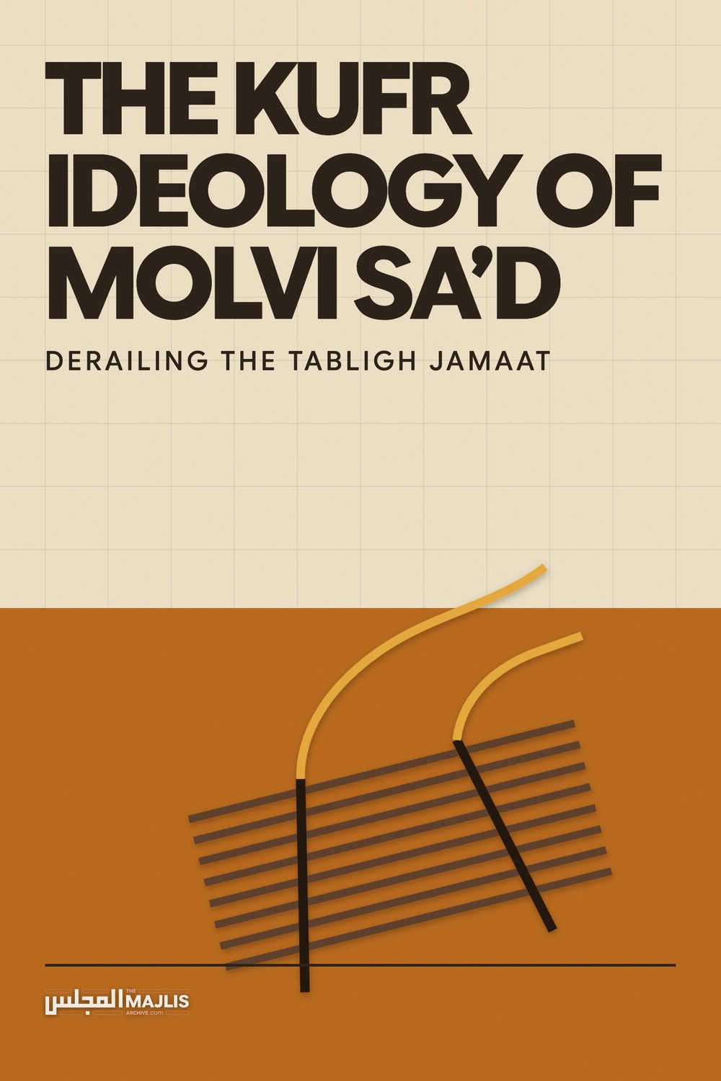

THE KUFR IDEOLOGY OF MOLVI SA'D
The Majlis · Voice of Islam
Mujlisul Ulama of South Africa

About this edition
This is a reproduction by The Majlis Archive (themajlisarchive.com) of a publication of The Majlis, Mujlisul Ulama of South Africa, made and published with their permission.
The PDF as The Majlis issued it is the original. This edition was read from that PDF's own structure and checked against it letter for letter; where the two differ, the PDF is correct.
Checked: 67 paragraphs, 0 differing; a second, independent PDF reader finds 100.0% of the PDF's words here.
Nothing has been reworded, added or removed.

THE KUFR IDEOLOGY OF MOLVI SA'D DERAILING THE TABLIGH JAMAAT
By:
Mujlisul Ulama of S.A.
Port Elizabeth, 6056

South Africa

QUESTION
Maulana Sa'd of the Tablighi Jamaat, had in a bayaan made some serious claims which have caused some consternation and confusion. Kindly listen to his bayaan and guide us. Are the views expressed by him in conformity with the belief of the Ahlus Sunnah Wal Jama'ah? He claimed:
1. Khurooj (emerging and travelling in Tabligh) is the Asal (actual objective). He basis his view on the Hadith of Hadhrat Ka'b (Radhiyallahu anhu).
2. Allah and His Rasool are displeased with those who do not make khurooj in Tabligh.
3. The greatest calamity of this age is that Muslims do not consider it a crime to abstain from khurooj.
4. Hidaayat is not in the Hands of Allah Ta'ala. He had therefore sent the Ambiya to impart Hidaayat.
5. Hidaayat is the effect of mehnet (effort). People had received hidaayat because of the mehnet of the Ambiya.
6. The Ambiya did not spread hidaayat with their tawajjuh and roohaaniyat.

ANSWER
Ghulu' (nafsaani extremism) is a satanic affliction bringing bid'ah and even kufr in its wake. A person suffering from the affliction of ghulu' disgorges any rubbish without applying his mind and without reflecting on the consequences of his stupidities.
Molvi Sa'd is guilty of ghulu' (haraam extremism). Unfortunately, the Tabligh Jamaat in general has slipped into ghulu'. He believes that the specific methodology of the Tabligh Jamaat is Waajib whereas it is not so. The Tabligh Jamaat's method is mubah (permissible), and will remain mubah as long as ghulu' and bid'ah do not overtake and destroy the Jamaat by deflecting it from its original path.
He is confusing or intentionally misusing the Jihaad campaigns of the Sahaabah with the Tabligh Jamaat's specific methodology, especially of its 'khurooj' method. He is equating Tabligh Jamaat khurooj to the Khurooj of the Sahaabah whose Khurooj was for Jihaad – Qitaal - to subjugate the lands of the kuffaar and to open and prepare the way for the conversion of the kuffaar nations of the world. In contrast, the methodology of the Tabligh Jamaat excludes non-Muslims. Its field of activity is limited to Muslims. While there is nothing wrong with this, it is wrong and not permissible to find a basis for the specific method of the Tabligh Jamaat in the Jihaad campaigns of the Sahaabah. There is no resemblance. The analogy is fallacious. There is no resemblance between the Tabligh Jamaat's khurooj and the Jihaad campaigns of the Sahaabah. The Tabligh Jamaat's khurooj groups do not encounter a thousandth of the hardships, dangers and trials which the Sahaabah had to face and bear in their Jihaad campaigns. The Tabligh Jamaat's khurooj groups move and live in comfort and even luxury.
The claim that Allah and His Rasool are displeased with those who do not make khurooj in Tabligh, is a monstrous lie fabricated on Allah Ta'ala and Rasulullah (Sallallahu alayhi wasallam). Did Molvi Sa'd receive wahi with which he could back up his preposterous falsehood? This contumacious claim comes within the purview of the Hadith:
"He who intentionally speaks a lie on me, should prepare his abode in the Fire."
His ghulu' has constrained him to disgorge this haraam flotsam. The baseless premises on which he has raised this palpable falsehood is that the only method of tabligh is the Tabligh Jamaat's methodology. Allah Ta'ala and Rasulullah (Sallallahu alayhi wasallam) are not displeased with anyone who does not adopt the methods of the Tabligh Jamaat. Sa'd has absolutely no Shar'i evidence for substantiating his preposterous claim of ghulu'.
His claim: The greatest calamity of this age is that Muslims do not consider it a crime to abstain from khurooj, is nafsaani drivel disgorged without applying the mind. The greatest calamity of the Ummah is gross disobedience – fisq, fujoor, bid'ah and even kufr. This is the actual cause for the fall and disgrace of the Ummah, not non-participation in Tabligh Jamaat activities. The Shariah has not ordained Tabligh Jamaat participation as an obligation. The Jamaat's specific methodology is mubah as long as it is not disfigured with ghulu' and bid'ah. Presenting it as 'waajib' and even 'fardh ain', is dangerous. This ghulu' will ultimately destroy the original Tabligh Jamaat. It will then become a deviant sect. With the Sa'd character, the process of deviation has gained much momentum. The Tabligh Jamaat elders have the incumbent obligation of arresting the slide of the Jamaat into deviation.
His claim: Hidaayat is not in the Hands of Allah Ta'ala. He had therefore sent the Ambiya to impart Hidaayat is tantamount to kufr. This is the most dangerous of Sa'd's claims. He is clearly espousing an entirely new concept of kufr. The Qur'aan Majeed is replete with aayaat which categorically state that Hidaayat comes from only Allah Ta'ala. Some random Qur'aanic aayaat follow to show the gross and dangerous deviation which Sa'd has introduced under cover of the Tabligh Jamaat.
(a) "Verily you (O Muhammad!) cannot give hidaayat to those whom you love. But Allah gives hidaayat to whomever He wills, and He knows best who are to be guided."
This Aayat explicitly negates the ability of granting hidaayat from Rasulullah (Sallallahu alayhi wasallam).
(b) "And, We have guided them (given them hidaayat) to Siraatul Mustaqeem. This is Allah's Huda (guidance/hidaayat) with which He guides whomever He wills from His servants. (Al-An'aam, Aayat 89)
It is Allah, Alone who provides hidaayat.
(c) "If Allah had willed, then they would not have committed shirk. And, We did not make you (O Muhammad!) a protector over them nor are you over them a guard."
The obligation of the Nabi (Sallallahu alayhi wasallam) was to only deliver the Message –the Deen. Providing hidaayat was beyond the capability of the Ambiya, hence the Qur'aan repeatedly instructs them to say: "Upon us is only to deliver the Clear Message."
(d) "Thus, Allah leads astray whomever He wills, and He guides (gives hidaayat) to whomever He wills." (Ibraaheem, Aayat 4)
(e) "Therefore, on the Messengers it is only the Clear Delivery (of the Deen) Verily, We have sent for every Ummat a Rasool so that they (their people) worship Allah and abstain from (worshipping) the devil. Thus, from them are those whom Allah guided, and among them are those upon whom dhalaal (the deviation of kufr) has been confirmed." (An-Nahl, Aayats 35 and 36)
(f) "(Even) if you (O Muhammad!) ardently desire that they be guided, then too, verily Allah does not guide those whom He has caused to go astray, and for them there is no helper." (An-Nahl)
(g) "If Allah had so wished, He would have made you all one Ummah, but He misleads whoever He wills and He guides whomever He wills." (An-Nahl, Aayat 93)
(h) "And, if your Rabb had willed, He would have made all mankind one Ummah, then they would not have differed." (Hood, Aayat 118)
(i) "If Allah had willed, He would have gathered them on guidance. Therefore never be among the jaahileen (believing that you can guide them all)."
(An-Aaam, Aayat 35)
(j) "Whomever Allah wishes, He leads him astray, and whomever He wishes, he establishes him on Siraat-e-Mustaqeem." (An-Aaam, Aayat 39)
(k) "If Allah had so desired, they would not have committed shirk. And, We did not make you (O Muhammad!) a guard over them, nor are you for them a protector."
(An-Aam, Aayat 107)
(l) "If He had willed, then most certainly He would have guided you all."
(An-Aam, Aayat 150)
(m) "If your Rabb had desired, then all people on earth would have accepted Imaan. What! Do you want to compel people until they become Mu'mineen?"
(Yoonus, Aayat 99)
(n) "And, whomever Allah misleads, there will be no guide for him." (Ra'd, Aayat 33)
The aforementioned are merely some Qur'aanic Aayaat chosen at random for the edification of Molvi Sa'd. The Qur'aan, replete with Aayaat of this kind, categorically confimrs that Hidaayat is a prerogative exclusively of Allah Azza Wa Jal. Hidaayat is in entirety reliant on Allah Ta'ala, NOT on mehnet (effort) as Molvi Sa'd contends. Apportioning Hidaayat to human beings is ordained by Allah Ta'ala. It is not the effect of the effort of the Ambiya, and to a greater extent not the effect of the mehnet of the Tabligh Jamaat.
While all people are required to strive and struggle in whatever occupation/profession they are involved, the end result, its success or failure, is the decree of Allah Azza Wa Jal. Thus, a man makes mehnet in the quest of his Rizq; in the quest of Knowledge, and in many other pursuits. But the final result is Allah's decree. The Rizq we received is not on account of our effort. It is not permissible, and it is nugatory of Imaan to believe that the consequences of Taqdeer are reliant on personal effort, and not on Divine Directive.
The Qur'aan repeatedly declares that Hidaayat is Allah's prerogative, not the effect of the mehnet of the Ambiya. If mehnet was the criterion and imperative requisite for Hidaayat, Rasulullah's uncle Abu Talib, Hadhrat Nooh's wife and son, Hadhrat Loot's wife, Hadhrat Ibraaheem's father and innumerable others closely associated with the Ambiya would not have perished as kuffaar. They would all have acquired the treasure of Imaan as a direct effect of the supreme mehnet of the Ambiya. Thus, Sa'd's contention that Hidaayat is not in the control of Allah Azza Wa Jal is blatant kufr. He must renew his Imaan. It is haraam for the Tabligh Jamaat elders to tolerate such a deviate within the ranks of the Jamaat.
Molvi Sa'd with his jahaalat, pivots hidaayat on mehnet (struggle/striving). This is a capital blunder which is the effect of ignorance. If the basis of hidaayat was mehnet, then his argument will imply that Rasulullah (Sallallahu alayhi wasallam) had, nauthubillah, failed in his duty of mehnet because there were many who did not accept Imaan despite all the efforts of Rasulullah (Sallallahu alayhi wasallam). And the same 'failure' stemming from the kufr view of Sa'd, will apply to all the Ambiya.
On the death occasion of his beloved uncle, Abu Taalib, Rasulullah (sallallahu alayhi wasallam) pleaded with all his heart in the effort to guide his uncle. But Abu Talib rebuffed Rasulullah's mehnet, and died without Imaan. Rasulullah (Sallallahu alayhi wasallam) spared no effort – he left no stone unturned in his mehnet to guide people. But, many remained mushrikeen and rebuffed all his efforts. It is palpably clear that hidaayat is not the consequence of the muballigh's mehnet. It is the effect of Allah's Will. He guides whomever He wills. The Qur'aan is categorical in this averment.
This Sa'd character is incapable of understanding even simple Qur'aanic aayaat and the facts of reality. The Nabi was Allah's Messenger. His duty was to only discharge the obligation of delivering the message of Allah Ta'ala. Hence the Qur'aan repeatedly instructs the Ambiya to say: "Upon us is to only deliver the Message."
The Maqsood is not mehnet. The Maqsood (Objective) is to discharge the obligation with which the Bandah has been entrusted. Whether a person will be guided or not, is beyond the control and ability of the muballigh. Hidaayat is the prerogative of Allah Ta'ala.
Molvi Sa'd claims that the deception of Muslims is their belief that change in the Ummah will occur by way of the spiritual state (Roohaaniyat) of the Auliya. This is obviously wishful thinking and the charge is false. No one entertains this idea. It is merely Sa'd's hallucination. The Ummah's condition will change only if Muslims obey Allah's Shariat whether they make Tablighi Jamaat type of khurooj or not. The Ummah's rotten state is not because Muslims do not participate in Tabligh Jamaat activities. It is because of the flagrant transgression of fisq, fujoor, bid'ah and kufr in which the Ummah is sinking.
Abstention from Tabligh Jamaat activities is not sinful. Participation is not Waajib. Non-participation in Tabligh Jamaat activities never was the cause of the fall and humiliation of the Ummah. In fact, the Ummah had scraped the dregs of the barrel of disgrace and degeneration many centuries before the birth of the Tabligh Jamaat.
The Khurooj during the era of the Salf-e-Saaliheen and even thereafter was always only for the purpose of Jihaad – Qitaal Fi Sabeelillaah. There never ever was mass khurooj for tabligh. While khurooj for tabligh is permissible and meritorious, it is not Waajib and the idea of it being waajib is haraam ghulu' which culminates in Sa'd type dhalaal and kufr. Applying to the Tabligh Jamaat activities the narrations which relate explicitly to Jihaad, is dangerous deviation. The thawaab of tabligh –i.e. tabligh of any method, not of only the Tabligh Jamaat, is immense. But to mislead the masses by presenting the Jihaad narrations as if they apply to the specific methodology of the Tabligh Jamaat is not permissible. It is a fabrication for which there is no basis in the Shariah.
Molvi Sa'd's istidlaal from Hadhrat Ka'b's Hadith is utterly baseless. His interpretation of the Hadith is baseless and erroneous. He is gumraah (astray) and leading others into gumraahi. Firstly, his claim that Khurooj whether it is khurooj in actual Jihad, or khurooj for Tabligh Jamaat activity, is the asal (i.e. actual objective), is manifestly baatil, baseless and corrupt. The objective of Jihaad is I'laa Kalimatullah for the sole purpose of gaining Allah's Pleasure. This is the Asal, not khurooj. Khurooj is merely a method for the acquisition of the Asal. But, Sa'd has placed the cart in front of the horse.
The displeasure incurred by Hadhrat Ka'b (Radhiyallahu anhu) for failure to participate in the specific Jihad campaign of Tabook, was 'disobedience'. He had failed to observe the command to emerge. He had unilaterally without valid reason decided to remain behind. This was his error for which Rasulullah (Sallallahu alayhi wasallam) had ordered the boycott.
Furthermore, Hadhrat Ka'b's error pertained to Khurooj related to actual Jihaad – Qitaal fi Sabeelillaah. It was not a khurooj for the specific method of tabligh which the Tabligh Jamaat had innovated some decades ago. If Sa'd's logic is to be accorded any credibility and validity, it will follow that the consequences of Hadhrat Ka'b's failure to make Khurooj should be extended to all those who refuse to make khurooj for Tabligh Jamaat activity. The logical result would be to boycott the almost 3 billlion Muslims of this era who not only do not participate in Tabligh Jamaat khurooj, but they also deny the essentiality of participation in the specific methodology of the Tabligh Jamaat.
A grave error of the Tabligh Jamaat is the predication of all the Jihaad narrations to their specific method of tabligh, whilst there is absolutely no affinity between the Tabligh Jamaat and Jihaad, i.e. the type of Jihaad of the Sahaabah. Whilst the absence of this affinity is not sinful, the appropriation of the Hadith narrations pertaining to Jihaad is inappropriate and not permissible. The Tabligh Jamaat has as its goal the reformation of Imaan and the impartation of the basic teachings of the Deen. Qitaal in our era for the acquisition of these fundamental requisites is not a condition as it was during the era of the Sahaabah. Qitaal was imperative to subjugate the lands of the kuffaar for removing the obstacles in the path of establishing the Deen. But this method of Qitaal does not form part of the Tabligh Jamaat's methodology. While the Tabligh Jamaat may not be criticized for this, the criticism for misusing the Jihaad narrations is valid.
Molvi Sa'd's claim: "In this age people do not regard as a crime and a sin reduction in emerging in the Tabligh Jamaat's way (of khurooj).", is another stupid fallacy. There is no Shar'i basis for believing that it is a crime and sinful to refrain from the specific khurooj methodology of the Tabligh Jamaat. Sa'd has no affinity with the Ilm of the Deen, hence he acquits himself as do the juhala, disgorging just any drivel of his nafs.
He presents the fallacious analogy of gheebat, speaking lies, theft, zina and riba in his ludicrous attempt to liken the so-called 'sin and crime' of non-participation in Tabligh Jamaat khurooj to the aforementioned kabeerah sins. This is a monstrous lie fabricated against the Shariah. The major sins of zina, riba, liquor, etc. are substantiated by Nusoos of the Qat'i category, while the contention of abstaining from Tabligh Jamaat khurooj being a crime and a sin is the horrid product of corrupt personal opinion stemming from ghulu'.
He finds fault with those who say that it is sinful to indulge in zina, liquor and gheebat, but not sinful to abstain from Tabligh Jamaat khurooj. This haraam opinion is scandalously baatil. Sa'd's ideology is scandalous. He constitutes a grave danger for the proper functioning of the Tabligh Jamaat. The deviation from the Jamaat's original principals bodes evil for the Tabligh Jamaat. It is Waajib for the elders of the Tabligh Jamaat to eradicate the evil and eliminate the rot which is gnawing at the foundations of the Jamaat.

