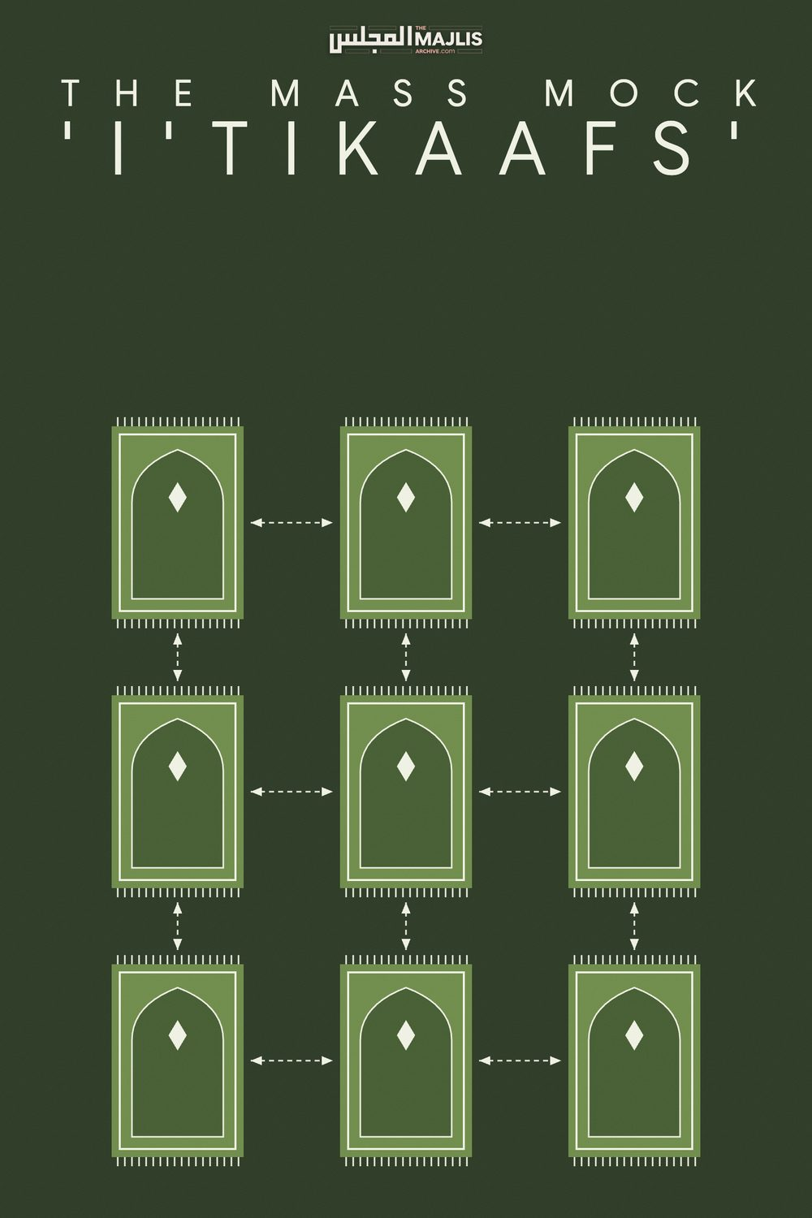

The Mass Mock Itikaafs English / Urdu
The Majlis · Voice of Islam
Mujlisul Ulama of South Africa

About this edition
This is a reproduction by The Majlis Archive (themajlisarchive.com) of a publication of The Majlis, Mujlisul Ulama of South Africa, made and published with their permission.
The PDF as The Majlis issued it is the original. This edition was read from that PDF's own structure and checked against it letter for letter; where the two differ, the PDF is correct.
Checked: 64 paragraphs, 0 differing; a second, independent PDF reader finds 100.0% of the PDF's words here.
Nothing has been reworded, added or removed.

A MOCKERY OF IBAADAT FOR NAFSAANI ENDS
Complaining about the merrymaking mock 'i'tikaafs' and other nafsaani shenanigans orchestrated in the Musaajid during the Holy Month of Ramadhaan, a Brother from the U.S.A. writes:
"Asalaamualaikum.
What is the ruling on the mass It'ikaaf that takes place in the last ten nights of Ramadhaan?
Some of the Alims who have set themselves up as Shuyookh of Tassawuf in the U.K will disappear for Umraah for the first 20 days of Ramadhaan (most probably to get away from Fasting for 23 hrs in the mid-summer heat) and then come back to conduct their mass or mess gatherings in the last ten days.
Their action boggles my mind because the last 10 days are the most sacred. Why leave such a Holy Sanctuary as the Haramain Shareefain to conduct the mass proceedings in the U.K. or U.S.?(The reason for rushing back for the last ten days is the pursuit of the dunya. They are deprived of the mass merrymaking in the Haramain Shareefain. There they will not stand out as 'hadhrats' to be worshipped. They will be ordinary laymen, and in this there is no fun, no acclaim, no aggrandizement and no hadyahs. - The Majlis)
You have not seen anything like this show which takes place in the last ten days and nights of this auspicious Month.. 500 or more persons take part. It is a 'memorable' sight to behold, and to shake your head in bewilderment. Their hadhrat saheb will have his own conspicuous tent, the size of a small room in one corner of Masjid if he is in Iti'kaaf, Or in some cases the Masjid is custom built in such a way that the Buzurg will have a small room with a toilet and shower just like in a hotel and Allah knows best ......
The best part of the pantomime show is at Fajr time, The Salaah of Fajr will always be delayed by 5-10 sometimes even 15 mins.(This is one of the shenanigans of the imposter 'shaikhs' to have all eyes focused on him when he emerges from his cloisturein full regalia. – The Majlis)
In anticipation of the hadhrat saheb to come out of hiding to commence Salaah there will be total silence, it would not be an exaggeration to say that if the Masjid had a hard floor a pin drop would be heard, No one will be making Dhikr at this time and everybody's attention will be focused on the door from which the 'wali' of Allah will make an appearance.
Then finally the door will creak open and the hadhrat with kingly dignity will walk into the Masjid taking baby steps with his elite group and entourage of servants following behind like bridesmaids behind the bride. (Was this the Sunnah of Rasulullah –sallallahu alayhi wasallam-? The poor hadhrat is blissfully ignorant of the fact that Rasulullah – sallallahu alayhi wasallam – always maintained an unostentatious presence when he was among a group of his Sahaabah. – The Majlis)
He will in slow motion look at the crowd, then, like the pope blessing his underlings, say 'Asalaamualaikum'. With 500 – 600 or even more chelas/followers in unison chanting "wa alay kumus salaam", it is another 'memorable' episode. After this, the entire congregation will stand up for Salaah. (In the Musjid the standing up for the Fardh Salaat is initiated by the Iqaamah, not by a man whom people have made an idol. – The Majlis)
I don't know if i am wrong to say this but it bothers me a lot. Why can't these hadhrat sahebs sit in anticipation for Salaah in the first saff a few moments before Salaah? Why can't these people adopt an approach which resembles humility instead of an approach of Pride? (They act like Fir'oun. They can't lower their hallucinated dignity by sitting in the saff with the 'rabble' because in this there is no attention drawn to them. Their ego is in demand of inflation. These jaahil peers and shaikhs are ignorant of the Sunnah, hence they set themselves up as 'gods' (Arbaabam min doonillaah).
I have been told such people have such a high level of humbleness and piety that they are totally oblivious to the fact that 500+ people are there watching. (If they had genuine tawwadhu' –humility – they would not be following in the shadows of Fir'oun, Haamaan and Nimrood. – The Majlis)
On one hand we have the so called hadhrats of England with their mass It'ikaaf gatherings, and on the other hand we have their American counterparts, the Imaams and trustees of Masaajid, organizing mass/mess so-called It'kaaf parties. Talk about mass deviation. The following are their shenanigans:
A massive tent that costs $35,000 is erected outside the Masjid. A barrier is then placed inside this tent to separate males and females. (The scenario of zina having habaailush shaitaan – the traps of the devil – in the same venue of merrymaking – The Majlis)
A chart/list is placed inside the Masjid for each of the 30 days of Ramadhaan. Brothers are encouraged to put their names on this list to fund the food for that particular evening's 'Iftaar' party. Please note, each night these shenanigans take place, it costs a whopping $1700 for food that is cooked in the local restaurants to feed 400+ Brothers and Sisters ,some of whom Allah Ta'ala has blessed with tremendous wealth. –(They devour carrion and a variety of mushtabah and haraam food with which to ruin their Fast. They are the brothers of shaitaan for squandering so much money when Muslims are starving world-wide. – The Majlis)
The red herring of "great reward to feed a fasting person in the month of Ramadhaan" is pumped into the minds of the ignorant public to fleece them of the money required to make this happen.
On Jumuah the Imaam preaches the following.
'Brothers and Sisters do not break your fasts at home, we will provide the food for everyone at the Masjid in the Holy month of Ramadhaan, you will gain the benefit of praying the Salaah's of Maghrib, Isha and Taraweeh with Jamaat". (We are living in the era of the juhala leading the juhala. The public is jaahil, the imams are jaahil, the trustees are jaahil and the hadhrats are jaahil. It is the Reign of Jahaalah predicted in the Hadith –The Majlis)
How can this so called fikr/good intention of theirs be justified when women also come in droves? (They have no good intentions. It is the quest for nafsaani gratification. – The Majlis)
Even if females didn't attend, it still does not make sense to feed 400 or 500+ people with bloated stomachs every day when the poor displaced Hungry and Homeless Muslims of Burma and elsewhere are suffering with no end in sight. What really makes my blood boil is that the modernist Imaam and his gang of Bid'atee Trustees are absolutely convinced that what they are doing is right.

OUR COMMENT
Allaamah Abdul Wahhaab Sha'raani (rahmatullah alayh), the Wali of Allah Ta'ala of the 9th Islamic century said regarding a 'shaikh' of Tasawwuf who claims to have renounced the dunya but erects for himself a mansion – a super structure as do these dacoits of 'tasawwuf' of this era – to lure people to come to him for 'islaah', is an imposter. The masses should flee from him.
I'tikaaf is the Ibaadat of this Ummah which replaces the Rahbaaniyat (Monasticism) which was the valid practice during the time of Nabi Isaa (alayhis salaam), and also during bygone times before him. I'tikaaf is a miniature Rahbaaniyat. It is renunciation of the dunya and the adoption of Zuhd (abstinence from most lawful activities). It is an occasion of communion with Allah Azza Wa Jal. It is a time of solitude like the solitude of the cave and wilderness where the Raahibeen (genuine Muslim monks of bygone times) found solace and comfort in the Remembrance of Allah Ta'ala. The Qur'aan Majeed states: "Behold! In the Remembrance of Allah do hearts find rest."
I'tikaaf is a time for strengthening the bond with Allah Ta'ala by focusing the mind and heart fully on Him with silent Thikr and Fikr (contemplation) which is the Salaat of the Soul. It is the Ibaadat in which all four Arkaan (Fundamentals) of Tasawwuf have to incumbently be given practical expression. These fundamentals are:

• Reduction in speech • Reduction in food

• Reduction in sleep

• Reduction in mingling with people.
But, lamentably, in the mock-mass 'i'tikaafs' of merrymaking organized in these times, all four Arkaan are eliminated and substituted with their exact opposites.
I'tikaaf has been designed by the Shariah for the acquisition of greater purity of the heart and greater concentration of the mind. For these achievements, solitude, silent and individual Thikrullaah and rigid practise on the four Arkaan of Tasawwuf are imperative. The Fiqhi validity of I'tikaaf is never adequate for the achievement of the spiritual objectives of this wonderful Ibaadat.
The Raahibs (sincere Muslim Monks of bygone times) devoted their entire lives in caves and in the wilderness, totally renouncing the dunya to gain the spiritual benefits of Zuhd. Such benefits are achieved only in an environment of genuine seclusion and solitude. That is the purpose for setting up a small enclosure/tent in the Musjid for the persons of I'tikaaf. Therein do they have to mediate on the solitude of the Qabr and its torments. It was precisely for this reason – to gain the Proximity of Allah Azza Wa Jal – that Rasulullah (sallallahu alayhi wasallam) would, prior to Nubuwwat, spend days and even weeks in I'tikaaf, in solitude and contemplation in the cold Cave of Hira in the wilderness. Allah Ta'ala has made it infinitely easy for this Ummah to achieve Divine Proximity by means of observing I'tikaaf in the Musjid. But the essential condition is to observe the I'tikaaf in the way it should be observed. The only reason why the venue of the Musjid has been selected for I'tikaaf is to ensure performance of Salaat with Jamaat. It is therefore haraam to abuse the Musjid with merrymaking and picnicking as the hadhrats are scandalously perpetrating nowadays in the name of Islam.
I'tikaaf is not a time for camping, picnicking, merrymaking and gluttony which accompany these mass-mock gatherings which they scandalously dub 'i'tikaaf'. This type of mock 'i'tikaaf' of waste, ostentation, pride and merrymaking as described by the Brother from the U.S. is not confined to the U.S. and U.K. The same style of khuraafaat in the name of 'i'tikaaf' has become the norm in South Africa as well. In the name of the 'i'tikaaf', the hadhrats are plundering the morals and Imaan of the laypeople. A massive mockery of the Deen is being perpetrated in the Musaajid during the Holy Month of Ramadhaan.
Nowadays, any chap can overnight become a 'hadhrat' of tasawwuf. Their tasawwuf nowadays is generally confined to public halqah thikr, singing nazams, gluttony, merrymaking and mass-mock 'i'tikaafs'. They block and pollute the Musaajid. They waste the Lillah funds of the public for gratifying their gluttony. They causes stinks and stenches in the Musaajid with their food of gluttony and the effects of constipation, the consequence of their gluttony. They chase the Malaaikah away and they cause distress to other musallis with all the stench they create in the Musjid.
The Mu'takaf (place of I'tikaaf) in the Musjid is not a Madrasah for conducting dars. It is neither a venue nor a time for delivering lectures. It is not a time for mass activity. It has to be a time of solitude. That is precisely why a small 'tent' is erected in the Musjid for the person of I'tikaaf. He has to remain in his tent engrossed in Thikr and Ibaadat in general. He may not wile away the time in conversation to combat his 'boredom'. In fact I'tikaaf is the cure for boredom. It is a time for communing with Allah Ta'ala, not for any other indulgences.
I'tikaaf is the best opportunity for giving practical expression to Rasulullah's command: "Remember abundantly that being which will sever delights, i.e. Maut." The person in I'tikaaf has to incumbently sit in solitude in his Mu'takaf to meditate on Maut. He has to reflect on the solitude of the Grave and its torments. This is among the primary objectives of I'tikaaf. The mass gatherings, gluttony, noise, mingling and merrymaking are all nugatory of this Maqsad (Objective).
I'tikaaf is not an assembly of people to be subjected to supervised programs and other activities, be these of a Deeni nature. Solitude and seclusion are the fundamental ingredients of I'tikaaf. Every individual should conduct himself as he would on the Day of Qiyaamah. No hadhrat will be allowed to supervise any program on that Day. What is transpiring at these mass gatherings where a mess is made of the I'tikaaf ibaadat, is hadhrat-worship. The hadhrats are utilizing the last ten days of Ramadhaan for promoting their nafsaaniyat. In so doing, they come within the scope of the Hadith in which one of the Signs of Qiyaamah, is:
"The dunya will be pursued with the amal of the Aakhirah."
Ibaadat which is an amal of the Aakhirah, is being used by the hadhrats for the acquisition of the dunya and for fulfilment of nafsaaniyat.
Never in the annals of Islam, were there such ludicrous 'i'tikaaf shows organized as are being perpetrated presently. These gatherings of merrymaking do not have the slightest resemblance with the Sunnah. They eliminate the spirit and ethos of I'tikaaf.
In the kitaab, Lataaiful Ma-aarif, the objectives of I'tikaaf observed by Rasulullah (sallallahu alayhi wasallam) are described as follows:
"And, Rasulullah (sallallahu alayhi wasallam) would observe I'tikaaf in these ten days in which the search for Lailatul Qadr is made, to terminate his (other) occupations, and to free him for the nights, and to be in seclusion for communion with his Rabb, and for His remembrance and for dua. He would prepare an enclosure wherein he would seclude himself from the people. Thus, he would not mingle with the people, not even for teaching knowledge, nor for reciting the Qur'aan (to the people). On the contrary, the most meritorious (afdhal) is to seclude oneself and to be silently engrossed with one's Rabb and in His remembrance, supplicating to Him.
This I'tikaaf has been ordained for observance in the Musaajid only to ensure that Jamaa-aat (Salaat) are not missed because any seclusion which prevents from Jamaat is forbidden...........
Thus, the Mu'takif imprisons himself (i.e. devotes himself) for the obedience of Allah and for His Thikr, and he severs from himself all activities which divert him from Allah. He focuses with his heart and body on His Rabb and on that which draws him closer to His Rabb. For him (the Mu'takif) there remains no concern besides Allah, and nothing can please him besides Allah."
According to the Hadith, the only objective of I'tikaaf is seclusion for the sake of ibaadat. By ibaadat here is meant original ibaadat – the Remembrance of Allah Ta'ala – for which man has been created as mentioned in the Qur'aan:
"I have not created man and jinn except that they worship
Me."
Ibaadat in the context of I'tikaaf does not bring within its scope tableegh, ta'leem and tarbiyat of others. All such acts of virtue are secondary. They are not the Maqsood (Objective) of man's creation. They are only the ways and means of achieving the primary Maqsood. This fact is adequately illustrated by Allah's command to Rasulullah (sallallahu akayhi wasallam):
"And when you have completed (your work of tableegh), then exert (yourself in direct Ibaadat)."
The tableegh of Rasulullah (sallallahu alayhi wasallam) was his primary obligation. Allah Ta'ala raised him for tableegh of the Deen. All day long Rasulullah (sallallahu alayhi wasallam) was occupied in this lofty Ibaadat of Tableegh. Despite his noble occupation, Allah Ta'ala commanded him to exert himself in the primary Ibaadat of Allah's Thikr during the night time. This ibaadat he had to execute in privacy – in seclusion.
Similarly, the objective of I'tikaaf is the primary Ibaadat of Thikrullah and to prepare for the Aakhirah. I'tikaaf is not the occasion for programs with others. Delivering bayaans is an interference with the purpose of I'tikaaf. It is not an occasion of halqah thikr. In fact there is no practice of congregational thikr in Islam for any occasion. Such collective acts and lectures are nugatory of the letter and spirit of I'tikaaf.
Besides primary Ibaadat there is no scope in the I'tikaaf for tableegh, lectures, and group thikr. When even secondary acts of ibaadat begate the spirit of I'tikaaf, what conclusion should be drawn from the merrymaking, noise, chatter, conversation (be it of a Deeni nature), gluttony, etc. which are salient features of the mass-mock i'tikaaf functions organized by the shaikhs and molvis of this age? They are making a despicable mess of the Masnoon I'tikaaf.
These functions of mass i'tikaaf are designed for show (riya) and motivated by pride (takabbur). The shaikhs of so-called 'tasawwuf' of this age have not even smelt of the fragrance of Tasawwuf. They are far, very far from even the confines of true Tasawwuf. Their bankruptcy in this sphere constrains them to resort to ostentatious activities for remaining in their 'tasawwuf' business. Thus, they are inordinately eager to expand their circle of mureeds. Some even send out agents to canvass and rope in mureeds. Public halqah thikr sessions, nazam concerts, luring females to their programs, and mass i'tikaaf camping are among their ways of promoting and projecting themselves. Riya, Ujub and Takabbur drips from them. It is clearly visible on their faces and in their misdeeds presented as acts of the Deen. They come within the scope of the Hadith:
"They pursue the dunya with the amal of the Aakhirat."
A person who is genuinely desirous of observing I'tikaaf, should search for a small Musjid in a quiet area – far from the madding crowd – so that he could engross himself with Allah Ta'ala in seclusion.

