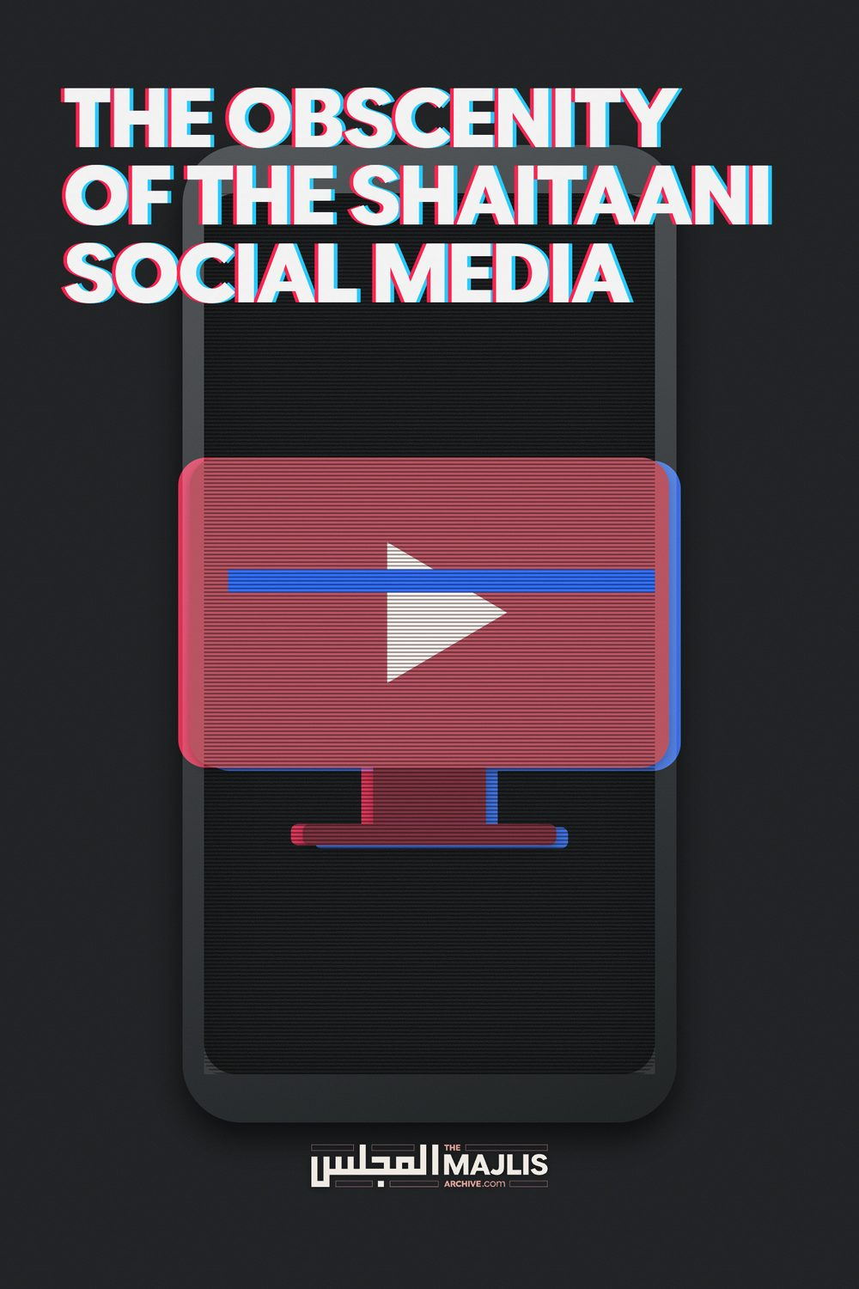

THE OBSCENITY OF THE SHAITAANI SOCIAL MEDIA
The Majlis · Voice of Islam
Mujlisul Ulama of South Africa

About this edition
This is a reproduction by The Majlis Archive (themajlisarchive.com) of a publication of The Majlis, Mujlisul Ulama of South Africa, made and published with their permission.
The PDF as The Majlis issued it is the original. This edition was read from that PDF's own structure and checked against it letter for letter; where the two differ, the PDF is correct.
Checked: 64 paragraphs, 0 differing; a second, independent PDF reader finds 100.0% of the PDF's words here.
Nothing has been reworded, added or removed.

Mujlisul Ulama of S. A.
6056, South Africa

SOCIAL MEDIA ENGAGEMENT – A HIGHLY ERRONEOUS FATWA
Please comment on the following fatwa issued by Mufti Ebrahim Desai's darul ifta'. To even an Islamically conscientious layman, there appear to be discrepancies in the fatwa. Your comments will be appreciated.

THE QUESTION:

MUSLIM FEMALES ENGAGING ON SOCIAL MEDIA.
We are living in the age of technology and everyone wants peace of the limelight. (What type of convoluted 'peace' does the shaitaani social media offer? Islam - the Qur'aan and Sunnah advocate the acquisition of peace in seclusion and solitude, and the Qur'aan states explicitly and emphatically: "Behold! In the Remembrance of Allah do hearts find peace." Pursuit of the limelight is abhorrent in Islam. –The Majlis)
What is the ruling regarding muslim females engaging on social media? There are groups like Muslim mums etc where muslim females post about their partners education levels (utter shamelessness- beheyaai and beghairati – The Majlis), household contributions, children's photos (Kabeerah sins of the utmost gravity – The Majlis), food cooked etc.
These groups certainly create awareness on certain topics (this is the shaitaani chimera for entrapment in haraam – The Majlis), however the greater part is just banter. (The evils and spiritual destruction wrought by banter are similar to the spiritual disasters of consuming haraam and mushtabah food. The nusoos of the Deen are replete with the evils of banter.
All of this khuraafaat –drivel, nonsense and flotsam – are factors of hurmat {prohibition} which an intelligent Muslim can understand. The photos and the banter are the worst aspects of shaitaaniyat and nafsaaniyat – The Majlis)
What are the Islamic views on groups of this nature? (All of these groups without exception are under the spell of shaitaani and nafsaani influence. They are entangled in the evil web of shaitaan without even realizing all the filth and villainy in which they are wallowing and eroding their Imaan incrementally each time they participate in these haraam media. – The Majlis)
Are we sinful for reading and or participating in posts about people's husbands, aunts, uncles, kids and neighbours who may not necessarily be on the group? (The sins are glaringly conspicuous. Only those who are spiritually blind and stupid fail to see and understand the evil of these media. Even their Imaani conscience has become totally extinguished, hence they fail to understand the meaning of the Hadith: 'Sin is that which agitates the conscience.' Since all vestiges of spiritual perception are obliterated from the hearts by reckless and constant indulgence in media evil, there is nothing but zulmat – spiritual darkness – enveloping their hearts, hence even these muftis have become blind to the reality of evils for which they are issuing haraam licences. – The Majlis)
Is posting food pics etc. ok? (No! It is not OK. The issue has to be viewed as a whole – a conglomerate of evil admixed with a smattering of mundane benefits which have absolutely no truck with the Goals of the Aakhirat for which Allah Ta'ala has created us. The dark and ominous silhouette of shaitaan and the nafs in the background in entirety negate the smattering of benefits. – The Majlis)

THE IMPROPER, ERRONEOUS FATWA
In the Name of Allah, the Most Gracious, the Most Merciful.
As-salāmu 'alaykum wa-rahmatullāhi wa-barakātuh. Sister in Islam. It is apparent to all that social media is a double-edged sword that can be beneficial or harmful depending on the way it is used. (This is a deceptive appearance. The 'double-edged sword' is double talk which is the trade mark of forked tongues – The Majlis)
That vast majority of your questions can be seen this way – it depends on the user's intention and the content of the post(s). (This type of deceptive posturing for providing a licence for haraam is a trade mark of today's liberal and modernist muftis. – The Majlis)
It is not so much of a question of whether the user is a male or a female (since your question specifically asks about females) – but rather, whether he or she is using social media in a permissible or impermissible way and whether the post that is being read/shared/written is permissible or impermissible. (The entire social media domain is impermissible. The question of sin in a shaitaani medium or using it in an impermissible or a permissible way therefore does not develop. Liquor will remain haraam despite its benefits. These media per se are haraam. – The Majlis)
If a person (male or female) reads/shares for example, beneficial posts that authentic scholars (All 'scholars' appearing on these shaitaani social media are agents of Iblees – The Majlis) share on their pages, or follows a business to get updates on upcoming deals or learns/shares a recipe for a dish they like, etc., then such users are clearly using social media for permissible and practical purposes – as long as there is nothing that would otherwise make such posts impermissible. (This type of logic is termed in the Qur'aan 'zukhruful qawl'. These are satanic inspirations with which shaitaan ensnares his victims to entrench them in haraam. What the mufti says here is stupid wishful thinking.- The Majlis)
Reading posts about others:
When you ask about reading posts about people's aunts, uncles, neighbors, etc. - again the basic principle is that if it is something innocent, such as mentioning somebody's recovery from an illness, someone returning from Hajj/Umrah, etc. then there is no harm in reading such posts as long as they are free from anything impermissible (i.e. slander, backbiting, etc).
(This is more forked tongue expression for building up the case for halaalizing the haraam media. Reading about the news of ghair mahaareem is shameless and lewd. Furthermore, these shaitaani media excel in immodesty and immorality- The Majlis)
Pictures of food might also be shared, for example, to show others how to make a certain dish or to thank Allah for being able to make a certain dish. (The mufti sahib is slandering Allah Ta'ala. He should have feared and not become so audacious to drag Allah Ta'ala into the scheme to justify these shaitaani social media which preponderate with pornography, zina adverts, zina chats, and all facets of zina. It is furthermore, spiritually destructive for Muslims to waste time advertising food recipes. Such khuraafaat are inimical and nugatory of the goals of the Aakhirat. Time may not be squandered on this type of drivel. – The Majlis)
In general, posts that allow one to share in the happiness or sorrow of another Muslim are perfectly okay to read as long as such posts are free from anything impermissible. (The whole miserable devilish medium is impermissible. – The Majlis) The above permissible uses are obviously not the same as reading posts that have impermissible content. (This averment is deceptive. Any perceived goodness/benefit in a haraam compound is also haraam as long as it constitutes part of the haraam compound. The flour, water and butter in najis dough are haraam when some urine or faeces is admixed. – The Majlis)
Needless to say, posts that deal with spreading rumors and gossip, showing off one's possessions or bragging about one's achievements are exactly the type of actions that a Muslim need to avoid, as one sin leads to another - and social media is a never-ending source for these things. (Despite the mufti conceding that the social media are a 'never-ending source for sins', he abortively forges a licence of permissibility for these satanic media. Evil and sin overshadow whatever little 'benefit' there may be in the satanism. – The Majlis)
Educational Achievements / Pictures of Food:
At the same time, it would be imprudent and impractical to issue a ruling for example about a sister writing about her husband's educational achievements (It is utterly shameless and lewd for a woman to advertise in the public domain anything about her husband and vice versa. Those whose brains are corrupted with western zina concepts are bereft of Imaani ghairat.
Thus, they are unable to perceive the shamelessness in such un-Islamic and kuffaar behaviour. – The Majlis) or posting a picture of a dish she mastered, etc. since she might just be sharing that information by way of thanking Allah and mentioning His favors upon her. (If the mufti is so stupid to believe this stupidity or if he is being just devious for building his case of permissibility for the haraam shaitaani social media, then he should know that there are countless people of intelligence who do not swallow this stupidity which he has disgorged. – The Majlis) We do not know her intention and we shouldn't harbor baseless suspicions. (Her ugly intention is advertised by her participation in the haraam media and by her denuding herself in the public domain for the eyes and ears of every faasiq, faajir, and kaafir Tom, Dick and Harry. – The Majlis)
If a person mentions the blessings and favors of Allah upon their family, by way of thanking Allah, then there is nothing wrong with that - as the purpose is to praise Allah for His Blessings and to get ourselves used to asking only Allah for one's needs since He is The Provider (al-Razzaq) and The Bestower (al-Wahhab). (Narrating and enumerating the blessings and bounties of Allah Azza Wa Jal are not executed by Muslim women standing denuded on a public stage and acquitting themselves with a rodomontade attitude which all and sundry, but the mufti sahib, can discern when the women express and advertise themselves on the shaitaani media. – The Majlis)
However, if a person mentions such achievements by way of bragging, showing-off or thinking himself to be better than others, then such pride is condemned and certainly impermissible. (This pretentious averment is despicably lamentable. It advertises either the ignorance or the deception of the mufti. It stands out as clear as daylight that the women who advertise themselves on these shaitaani public haraam media are embodiments of the evil attributes to which the mufti refers here, and which he is vainly attempting to deny. Assaulting the intention of shameless women advertising themselves on the shaitaani media is never baseless suspicion. It is based on reality. – The Majlis)
Best Approach: The best approach would be to stay away from all those things that are clearly impermissible, and to be cautious in one's approach towards those type of posts that can be a gray line between halal and haram but without harbouring baseless suspicions about others' intentions. (This averment is a classical example of forked tongue acquittal. All caution is thrown overboard on these shaitaani media. These are platforms of self-expression, advertising and shaitaaniyat. What the mufti says here is plain drivel. –The Majlis)
When in doubt, avoid doubtful posts, so that one does not inadvertently commit a sin by reading gossip or defamatory content (ghibah) as reading such content is the same as listening to it. (The issue of doubt from which abstention is Waajib, does not apply to these evil social media. It is an issue of conspicuous HARAAM.- The Majlis)
Backbiting others is a major sin, but unfortunately some do not realize the gravity of what they are doing as it has become a part of their daily life on social media. In fact, since these posts (which backbite/slander others) are shared, they will stay in the public domain long after having been written which means that the author (and those that share these posts) will continue to receive sin as long as people read that content. May Allah guide them. Ameen. For further details, please see: http://askimam.org/public/question_detail/35542 (This advice is an evocation of Imaan which the mufti was compelled to state. Despite his liberality and defence of the shaitaani media, Imaan has constrained him to proffer this advice which renders his forked tongue 'fatwa' highly incongruent. This advice makes his fatwa ambiguous. There is no proper guidance for Muslims in this type of ambiguity which condones the lewd fitnah of these evil social media domains.
Posting pictures: As for your question regarding posting pictures of one's children, etc. the position of the Darul Iftaa is that it is not permissible to take digital photos of yourself, male or female, adults or children and neither is it permissible to post them on social media sites. (At least a ray of light is displayed here. – The Majlis) And Allah Ta'āla Knows Best Rabiul Islam, Student Darul Iftaa Detroit, Michigan, USA Concurred by: Mufti Sohail Bengal Chicago, IL (USA)
Checked and Approved by Mufti Ebrahim Desai.
(Indeed a baseless concurrence and checking – The Majlis)
(End of the fatwa)

OUR FURTHER COMMENTS
Allah Ta'ala says in the Qur'aan Majeed:
"They ask you (O Muhammad!) about liquor and gambling.
Tell (them) that there is great sin in it, and many benefits for mankind whilst its sin is greater than its benefit."
Despite recognizing and stating with clarity the 'many benefits' of liquor and gambling, the Qur'aan Majeed proscribes these evils on the basis of the preponderance of their evil. This Aayat is a general principle on which the rulings of many issues are based and can be based.
The Shariah's Ruling regarding these evil social media is based on this Qur'aanic principle as well as on other Fiqhi principles of which the Mufti sahibs of this era appear to be ignorant.
Despite the smattering of superficial benefits claimed by the votaries of these media, these shaitaani platforms are awash with immorality, obscenity, shamelessness, shaitaaniyat and nafsaaniyat. It is most unintelligent for even a layman to believe that these social media can be halaal. For muftis to venture a halaal ruling is shockingly lamentable, and it only portrays their stark ignorance of the operation of the principles of the Shariah. Their attitude further conveys that they are bereft of understanding the Islamic ethos which is acquired from companionship of the Saaliheen. The vital necessity of such suhbat is commanded by even the Qur'aan Majeed: "Join the ranks of the Saadiqeen."
However, the heart-breaking problem in this era is the almost total disappearance of the Saaliheen. Predicting this sad state of affairs, Rasulullah (Sallallahu alayhi wasallam) said:
"The Saaliheen are departing (from this dunya) one after the other (in quick succession). Then will remain only Hufaalah
(rubbish, flotsam, waste-matter) like the hufaalah of barley or dates. Allah will not have any care for them."
In issuing the licence of permissibility for the glaringly haraam social media which is preponderated with haraam, the Mufti Sahib and his Students have portrayed ignorance of the principle stated in the aforementioned Qur'aanic Aayat, and of the principle of Saad-e-Baab (i.e. Blocking the avenue of fitnah and fasaad). They display gross jahaalat of the principle which constrained the imposition of the Wujoob for women concealing their faces in public despite its exclusion from Satr per se.
With their fatwa issued so ineptly they have acquitted themselves like modernist laymen. This fatwa is devoid of the dignity of Faqaahat and Ilm. Leave alone faqaahat and baseerat, the fatwa displays lack of even textual academic knowledge which by virtue of external trappings could be passed off as a fatwa by an experienced Mufti.
By harping on the smattering of superficial mundane benefits and pretending to be oblivious or ignorant of the tremendous harms of these social media, the muftis have demonstrated their incompetence in the Department of Ifta. It is imperative for them to study the meaning of Ifta', its tremendous importance, its dangers and the requisite qualifications of an Aalim who could be authorized to issue fatwas. But in this era this august Department has been rudely wrenched from its pedestal of sublimity and cast into the dregs of ludicrousness. The muftis are shockingly diseased with jahaalat, ineptitude, great deficiency in textual knowledge, and totally bankrupt in Islamic morality which has transformed Taqwa into an alien and incomprehensible concept for them. How is it ever possible for such chaps to mount the pedestal of Ifta and issue fatwas for the guidance of humanity?
Everything of the Muslim woman is Aurah. It is Waajib that her entire body, her voice, her garments, her identity, her name – everything of her – be concealed from the public gaze and awareness. Self expression is morally a fatal poison for the Muslim woman. What has happened to the Aql of these muftis who are promoting female expression and female exhibition when Allah Ta'ala has proscribed her voice even when she is performing Salaat alone in a remote corner of her home? When she is not allowed to audibly proclaim even the Name of Allah Azza Wa Jal in public, by what stretch of Imaani logic can it ever be permissible for her to publicly advertise food and cake recipes and to advertise the affairs of her husband on such evil, filthy, shaitaani haraam media as facebook, etc.? Truly, shaitaan must have urinated in the brains of these liberals who fabricate junk fatwas.
It is not permissible for a woman to narrate even the virtues of her husband to another woman. Such a misdeed is immodest in terms of the Shariah's concept of Haya (Shame and Modesty). How can it ever be permissible for her to advertise any aspects of her husband from a public platform, and worse, if the platform is a tool of shaitaan such as these social media? Women in droves are glued to these media even into the late hours of the night. Can these muftis not understand that a woman's preoccupation with this organ of shaitaan is in total negation of her role as a wife and mother, and also in negation of Hijaab? Innumerable women are trapped into zina relationships via these social media.
Social media are not instruments of necessity. There is absolutely no imperative need for exhibition on these media. It is therefore downright stupid for a mufti to cite the smattering of worldly and secular benefits in an abortive bid to halaalize a medium which is fraught with such grave and obscene consequences as are these social media platforms.
The mufti has not presented a single daleel which can be tenable in the Shariah for permissibility of these satanic social media of gossip and slander.

