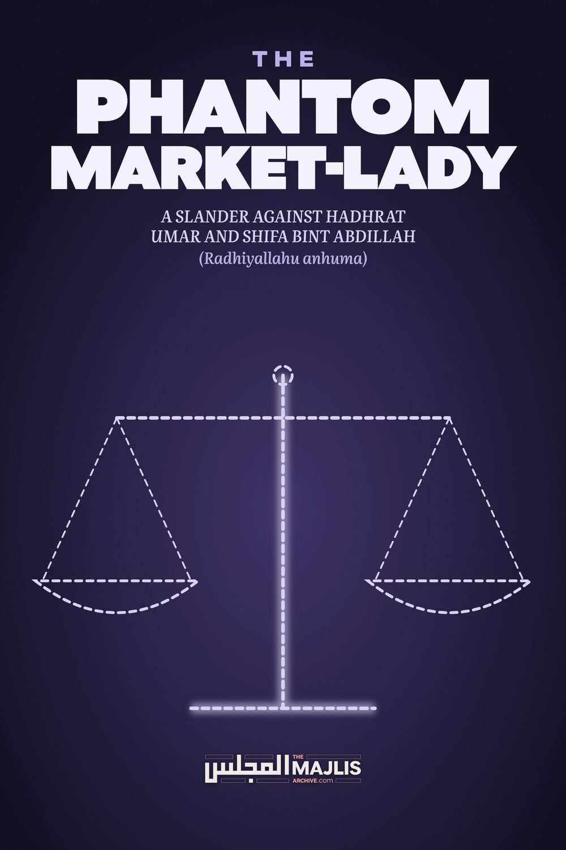

THE PHANTOM LADY MARKET SUPERVISOR
The Majlis · Voice of Islam
Mujlisul Ulama of South Africa

About this edition
This is a reproduction by The Majlis Archive (themajlisarchive.com) of a publication of The Majlis, Mujlisul Ulama of South Africa, made and published with their permission.
The PDF as The Majlis issued it is the original. This edition was read from that PDF's own structure and checked against it letter for letter; where the two differ, the PDF is correct.
Checked: 235 paragraphs, 0 differing; a second, independent PDF reader finds 97.8% of the PDF's words here.
Nothing has been reworded, added or removed.

A SLANDER AGAINST HADHRAT UMAR AND SHIFA BINT ABDILLAH (Radhiyallahu anhuma)
Mujlisul Ulama of S.A.

Port Elizabeth
6056 South Africa

A SLANDER AGAINST HADHRAT UMAR AND SHIFA BINT ABDILLAH (Radhiyallahu anhuma) THE PHANTOM LADY MARKET SUPERVISOR

Question
Currently in certain quarters, women (backed by certain Ulama) are supporting the stance of women being allowed to take up a profession and venture into different areas of work. Amongst the proofs cited by these people, one seems to be their main point of support, i.e. the appointment of Umar (radhiallahu anhu) of Shifaa (radhiallahu anha) in the marketplace.
Answer The claim that the noble Sahaabiyyah, Hadhrat Shifa Bint Abdullah (Radhiyallahu anha) was appointed supervisor of the market in Madinah by Hadhrat Umar (Radhiyallahu anhu) is a satanic calumny fabricated by Ibleesi 'scholars' and hadith fabricators whose brains have been vermiculated with kufr and zina cravings. The motive of these agents of Iblees whose brains are necrotized with immorality is to provide grounds and justification for the western kuffaar concept of gender equality which in reality is a satanic licence for promiscuous interaction, immorality and fornication.
The plot is to drag females into the public domain to gratify the lustful cravings of fussaaq, fujjaar and kuffaar. The noble Lady, Hadhrat Shifa Bint Abdullah (Radhiyallahu anha) was NEVER the supervisor of the marketplace. She was NOT appointed market supervisor, neither by Hadhrat Umar (Radhiyallahu anhu) nor by anyone else. It is a filthy slander uttered by evil agents of Iblees.
The womanising rubbish, moron 'scholars' of our age are desperately clinging to this confirmed fabrication like a drowning man clutches at straws. Regarding this slanderous narration, Imaam Maalik (Rahmatullah alayh) said:
"It (this narration) is not authentic. Therefore, do not pay any attention to it. Verily, it is among the conspiracies of the fabricators in Hadith."
The son of Hadhrat Shifa Bint Abdullah (Radhiyallahu anhu) was offended by this fabrication which claimed that his mother had been appointed supervisor of the market place. Ibn Sa'd narrated:
"It is said that Umar Bin Khattaab had appointed her over the marketplace. However, her son refuted this and would become wrathful (extremely angry) over this (false allegation)."
The supervisor of the marketplace appointed by Hadhrat Umar (Radhiyallahu anhu) amongst others, was also Sulaimaan Ibn Abi Hathmah who was the son of Shifa Bint Abdullah. She was from the Muhaajiraat (Ladies who had migrated in the initial era of Islam). She was a senior Sahaabiyyah of great intelligence, hence Hadhrat Umar (Radhiyallahu anhu) would sometimes consult her. Such consultation is perfectly valid. Even Rasulullah (Sallallahu alayhi wasallam) would consult with his noble Wives. But consultation with her NEVER means appointment as supervisor of the marketplace. This is a calumnious LIE disgorged by rubbishes with necrotized brains.
Nowhere in any authentic Hadith Source is it mentioned that Hadhrat Umar (Radhiyallahu anhu) had appointed Shifa Bint Abdullah (Radhiyallahu anha) as supervisor of the market place whereas it is explicitly mentioned that he had appointed her son to be in charge of the marketplace.
Let us for a brief moment accept the falsity hallucinated by the modernist rubbishes and their rubbish molvi backers that the Lady was appointed supervisor of the marketplace. Even on this basis not a shred of justification can be adduced to bolster today's female participation in the public domain. It should be well understood that when need demanded, this noble Lady of Islam, like all other Ladies of the time, emerged from her home in the state of tafilah. That is: wrapped in such a large unattractive outer sheet which was capable of concealing two women. It was not the type of flashy, attractive abayas of today which women with prostitute tendencies don.
Furthermore, even the face-covering was unlike today's stylish niqaab. Hadhrat Aishah Siddiqah (Radhiyallahu anha) describing the face-covering of the females of her era explained that it was the same shabby outer-shawl which would be drawn over the head to cover the entire face in such a manner that the woman would see with only ONE eye. She would literally peep with one eye as she went along clinging to the buildings on the sides of the street. She would not walk and saunter in the middle of the pathway as do the lewd women of today.
Women in this age, who explode from their homes into the streets and brush shoulders with fussaaq, fujjaar and kuffaar males in the public domain are rubbishes – pure dirt and flotsam. Only brains convoluted by shaitaan can forge a comparison between the Sahaabiyyah and the flotsam zaaniyaat of today.
Hadhrat Umar (Radhiyallahu anhu) was the first Khalifah to enact the ban on women attending the Musjid. Some Qur'aanic laws of Hijaab were revealed in conformity with the strict view of Hadhrat Umar (Radhiyallahu anhu). Hadhrat Umar (Radhiyallahu anhu) advised that women should not have a wardrobe full of garments. The more garments she has the more will she desire to emerge from the house. It is inconceivable that Hadhrat Umar (Radhiyallahu anhu) would ever appoint a female to a position of leadership.
Furthermore he was fully cognizant that Rasulullah (Sallallahu alayhi wasallam) said: "Never ever will prosper people who entrust their affairs to a woman." How can we now conceive and concede that Hadhrat Umar (Radhiyallahu anhu) would ever appoint a female to be the supervisor of a marketplace which Rasulullah (Sallallahu alayhi wasallam) said is "the worst place on earth"?
There is Ijma' (Consensus) of the Ummah that it is not permissible to appoint a woman to the position of leadership. Only immoral zindeeqs are able to hallucinate that Hadhrat Umar (Radhiyallahu anhu) acted in flagrant contravention of the Qur'aan and Sunnah by appointing a female to be the supervisor of a marketplace, "the worst of all places on earth".

THE FALLACY OF FEMALE PARTICIPATION IN JIHAD
Question: They also present the narrations about some women who had participated in Jihad during the time of Rasulullah (Sallallahu alayhi wasallam) to bolster their view. What is the explanation for this?
Answer The mere presence of a person in a scenario cannot be described as participation therein. One may be present in an activity without being a participant. The presence of some ladies during Jihad campaigns of the Sahaabah does not cancel the Shariah which Rasulullah (Sallallahu alayhi wasallam) had taught to the Sahaabah and which they have passed on to posterity via the Chain of the illustrious Fuqaha and Aimmah Mujtahideen.
It is established beyond the slightest vestige of doubt that women would attend the Musjid during the age of Rasulullah (Sallallahu alayhi wasallam). Despite this indisputable fact, the Sahaabah unanimously banned them after the demise of our Nabi (Sallallahu alayhi wasallam). This mas'alah has been discussed and explained in great detail in several of our publications. The prohibition cannot be reversed or cancelled by citing acts which were committed and practiced prior to the ruling of prohibition or in the face of an explicit prohibition such as the prohibition of women participating in Jihad – a Prohibition enacted by Rasulullah (Sallallahu alayhi wasallam). Thus, morons should endeavour to clear their brains of the satanic vermin which has necrotized their thinking and understanding so that they may comprehend this simple issue: That the presence of some Ladies in Jihad campaigns in isolated cases does not and cannot cancel the Prohibition announced by Rasulullah (Sallallahu alayhi wasallam).
The participation of women in Jihad was not for the purpose of wielding the sword. They had participated in a very unorganized, low profile manner without the permission of Rasulullah (sallallahu alayhi wasallam). At no stage did Rasulullah (Sallallahu alayhi wasallam) or the Sahaabah call on females to participate in Jihad. In fact, the exact opposite was the stance of our Nabi (Sallallahu alayhi wasallam). Some women simply accompanied their husbands.
Women were discouraged and even prohibited by Rasulullah (sallallahu alayhi wasallam) from participating in Jihad. They were not encouraged nor lured out of their homes to participate in Jihad. No tashkeel of females was made. They were not formed into groups, and battalions/regiments, etc. to wage Jihad in battle array. They were insignificant entities, hardly noticeable, for they were concealed in tents and remained in the extreme background. A very few, a mere handful – would accompany their husbands.
When Rasulullah (sallallahu alayhi wasallam) took along one of the Azwaaj-e-Mutahharaat in Jihad, she was completely concealed in a cabin (houdaj) which was mounted on a camel. These cabins were specially used for Purdah Nasheen ladies who had to travel when the need arose. But the Hijaab was complete. From the example of Rasulullah (sallallahu alayhi wasallam), it will be manifest that even in Jihad, Hijaab was observed as far as was possible, and the Hijaab was not of the deficient, mock 'hijaab' of this age. It is the height of insolence and stupidity to justify today's nude women participating in the public domain with the Sahaabiyyah who had been present in some Jihad campaigns in conditions of concealment (purdah).
The Ahaadith make it clear that women never participated in Jihad in any organized form. There was no 'ladies regiment', 'ladies battalion' or 'ladies jamaat' operating 'side by side' with males. The presence of women in the Jihad campaigns paled into insignificance by virtue of their negligible number, unofficial, rare and unorganized participation.
Even if women participated in Jihad campaigns it cannot be cited as justification for the ladies participation in the public domain as the modernist juhhaal are advocating, just as permissibility for Musjid attendance may not be extrapolated on the basis of the permissibility which had existed during the age of Rasulullah (sallallahu alayhi wasallam). The Ahkaam of both differ. The one cannot be argued on the premises of the other.
Jihad is a matter of life and death. It is a field of Activity of its own kind. Women's public tabligh activity such as that of the Tabligh Jamaat, and the presence of women in offices, malls, factories, universities and the like cannot be argued and justified on the basis of Jihad even if it be assumed that some females had participated. But the reality is that even this exceptionally baseless assumption is stupid since women did not participate in Jihad. On the contrary, Rasulullah (Sallallahu alayhi wasallam) prohibited them from participating in Jihad.
Where a female was constrained to fight, such engagement in actual fighting activity with the kuffaar was in the course of events, extremely rare. And compelled by circumstances and does not constitute a bases for justifying the presence of lewd women, adorned and decorated, in the public domain alongside fujjaar, fussaaq and kuffaar males. Their participation was extremely insignificant. Isolated episodes of participation do not represent a general rule.
Liquor may not be justified on the basis of a Sahaabi having consumed it. Similarly, zina cannot be justified on the basis of it having been committed by some Sahaabah. The errors and also errors in the judgment of some Sahaabah do not cancel any command of the Shariah.
Despite the great importance of Jihad, Rasulullah (sallallahu alayhi wasallam) did not encourage ladies to participate. In the same way they are not encouraged to perform Salaat in Jamaat, even if they are only women at home. The following Hadith indicates Rasulullah's (sallallahu alayhi wasallam) actual attitude to the question of women emerging from their homes even to participate in the Fardh Kifayah obligation of Jihad.
"Hadhrat Umme Kabshah (radhiyallahu anha) says;
'A woman of the tribe of Usrah Bani Qudha-ah requested Rasulullah (sallallahu alayhi wasallam):
'O Rasulullah! Do you permit me to participate in that army?'
Rasulullah (sallallahu alayhi wasallam) refused permission. The lady said: 'O Rasulullah my intention is not Jihad. My motive is to tend to the wounded and sick and give them water to drink'. Rasulullah (sallallahu alayhi wasallam) replied:
'If it was not for the fear of women's participation in Jihad becoming Sunnat and people saying (in future) that a certain woman (Sahaabiyyah) went in Jihad, I would have given you permission. Therefore you, remain behind."
This Hadith is found in many Hadith kutub.
Herein is a salubrious lesson for these deviated modernists and evil molvis who support the modernist view. Rasulullah's reason is a clear message for these morons.
This Hadith portrays: (1) Rasulullah's (sallallahu alayhi wasallam), express refusal to women's participation in Jihad even in a secondary capacity, and (2), the reason for the refusal. The reason for Rasulullah's (sallallahu alayhi wasallam) refusal is given by Nabi (sallallahu alayhi wasallam) himself as the fear that women's participation in Jihad will be interpreted as a Sunnat whereas it is not a Sunnat. Rasulullah (sallallahu alayhi wasallam) did not wish his Ummah to cite women's participation in Jihad campaigns during the age of Rasulullah (sallallahu alayhi wasallam) as being a standard Sunnat practice, hence he refused permission and immediately furnished the reason for the refusal, viz., "THE FEAR THAT WOMEN'S PARTICIPATION IN JIHAD WILL BECOME TO BE ACCEPTED AS A SUNNAT".
This Hadith is in fact a prediction pertaining to the future. In these times the moron modernists and jaahil molvis are giving practical expression to the fear of Rasulullah (Sallallahu alayhi wasallam). The issue he had feared is now a reality. Now since Rasulullah (sallallahu alayhi wasallam) himself negates women's emergence from the home to participate in the superior Ibaadat of Jihad, it will be highly improper and in total conflict of the purport and spirit of Rasulullah's (sallallahu alayhi wasallam) teaching for us in this age to equate women in the public domain to the noble Ladies who had been unobtrusively present in some Jihad campaigns.
The arguments of the modernist morons and their moron molvis is devoid of Shar'i substance. There is simply not a single valid argument to bolster their modernist haraam view.
The Haqq has arrived and baatil has perished, for verily baatil (by its very nature) perishes.
(Qur'aan)
The following is a dissertation on this topic by a Student of Islam in the UK.

THE MYTH OF SHIFA BINT ABDULLAH BEING THE SUPERVISOR OF A MARKETPLACE AL-SHIFA BINT ABDULLAH (RADHIYALLAHU ANHA) AND THE MARKET OF MADINAH
Contrary to what the feminists today have been propagating quite fervently, the second Khalifah, Umar (radhiyallahu anhu), never appointed the noble Sahabiyyah, al-Shifaa bint Abdullah (radhiyallahu anha), in-charge of the marketplace in Madina.
Regarding this baseless allegation which is designed to tarnish, intentionally or otherwise, the impeccable reputation of both these great Sahabah (radhiyallahu anhum), the 5th century Maliki authority, Qadi Ibn Arabi, said:
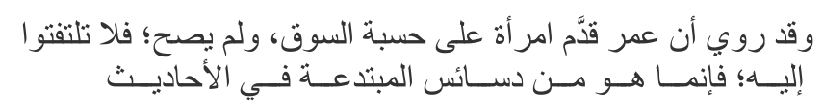
"It is not authentic so pay no mind to it, as it is one of the conspiratorial machinations of the heretics in hadith." (Ahkaam ul-Qur'aan)
The fact that it is a complete fabrication will become quite clear by the end of this article.
The false allegation did find its way into several classical Islamic texts. However, despite the fact that in almost every source no sanad is cited, or in one source an extremely defective sanad (a weak narrator, an unknown narrator, and a break in the chain) is given, modern day versions of those heretics continue to cite this story with great relish almost as if its authenticity has been confirmed by divine revelation (Wahi).
We cite below a few examples.
Akram Nadwi, in the footnotes to his translation of Ibn Hazm's dissertation on women attending mosques, after having just dismissed a number of Hadiths with genuine and authentic sanads, and having also committed chicanery in the actual translation, states unashamedly:
"And it was Umar who appointed a well-known and learned companion from a noble family, al-Shifa bint Abdillah al-Adawiyyah, as the supervisor of the market of Madinah."
Akram Nadwi's fraud in the translation and footnotes of this particular book will be the subject of a future article insha-Allah.
Yusuf Qaradawi, who, like Akram, also has a special penchant for dismissing genuinely authentic Hadiths with real chains of narrations whilst confidently affirming fabricated and chainless narrations in the very same breath, states as a matter of fact in his book, "Malaamih ul-Mujtama' ul-Muslim":
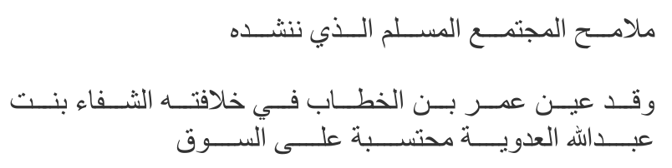
"Umar ibn al-Khattaab, during his Khilafah, appointed al-Shifaa bint Abdullah al-Adawiyyah as the inspector of the market."
The celebrity story-teller, Omar Suleiman, in the article, "Gender Equity & the Advent of Islam", co-authored with two others, somehow manages to provide further detail to the actual duties involved in the imaginary and supervisory role fabricated for al-Shifaa bint Abdullah (radhiyallahu anha):
"Coming back to Umar ibn al-Khattab's shifting perspective: during his caliphate, he appointed two different women, Samra b. Nuhayk [8] and Shifa b. Abdullah,[9] to fulfill the role of market supervisors. They would patrol the markets to ensure that fair business practices were being carried out, and proper Islamic behavior was maintained."
In the same grain, the popular online magazine, Muslimmatters, have had this fabrication, along with the compulsory extra duties conjured up and attributed to al-Shifaa bint Abdullah (radhiyallahu anha), up on their website for nearly 10 years now:
"Al-Shifa bint AbdAllāh, appointed by Umar raḍyAllāhu 'anhu (may Allāh be pleased with him) as market controller in Medina….Shifa bint AbdAllāh, as the market controller, had to ensure that business practices should always be consistent with Islam. She would go around the market, making sure that trading was being done on fair policies, and that that buyer and seller conformed to Islamic values."
Popular orator, Dr Muhammad Tahir-ul-Qadri, in his article, "Gender Equality and Islam", gives a succinctly vivid description of al-Shifaa's imaginary role:
"The Caliph Umar appointed Shifa bint Abdullah as in-charge of a bazaar, the in-charge accountability court and market administration."
Even the Dar al-Iftas (scholarly institutions dedicated to issuing religious edicts) are at it. Dar al-Ifta al-Missriyyah, as justification for women working outside the home, states as supposedly unassailable proof in one of its Fatwas:
"Shifa Bint 'Abdullah held the post of market supervisor during the caliphate of Umar Ibn Al-Khattab (may God be pleased with him)."
It appears that the internet and modern Islamic literature is replete with this story, especially modern adaptations of it.
It is clear that the role envisaged for this noble and most eminent Sahabiyyah (radhiyallahu anha) in the examples cited above and in almost every other place where this story is related today, is of a thoroughly western mould – one similar to a modern female corporate office manager who roams about freely, interacting with all and sundry, albeit coated with a thin veneer of supposedly modest behaviour and dress which are hallucinated to be Islamic, but are, in reality, in violent conflict with the true teachings of Islam – such teachings, which, as prophecized in authentic Hadiths, are becoming increasingly Ghareeb (strange, alien, forlorn) with each passing day.
From this perspective, the story, in the form that it is being propagated today, is a great slander on Umar (radhiyallahu anhu), on al-Shifa bint Abdullah (radhiyallahu anha), and on the generality of the Sahabah (radhiyallahu anhum) who, by implication, are alleged to have tolerated and condoned numerous contraventions of the Shari'ah including the prohibition of women emerging outside the home without genuine need, the prohibition of women interacting with men, without a barrier and without genuine need sanctioned by the Shari'ah, and, quite squarely, the prohibition of falling under the purview of the Prophetic warning that never will a people succeed who make a woman in charge of their affairs.
To provide sincere readers with a brief glimpse into the vastness of the chasm of difference between the "Islam" as propounded by the modernist charlatans who masquerade as scholars today, and true, Ghareeb Islam as expounded by the great Fuqaha (jurists) of the past, we cite here the 5th century authority, Imam Baghawee, transmitting the Ijma' (agreement of the scholars) on the prohibition of a woman assuming a leadership position in a public role:
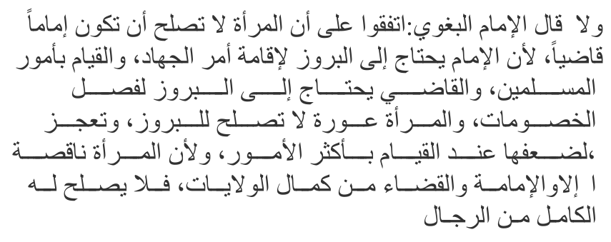
"They (the scholars) are in agreement that a woman is not suitable to be a leader or a judge because the leader is in need of coming out into the open to establish the matter of Jihaad and to carry out the affairs of the Muslims, and the judge is in need of coming out into the open to settle disputes. And the woman is something that has to be concealed and is
(thus) not suitable for coming out into the open. She is incapacitated, due to her weakness, in undertaking many matters (of the public). The woman is deficient, while leadership and judgeship is from the elite roles, thus none is suitable for them except the accomplished from men." (Sharh us-Sunnah)
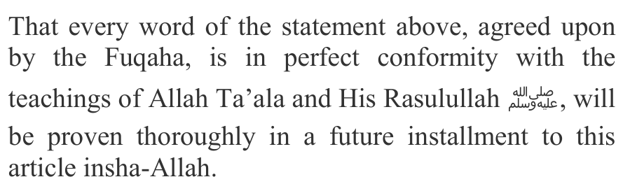
Rare and isolated opinions of scholars which maybe excavated from our tradition and which contradict the above or which, for example, permit the listening of music, the killing of civilians, viewing one's prospective bride in the nude, etc. do not affect the Ijma' (agreement that has a binding effect) that occurs in any matter.
Returning back to the sources which clarify the reality behind the myth of al-Shifa's leadership role in the market, the author of one of the early and most authoritative biographical dictionaries, Ibn Sa'd, mentions how al-Shifa bint Abdullah's (radhiyallahu anha) progeny would take offence, and understandably so, to the false allegation that she had assumed a leadership position:
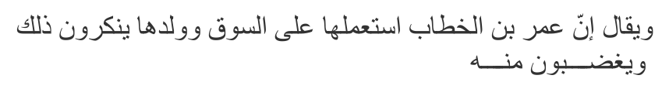
"And it is said that Umar ibn al-Khattaab appointed her in-charge of the marketplace. However, her progeny would deny this and would get angry over this." (Tabaqaat ul-Kubraa)
So who did Umar (radhiyallahu anhu) appoint as the supervisor of the marketplace in Madinah?
When we turn to authentic sources, the names of three men come up: as-Saa-ib ibn Yazeed, Abdullah ibn Utbah ibn Mas'ood, and Sulayman Ibn Abee Hathmah (radhiyallahu anhum).
Imam Malik narrates in his Muwatta, with an authentic chain:
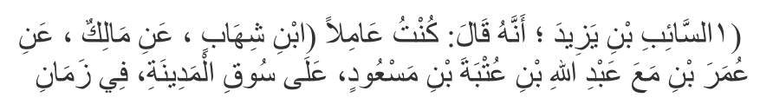
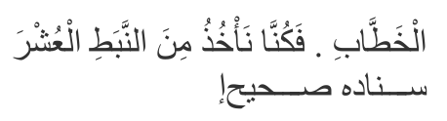
"as-Saa-ib ibn Yazeed said: "I was the administrator of the marketplace of Madinah, with Abdullah ibn
Utbah ibn Mas'ood, in the time of Umar ibn al-Khattaab…"
Similarly, Imam Bukhari narrates in at-Taarikh al-Awsat:
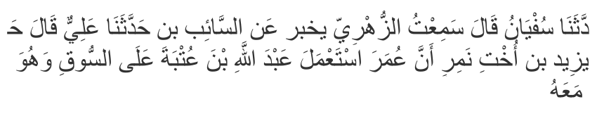
"az-Zuhree relates from as-Saa-ib ibn Yazeed, the nephew of Namir, that Umar placed Abdullah ibn
Utbah in charge of the marketplace, and he was with him."
Ibn Sa'd narrates with an authentic chain to az-Zuhree:
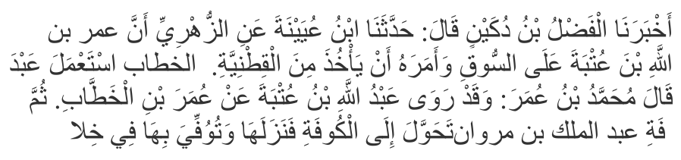
"Umar ibn al-Khattaab placed Abdullah ibn Utbah in charge of the marketplace and he ordered him to collect legumes (as tax from foreigners)… then he was transferred to Koofa. So he settled there and passed away there during the reign of Abdul Malik ibn
Marwaan." (Tabaqaat al-Kubraa)
It is possible that after Abdullah ibn Utbah was transferred to Koofa, Sulayman ibn Abee Hathmah, the third Sahabi (radhiyallahu anhu), was appointed to replace him and accompany as-Saa-ib ibn Yazeed (radhiyallahu anhum) who remained in his role as administrator of the marketplace in Madinah.
Ibn Abee Khaythamah relates from the early biographer, Mus'ab ibn Abdullah az-Zubayree, the fact that Sulayman ibn Abee Hathmah did accompany as-Saa-ib ibn Yazeed as administrator of the marketplace:
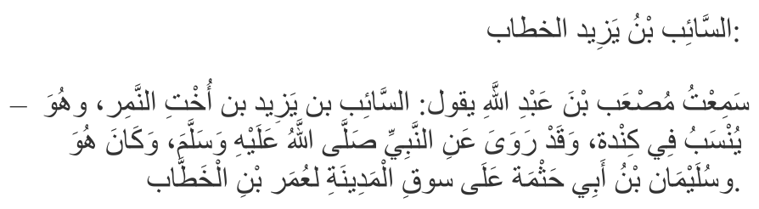
"as-Saa-ib ibn Yazeed…he and Sulayman ibn Abee
Hathmah were in charge of the marketplace of
Madinah, for Umar ibn al-Khattaab." (at-Taarikh al-Kabeer)
The fact that the mother of Sulayman ibn Abee Hathmah (radhiyallahu anhu) was none other than al-Shifaa bint Abdullah (radhiyallahu anha) enables us to begin unravelling the conundrum of how the heretic fabricators, referred to by Qadi Ibn Arabi, had been able to contort the actual reality and interpolate some of the early books with the false version that is being currently propagated with great relish by their inheritors today.
While it is forbidden, by Ijma', to place a woman in a position of leadership in a major public role, it is perfectly valid to entrust certain limited matters to a woman provided all the commandments of the Shari'ah can be abided by. And, in respect to al-Shifa bint Abdullah (radhiyallahu anha), this seems to be the case.
The major reference books relating the biographies of the early personalities indicate just that.
For example, Ibn Abdil Barr, in his "Istee'aab", relates under the biographies of Sulayman ibn Abee Hathmah and his mother:
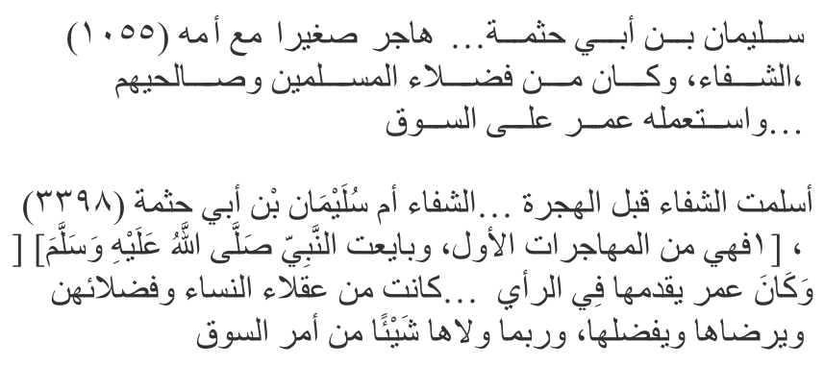
"Sulayman ibn Abee Kathmah…emigrated as a child
with his mother, ash-Shifaa… Umar placed him in charge of the marketplace … ash-Shifaa, the mother of
Sulayman… sometimes he (Umar) would entrust her a certain matter of the marketplace."
Note the bolded words, "sometimes" and "certain matter" (or "a thing"), which makes a world of difference to the unrestricted leadership role assigned to al-Shifa by the celebrity orators and intellectuals of today – a role that was, in fact, given instead to her son and two other Sahabah (radhiyallahu anhum), as proven by the authentic narrations cited earlier.
The same is stated in both Tahdheeb ul-Kamaal of al-Mizzee and Tahdheeb ut-Tahdheeb of Ibn Hajar al-Asqalani, two of the most important and most commonly used reference books in that particular field:
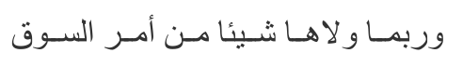
"And sometimes he would entrust her with a certain matter (or a thing) of the marketplace."
In Jamharah Ansaab ul-Arab of Ibn Kalbee, Taarikh ul-Kabeer of Ibn Abee Khaythamah, and Nasab Quraysh of Mus'ab ibn Abdullah az-Zubayree, three very early texts from authorities in their respective fields, it states (with very slight and inconsequential differences between the three texts):
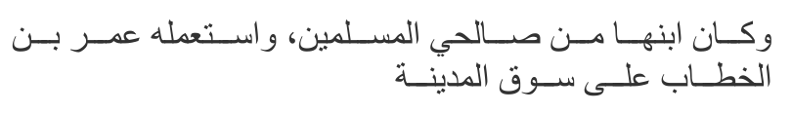
"And her (al-Shifaa bint Abdullah's) son was from the righteous Muslims, and Umar ibn al-Khattaab placed him in-charge of the market of Madinah."
Again, the distinction between al-Shifa bint Abdullah and her son, and the identity of who was actually placed in charge of the market, is crystal clear.
Ibn Asaakir, in his Taarikh, relates the same concern of al-Shifa bint Abdullah's progeny regarding her alleged appointment, as did Ibn Sa'd earlier:
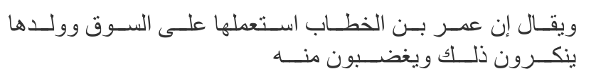
"It is said that Umar ibn al-Khattaab appointed her as in-charge of the marketplace, and her progeny would reject that and get angry over it."
There is no need to conjecture on how all the modernists who quote the fabricated story of al-Shifa's (radhiyallahu anha) appointment, somehow manage to overlook, with a great deal of skillful adroitness, the clear distinctions and clarifications made in so many of the authoritative texts cited above and others.
The glasses tinted with the stain of their soiled nufoos (base desires), with which these modernists read the classical texts can be appreciated by the following example.
Under the biographies of as-Saa-ib ibn Yazeed and al-Shifaa bint Abdullah (radhiyallahu anhum), Ibn Hajar states in "al-Isaabah":
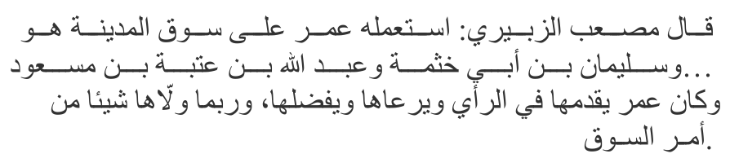
"Umar appointed him (i.e. as-Saa-ib ibn Yazeed) in charge of the marketplace of Madinah – him, Sulayman ibn Abee Hathmah, and Abdullah ibn Utbah ibn Mas'ood… Umar used to give precedence to her
(al-Shifaa) in opinion, would take care of her, and give her preference. And, sometimes, he would entrust her with a certain matter (or a thing) of the marketplace."
Again, note the world of difference the bolded words make when compared to a modern version below of the same citation from Ibn Hajar's book, filtered, refracted and thoroughly mutilated though the lens of stained glasses, which is currently doing the rounds on the internet:
"Ibn Hajar (rh), the great 15th century Muslim scholar said, 'Umar as caliph used to consult with Shifa bint Abdullah and honor her. He made her the WALI (incharge) of the affairs (amr) of the market. (Al Isabah vol 8 pg 202)."
While the actual text is very clear that al-Shifa bint Abdullah (radhiyallahu anha) would only occasionally be entrusted with "a thing" from the marketplace, the modern version assigns to her complete leadership of the marketplace! Furthermore, the very same book states very clearly the three male Sahabah (radhiyallahu anhum) who had been given that particular leadership role.
Such distortions to the actual translation which renders a completely different meaning to the actual reality is also known as chicanery and fraud. The one who knowingly propagates such chicanery, and the one who fails to publically retract after having been apprized of the truth, fully deserves to be branded a fraudster. Ironically, the author of this particular act of blatant fraud accuses another person, Daniel Haqiqatjou, of lying, when he said, allegedly:
"Shifa bint Abdullah wasn't in charge of the market of Medina. She had a whip and she would beat women up."
Undeniably, the first sentence is the absolute truth, as proven from the authentic narrations cited in this article, which have real and authentic sanads, as opposed to non-existent ones. The second sentence is conjecture, unless the claimant has authentic proof for his claim. It may or may not be the truth.
So far we have not come across any authentic narration, or even an inauthentic one, which provides more detail on the specific "thing" al-Shifa bint Abdullah (radhiyallahu anha) was entrusted with by Umar (radhiyallahu anhu), and on certain occasions only.
However, there are reasonable grounds to make the conjecture that al-Shifa bint Abdullah (radhiyallahu anha) was responsible for disciplining women who misbehaved in the marketplace. Since a great proportion of women during those early eras were extremely pious, fearing of Allah Ta'ala, and who would very rarely, if at all, emerge from their homes (as will be proven in a future installment to this article insha-Allah), the task of disciplining women would only arise sometimes. And, rather than her son, Sulayman, or the two other Sahabah (radhiyallahu anhum), who were given charge of the marketplace, carrying out the act of disciplining women, it may have been more appropriate and more conducive to the requirements of Hijaab, for a woman to carry out this need which would inevitably arise from time to time.
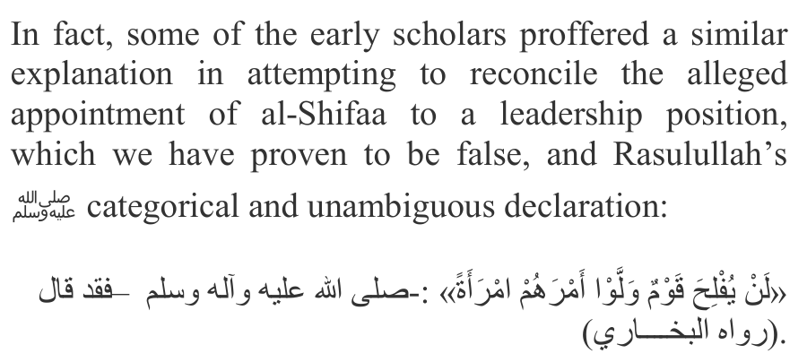
"Never will a people succeed who give charge over their matters to a woman." (Saheeh Bukhari)
The 5th century Maliki authority, Imam al-Maaziree, states:
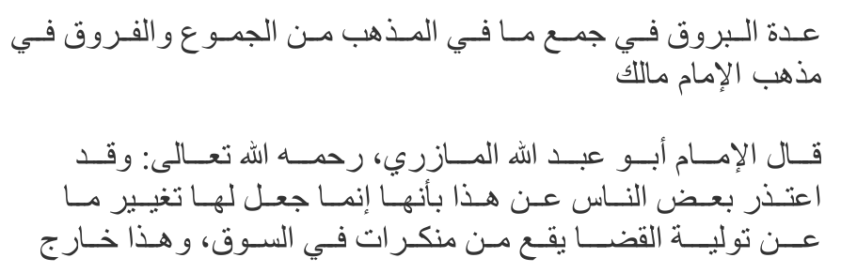
"And some people gave an explanation to this (by saying) that he (Umar) only entrusted her (the task of)
changing what would occur from the wrongdoings in the marketplace, and this is outside (the remit) of entrusting judgeship." (Uddat ul-Burooq of al-Wanshireeshee)
Another basis for the conjecture that al-Shifa bint Abdullah's (radhiyallahu anha) limited role entrusted to her on certain occasions by Umar is related merely to disciplining other women is the fact that a similar role did actually exist according to another narration, authenticated by certain Hadith specialists, which describes another elderly Sahabiyyah, Samraa' bint Naheek (radhiyallahu anha), and which is also exploited by the modernists today as an example of a woman supposedly given charge of the marketplace. However, due to certain details described in the actual narration, such as summary "judging", instant punitive measures and heavy clothing in a scorching climate, which conflict with the idealistic worldview of the "don't judge me" and thinly-clad (including male) feminine modernists of today, the actual narration is very rarely cited by them, even though it is far more authentic than the fabricated story regarding Al-Shifa bint Abdullah (radhiyallahu anha), hence why we deem it necessary to cite the narration in full below.
Al-Haythami narrates in his "Majma'":
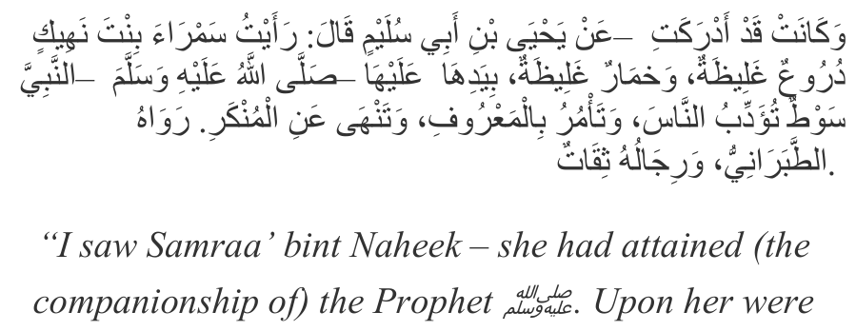
thick chemises, and a thick Khimaar. In her hand was a whip (with which) she was disciplining the people, commanding righteousness and prohibiting wrongdoing." (Tabaraani – the narrators are trusted)
Since in this worst of eras, close to the final hour, the obvious has become very unobvious and strange (Ghareeb), it needs to be clarified that the word "an-Naas" (people), in the context above, refers self-evidently and exclusively to misbehaving women. It would not be surprising, however, if the feminists, with their extremely deficient intellects and twisted worldview, actually deem it possible, both physically and in terms of the Shari'ah, for an extremely elderly and pious lady to mix and interact with the huge, burly and rugged men who used to frequent the marketplace of that era, whipping them left, right, and centre, and in doing so, heralding the dawn of a golden new age of feminist "liberation" (i.e. self-immolation).
Note also that there is absolutely no indication in the narration, nor in any of the biographical dictionaries and other classical texts, that Samraa' bint Naheek (radhiyallahu anha) was given a leadership role, or even any role in the marketplace. At most, it merely describes a very elderly Sahabiyyah (radhiyallahu anha) whipping miscreant women in an unspecified location, a task of very limited remit which might have arisen only on certain occasions, as with whatever task Umar (radhiyallahu anhu) had entrusted al-Shifa bint Abdullah (radhiyallahu anha) with.
In conclusion, it has been proven very clearly on this page that:
1) al-Shifaa bint Abdullah (radhiyallahu anha) was never given charge of the marketplace by Umar (radhiyallahu anhu).
2) Authentic narrations confirm that three male Sahabah, most likely two at any one time, were given charge of the marketplace. One of them was the son of al-Shifaa bint Abdullah (radhiyallahu anha). None of these authentic narrations which specify very clearly and precisely who was appointed even indicate towards al-Shifa bint Abdullah (radhiyallahu anha).
3) According to the biographical dictionaries, al-Shifa bint Abdullah (radhiyallahu anha) was possibly entrusted with only a "certain matter" of the marketplace and only on certain occasions.
