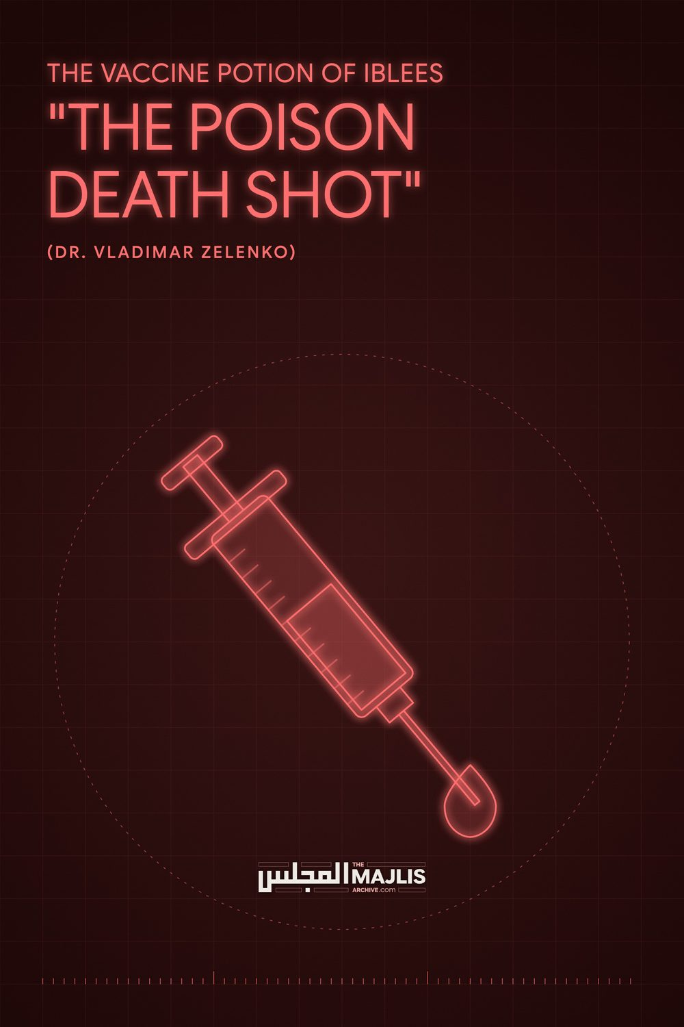

The Poison Death Shot
The Majlis · Voice of Islam
Mujlisul Ulama of South Africa

About this edition
This is a reproduction by The Majlis Archive (themajlisarchive.com) of a publication of The Majlis, Mujlisul Ulama of South Africa, made and published with their permission.
The PDF as The Majlis issued it is the original. This edition was read from that PDF's own structure and checked against it letter for letter; where the two differ, the PDF is correct.
Checked: 89 paragraphs, 0 differing; a second, independent PDF reader finds 100.0% of the PDF's words here.
Nothing has been reworded, added or removed.

THE VACCINE POTION OF IBLEES

(DR. VLADIMAR ZELENKO)
Published by:
6056, South Africa

WHO IS DR. VLADIMAR ZELENKO
"So I'll just quickly give you my experience. My team has directly treated – successfully – 6000 patients. I've trained hundreds of physicians who are now training their students. And as a cumulative group, we have now treated millions of patients successfully. President Trump was my patient, Rudy Giuliani was my patient, the Health Minister of Israel was my patient) I'm just telling you which people have contacted me for care – including President Bolsonaro of Brazil.
Now, my experience has given me a very unique perspective in approaching Covid-19, which is basically keeping people out of the hospital. Regarding children; the only reason you would want to treat a child is if you believe in child sacrifice. If you want to be the marker of children – it's a very good reason to give them the shot. Otherwise, there's no necessity."
THE POTION OF IBLEES – EVIDENCE WHICH ONLY DEVILS AND JUHHAAL MUFTIS STRUGGLE TO CONCEAL
The condemnation of vaccines for their horrible, harmful consequences by thousands of scientists and medical experts conspicuously illustrates the horrible jahaalat of those muftis and molvis who with bootlicking obsequiousness struggle to gain the favour of the government, the atheists and modernist juhhaal so-called 'intellegentsia'. The modus operandi of these Ibleesi muftis and molvis is to churn out rubbish fatwas to conform with and to bolster the satanic, kufr theories of the covid atheists. In this vile exercise they display appalling ignorance of reality which they acquit with ludicrous unprofessionalism in their ghutha fatwas.
Their ignorance is twofold: (1) Ignorance, feigned or genuine, of the massive delige of expert medical evidence proving beyond the slightest vestige of doubt that vaccines are murderous potions of Iblees, and (2) ignorance stemming from lamentable lack of panoptic Mutaala-ah (Research) of the Kutub of the SHariah, hence the unprofessionalism percolating their fatwas.
These agents of Iblees stupidly lean over their backs, disgorging Ahaadith which they satanically misinterpret to gain the favour of the government and the other outfits of shaitaan. Lacking in entirety true information regarding the murderous effects of the potion of Iblees, or deliberately turning a blind eye to the deluge of scientific evidence staring them in the face, these juhala muftis present Ahaadith which have absolutely no relationship with the vaccine potions of the devil.
With the Ahaadith pertaining to medicine, the juhala mufti agents of Iblees stupidly and most perfidiously labour to license vaccines. For example the jaahil muftis of Darul Ifta Mahmudiyyah, of Darush Shaitaan, of the MJC and similar deviated outfits masquerading as 'authorities' of the Shariah, cite in their ghutha fatwas in justification of the potion of Iblees Hadith narrations such as:
"They (i.e. medical treatments) are all from the decree (Taqdeer) of Allah.", and other narrations relevant to valid, halaal, pure medicines. The citation of Ahaadith by these jaahil muftis in support and promotion of the poisonous filth known as 'vaccines', is the equivalent of promoting pork-consumption with such Ahaadith and Qur'aanic Aayaat which proclaim the halaal status of meat. Since pork is meat, it becomes 'halaal' in terms of the interpretation proffered by these agents of Iblees who masquerade as muftis.
Vaccines are pure filth and poisonous – haraam trash which maims, injures and kills by slow torture.
Vaccination is the introduction of poisons and filth into the healthy human body. It is the introduction of filthy disease into the human body. Thousands of scientists and medical experts have testified to this undeniable fact and reality in their innumerable publications, and the tide of scientific condemnation of vaccination is incremental by the day.
Bill Gates, Pharma, Mainstream Media & Iblees have failed in their conspiracy to conceal the reality of the murderous effects and consequences of vaccines. By the day, more and more evidence is emerging of the brutality which the devils have inflicted on millions of people with their devil's potion.
These stupid muftis of today also quote some of our senior Ulama in a bid to bolster their stupid fatwas. It should be well understood that our senior Ulama a century ago were not aware of the reality of vaccines. Vaccination was presented to them as valid medical treatment. The Ulama then were only concerned with the ingredients. If it was conveyed to tem that all the ingredients are halaal, they would naturally proclaim the potion to be permissible. If the rubbish contained haraam ingredients, our senior Ulama would proclaim it permissible in cases of real need when a halaal remedy was not available. That was the sum total of the fatwas of the Akaabir pertaining to vaccination. They were not aware of the filth, poisons and excessively vile, injurious consequences of the Devil's potion. They did not have the haziest idea that vaccination is the introduction of filth and poison into the body. They had no idea of the avalanche of criticism of the devil's potion by countless medical experts. Those who required fatwas of permissibility would invariable conceal the truth if they were aware thereof. The Akabir were made to understand that vaccination is a valid medical treatment with valid medicine. The issue only centred around ingredients to enable the Ulama to determine permissibility or impermissibility.
Muslims should not allow themselves to be duped and tricked by these shaitaani muftis who quote the names of our Akaabir Ulama. In view of the truth being presently freely available, even laymen are now able to understand that vaccination is haraam, and for this fatwas of muftis are not at all necessary. Just as a fatwa is not required for understanding pork or liquor being haraam, so too is it with vaccination due to the deluge of evidence available to every Tom, Dick and Harry in the street.
The ensuing pages present some evidences taken randomly from the floods of expert evidence.
Covid-19 vaccines – the raging debate after Dr Susan Vosloo's controversial video
19th August 2021 by Nadya Swart Last week, a video was uploaded to Bitchute in which Dr Susan Vosloo, South Africa's first female heart surgeon, raised grave concerns about the safety of Covid-19 vaccines. Dr Vosloo also questioned the manner in which Covid-19 has been addressed, stating that 'This disease is the first medical condition ever that is predominantly, I would say, 'mismanaged' not by knowledgeable people but by politicians, bureaucrats and academics. And it's fueled by relentless scaremongering created by the media.'
Throughout the pandemic, various experts and doctors have spoken out against the official Covid-19 narrative – at the risk of their reputations and their livelihoods. One such expert is Dr Vladimir Zelenko who has personally treated over 6000 Covid-19 patients, including former US President Donald Trump.

Dr Shankara Chetty on Dr Vosloo's video:
Dr Vosloo made a video the other day where she was admonished by Netcare and Discovery and the rest. She has a right to her opinion and it is absolutely based in science. Why would Netcare decide to have an opinion on it? They are just an administrator. Why would you want to criticise a health care medical professional on her opinion on health care? What right do you have? And Netcare has my article from a year ago – what have you done to help the people around you? Nothing. So I don't see that there's a lot of anonymous experts out there, there are a lot of people with agendas.
This is new. No one's been in a pandemic before. How do you justify yourself an expert when you haven't seen a covid patient in your life or have attempted to treat anyone with covid? So all of these people pushing pens behind desks should keep it to themselves. The bottom line is – this needs a robust debate. We can't have some person on TV, with no medical knowledge, criticising people and castrating their characters. That doesn't fly.
So, I mean, I'm getting messages every day from Discovery Health to tell me that I qualify for the vaccine. Who are you? Since when do you have the medical knowledge to tell me that I qualify for a vaccine? You're telling that, you're saying that to all my patients. The patient should come to me and I should make the choice whether the vaccine would be harmful to them or not. Not some administrator, not some medical aid. They've got hidden motives behind this.
Dr Chetty on the Covid-19 vaccines: Now, we've seen myocarditis in children. We've seen blood clots, we've seen neuropathies. Shouldn't these have been put into patient leaflets to say, 'Patients with heart conditions, patients with clotting problems, patients with neuropathies should not be given the vaccine.' You know that these are the side effects. You should exclude that population.
So your vaccine's got so many side effects that you can only give it to absolutely healthy people. Everyone else should be excluded because they might be injured by it. So there is a far bigger game at play. This was something where I think society was primed for this. We were deliberately stifled in early treatment so that we could jig the numbers the way we wanted. We could create enough panic around the globe and we could sell a vaccine based on religion rather than any good scientific knowledge out there.
If there is anyone out there who can show me that the vaccine is safe and effective, I'll change my view. But until that point, I'd like them to talk of the science. I would expect [that with] my views on vaccines, [I'd] have my character attacked, but I actually don't care – they can bring it on.

Dr Chetty on his experience with Covid- 19 in South Africa:
There's a lot of lawyers around the country that have gotten in contact with me. There's a lot of MP's around the country that have gotten in contact with me. I know many patients [that are] injured and are dying from this vaccine. And hospitals refuse to admit it as a vaccine side effect, so this ain't gonna last too long. At some point, people's eyes are going to be open to the truth around it. So it's unfortunate that we are faced with this situation.
But the vaccine; all it's done from my perspective as a doctor treating patients on the front line – [it] has complicated the entire management of covid. There is absolutely no benefit that I have seen from the vaccine and the benefits that they claim are only visible in statistics and cannot be attributable to a single patient and are clouded by their poor rollout of the vaccinations.

Dr Chetty on natural immunity:
They vaccinated in the Eastern Cape, where there was a high herd immunity. Now you can't claim that your J&J vaccine works that well – half those people had covid already and they didn't need a vaccination in the first place. You want to bring out a vaccine passport, but you refuse to acknowledge natural immunity. Now, there are two ways to that immunity; through natural infection or through vaccine-induced immunity.
So why don't you bring out a test to test for immunity? Make it an immunity passport. Test for long-term immunity. And anyone that has immunity can throw their mask away and go back into society again… But no, we want to make a vaccine passport. These tests have been developed; T and B cell testing. They sit with the FDA and they refuse to acknowledge or authorise it. Two things. If you have a person recovered from infection test positive, then there's no reason to vaccinate them. And this test might prove that your vaccine is wholly ineffective, so best not to authorise it and keep this narrative going.

Dr Vladimir Zelenko on his experience treating Covid-19:
So I'll just quickly give you my experience. My team has directly treated – successfully – 6000 patients. I've trained hundreds of physicians who are now training their students. And as a cumulative group, we have now treated millions of patients successfully. President Trump was my patient, Rudy Giuliani was my patient, the Health Minister of Israel was my patient… I'm just telling you which people have contacted me for care – including President Bolsonaro of Brazil.
Now, my experience has given me a very unique perspective in approaching Covid-19, which is basically keeping people out of the hospital. Regarding children; the only reason you would want to treat a child is if you believe in child sacrifice. If you want to be the marker of children – it's a very good reason to give them the shot. Otherwise, there's no necessity.

Dr Zelenko on Covid-19 vaccination in children:
Let me explain. Anytime you evaluate any therapeutic – you need to look at it from three perspectives: Is it safe? Does it work? And do you need it? Just because you have a capability, doesn't mean that you have to use it. There has to be a medical necessity. There has to be a need for it. If you look at the CDC; the statistics for children under the age of 18 that are healthy – the survival rate is 99.998% – the survival rate with no treatment.
Just like Dr Yeadon said, the influenza virus is more dangerous to children than Covid-19 and he made an estimate that per million – 100 children would die from the vaccination. I feel the number would be significantly higher and I'll explain to you the rationale for it.
If you have a demographic that has no risk of dying from an illness – why would you inject them with a poison death shot? Now, let's see if this thing works. The two countries in the world that have most most vaccinated its citizens are Israel – with a high 85% rate of vaccination – and an island nation in the Indian Ocean called the Seychelles – also over 80% [vaccination].
Both countries are experiencing a delta variant outbreak. So, let me ask you a question: if you vaccinated the majority of your population – why are you still having an outbreak? That's number one. Number two: why would you even get a third shot of the same stuff that didn't work the first two times? That's whether or not it works.

Dr Zelenko on the safety of the Covid-19 vaccines:
Let's talk about safety. Now this is the real issue. There are three levels of safety or death that we need to look at. One is acute, one is subacute and then long-term. Acute [will] I'll define from the moment of injection until three months. The number one risk of the shot is blood clots, just like Dr Yeadon said.
By the way, everything I'm saying I will defend with documentation and please don't take my word for it. You should do your due diligence. I can provide proof for everything that I'm saying.
According to the Salk Institute, when a person gets an injection of these 'vaccines' – quote unquote – the body becomes a spike producing factory making trillions of spikes which migrate to the endothelium which is the inner lining of your blood vessels – and it's basically little thorns on the inside of your vascular tract.
As the blood cells flow through it, they get damaged, they cause blood clots. If that happens in the heart, it's a heart attack. If that happens in the brain, that's a stroke. So we're seeing the number one cause of death in the short term is from blood clots and most of it is happening within the first three, four days. 40% of it is happening within the first three days of injection of this poison death shot.
Now, the other problem is that it's causing myocarditis or inflammation in the hearts of children – in the hearts of young adults. And the third problem, which is the most disturbing, is according to the New England Journal of Medicine article – their preliminary data – [is] the miscarriage rate in the first trimester if a woman gets vaccinated in the first trimester [it] goes from 10% to 80%.
I want you to understand what I just said. The miscarriage rate in the first trimester of pregnant women when they get vaccinated goes up by a factor of eight. That's preliminary data, it may change with time – but I'm just telling you what it is as of today.
"VACCINES ARE TRASH" Lancet Letter Demolishes Vaccination Says vaccination does not even slow down the pandemic Igor Chudov Dec 1 The Lancet is one of the most respected medical journals in the world. This is an amazing read!!! The fact that they actually published this letter is proof that the world is finally waking up to the fact that these experimental jabs are worthless!!!
An amazing Lancet letter "The epidemiological relevance of the COVID-19-vaccinated population is increasing" was just published.
The largest significance is that the article WAS ALLOWED TO BE PUBLISHED BY LANCET.
This means that the tide of scientists being scared by government/globalists/Big Pharma funding is turning, and the truth is coming out at the highest levels of science such as the Lancet.
The article is great, but the things it is saying are a regular subject of our discussion.
• In the UK it was described that secondary attack rates among household contacts exposed to fully vaccinated index cases was similar to household contacts exposed to unvaccinated index cases (25% for vaccinated vs 23% for unvaccinated).
• 12 of 31 infections in fully vaccinated household contacts (39%) arose from fully vaccinated epidemiologically linked index cases.
• Peak viral load did not differ by vaccination status or variant type
• In Germany, the rate of symptomatic COVID- 19 cases among the fully vaccinated ("breakthrough infections") is reported weekly since 21. July 2021 and was 16.9% at that time among patients of 60 years and older [[2]]. This proportion is increasing week by week and was 58.9% on 27.
• In Israel a nosocomial outbreak was reported involving 16 healthcare workers, 23 exposed patients and two family members. The source was a fully vaccinated COVID-19 patient. The vaccination rate was 96.2% among all exposed individuals (151 healthcare workers and 97 patients). Fourteen fully vaccinated patients became severely ill or died, the two unvaccinated patients developed mild disease
• US Centres for Disease Control and Prevention (CDC) identifiesfour of the top five counties with the highest percentage of fully vaccinated population (99.9–84.3%) as "high" transmission counties
• A similar situation was described for the UK. Between week 39 and 42, a total of 100.160 COVID-19 cases were reported among citizens of 60 years or older. 89.821 occurred among the fully vaccinated (89.7%), 3.395 among the unvaccinated (3.4%) [[3]].
This reinforces my opinion that the Covid Cult is coming apart at the seams and the failure of "Covid vaccines" is no longer a secret.
The key to any sort of narrative revolution of information warfare is NOT to convince your crazy Fauci-worshipping neighbor. The point of it is to convince decision makers and opinions makers that they are holding onto untenable positions.
Please spread this article, or the Lancet article with your own comments, as widely as possible. It will make it increasingly impossible to ignore.
People who profess how "they believe in science" usually least understand science and can only understand Dr Leana Wen from CNN or Dr Fauci, so doubtfully they can even understand the text of the Lancet article. Please explain the meaning of this article to them. Tell them "the biggest medical science magazine just published an article saying vaccines are trash and do not even slow down the pandemic". If they show any interest, tell them that hundreds of thousands of terrified people are desperately seeking to get "un-vaccinated". Ask them why do they want increasingly frequent boosters.

"COVID IS A CRIME STORY" – Its Blackmail On A Global Scale
ByIgor Chudov If you view this whole 'pandemic' situation through the lens of health, safety, science and saving lives, then most of it makes little sense. If you view it through the lens of money, power, control, and wealth transfer, then all of it makes perfect sense.
Covid is not an epidemiological story. Covid is a crime story.
They needed the lockdowns. They needed the lockdowns to be long, destructive and depressing. They need everyone to be scared of more lockdowns so that they can say, "To avoid further lockdowns you need to accept Vaccine Passports."
The lockdowns, mandatory muzzles, anti-social distancing and the other measures did nothing to protect or improve public health- they were never designed to do so.
They were all designed to deliberately break the global economy (and crush competition, especially small businesses) as well as break people's minds, will and the social fabric, in order to "build back better", according to the diabolical and dystopian visions of the psychopaths waging this class war, which is essentially a billionaires utopia, in which they own the planet like a techno-feudal fiefdom, and oversee the drastically reduced population of digitally branded humanity like cattle in a super-surveilled technocracy.
The injections are the Trojan horse to get us in the door of that digital concentration camp (as well as the metaphorical gas chambers), starting with vax-ports, followed by digital IDs, and then connected to CBDC accounts and UBI scrip, which will allow them to track our every move and purchase, and "nudge" us toward whatever medical, dietary, or lifestyle choices they desire, at threat of having our rations reduced, or, if we misbehave too badly, being shut out of the system altogether.
They're specifically targeting kids and young people most of all, deliberately inflicting mass trauma on them, because they're the ones who'll grow up in that New Normal™R, and the goal is to condition them to accept total control over every aspect of their lives and a dehumanized screen-based existence, to the point where they won't remember living any other way, breathing free, being free.
All talk of so-called efficacy of these poison injections are meaningless distractions and quite besides the (existentially urgent) point when you understand that the virus/disease they're allegedly designed to protect against doesn't exist in the first place and, additionally, what their real, abovementioned purpose(s) is.
It's blackmail on a global scale.
https://igorchudov.substack.com/p/lancet-article-demolishes-vaccination

"I know many patients who are injured and are dying from this vaccine." Dr. Shankara

Chetty

