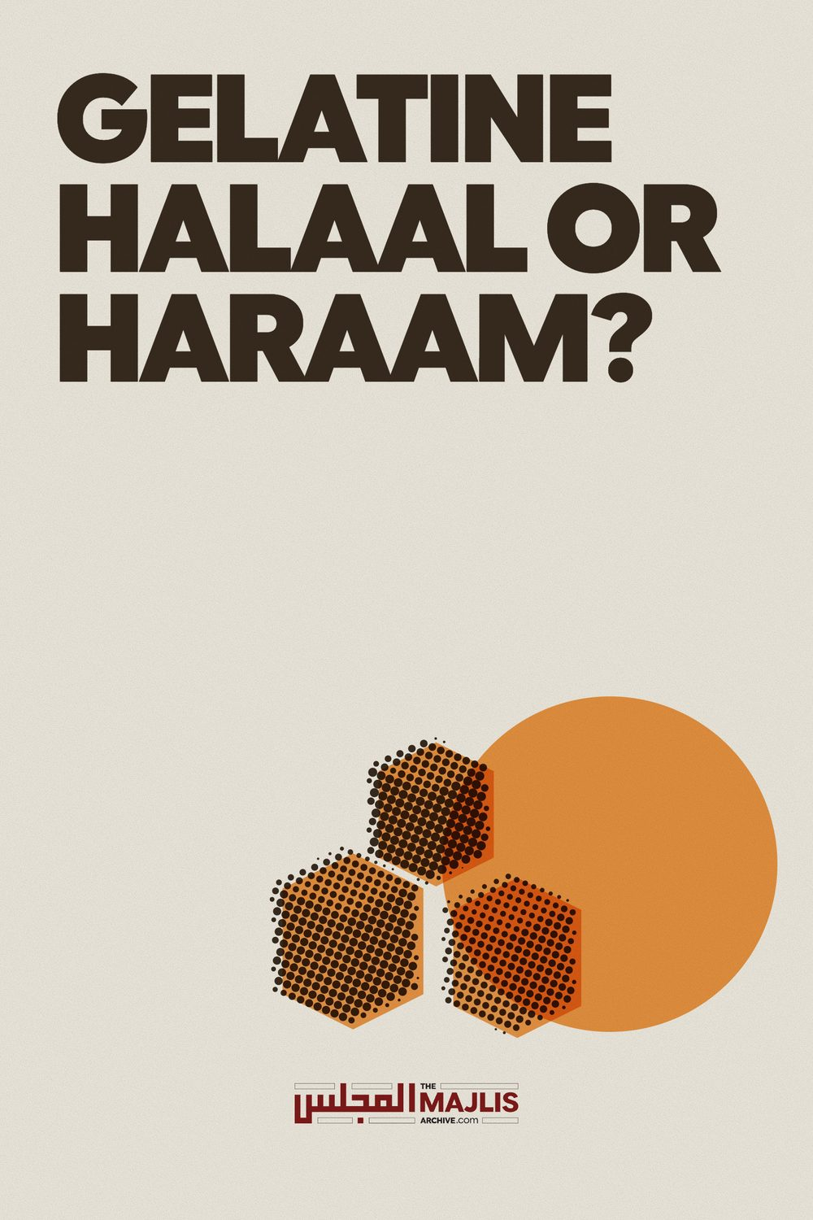

THE QUESTION OF ANIMAL GELATINE
The Majlis · Voice of Islam
Mujlisul Ulama of South Africa

About this edition
This is a reproduction by The Majlis Archive (themajlisarchive.com) of a publication of The Majlis, Mujlisul Ulama of South Africa, made and published with their permission.
The PDF as The Majlis issued it is the original. This edition was read from that PDF's own structure and checked against it letter for letter; where the two differ, the PDF is correct.
Checked: 362 paragraphs, 0 differing; a second, independent PDF reader finds 100.0% of the PDF's words here.
Nothing has been reworded, added or removed.

BY MUJLISUL ULAMA OF SOUTH AFRICA P.O. BOX 3393, PORT ELIZABETH SOUTH AFRICA 6056

THE QUESTION OF ANIMAL GELATINE
s animal gelatine halaal or haraam? This Gelatine controversy has been perpetuated for more than three decades. Recently it has been resurrected with greater vigour by the mercenary self-styled, so-called 'halaal' authorities. There are several such miscreant, misguided and despicable bodies vying with one another to dominate the haraam 'halaal' certificate market which brings in large sums of money for the coffers and pockets of the haraam 'halaal' certificate vendors who peddle their despicable scraps of paper in reckless disregard for the Imaan and morals of the Muslims community.
Since the aim of the 'halaal' certificate business is nothing other than monetary gain, the scraps of paper being peddled are sold for exorbitant sums – and annual renewal fees – to non-Muslim business-houses whose sights are focused on the Muslim community. These haraam certificates are issued left, right and centre to just any pork-vendor as long as Mr. Porky agrees to pay the fee.
Under the banner of these haraam certificates Muslims are ingesting into their bellies avalanches of haraam food, thus ruining their Imaan and corrupting their akhlaaq (morals). Islam has emphasized the warning to abstain from haraam and mushtabah food, for such 'food' tarnishes the heart and produces attributes of immorality. The resistance against the inordinate dictates of the carnal nafs is totally eroded and even effaced in consequence of the consumption of the poison of haraam and mushtabah foods. The importance of halaal food is succinctly and sufficiently borne out by the Qur'aanic aayat: "O Rusul (Messengers)! Eat halaal (food), and practise deeds of righteousness."
Silhouetted in the background of the Gelatine controversy and the mad desire to pass off this najaasat (impurity) as halaal food fit for Muslim and human consumption, is the satanic 'halaal' certificate enterprise which has even resulted in the haraam 'halaal' certificate bodies going for each other's throats in the bid to capture the certificate market.
Since innumerable processed foods of non-Muslim manufacturers contain gelatine as an ingredient, and which haraam foods Muslims hitherto do not consume, the purveyors of the haraam scraps of paper are viewing with gluttonous eyes the large amounts of added revenue if these haraam products could somehow be presented as 'halaal' to the Muslim public. If the haraam certificate vendors succeed in convincing Muslims that the carrion and impurity known as gelatine is 'halaal' it will open a lucrative avenue for selling haraam 'halaal' certificates and ensure a huge amount of a continuous inflow of money by way of annual renewal of the haraam licences which will be granted to the non-Muslim producers of haraam products.
The 'halaal authorities' have realized that they can achieve their mercenary aims by means of the gimmick of Qalbul Maahiyat' or total metamorphosis of a substance into a new substance. While Qalbul Maahiyat is a valid principle and a purifying agent in the Shariah, it does not remotely apply to the najaasat known as gelatine. The vendors of the haraam certificates are at pains to convince the masses of Muslims that the haraam skins and muck of haraam animals which are the raw material from which gelatine is manufactured, undergo such a metamorphosis which renders the filth halaal. But no such metamorphosis takes place. Faeces transformed into another form by the addition of some ingredients, does not become taahir and halaal. The same applies to the najaasat known as gelatine.
The public is being bamboozled and misled by the money-hungry 'halaal' bodies who are intent on nothing but selling the haraam certificates. The metamorphosis story in the gelatine debate is old hat. The Ulama had thoroughly investigated and studied gelatine-production at first hand, making a thorough inspection of the factory which manufactures gelatine in South Africa. While some may have made superficial inspections with hidden agendas and corrupt motives, the most exhaustive and intensive investigation and in-depth study have been made by the Ulama of Waterval Islamic Institute (Mia's Farm). We reproduce here the full text of their "In-depth Study and Fatwa on Gelatine". All those who read and study the Fatwa with an open mind for understanding the reality and the truth will not fail to conclude that gelatine is haraam najaasat.
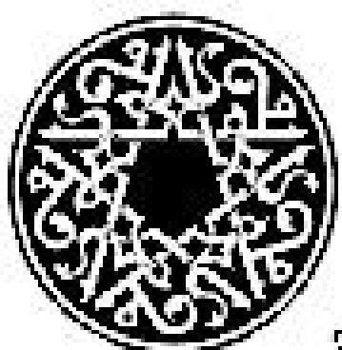

GELATINE

– AN IN-DEPTH STUDY AND FATWA WATERVAL ISLAMIC INSTITUTE
Fatwaa No -: 10-2000/801 - W446
Thoel Hijjah 22, 120
March, 29, 2000 Moeh-tarum S Mahomedy C/o S.A.N.H.A P. O. Box 2092 Durban Kwazulu-Natal
Tel:- 031-332-2320 Fax:- 031-332-2324
Moeh-tarum
Haamidan wa Moe'salliyan wa Moesalliman (We begin by praising Al-laah and conferring blessings upon Rasoeloulaah sallallahu alaihi wasallam. Jazaa-koemoullaahoe Khairan (May Al-laah reward you in the best way) for your query.

INTRODUCTION.
After numerous request and many different approaches over a long period of ( ± 15 months) in the August of 1990, 1411 Hijri Maulana Yousuf Abdullah Karaan on behalf of the Muslim Judicial Council of the Cape had arranged a meeting and an inspection tour of the Davis Gelatine Industry Pty. Ltd., factory for members of the Jamiatul Ulama. The need for this arose because of numerous queries from the Moesliem public regarding the Hillat of gelatine which is manufactured by Davis Gelatine Industies situated on the West Rand at 25 Verster Street, Delporton, West Krugersdorp. 1740.
The Moesliem Judicial Council of the Cape for some years had issued a Halaal Certificate to this factory in the Transvaal. The Moesliem Judicial Council's emblem is printed on the packaging material of Davis Gelatine to inform the Moesliem public of their approval.
It was during 1984/1985 that on behalf of the Moesliem Juducial Council, Moeftiy Ali Moosagie had made research on gelatine manufactured at the Davis Gelatine Factory at Krugersdorp West. His research was based mainly on documentary material made available by Davis Gelatine. He did not visit the plant in Krugersdorp. His findings were that "Qalboel Maahiyat" or "Tabdiyloel Maahiyat" (i.e. a complete transformation of the original body structure, tissue matter and the matix) takes place during the processing. Therefore, this gelatine was Halaal and good for Moesliem consumption.
This was even though the manufacturer wrote that "a fairly pure collagen is left" and also stated that "(Collagen incidently, is the major structural material of bone and connective tissue. It is to the animal world that what cellulose is to the plant world!)".
Moeftiy Aliy Moosagee's findings indicate that the filtration, evaporation, refiltration, drying, grinding, blending of various grades of gelatine is infact "Qalboel Maahiyat". Moeftiy Ally Moosagee's attention was drawn to this particular point in a meeting at Waterval, Johannesburg.
It is noteworthy that the Fatwa issued by the Jamiatul Oelamaa' Natal at the time was based on documentry information, and to the best of our knowledge the Oelamaa' of Natal did not inspect this plant prior to our visit.
The visit to Davis gelatine Industries was arranged for 09:45h on Wednesday, August 15, 1990 corresponding to Al-arbie-aa', Moeharrum 23, 1411 Hijriy.
Some members of the Jamiatul Oelamaa' had arranged to meet Maulana Yousuf Karaan at Jan Smuts Airport and from there to go for the appointment. Maulana Yousuf Karaan is the head of Fatwa Committee, and Vice President of the Moesliem Juducial Council of the Cape.
A number of Oelamaa' had first gathered at the Burgersdorp Musjid and from there all proceeded to Delporton. All in this delegation had agreed that this visit to the Davis Gelatine Industires (Pty) Ltd factory shall be with an open and clear mind for educational purposes.
(Note: The original fatwa of 1990/1991 - Meohur-rum 1411 Hijr was prepared Moeftiy Basheer Ahmad Sanjalvi, And Ahmad M. Mi. There was also some input and contribution by Moefity Radhaa-oul Haq, Moeftiy Sulaimaan Qasiem and Moeftiy Moe-huammud Saeed Motara. This fatwaa of the year 2000/ 1421 Hijrinow has additional information from (internationally renowned) gelatine factories also). Those OeOelamaa' who visited the Davies Gellatine Industries on this occasion, in 1990, were; 1. Maulana Ibrahim M. Mia 2. Moeftiy Bashir Ahmed E. Sanjalvi 3. Moeftiy Ahmad M. Mia 4. Maulana Yousuf Abdullah Karaan 5. Moeftiy Sulaimaan M Qasiem 6. Moeftiy Radhaa-oul Haq 7. Molvi Shabbier Ahmad Saloojee 8. Molvi Hakiym yousuf A.R. Molvi 9. Molvi Haidar All Dhorat 10. Molvi Muhammad A.H. Kaka 11. Molvi Ebrahim I. Bham 12. Molvi Ismail M. Choonara
At the Davies Gelatine Industries, Delport factory, Mr A R Tait, the sales manager, BISMILLAH HIR RAHMAAN NIR RAHEEM welcomed the Oelamaa, delegation. It was suggested that Mr A R Tait first explain the plants workings and processing before proceeding through the plant. Because the main boardroom was occupied, this was a standing meeting on the lawn at the entrance of the administration block.
Mr A R Tait had outlined that:
The Davis Gelatine Company was first founded in New Zealand in 1881. Then also established in Australia in 1883. Davis Gelatine was imported to a depot in South Africa from 1921. It was in 1951 that the Davis Gelatine Industry (Pty) Ltd was established in South Africa. 95% of the local gelatine is produced by Davis Gelatine Industries (Pty) Ltd, Delporton, Krugersdorp West. There could be 5% of other gelatine used locally.

PRINCIPLE IN MANUFACTURE
* The Egyptians first extracted gelatine. The basic method of making gelatine today is still the same as it was with the Egyptians in earlier times. However, more modern machinery and equipment is used to achieve the end product.

SOURCES OF RAW MATERIAL
* Material derived solely from cattle hide which had been slaughtered for human consumption is used (i.e. not Muth-booh). Hairy hide waste constitutes the bulk of the raw material. This is obtained from various abattoirs and meat processing plants in the Transvaal, (especially the Reef).
* Also the partially processed hide material which is obtained from the tanning industry is used for making gelatine. This is obtained from local and also overseas sources.
* Raw hides with hair and without hair are used. Some dry hides in bales were seen at the factory. These were imported from South America.
* Further, fresh trimmings of hide are used in this process. The forehead skin, facial skin, whole ears of cattle with pieces of meat on the skins were seen in a huge heap of trimmings which were delivered for processing on that day.
* It is not necessary that all hides or trimmings used in this factory are of animals which are muth-booh according to Shar-iy requirements, and are neither Halaal. The major portion of skin are from non-halaal animals.
* Gelatine is also made from bones of bovine animals, or from pig skins and bones. However, we were told that this type of raw material is not used at the Delporton gelatine factory. At no point is there any pig skin or alcohol introduced into the product.

PREPARATION OF RAW HIDES (Plant- dirty section)
* The raw material, trimmings and hides are first put through a crusher to cut these to a manageable size for processing.
* The hide pieces are washed to remove blood, water soluble impurities, salt and other foriegn matter.
* Once more, the raw material hide pieces are put into square cement pits in a mixture of lime and water. This assists in ripening the hide pieces and also removing hair, water soluble impurities and unwanted matter. In these pits the hair floats on the surface of the water. The hide pieces are not clearly noticed because of the hairy sludge.
* The hair etc., is dissolved and the sediment and residue is removed with the water sludge to slimes dams. This is used to make fertilizer.
* Thereafter, the hide pieces, which are fairly cleaned from hair and impurities are once again immersed into simmilar pits. This is in a sollution of water which is aerated with sulphuric acid gas and/or alkalai and acid sodium. This is done so that non-collagenous protien matter and other water soluble traces of inorganic impurities are completely dissolved and leached out of the original skin (or collagen) matrix. This cleaning process leaves behind the proper major structural material of connective tissue of the hide itself without any transformation at all.
* This submersion of hide pieces for cleaning the raw material is in alkalai acid solution which further assists in neutralizing the hide tissue structure matrix for further process.
* These pits are regularly hydrolized by means of pumps. The water is aerified and aerated at regular intervals. A weekly inspection is done to determine the cleansing and preparation process.
* The effect of this treatment on the hide tissue structure (matrix) is that the material is further clarified, hydrolized and has a fairly good swelling texture with a considerable "plumping". This is now sticky and jelly like. At this point the hide pieces are referred to as "neutralized molecules", a "collagen protein", or "gelatine protein". (Note: This is still the orignal hide tissue structure).
* This section in which cleansing and preparation is done is for further processing. This takes a period of approximately three to eight weeks. At this stage the dirty section of the factory ends and thereafter the hide tissue structure (matrix) pieces are transferred into the clean area of the factory. From here on the pieces are called "collagen protien" or "gelatien protien". Collagen is the main protien constituent of the hide or its tissue structure.
* There is no difference at all in the molecular set up of a hide, collagen protien or gelatine protien.

PROCESSING OF GELATIN (factory - clean section)
* In this section, the "protein constituent of the hide tissue structure" is introduced into large stainless steel vats. This is kept hot by means of passing steam through a pipe in the centre of the vat. The water and the "protein constituent of hide tissue structure" is thus heated, and melts. This process causes the gelatine to be further liquified thus resulting in a solution. This heat draws out 100% of the gelatine leaving no residue at all. Here collagen is converted to gelatine.
* With the perfectly pre-conditioned original hide structural tissue ("collagen protein" or "gelatine protein") there should be little or no residue left at this stage of processing. Hence the cleaned, leached, jelly like hide tissue structure is in fact "gelatine protien".
* The hide structure tissue matrix, collagen protein or gelatine remains in this steamed hot water for approximately six days. The heat in the vats is kept at a constant 40°c to 60°c.
* The colour and clearness of each batch of gelatine varies according to quality of the hides. The gealtine solution is then filtered through especially designed paper filters at ±3500 kpa. This is done with very high pressure for further cleaning the gelatine solution, and the gelatine solution is also sterilized by a flush sterilizer. At this stage 70% of the gelatine protien remains. This streilization is for preservation and to kill bacteria.
* Gelatine is good to grow bacteria. Bacterial growth develops very quickly if gelatine moisture is not controlled. This is characteristic of bovine flesh, which remains in gelatine to the end.
* Thereafter, this gelatine solution is filtered, evaporated, re-filtered and evaporated a number of times. This is to further cleanse the solution and reduce the moisture for a longer shelf-life. Evaporation is done to reduce the water content of the gelatine solution.

DRY STAGE (factory -clean section)
* The gelatine solution is then cooled in a chiller where it quickly solidifies. The solidified gelatine is then minced by means of votater machines into a speghetti like form. This gelatine is then further dry-heated and de-humidified at various temperatures whilst moving on a conveyer. This is to remove all traces of excess hydrolized moisture. Thus 10% to 12% moisture remians.
* The gelatine is then grounded into granules and also a powder form to the required consistency for the ultimate user.
* The blending is done because every batch of gelatine does not have the grade of bloom strength (i.e gelling qaulity). The gelatine of different bloom strengths are mixed and blended to make up batches of a graded gelatine for the requirement of the user.
* The bloom strength is measured in grams. This would vary between
80 or 90 to 250. A difference of bloom strength could be found between the beginning and end in one particular batch.

GELATINE GLUE.
* Glue from an animal base is also made. This is the wet gelatine solution before it is chilled and dried. The gelatine pulp is not thoroughly sterilized for the gum use application. This glue is used mainly in matches, and sand paper, and also in wood work in small amounts today. This hide glue is used by people who do restoration of old furniture etc.. This glue is also used on envelopes. This glue is prepared in liquid and dry form.

GELATINE IN IN WINE.
* Wet gelatine which is treated with an ezyme is used in the wine industry. This is mixed into wines in the Cape because the gelatine assits in clarifying the wine. The gelatine takes traces of any foreign
particles to the bottom of the wine, which could be noticed as sediment at the bottom of the wine vessel.

GELATINE IN SWEETS AND CONFECTIONERY.
* All gelatine has an animal organic tissue type of smell. Gelatine also has a slight beefy taste. However, in futher processing, confetionery etc. this smell or taste cannot be detected.
* Gelatine has the quality of holding the substance of an edible together and melting at body temprature, thus allowing the flavour to spread into the mouth of the consumer. For example, in a marshmallow the gelatine holds the aerified froth together, and would melt in the mouth by body heat temprature.
* Gelatine is used in some sweets, jellies, yoghurts and, in cream in biscuits and confectionery. From a minimum of 3 ½ % to a maximum of 17% is used in confectionery.
* Locally manufactured bubble-gum has no gelatine.

ADDITIONAL INFORMATION.
* Gelatine will burn into ash and not melt when put over an open flame, whereas it will melt by indirect heat at body temperature.
* Soft and hard capsules are made from gelatine.
* Other substitutes and jellying agents are made also from seaweed, kelp, agar, carrageenan, etc. None of these give the same smooth jelly texture. There is no synthetic gelatine on the market to date. The great disparity in manufacturing costs, still leaves gelatine production to be the most viable. A small amount of agar is being produced locally by Taurus Chemicals. This began first in Butterworth, and now is being done in Namibia.
* Out of 30 tons of raw material processed only (6 ½) six and a half tons of gelatine is made. The full time period of manufacturing a batch of gelatine in this factory is approximately two months.
* The Austrailian Jewish Bethdin has passed the Austrailian factory. However, the South African Bethdin has not passed this local factory. They had visited this factory on several ocassions.
* Mr Tait ensured the group that if there are any queries regarding the manufacture of gelatine they could contact him or Mr White or Mr Cole in the Davies Gelatine Industries laboratories.

IMPORTANT NOTES.
* Cattle hides and trimmings thereof are used as raw material to be processed at this factory. Trimmings include the animals forehead skins, facial skins with pieces of meat, complete ears of cattle and also dry hides of aniamls which were imported.
* Hides and trimmings used as raw materials are not necessiraly Muth-booh or Halaal.
* Pig bones or skins are not used at this factory. (However, there is no gaurantee that this would never be used in future).
* No alcohol is mixed into or used in the processing of gelatine.
* Soaking in the lime pits does not cause "Qalboel Maahiyat". These merely cleanse and prepare the hide for the next stage in processing gelatine.
* Further, soaking in water which is aerated with sulphuric acid gas, and/or alklai and acid soduim is also merely for the cleansing of the hide. This also assists in the preparation of the hide for processing. The hide tissue structure is clarified, hydrolized and at this stage develops a good swollen texture with considerable "plumping" which is also sticky and jelly like. This does not cause "Tabdiyloel Maahiyat".
* The same tissue structural body matrix is named a "hide trimming" at one point, then termed a "neutralized molecule" at another point, and then called "collagen protien" at a further point and then finally labelled as "gelatine protien".
* Since there is no residue from the vat, it is actually the original hide tissue structure matrix which melts in heated water to form a gelatine protien solution.
* Hydrolizing, evaporation, filtration and steralization dose not make "Qalboel Maahiyat" as is required by Shari-ah.
Mr A. Tait explained that:
* Glue from animal based gelatine is also made. The gelatine pulp is not thoroughly sterilized for gum use application. (i.e. glue in matches, sand paper, and envelopes).
* All gelatine has an organic tissue type of smell. Gelatine has also a slightly beefy taste. Gelatine burns when on an open flame, and after burning to ash it does not retain its quality of jellyfication. (Hence, there is still no "Qalboel Maahiyat)".
* Wet gelatine based wood-glue has a beefy taste like that of animal hide. * Gelatine protein of ghair muth-boob bovine animals is a Huraam and Najies substance which has not actually changed from it's original source as a hide, ( and as required for transformation in Shari-ah).
* The consumption of sweets and confetionaries with gelatine is neither an esential, necessary food item, fundamental comodity for human consumption, nor a basic need as a food for sustaining human life.
* Where no proper substitute is available whilst bodily harm and/or death is imminent, and a well known Hathieq Moesliem `tabieb (expeirience hakiym or doctor) prescribes medicine in a gelatine capsule, the issue of "at Tudaawiy bil Mu-hurramaat" could be considered.
The following information is transcribed from the KIND & KNOX home page:
* The starting point for the manufacturing of consistently high quality gelatine rests with the selection of quality raw materials. Gelatine is manufatured from a number of raw material sources. The most common are cattle bone chips, cattle hides, and porkskins. Gelatine derived from cattle hide and bone is used primarily in photographic and pharmaceutical applications, while porkskin is the most significant raw material source of edible (food) grade gelatine.
* Although quality gelatine is produced from both cattle bone chips and porkskins, the production processes are distinctly and uniquely different. In the bone process, bone chips are treated with dilute hydrochloric acid to remove mineral salts. This demineralized bone is called ossien. The ossien is then subjected to a lenghthy treatment with alkali and water for several weeks to further condition it prior to extraction.
The following information was copied from the DYNAGEL home page. DYNAGEL is 100% member of the GELITA GROUP:
* Gelatine is derived from naturally occurring collagen protein, which Kind & Knox sources from cattle bone chips and porkskins. Gelatine, which is food itself, is popular for use in many food products because of its important fuctional properties. When a gelatine sollution is cooled it forms a gel, yet when consumed, returns to a liquid state. This thermo-reversibility, makes gelatine uniquely suited for a variety of products.
* Gelatine is used in variety of applications in the food, photographic and pharmaceutical industries.
* Is the U. K's foremost supplier of edible gelatine, offering a wide range of bovine and pork sourced gelatine grades to all sectors of the food industry.
* Edible gelatine is a natural product, consisting almost entirely of protein. * Gelatine's unparalleled versatility makes it indispensible in the preparation of many foods. Its remarkable combination of properties has proved irreplaceable. It gels, foams, stabilises, emulsifies, binds, thickens... often fulfilling several functions at once.
* One of the key properties of gelatine is it's unique ability to form a gel when cooled, which subsequently liquifies again on heating. It has thermoreversibility which results in the attractive "melt-in-themouth" quality for which it is prized. Effective even in small quantities, gelatine offers a cost-effective solution to many functional problems.
* Gelatine is produced from selected collagenous raw materials - pigskin, bovine hides and bovine bones. These materials are obtained only from animals certified fit for human consumption. (i.e. by non-moesliem standards).
* The GELITA GROUP produces a wide range of gelatines from different raw materials: pigskin, bone chip and hide split.
* Practical experience has shown that many problems can be solved with gelatine:
* The formation of elastic, thermo-reversible gels. (i.e. gelatine is a dried gel which has a thermo-reversible quality.)
* Increase of fat binding in meat emulsions and pastries.
* Decrease or loss through cooking of sausage filling.
* Increase in the water absortion of meat emulsions.
* Improvement of the whipping and melting properties of ice cream.
* Binding of compressed powders and tablets.
* From this list, it is clear that the prime properties of gelatine are the texturising, gel formation, water binding and surface effects such as emulsion and foam formation. Thus, typical functional properties of gelatine are:
* Gel formation.
* Water binding.
* Texturising.
* Thickening.
* Emulsion formation and stabilization.
* Foam formation and stabilization.
* Film formation.
* Adhesive / cohesion.
* Protective colloidal function.
When liquid gelatine is purified.
The approximately 5% gelatine solution obtained from the extraction process is freed from any residual fat and fibres that may still be present using high-performance separators. Pre-purification is completed by passing through self-cleansing kieselgur (diatomaceous earth) pre-coated filters which are capable of retaining extremely fine particles and subsequently through cellulose plate filters similar to those used in the beverage industry.
There are two basic categories of gelatine: Type A products via an acid process and usually sourced from pigskin whereas their Type B counterparts are alkaline-processed from bovine hides or bones. As the two categories exhibit different characteristics, the type should be chosen according to the application and desired product characteristics.
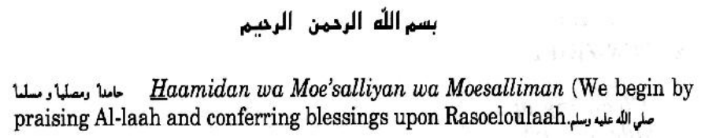
In Arabic the word "Houlaam" is used to describe gelatine because of its sticky substanace and texture. Hence, it is from this root-word that the term "Haliym" comes, and which is also used for the name of a sticky stock or soup made by boling meat and bones. In regard to the making of gelatine and its consumption, there are some Shar-iy principal guidelines and Dieny considerations. These are mentioned in the ensuing pages.

1. A'SL MAADDAH WAL JOWHAR. (Basic raw material and element.) 1.1 It is now an established fact that at this factory hairy hide waste constitutes the bulk of raw material used. Also that all raw material used at this factory for making gelatine are solely from cattle hide which is from non-Halaal and `ghair muth-booh cattle. This is the case whether such hides are fresh or dried when received at the factory, and/or whether these are obtained locally or imported.
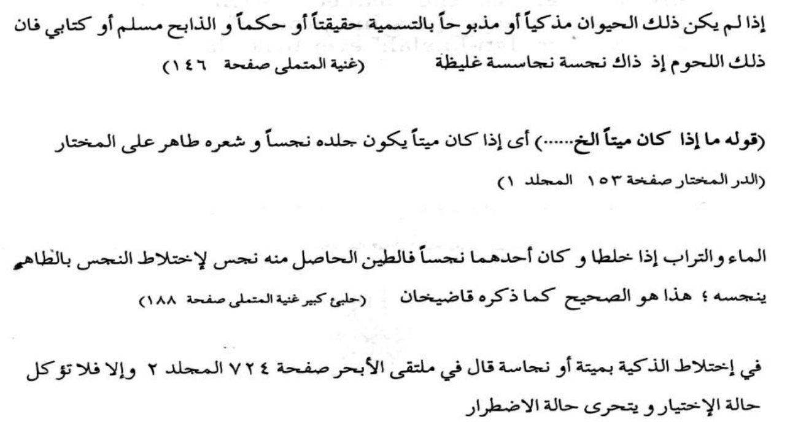


2. TUN-ZHIEF. (Cleansing of hide matrix).
2.1 In addition, those hide pieces which are fairly cleaned from hair and impurities are once again immersed in simmilar pits in a solution of water which is aerated with sulphuric acid, gas and or alaklai and acid sodium. This is done so that noncollagenous protein matter and other water soluble traces are completely dissolved "and leached out of the hide matrix". This process leaves behind the proper major structural material of connective tissue of the hide itself without any transformation at all.
This submersion of hide pieces for cleaning raw material is in an alkalai acid solution which further assists neutralizing the hide tissue structure matrix for further process. This takes a period of approximately three to eight weeks. Thereafter, the hide tissue structure (matrix) pieces are transferred into large stainless steel vats.
These hide-proper, major structural material pieces are at this stage referred to as "collagen protein", or "gelatine protein". Collagen is the main protein constituent of the hide or it's tissue structure (i.e. the matrix). There is no difference at all in the molecular set up of hide, collagen protein, or gelatine protein. At this stage the hide pieces structure develops a good swollen texture with considerable "plumping" which is also sticky and jelly like. Hence, the cleaned, leached, jelly like hide tissue structure is infact "gelatine protein" in which no "TabdiyloelMaahiyat" or "Istihaalah" ever took place.
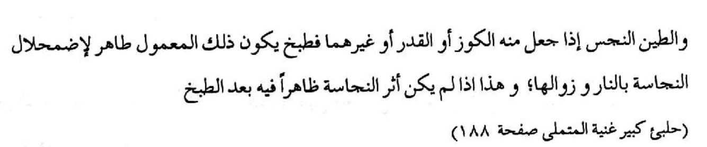
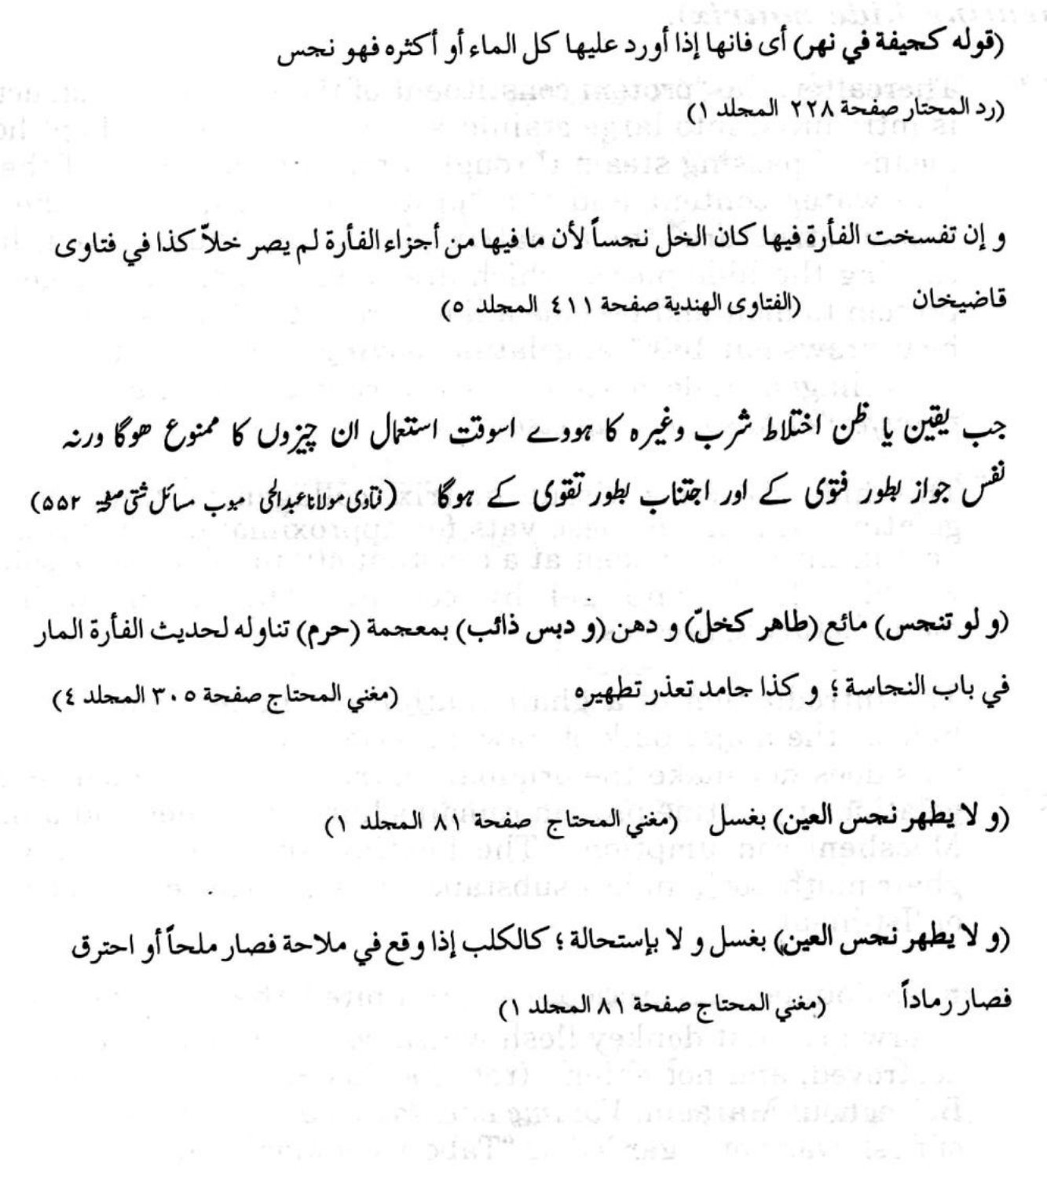

3. AT-TABKH WAL GHILYAAN. (Further process of heating hide matrix). 3.1 Thereafter, the "protein constituent of the hide tissue structure" is introduced into large stainless steel vats. This is kept hot by means of passing steam through a pipe in the centre of the vat. The water content and the "protein constituent of the hide tissue structure" (hide matrix pieces) are thus heated, hence causing the hide pieces which are collagen gelatine or gelatine protein to melt and become a liquid resulting in a solution. This heat draws out 100% of gelatine leaving no residue at all. Here, the collagen (hide matrix) is converted to liquid gelatine, (not transferred to something else).
This hide structure tissue matrix, collagen protein, or liquid gelatine remains in these vats for approximately six days. The eat in the vats are kept at a constant 40° to 65°c. This solution would solidify and gel by cooling. This is done in the manufacturing process.
The introduction of a ghair math-booh, najies and non-halaal hide as the major bulk of raw material into water pits and then vats does not make the original matrix `taahier. Such collagen gelatine or gelatine protein remains huraam, najies and unfit for Moesliem consumption. The heating and mere melting of a ghair muth-booh, najies substance does not cause trasformation or `Istihlaal'.
Rasouloulaah sallallahu alaihi wasallam prohibited the flesh of donkeys, afterwhich that donkey flesh which was boiling in pots was also destroyed, and not eaten. (ref; Soeblus Salaam, commentary of Boloeghoul Maraam, Volume one, Page 35). In this event boiling of flesh was not regarded as "Tabdiyloel Maahiyat".
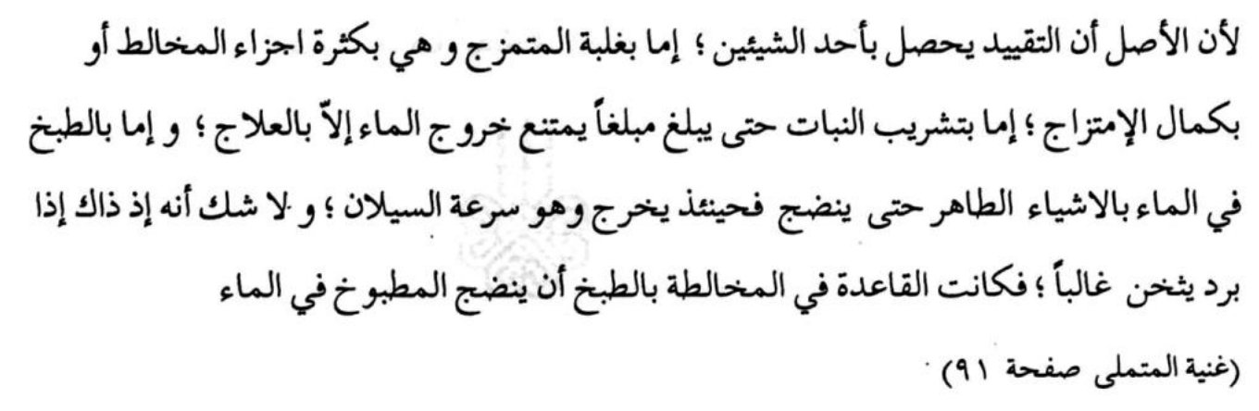
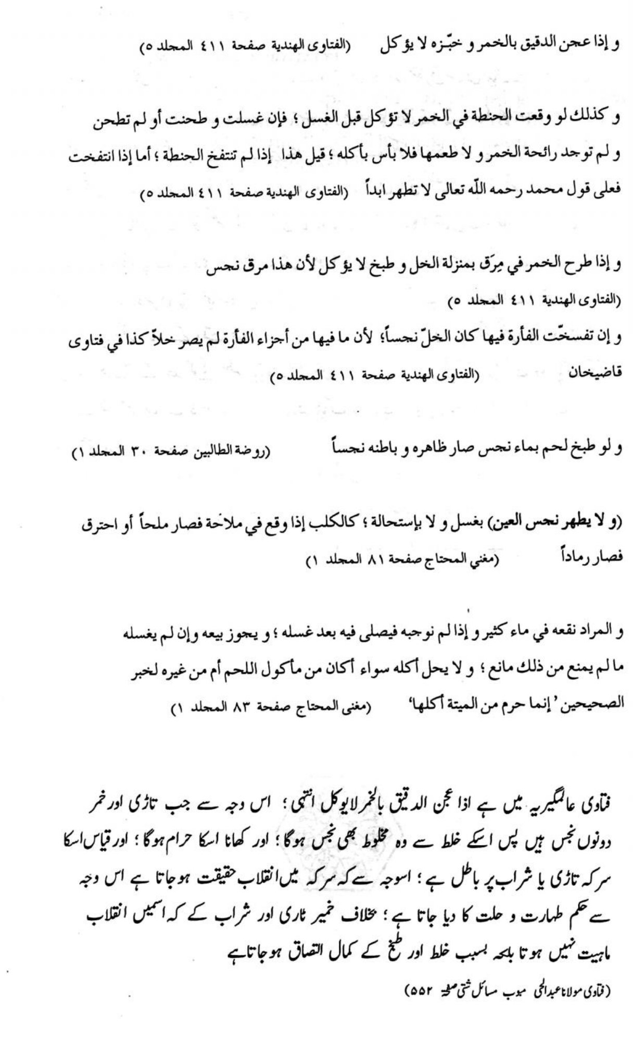
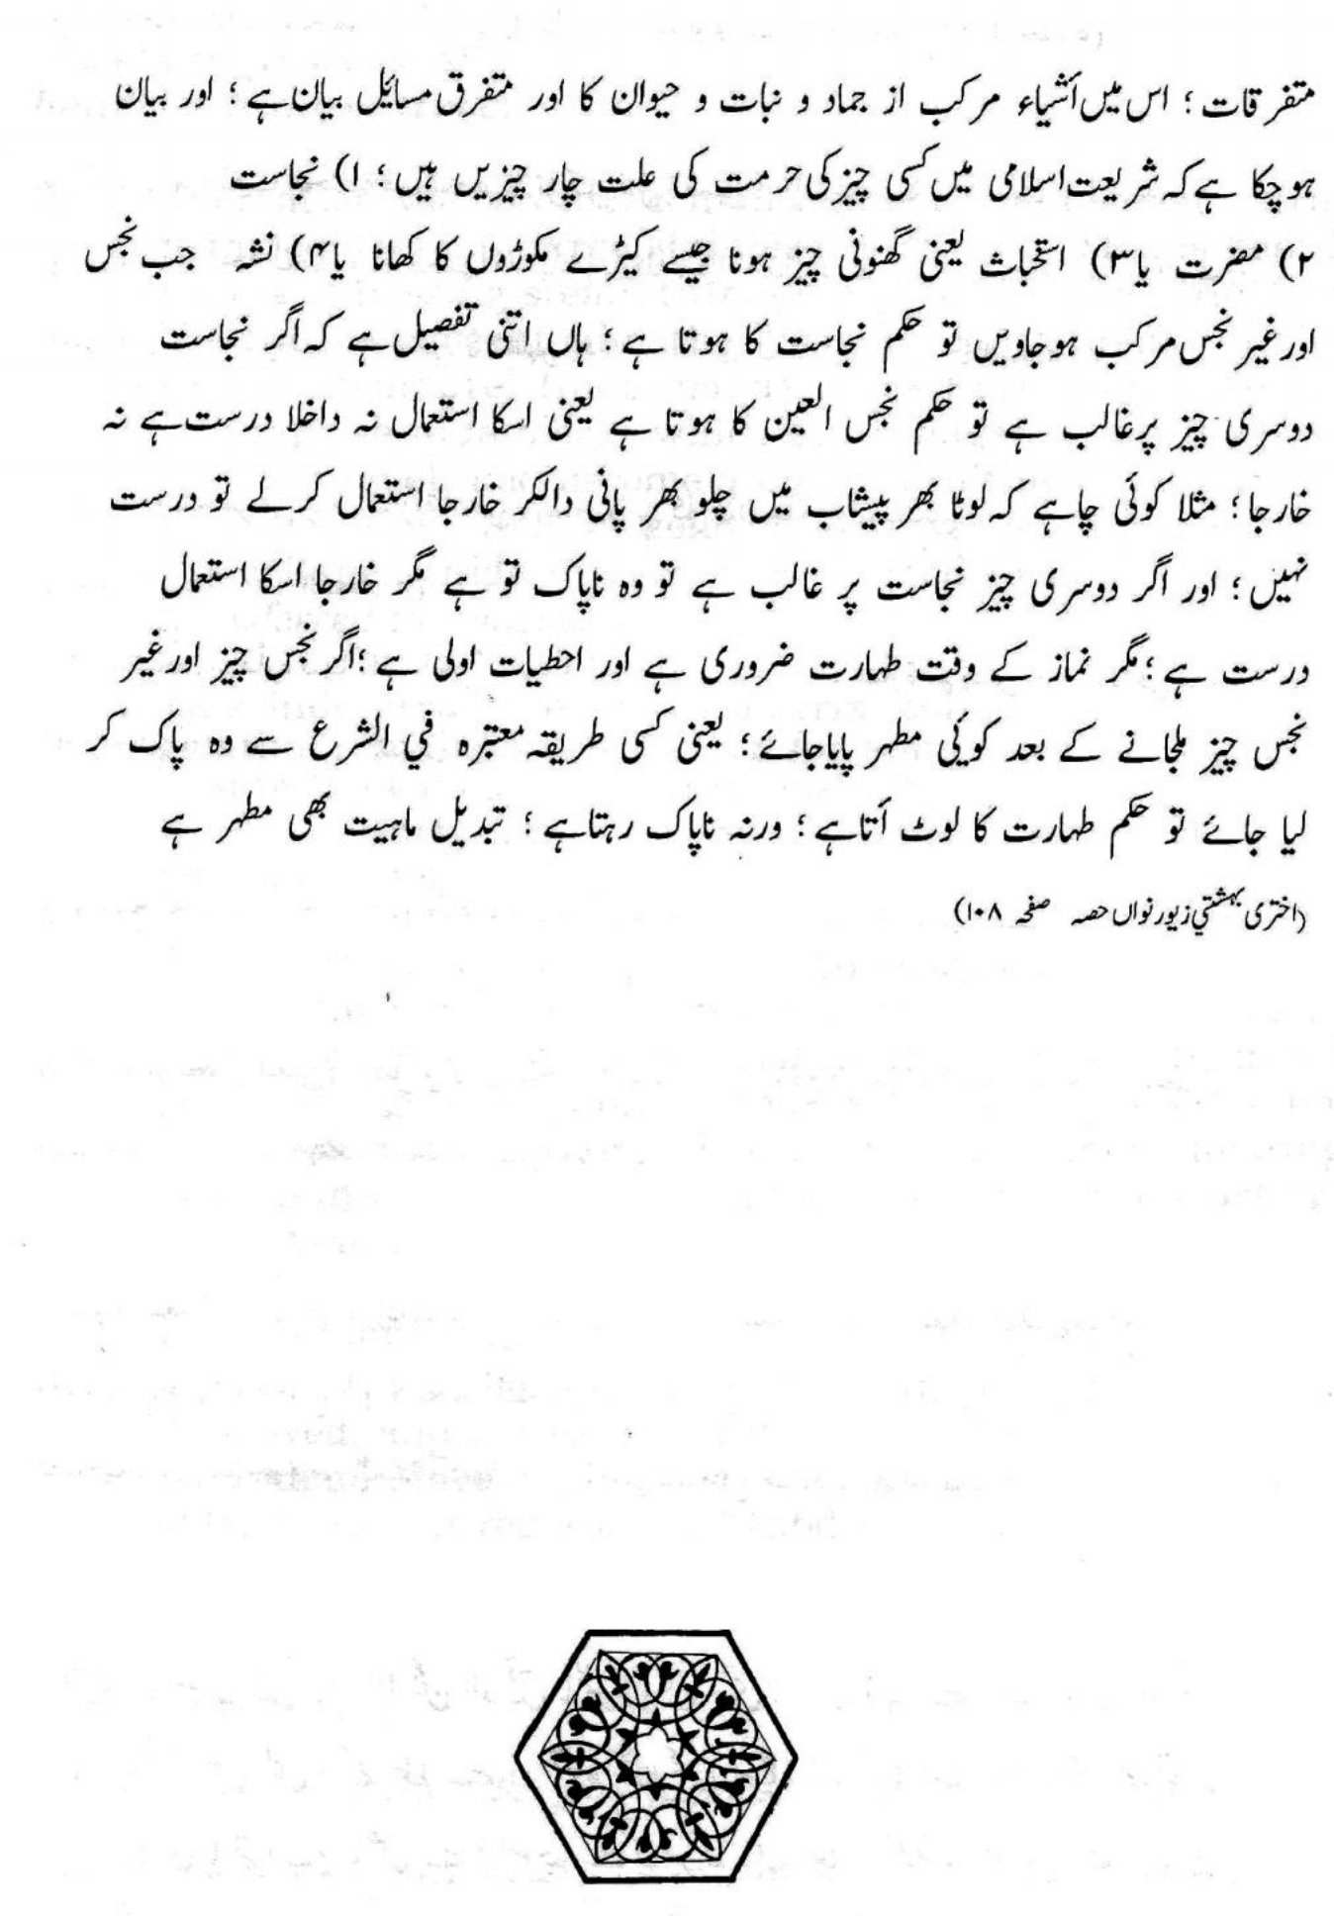
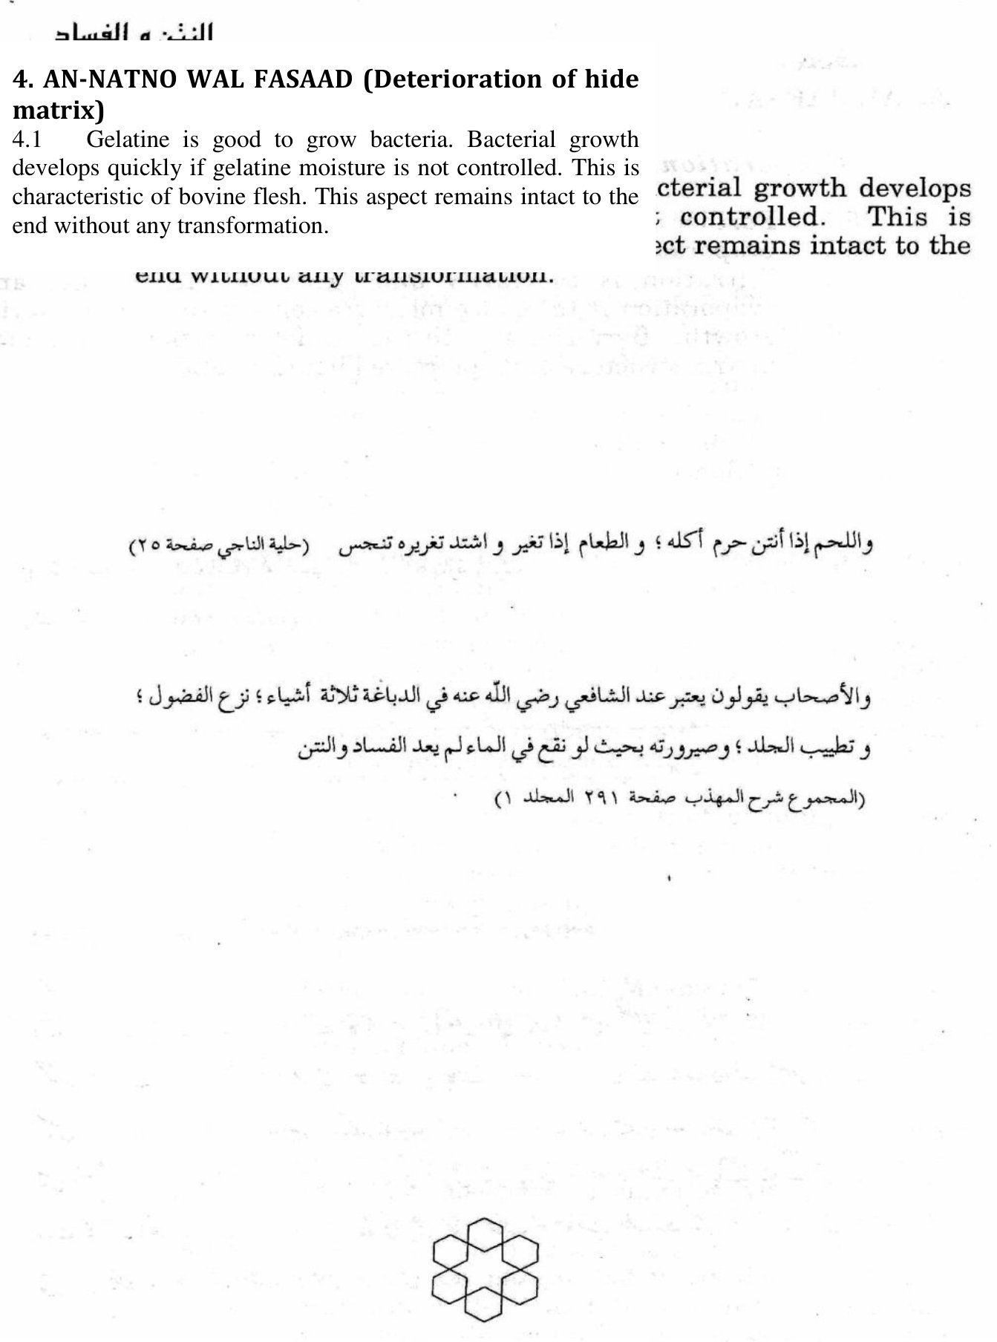

4. AN-NATNO WAL FASAAD (Deterioration of hide matrix)
4.1 Gelatine is good to grow bacteria. Bacterial growth develops quickly if gelatine moisture is not controlled. This is characteristic of bovine flesh. This aspect remains intact to the end without any transformation.
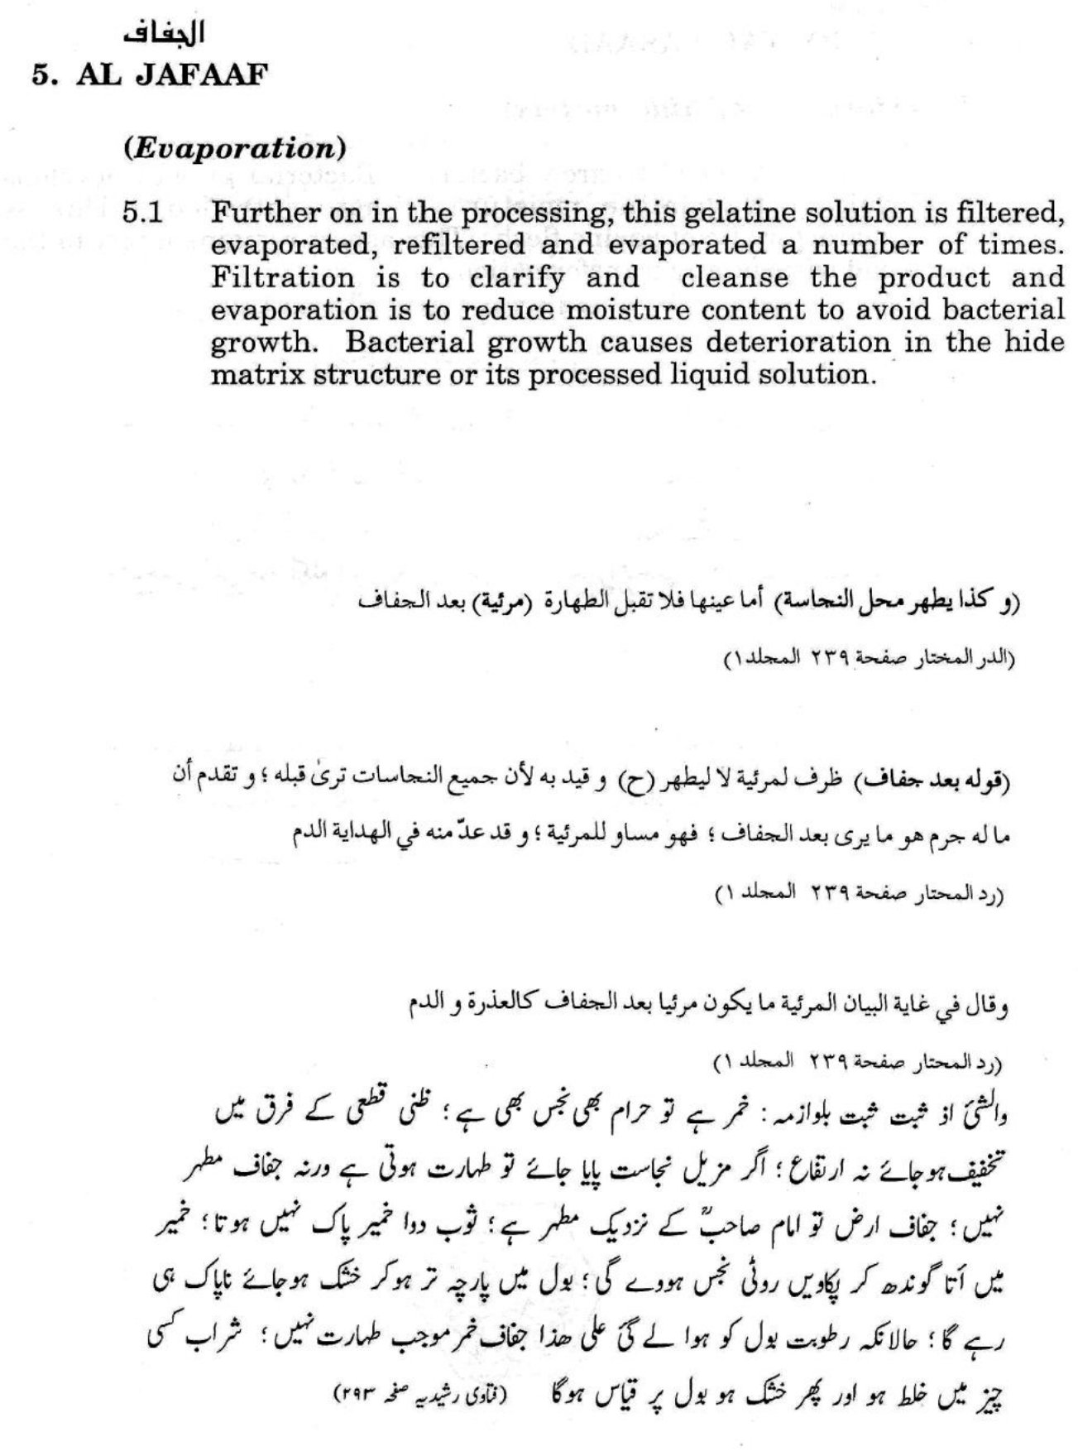
6. AT TABDIYLO - FIEL MAAHIYAT (A change of imbedded natural characteristics and nature of an item)
6.1 Tabdiyloul Maahiyat is the total transformation of the imbedded natural characteristics of something. Such transformation is also termed Isti-haalah' and or Inqilaab. By Tabdiyloul Maahiyat or Isti-haalah rules of usage and consumption change. With regard to human consumption, the Tabdiyloul Maahiyat or Istihaalah has to be into something which is wholesome and beneficial to the body. This is termed "Tayibiyah".
One example of this is that grape juice is 'Taahier (pure, good and halaal for Moesliem consumption). When grape juice is heated and treated, it ferments, then changes into an intoxicant and it becomes najies (haraam, ritually unclean and also improper for human consumption). The intake, drinking and usage thereof is totally prohibited. Thereafter when this intoxicant is transformed into vinegar, it becomes 'Taahier and is a halaal wholesome edible relish.
Another example of Isti-haalah is that of dung or cattle manure. When burnt, this transforms into ash, or when mixed into the soil, it takes the form of the earth and niether leaves any trace of its originality at all, nor leaves the effects of its imbedded activating nature.
A third example of "'Tabdiyloul Maahiyat" is from a hens egg. A hens egg is 'Taahier, halaal, wholesome and good for Moesliem consumption. However, once it turns into a blood clot the relative principal in Shari-ah of blood would apply.
In addition when this same blood clot develops into poultry white meat, it becomes 'Taahier and pure. This would be halaal and good for Moesliem consumption when such bird is properly slaughtered as Muth-booh, and also thereafter remained under Moesliem supervision. Hence, the egg was 'Taahier, then turned najies, and lastly developed into a totally transformed flesh and bone substance which is 'Taahier if and when slaughtered and processed according to the requirements of the law of Shari-ah.
Also when total "Inqilaab" takes place from one clean and pure thing to another 'Taahier substance, the relevant principle shall remain. For instance, the bone from the beef carcass is 'Taahier and when it is burnt to cinders; the ash remains 'Taahier upon its original relative Shar-iy principle. On the contrary, when sperm develops and turns into blood, total transformation does take place. However, since both sperm and blood by law of Shari-ah are najies, the relevant Shar-iy rule remains applicable.
In the case of gelatine from skins of Ghair Muth-booh cattle, the hide matrix or gelatine protien, it is basically a piece of skin which is hydrolised, cleanesed, melted, filtered, cured by evaporation to control bacterial growth, chilled, then further dried for longer shelf life, and groud for suitable and easy use.
This aforementioned process does not change the reiligious rule and Dieniy requirement of ghair Muth-booh hides.
It is an acknowledged fact that all gelatine manufactured from animal hides has a light beefy smell. The ultimate product which is pure gelatine also has this faint beefy smell and taste. Hence, there is neither Tabdiyloul Maahiyat, Isti-haalah, Inqilaab and nor any significant change or particular transformation of the fundamental imbedded natural characteristics of the hide pieces used for gelatine.
When is liquid gelatine purified?
The approximately 5% gelatine solution obtained from the extraction process is freed from any residual fat and fibres that may still be present using high-performance separators. Pre-purification is completed by passing through self-cleansing kieselgur (diatomaceous earth) pre-coated filters which are capable of retaining extremely fine particles and subsequently through cellulose plate filters similar to those used in the beverage industry.
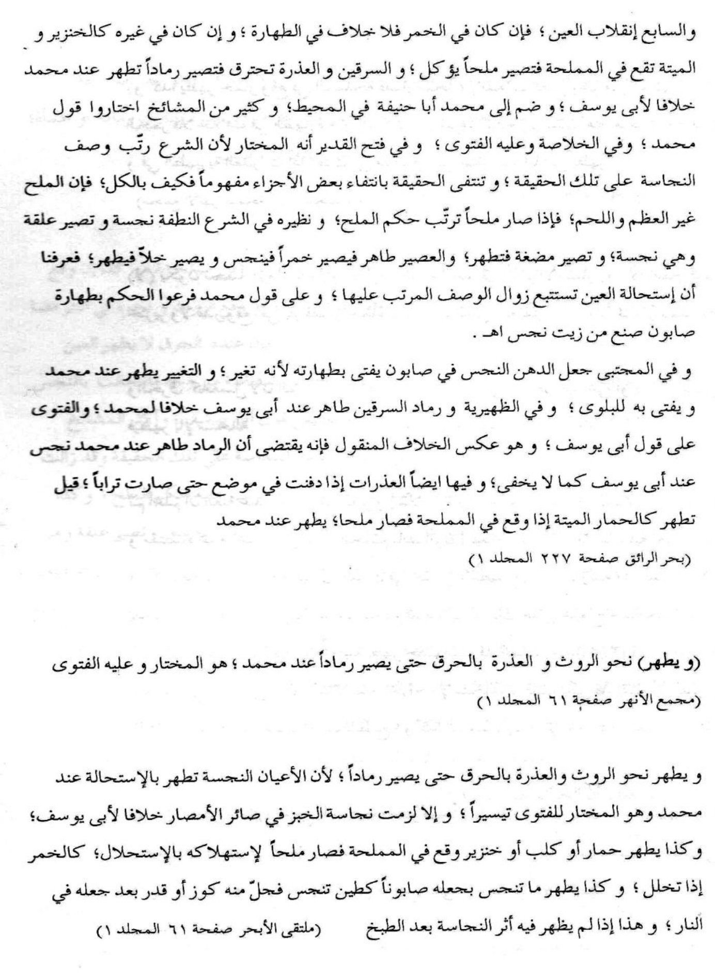
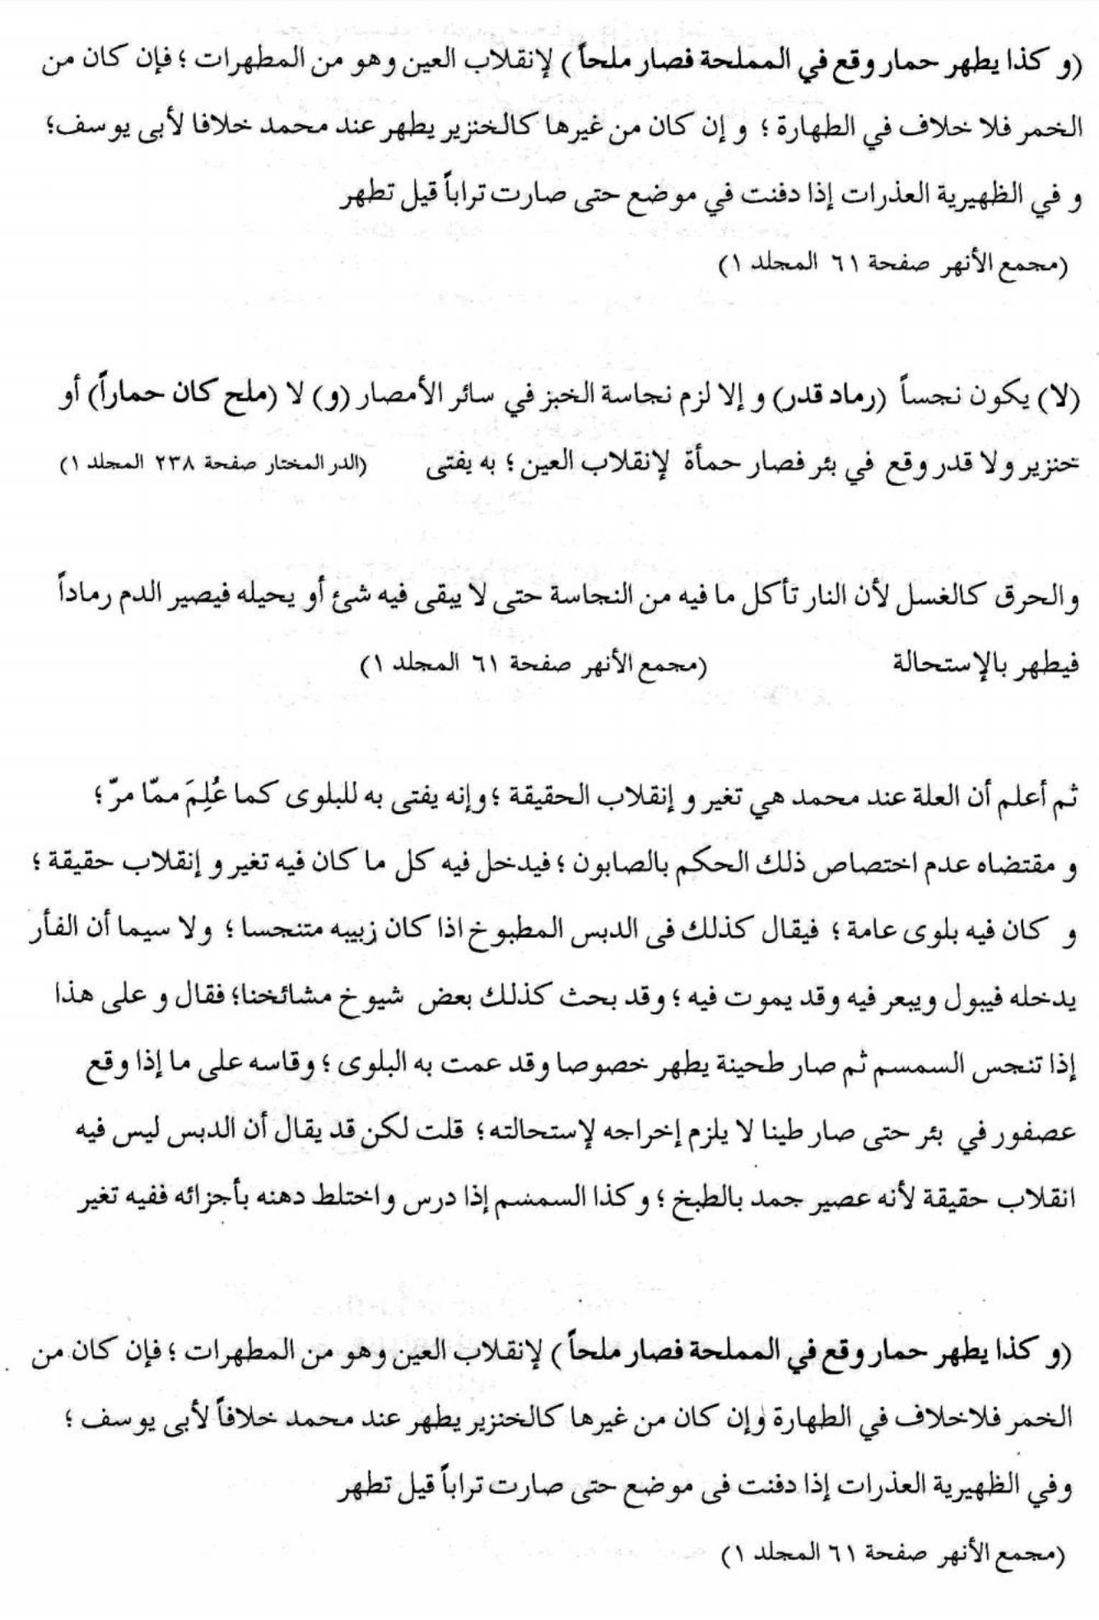
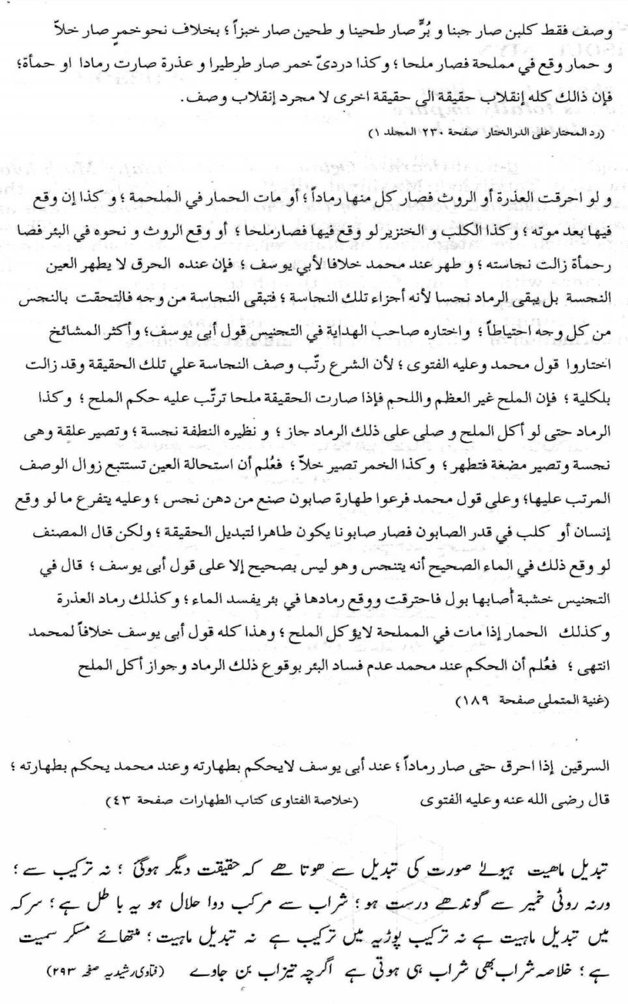
7. NAJISOUL AIYN (by shari-ah an item which is totally impure in substance and body 7.1 Though the ah-naaf (learned Oelamaa' of the Hunafiy Muth-hub) opine that Tabdiyloel Maahiyat affects the applicable rule, the Shawaa-fe (learned Oelamaa' of the Shaafe-iy Muth-hub) take an extremely stricter stance in regard to the Najisoel Aiyn. Those things which are categorised as Najisoel Aiyn by Shari-ah are items which are to the core absolutely un-clean in substance and body. In accordance with the Shaafe-iy muth-hub the "Najisoel Aiyn" items would not be regarded as "Taahier, clean and fit for Moesliem use and consumption by Isti-haalah. Isti-haalah is the total transformation of entity, originality, and natural characteristics.

8. MOESH-K. (A clarification on Mush)
8.1 Musk is halaal due to a `sahiyh hadieth of Rasoeloellah sallallahu alaihi wassallam "For indeed Musk is the best fragrance". The Nabiy sallallahu alaihi wasallam used Moesh-k. Imaam Nawawiy rahmatullahi alaih has recorded a consensus of Moesliem scholars in that Moeshk is 'Taahier (clean and good for Moesliem use and consumption). In addition trading in moesh-k is also allowed in Shari-ah.
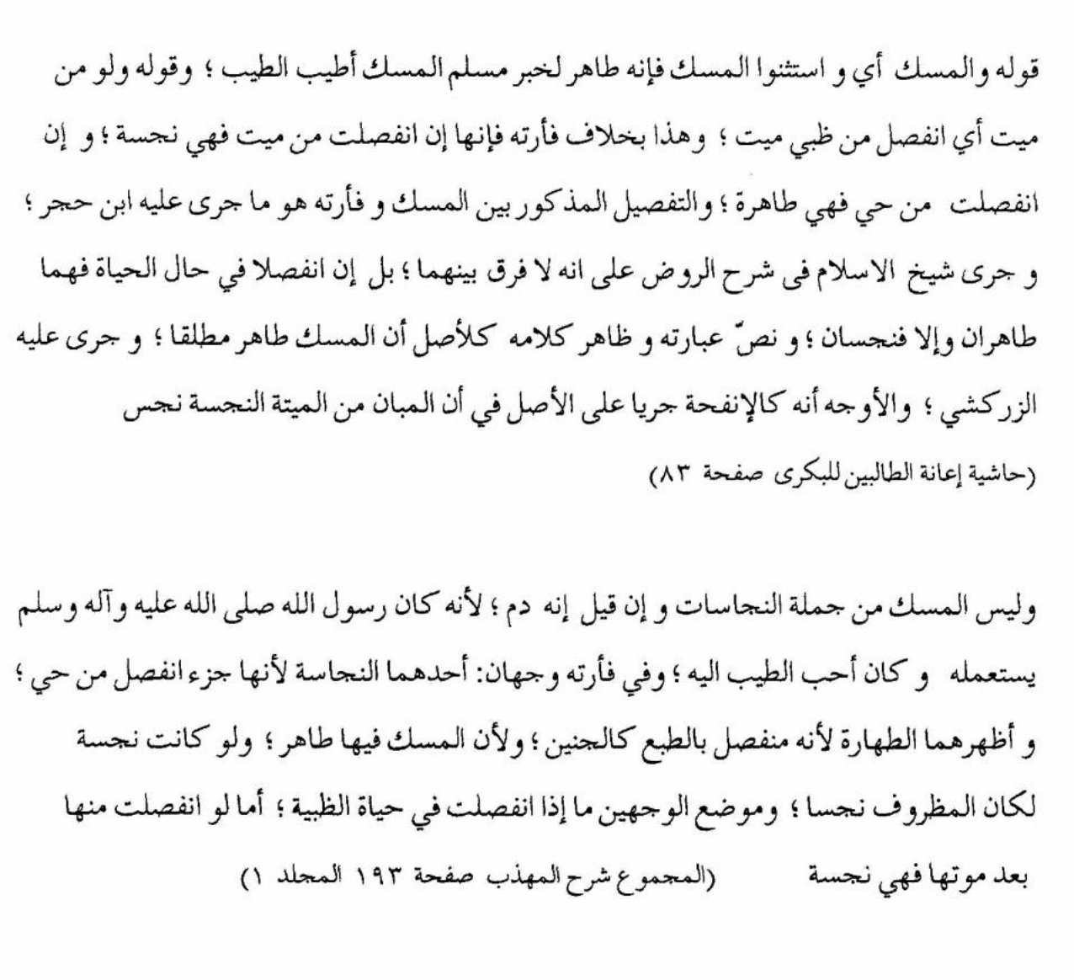

9. AD DEBAAGHAH. (Tanning of hides)
9.1 There are two types of Debaaghah. The first is a Hoekmiy Debaaghah. This is a temporary curing of the animal-hide to save it from deteriorating and rotting. This Hoekmiy Debaaghah could be achieved by covering the inner side of the skin with a layer of sand or gravel, or by a sprinkling of coarse salt or by sun-drying or breeze drying. Thus, it would last about a year or so, and could otherwise be eaten by rodents.
9.2 After this type of Hoekmiy Debaaghah, when such a hide is once again made wet and hydrogenated by water, or even dampened by excessive humidity, such a hide would once again regain it's greasy fattiness, (like a raw hide); and also be set back to the vulnerability of bacteria developing. This wetting and dampening would cause rotting and a feted stench. Also by this watering the hide would not retain it's dryness, with it's preserving quality in the fabric, which has been obtained and achieved by such a temporary treatment. Thus, it may rot or when not looked after may be eaten by rodents.
9.3 Such treatment of an animal-hide for the removal of greasy fattiness and drying-out for curing and preserving a skin would merely bring the animal-skin into a state of `Ta-haarah. This qualification by standards of Shari-ah is for such a product which is for external usage; but is not in this state; allowed for moesliem consumption. This type of semi-cured hide is also not recommended for Moeslim dress.
9.4 The point to be clearly understood is that in law of Shari-ah an animal's skin is not from among those items from a carcass which are regarded as an edible, and is commonly repugnant when introduced into foods. This is so especially in a dried semi-cured state. However, some non-moeslims do consume the pig's skin when they cook it whilst being attached to portions of pork.
9.5 Furthermore, a maituh is such an animal which has died from natural causes, or is killed and not slaughtered by proper Islaamic Standards. Therefore, though the nerves, hardened muscle (string like) fibre tendons, bones, horns, skin, hair and wool fibre, hooves and claws or nails of a maituh are categorised to be `Taahier (when there is no greasy fattiness on them), Moesliem (human) consumption of these things are indeed prohibited.
9.6 Whereas, Debaaghah Haqieqiy is the treating of an animal-hide by the usage of stronger chemicals. Chrome tanning salts are used for curing and tanning skins to produce a softer type of product, e.g. handbags, purses, leather jackets etc. A vegetable tanning extract from wattle bark is used to cure the leather for shoe soles etc. This is a harder, firmer type of leather.
In this process of Debaaghah, once the hide is tanned and thereafter subjected to treatment by water, hydrogenation or excessive humidity. No froth or fatty, greasy substance; like that of a raw, fresh animal hide; would appear again, recur or even redevelop in or from the skin. Such a skin would also neither rot nor give off a feted, offensive stench. The leather would retain it's fabric and texture as a leather product and not become flexible and fatty, like a raw, fresh hide.
9.7 In this regard, one should not be oblivious of the fact that the consumption of an animal of prey is totally Huraam by standards of Shariy-ah. Whereas, once an animal of prey is properly slaughtered according to the requirements of Islaamic law; the hide of such an animal would be `Taahier for usage after the Haqieqiy Diebaaghah in tanning for leather and it's further products. This niether causes the consumption of parts of that animal of prey to be good, nor is allowed for Moesliem (human) consumption.
9.8 Therefore, in the issue of the maituh, the fatwaa is on the disallowance and prohibition of it's consumption. Obviously, the consumption, of the nerves, hardened muscle (string like) fibretendons, bones, horns, skin, hair and wool fibre, hooves, claws or nails is certainly not permitted. These are not the eaten portions of any maituh animal; be it one of prey or not. Rasoeloul-laah sallallahu alaihi wasallam has said "Indeed the consumption of it's flesh is prohibited". The understanding of the leading 'Sa-haabuh was also this particular point; that human consumtion of all parts of the maituh is not allowed. This is either due to, Khoebth and Isthiekh-baath; mudharrah, or najaasah by the fatty substance thereupon, and also the clear Hoermut.

GELATINE FROM BONES.
9.9 Whereas, gelatine from a bone is from the fatty, sticky substance which is on and also in the bone structure itself (not the bone marrow). This is reffered to as "Doesoumatoen", it is in fact drawn out from the bone proper by a heating and boiling process. Such stickiness increases as the boiling process continues, e.g.. The sticky, gel-like Huliym (sticky soup) prepared from bones. Thus, it is this sticky, fatty, greasy Hulloum substance from the bone which is a principal cause and also gives rise to the retention of the prohibiting najasah upon the bone.
9.10 The foequ-ha have mentioned the total prohibition for consumption of the maituh animal bones which have this type of greasy fattiness.
Therefore, it would be incorrect and way-ward to give the bonses' rule of `Ta-haaruh to the fatty, sticky substance extracted from such maituh bones.
9.11 Debaaghah is a hide tanning process. In this hide tanning the hide's condition is preserved and improved. The excess moisture in the fresh hide is removed. This prevents rotting and deterioration of the hide. It also keeps the hide from developing a repugnant stench. Furthermore, by the re-introduction of such hide to water, the cycle of original bacterial growth, deterioration of the hide and offensive rotting situation would not recur.
9.12 Debaaghah is allowed in Shari-ah. The tanned hides of animals which are not "Najiesoel Aiyn", or skins which are not untanable may be used, and sold. However, it is not permissible to consume treated or tanned skins of non-halaal, ghair muthbooh animals.
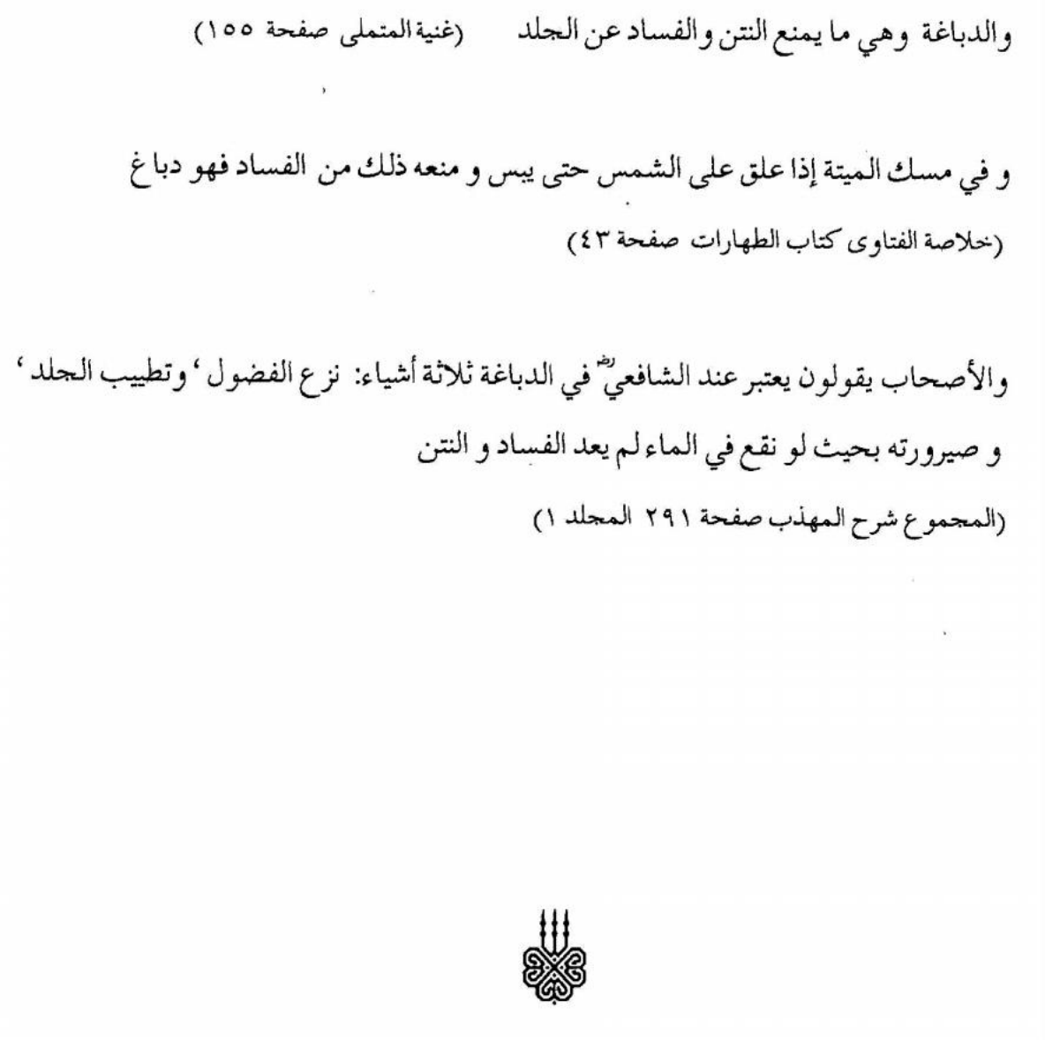
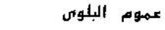

10. OEMOOMOUL BULWAA (Common indulgence without which survival is not possible)
10.1 The consideration by Shari-ah of general Moesliem indulgence, without which survival is impossible is termed "Oemoomoul Bulwaa". All gelatine manufactured from animal hides has a beefy smell. This type of gelatine also has a slightly beefy taste. This gelatine is without any particular transformation of the skin of ghair muthbooh animals.
10.2 Though this smell or taste is not detected in further processed sweets or confectionery, its introduction shall jeopardise the "'Tahaarah" status of such edible. This is because of the pieces of skins which had come from ghair muth-booh animals. 10.3 Gelatine is used in some sweets, jellies, yoghurts and also creams in biscuits and confectionery. Gelatine has the quality of holding the substance of an edible together and melting at body temperature, thus allowing the flavour to spread into the mouth of the consumer. For example in a marsh-mellow, the gelatine holds the aerified froth together, and would melt in the mouth by body heat temperature. The consumption of such luxuries could not be regarded as a basic need for survival, wherein the rule of "Oemoomoul Bulwaa" could be applicable.


11. ISTIKHDAAM AAKHAR. (Other usage)

11.1 GELATINE GLUE.
From this type of animal base a glue is also made. This is the wet gelatine solution before it is chilled and dried. The gelatine pulp is not thoroughly sterilized for such a gum use application. This glue is mainly used in matches, sand-paper and in woodwork in small amounts today. This glue is also used on envelopes. This hide glue is used by people who do restoration of old furniture etc. This glue is prepared in liquid and dry form.

11.2 GELATINE IN WINE.
Wet gelatine which is treated with an enzyme is used in the wine industry. This is mixed into wines, in the Cape, because the gelatine assists in clarifying the wine. The gelatine takes traces of foreign particles to the bottom of the wine vessel.
Moesliems are required to exercise care in regard to gelatine glue and its usage and not to turn a blind eye to such applications in which this hide-glue is used.
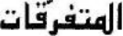

12 MOETAFRRIEQAAT. (Miscellaneous)
* An additional explanation on some principle rules is given below regarding the consumption and/or usage of a combination of items. These would either be from solids, like minerals etc., plants or animals.
It should be understood that there are four fundametal reasons for the prohibition of some edible or consumable in Shariy-ah. These are: a. Najaasah; - Ritual impurity e.g. urine, excreta, flesh or portions of animals or birds killed in a manner contrary to the required Islaamic procedure. b. Mudharrah; - Being injurious and harmful, e.g. the consumtion of poisonous plants or something which is noxious or is lethal. c. Istiekhbaath; - Being repungant, noxious, offensive and also harmful, e.g. the eating of worms, insects or similar invetebrate, such as spiders, ticks or centipedes etc. d .Sukr; - Intoxication, and also impairing of sensible judgement, e.g. alcoholics, marijuana, dagga leaves, chemical substances etc.
* When a najies and a non-najies thing is mixed, the principal rule of najaasah shall remain. However, if the najaasah introduced is more then the rest, same would be catogorised as "Najisul Aiyn". Any "Najisul Aiyn" thing is impure, unclean and unfit for human usage or consumption by Shariy-ah. Where someone had mixed one handful of water into a jug of wine, then by Shari-ah it would be incorrect to consume, or even externally use such a mixture. In the event the najaasah mixed is less in proportion to the remainder, same would still be regarded as unclean by law of Shari-ah. Therefore, in the absence of a `Taahier, ritually clean alternative this mixture may be used externally only, whilst taking care that `Tahaarah as a necessity is acquired at the times of `Salaah. However, in such circumstances Ih-tiyaa't, (timely care, and precuation), is commendable.
* In the instance where a najies and a `Taahier substance has mixed, after which such a Moe'tuh-hier (purifier and purger) which is recognised in Shari-ah is correctly administered, then thereafter such mixture would once again be regarded as `Taahier, and if not; the rule of najaasah shall remain.
Tabdiyloel-Maahiyat, which is total transformation of the originality and a fundamental imbedded nature of an item, is regarded as a Moe'tah-hier (cleanser and purger in Shari-ah).
* In addition, when a harmful thing is mixed with a non-harmful substance by which it looses its Mudharrah and injurious detrimental effect, the Shar-iy priciple of prohibition will also similarly change. For instance, when an antidote or a nuetraliser is mixed into arsenic, or poison is used in a treatment for beneficial oral use or consumption, then the use of such poison in quantities which are not harmful would be allowed.
Also if a repugnant, offensive noxious thing is mixed into a good, clean substance yet the Iestiekh-baath remains, the relevant principle of prohibition shall also remain effective, otherwise the Hoekm of Hiellat (permissibility) would be applicable. These rules do not apply to intoxicants or chemicals and substances which impair one's judgment.

CONCLUSION.
The phrases of Rasoeloul-laah sallallahu alaihi wasallam "Iestumta-tum biehaa"
and "fal- yuntafi-e-biehiy" are mentioned in relation to a clear injunction of the prohibition of eating the maituh's meat. This is indicative of the issue of Moesliem (human) consumption.
In a Hadieth it is explained that Rasoeloul-laah sallallahu alaihi wasallam asked for water to perform woudhoe. The response was we only have it in a (skin) water holder from a maituh (carrion carcass). The Rasoel sallallahu alaihi wasallam asked: "did you tan it?" (i.e. reference for external usage).
Abdoer Ruzzaaq in his Moe'sunnuf relates that ibn Jouraij mentioned that, he inquired from A'taa'; "Can a person sell a sheep skin of a maituh (i.e. carrion carcass not slaughtered in the proper Shar-iy manner); which was not cured.
A'taa' responded: "Niether do I ascribe to such transaction, nor do I prefer that one should consume the takings from the sale thereof; even though the skin had been tanned".
Imaam Hasan said: "one may benefit from it (i.e. the maituh's hide) but it must not be sold (i.e neither to reap any advantage from the takings of it's sale, nor consume the value of such further transaction).
Hence, the allowance is for the mere usage of the maituh's tanned hide as an instrument or utensil. In addition one shall neither reap any advantage from the takings of it's sale nor consume the value from such further transactions.
It is also mentioned that Aa-ishah radiallahu aanha regarded the wearing of clothing items from the maituh to be makrooh (undesirable and to be abstained from).
(ref see Moe'sunnuf Abdoer Razzaaq, vol. 1) viz., This was an extremely precautionary step to abstain from taking benefit from a maituh product even though it maybe `Taa-hier.
Gelatine is either made from bones and hides of bovine animals or pig skin and bones.
In the making of gelatine or glue from hides or bone "Qalboul Maahiyat" as described and required by law of Shari-ah does not take place at all.
The same tissue structural body matrix is named a "hide trimming" at one point, then termed a "neutralized molecule" at another point, and then called "collagen protein" at a further point and then finally labelled as "gelatine protein". Changing of the name of a tissue structural body matrix cannot be termed "Tabdiyloul Maahiyat".
Hydrolizing, evaporation, or filtration does not cause a transformation or "Qalboul Maahiyat".
Gelatine protein of ghair muth-booh_ bovine animals is Haraam and a najies substance which has not actually changed from it's original source as a hide. The principle of "Qalbuol Maahiyat" requires a total transformation.
Where the hide of "ghair muth-booh_" bovine animals are used in the making of gelatine protien or glue the resultant solution, granules or powder would be disallowed, Haraam and also najies by law of Shari-ah.
In the event this Haraam and najis substance is mixed into the ingredients of a sweet or confectionery, such product would be disallowed by law of Shari-a-h. (See Ad Durroel Moekhtaar, Vol 1, Page 233 - No'amaaniya, and also Fataawa Mahmoodiya Vol 9, Page 43)
One aspect may be considered. This is the issue of "At Tadaawiy bil Moeharramaat". Where no alternative substitute for medication is available or death is imminent, and a recognised, accepted Moesliem `Tabiyb Haathiq (a prominetly known, experienced hakiym or doctor) suggests a prescription containing further processed products of ghair muth-booh animals, such medicine would be allowed. We trust in Allaah that there will be no reproach in the Aakhirah for such particular necessity, for indeed He is the All Knowing, and alone is sufficient for us, and is indeed a kind, indespensible gaurdian.
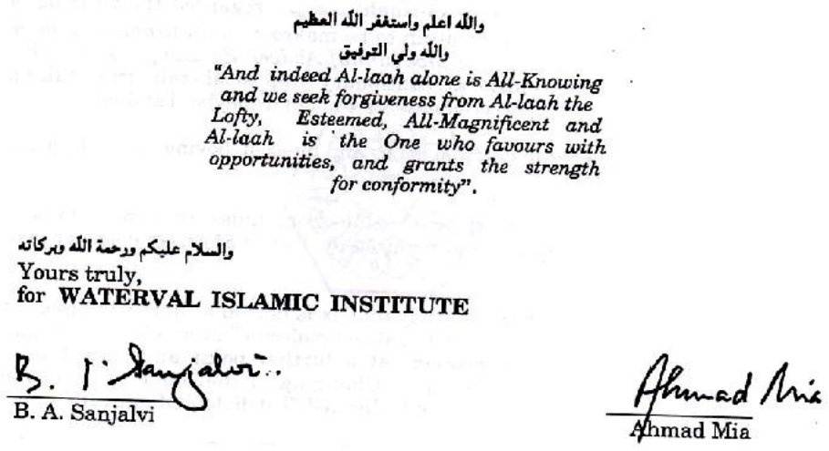

HIDES AND SKINS
In gelatine production, hide/skin pieces obtained from ghair-mathbooh (un-Islamically killed) animals are used. Such hide pieces are acquired locally as well as imported from other countries.
Gelatine is actually the collagen – an insoluble fibrous protein – which is a fundamental constituent of the hides. The hides are not transformed into any new substance which has its own existence in nature. An extract from the skins is not the effect of Qalbul Maahiyat (total metamorphosis). The components which make up the hide are blood, fat, collagen and some other substances. The skin of the haraam animal is impure (Najis) on account of the presence of these moist impurities. The hair, hooves and horns of haraam animals are taahir (pure), but not so the skin. The horns and hooves do not contain substances which remain impure if the animal is not slaughtered Islamically, hence these are considered pure.
On the other hand, the skin, on account of its composition of moist substances will be impure and haraam if thabah or dabaaghat is not effected. Dabaaghat or tanning is the process which expels all the moist substances from the hide. After expulsion of the impurities, the skin does not decompose.
In gelatine manufacture, the hide is not transformed into a new substance. What happens, is that the substance called collagen which is the primary constituent of the hide, is extracted, and this in fact is the gelatine. The very constituents which render the hides of non-thabeehah animals are the end product which they call gelatine. The hides of haraam animals are impure/haraam on account of the very presence of the constituent 'gelatine' in them. The only thing which is accomplished in the factory is the preparation of this raw 'gelatine' into processed and so-called 'purified' gelatine. This is clearly borne out by Waterval's inspection and Fatwa which states in this regard:
"The effect of this treatment on the hide tissue structure (matrix) is that the material is further clarified, hydrolyzed and has a fairly good swelling texture with a considerable 'plumping'. This is now sticky and jelly-like. At this point the hide pieces are referred to as 'neutralized molecules', a 'collagen protein', or a 'gelatine protein'. This is still the original hide tissue structure. There is no difference at all in the molecular set-up of a hide, collagen protein or gelatine protein."
It does not require the brains of a genius to understand that absolutely no metamorphosis of the type envisaged by the Shariah, and known as Qalbul Maahiyat or Tabdeelul Maahiyat occurs in gelatine-production. Nor is it necessary for an unbiased Muslim in search of the Truth to be an expert in chemistry and physics to understand that the only action which occurs in the lengthy process of gelatine-production is the extraction of the impure gelatine from the haraam and najis hides. This raw gelatine is processed and presented in what they will term 'refined and purified' state ready for use by people who have become immune to the consumption of maitah (carrion) and najaasat (impurity).

WHAT IS DABAAGHAT?
Some molvis and muftis have gravely erred in the opinion that during the process of gelatine-production Dabaaghat takes place. They contend that in view of dabaaghat, the impure and haraam hides are rendered taahir (Islamically pure). Gelatine is made from these 'purified' hides, hence it is 'halaal'. Those who have made this preposterous claim are either ignorant of the meaning of dabaaghat, or ignorant of the process of gelatine-manufacture, or simply evil and corrupt, following in the footsteps of the corrupt scholars of the Yahood and Nasara who would fabricate corrupt and baatil fatwas for pecuniary gains.
Dabaaghat or tanning is the process of tanning or treating the skin to eliminate every vestige of moisture/impurity from the hides. After dabaaghat, the hides become leather fit for manufacturing leather products such as shoes, belts, bags, etc. A madboogh hide (tanned/treated skin) cannot be utilized for producing gelatine. Should it be assumed that even after dabaaghat by some chemical process the skin can be used for gelatine-production, then too, the irrefutable fact remains that no dabaaghat is effected to the hides in the process of gelatine-production. This could be ascertained with clarity from the report and Fatwa of Waterval Islamic Institute. Even the manufacturers of gelatine concede that whole hides are not used in gelatine-production. Whole hides are used in the tanning industry for leather production. Dabaaghat is effected to the whole hides in the tanning industry for preparing leather. For the production of gelatine, hide trimmings and hide waste matter are used.
The very constituent, collagen which is the main protein component of the hide, is the gelatine embedded in the hide. This 'gelatine' is acquired from the hides which are by no stretch of even imagination, madboogh. Absolutely no dabaaghat of the hides takes place during the entire process of manufacturing gelatine, neither prior nor afterwards.
There are only two ways in which animal gelatine can be halaal.
(1) All the hides used must be from only halaal animals (goats, sheep, cattle) which have been slaughtered Islamically.
(2) If the hides are of halaal animals which were slaughtered un-Islamically, then such hides should first be subjected to proper dabaaghat. Thereafter, the madboogh (tanned/treated) hides may be subjected to further processes to extract the collagen protein for producing the end product, gelatine.
There is no third method of producing halaal gelatine.

WHAT IS QALBUL MAAHIYAT?
Qalbul Maahiyat means the changing of the natural constituents of a substance to produce another substance which has its own independent existence. A substance undergoes a total metamorphosis which completely eliminates the earlier entity/substance resulting in the production of another substance which has its own independent existence.
The simple example which the Fuqaha give of Qalbul Maahiyat is a dead animal in a saltpan. The animal decomposes and by the natural process of putrefaction is in time converted into salt, not leaving a trace of the dead animal. The resultant salt is halaal since the process of Qalbul Maahiyat has been validly effected. Qalbul Maahiyat is not a process of extraction by means of which the impurities in the dead body are leeched out, then subjected to chemical treatment to merely change the outward form of the impurities, or the transformation of impure flour and water into bread or cake, or the transformation of impure fruit pulp into jam. Giving such transformed impurities a fanciful name does not mean that Qalbul Maahiyat has occurred.
An important stipulation for valid metamorphosis is that there should be no manifestation of any sign whatsoever of the original impurity (najaasat). But the end product, gelatine has a beefy odour and a beefy taste. This is merely an additional factor. The hukm of haraam South African gelatine is not based merely on this condition of gelatine. Nevertheless, by itself, this stipulation is an adequate refutation of the Qalbul Maahiyat claim.
Furthermore, Qalbul Maahiyat is a weak and defective purifying action. There is no consensus of the Fuqaha of the various Math-habs on the validity of metamorphosis being a purifying agent. In fact there is no consensus even among the Fuqaha of the Hanafi Math-hab on this issue. The determinant in the fatwa of permissibility of certain products said to be pure by virtue of Qalbul Maahiyat, e.g. soap made from impure fat/oil, is the intensive and extensive need and involvement (Balwa) of the masses.
However, in the case of gelatine, there is no Balwa. Muslims are generally abstaining from consuming the myriad of luxury edibles such as sweets, chocolates, puddings, jellies, etc., which contain gelatine. But, now these evil 'halaal authorities' are hell-bent on creating a 'balwa' for the future by addicting the Muslim masses to the consumption of haraam luxuries certified 'halaal' by the scraps of papers doled out for exorbitant fees.

GELATINE – A MISLEADING ARRAY OF NAMES
In the attempt to peddle the permissibility of haraam gelatine, a pamphlet issued by the NIHT vendor of haraam certificates, purveys a list of 18 dignitaries who have given the green light of 'halaal' to the filth known as gelatine. With this misleading array of names, the NIHT vendor seeks to impress gullible Muslims and to stampede them into acceptance of the haraam 'halaal' certificates which these miscreant vendors are doling out to manufacturers for exorbitant haraam fees.
In the list comprising mainly of non-entities furnished by the NIHT pamphlet, two are of concern, namely, Hadhrat Mufti Rashid Ludhyaanwi (rahmatullah alayh), and Mufti Taqi Usmaani. Both these Ulama are from Pakistan. There is a need to examine the fatwas of these two senior Ulama.

MUFTI RASHID LUDHYAANWI'S FATWA
The following question was posed to the venerable Mufti Saahib: "Bread is eaten with jelly (i.e. in Pakistan). Some people say that it (the jelly) is not permissible because it is made from the skins and bones of animals. What is your research in this matter?" Mufti Rashid Saahib answered: "Firstly, there is no incumbency for manufacturing jelly (gelatine) from bones and skins. It is also made from the leaves of trees, etc. Secondly, if it is made from skins, etc. then it is not necessary that the skins are from dead (haraam) animals. The skins of halaal Thabeehah (Islamically slaughtered animals) are overwhelming. Thirdly, in the manufacture of jelly (gelatine) there is the possibility (emphasis ours) of Tabdeel-e-Maahiyat (metamorphosis). In this event, gelatine made from the skins of haraam animals is also halaal."
(Ahsanul Fataawa, Vol., 8, Page 128)
Comment (1) The issue of 'incumbency' is irrelevant in our context here in South Africa. No one here questions the status of plant / vegetable gelatine. While the questioner did not specify the type of gelatine, we state categorically that our discussion and concern pertains to only animal gelatine. The doubt which Hadhrat Mufti Rashid Saahib presented thus has no relevance in the context of our discussion. Here in South Africa animal gelatine is specified. The discussion is thus restricted to this issue. Thus, the first argument of Mufti Rashid has no relevance to our situation.
(2) Mufti Rashid Saahib's view of the skins being overwhelmingly from halaal animals slaughtered Islamically, is applicable to Pakistan where 99% of the animals are slaughtered by Muslims. The overwhelming possibility of halaal skins alluded to by him therefore has validity in Pakistan, not in South Africa where even the vendors of haraam certificates concede that the overwhelming supply of skins is haraam. (3) In his third argument, Hadhrat Mufti Rashid bases his conclusion of 'halaal' on uncertainty. He speaks of the 'possibility' of metamorphosis. It is clear that the venerable Mufti Saahib lacked expert knowledge of gelatine manufacture, hence he was constrained to postulate 'possibility', and not certitude. The venerable Mufti Saahib's conclusion of the 'possibility of Tabdeel-e-Maahiyat' occurring in gelatine manufacture is peculiar, untenable and unacceptable. His fatwa was not based on fact. We therefore have to dismiss this fatwa. It has no relevance to gelatine manufacture in South Africa where this haraam substance is made from impure and haraam skins which has retained its fundamental structure along with much of its inherent impurities. Absolutely no Tabdeel-e-Maahiyat takes place. The conclusion based on a possibility is therefore baseless.

MUFTI TAQI USMAANI'S FATWA
The Bid'ati NIHT states in its pamphlet that according to Mufti Taqi Usmaani, gelatine is 'HALAAL'. This statement is highly misleading. Mufti Taqi Saahib's full statement on the gelatine question is as follows:
"The substance of the Fatwa is that gelatine acquired from the bones can be held as pure (Taahir) and the gelatine acquired from the hides of un-slaughtered animals can also be held as pure because chemical process fulfils the requirement of tanning (Dabaghah) but there are two points to be kept in mind. This ruling applies only to the animals other than pig. Secondly, my ruling was to the extent of purity of gelatine. So far as its oral use is concerned there is difference of opinion among the Muslim jurists. Some Fuqaha are of the view that hides of a halaal animal can be used orally after being tanned but the majority of the jurists are of the view that it is not allowed for oral use. The latter view has been preferred by most of the Hanafi jurists. However, some of the Hanafi jurists and a large number of Shaafi jurists have preferred the permissibility of oral use of the hides of Halal animals after dabaghah. Consequently, the use of gelatine taken from halal animals, like cow, should be avoided as far as possible acting on the opinion of the majority of the jurists. However, since Imam Shaafie in his latter view has opined it to be Halal and a large number of the Shaafie jurists as well as some Hanafi jurists take it as such, the view of these Fuqaha can be acted upon in the cases of genuine needs." (This is a verbatim reproduction of the English fatwa of Mufti Taqi Sahib).
Concluding his Urdu fatwa on gelatine, Mufti Taqi says: "……In the preparation of gelatine, does Inqilaab-e-Maahiyat (total metamorphosis) occur or not? On this question, I am still in doubt."
Comment This is a far cry from the emphatic attribution of 'halaal' to Mufti Taqi Saahib. He has stated his uncertainty on this issue with clarity. The salient facts in his fatwa are:
He has no certitude on the issue of Tabdeel-e-Maahiyat in gelatine manufacture. If dabaaghah (tanning) does take place, it will render the resultant gelatine taahir for external use, but consumption should be avoided in view of the majority view of prohibition.
There is scope for consuming gelatine (if it is pure) only "in cases of genuine need".
The claim of 'halaal' which has been unconditionally attributed to Mufti Taqi by the Bid'ati NIHT is palpably dishonest and misleading.
Assuming that dabaaghat does occur (but in reality it does not), then too, according to Mufti Taqi, there is scope for consuming only in "cases of genuine needs". The myriad of products which the haraam certificate purveyors and marauders of morality and Imaan contemplate certifying are never "cases of genuine need".

MINORITY
Furthermore, the view of the minority should not at all have been cited by Mufti Taqi. In this era of liberalism and admut taqleed (abandonment of Taleed) it has become fashionable to set aside the fourteen century rulings of the Shariah for invalid reasons – for nafsaani motives to satisfy nothing but carnal emotions such as the inordinate desire to consume haraam luxury food items, e.g. ice creams, sweets, chocolates and the numerous other kinds of absolutely non-essential foodstuff which in fact are injurious to the health on account of the permeation of chemical poisons – preservatives, emulsifiers, stabilizers, colourants, flavourings, and host of haraam ingredients camouflaged with E-numbers. To soothe the conscience, views of the minority are cited in justification and to reject the rulings of the Jamhoor Fuqaha (the overwhelming majority of the Fuqaha). The view of the minority may be availed of only in situations of dire need, not for gratifying the nafs with non-essentials which are even injurious for the health of the body.
It was highly improper for Mufti Taqi to acquit himself in his fatwa so ambiguously by the presentation of the discarded view of the minority in the endeavour to water down the significance and importance of adherence to the ruling of the Jamhoor. Even according to the Shaafi Math-hab, the Jamhoor refutes the minority view. Imaam Nawawi states: "The most authentic of the two versions according to the Jamhoor is the Qadeem (i.e. the original view of Imaam Shaafi), and that view is Tahreem (i.e. it is haraam). And, this mas'alah is among those (masaa-il), the fatwa of which is given on the Qadeem." (Al-Majmoo' Sharhul Muhzzab)
Anyhow, this permissibility according to the minority applies only if the skin is halaal and taahir. In the case of the skins from which gelatine is made, they are neither halaal nor taahir since the alleged dabaaghat does not take place. TABDEEL
It is clear that Mufti Taqi Saahib is also unaware of the factual position regarding gelatine production. He wavers on the issue of Tabdeel-e-Maahiyat claimed for gelatine. Mufti Taqi has based his view of the purity (tahaarat) of gelatine on the erroneous understanding that the process of dabaaghat (tanning) occurs prior to the obtainment of the end product, viz., gelatine. This is a misunderstanding and an error based on either insufficient or incorrect information furnished to Mufti Taqi. Dabaaghat (tanning) is a purifying act (mutahhir) because it expels every vestige of impurity and moisture in the skin. Partial extraction of impurities and moisture is not dabaaghat according to the Shariah. Stating the definition of dabaaghat, Mufti Taqi Saahib cites Allaamah Kaasaani (rahmatullah alayh) as follows:
"Verily, the impurities of carrion such as the moistures and flowing blood are eliminated by means of dabaaghat. It (the skin) is thus purified just as impure garments are purified when washed with water."
If all the impurities and the moist substances of the skin are not eliminated, dabaaghat does not take place, and the skin remains impure and haraam for use of any kind, even external use. There is consensus of all Math-habs on this issue. If dabaaghat is to be truly effected to the hides and skins, these would become totally unfit for producing gelatine. Gelatine cannot be made from skins with which shoes, belts and other leather products could be manufactured. On the contrary, leather products cannot be manufactured from gelatine or from such skins which retain moisture, tissue, and which have been converted into a slimy sludge from which comes forth the gelatine. When dabaaghat has been effected, the skin is ready for manufacturing leather products. But gelatine cannot be made from such dried out skins from which every vestige of moisture and impurity has been expelled.
Gelatine is made from impure pieces of haraam skins to which dabaaghat is not applied. It is a misconception to assume that the raw material for gelatine is obtained from skins after dabaaghat. Mufti Taqi Saahib has wrongly inferred that gelatine is produced from the skins after the process of dabaaghat. No dabaaghat whatsoever takes place in the process of gelatine-manufacture. After reading this booklet, every honest and unbiased person will conclude that gelatine is haraam filth.

CONCLUSION
It should now be quite clear and conspicuous that:
• In gelatine-production there is no occurrence of Qalbul Maahiyat
(metamorphosis).
• Gelatine is not made from madboogh (treated/tanned) hides and skins. • Gelatine is in reality the primary extract obtained from the impure and haraam hides.
• Gelatine is thus najis (impure) and haraam. • All edible products containing gelatine are haraam.

GELATINE (Vol 20 #03)
Q. Is animal gelatine halaal? The MJC and a number of other Ulama are saying that animal gelatine even from un-Islamically slaughtered animals, even pigs, is halaal because in the process of making gelatine, the Shariah's principle of Tabdeel-e-Maahiyat (metamorphosis – a total change) takes place. They say that Pakistan gelatine is halaal. What is the fatwa?
A. Animal gelatine is haraam. As far as the MJC is concerned, never should their word be accepted. The MJC is a totally mercenary organization. It has no understanding of Shar'i principles nor has it any relationship with halaal and haraam in the Shar'i sense. Its objective in life is only to make money, and in this pursuit the MJC has fed the masses haraam meat, carrion chickens and even pork. The MJC operates a 'lucrative' money-making haraam 'halaal' certificate industry. Those who consume meat on the strength of the MJC's certification do so at the peril of destroying their Imaan, for the MJC is a body lacking in entirety in Shar'i scruples. They claw at different Math-habs to eke out a basis for proclaiming haraam maitah 'foods' halaal – 'food' which Islamically is fit for only the shayaateen and vultures.
And SANHA is hot in the heels of the MJC.
As far as the other Ulama are concerned – those who say that animal gelatine is halaal because of a metamorphosis – they are extremely short-sighted. They lack depth and they do not understand the meaning of Tabdeel-e-Maahiyat, hence the one Mufti states with ambiguity (in the article you have sent):
"However, if it undergoes a complete change of metamorphosis (Tabdeel-e-Maahiyat), the gelatine will be permissible, i.e. if metamorphosis takes place in pork gelatine or gelatine derived from an animal not slaughtered according to the Shariah, it will be halaal."
This answer is unbecoming of a Mufti. Despite his uncertainly and ambiguity, he ventures to proclaim even pork gelatine halaal. Gelatine is an ingredient which is widely and intensively utilized in industrial food products. But the Mufti says: "if metamorphosis takes place". From this uncertain statement it is clear that the Mufti lacks knowledge regarding gelatine. Either metamorphosis takes place in gelatine manufacture or it does not. If the Mufti is unaware, he should not have given this ambiguous answer thereby opening up the doorway for haraam consumption. If he is 100% convinced that tabdeel-e-maahiyat takes place, then he should state so unequivocally and not sit on the fence with the word 'if' to enable him to jump out of the window if cornered. If he does not know how gelatine is manufactured, then he should state so with clarity and not conceal his unawareness. There is nothing wrong if a Mufti does not know. There are thousands of things about which we all are ignorant. But he must say so and not conceal his unawareness in ambiguity. It is not incumbent for a Mufti to answer every question, whether he knows or not. He utilized the word "if" to open a doorway for even pork gelatine – Walahoula!
Metamorphosis does not take place in gelatine manufacture. Our detailed article in refutation of the metamorphosis view has been published in book form. Just remember that animal gelatine is HARAAM, even the gelatine from Pakistan. In fact, Pakistan or 'Napakistan (the Impure state) is perhaps one of the worst offenders in matters of halaal and haraam. That is not an Islamic state. The meat in that Impure state is haraam, diseased, rotten carrion. Those who visit Napakistan should never commit the mistake of consuming meat there.
Although our booklet on Gelatine answers the arguments of the halaalizers of gelatine, we shall, Insha'Allah, publish a further detailed rebuttal of the arguments of the MJC.

Vol 20 #04 ALL ANIMAL GELATINE IS HARAAM
Q. Some Ulama are of the view that animal gelatine is halaal even if the raw material is from animals slaughtered un-Islamically or even from pigs. They claim that the gelatine is the end product of a process in which total change takes place. Is this correct?
A. Tabdeelul Maahiyat means metamorphosis or a complete change of one substance into another substance which has its own independent existence with its own distinct properties. The popular example given in our kitaabs is that of a dead animal in a saltpan. Putrefaction in time totally transforms the animal into salt. Not a vestige of the animal remains. It is only salt and nothing but salt. This salt is halaal. Tabdeelul Maahiyat has occurred.
Another example is liquor changing into vinegar. These are two entirely different, independent substances. The resultant liquor which is formed from vinegar is not a hybrid substance such as bread for example. In bread-baking there is also a change. In fact a total change from the flour and the other raw ingredients into bread which is not the flour, etc. But the Shariah does not regard metamorphosis as having taken place in bread-baking. Hence if the flour is najis, (impure) or some urine is added to the mixture, or any haraam ingredient, the resultant bread will be haraam despite bread being another item apart from flour.
When an impure substance is burnt and reduced to ash, Tabdeedul Maahiyat has taken place, hence the ash is taahir (paak/pure). Ash is not a hybrid substance. It is an independent substance, not a hybrid substance.
In gelatine manufacture no such metamorphosis occurs. We have explained the process in detail in our book, titled, GELATINE.
Gelatine is a hybrid product such as bread, cake, jam, pudding, ice-cream, etc., etc., etc. It is made from 100% haraam items, including a considerable amount of pork products. The end product stinks and will rot if not refrigerated. It is most assuredly not an independent substance which exists in nature for example. Thus gelatine made from haraam substances is haraam. If you see gelatine manufacture, you will be so nauseated that even if the raw materials are halaal, you will shrink from consuming it.
Vol 20 #04 Q. Malaysian sweets containing bovine gelatine are currently being imported by Muslim traders on a large scale. These sweets containing gelatine, bear a Malaysian halaal stamp. These sweets are also approved by SANHA who affixes its halaal sticker to the sweets. Can we consume these sweets on the basis of the country of origin being Muslim?
A. There is no proof that the Malaysian gelatine is halaal. Malaysia imports huge quantities of meat – haraam 'halaalized' meat from various countries. There is valid reason to believe that the gelatine is not halaal. Besides gelatine, the sweets contain all the ingredients which sweets usually have such as emulsifiers, stabilizers, colourants, flavourants, etc. All these substances at a minimum are mushtabah. These substances are obtained from both plant and animal sources. It is therefore necessary to abstain from all these imported sweets regardless of the country of origin. In this era Muslim countries are not governed by the Shariah. They all, without a single exception, have embraced kufr law and kufr lifestyle.
"O People! Eat from the earth what is halaal and tayyib (lawful and wholesome) and do not follow in the footsteps of shaitaan. Verily, he is for you an open enemy." (Qur'aan)
Subscribe to:

"Voice of Islam"
Presenting the Knowledge of Islam, the Qur'aan and the Sunnah in Pristine Purity.
Presenting the Deen of Islam as propounded and practised by Rasulullah
(sallallahu alayhi wasallam) and his illustrious Sahaabah (radhiyallahu anhum).
Rates R30.00 (South Africa)

US$15 (Neighbouring States)
US$20 (Rest of the world)
Send your subscriptions to:
The Majlis, Subscription Dept.

South Africa

Printed by: As Saadiqeen Islamic Centre (A.S.I.C) Email: assaadiqeen@gmail.com
Some of our other publications
1. Cheese-is renet halaal?
2. Islam,vaccines and health 3. Soft Drinks The Facts of COKE 4. Shrimps Halaal or Haraam?
5. The Wonderful Apple and Pommegranate 7. Vaccination The devils Medicine Hard copies of the books may be requested from:
The Publisher: or Mujlisul Ulama
The printer:

As-Saadiqeen Islamic Centre
(Asic)

South Africa
P.O. Box 818 De Deur, 1884 South Africa Email:assaadiqeen@gmail.com

THESE PUBLICATIONS ARE DISTRIBUTED FREE OF CHARGE

Your contributions may be forwarded to:
Bank: Nedbank Acc name: As Saadiqeen Islamic Centre (A.S.I.C) Acc no: 1039 363 458 Branch Code: 1284-05 Ref: Publications Swift code: NEDSZAJJ
Please send confirmation of deposit to: Fax: 086 260 3071 Email: assaadiqeen@gmail.com

