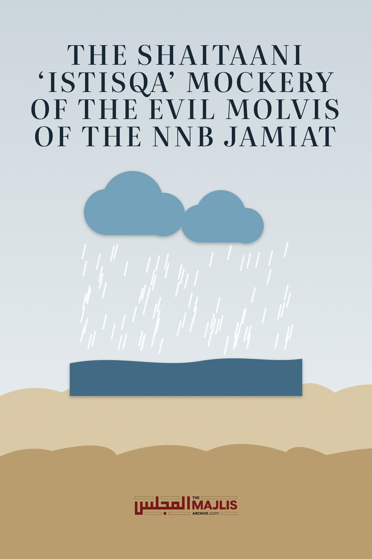

THE SHAITAANI ISTISQA MOCKERY
The Majlis · Voice of Islam
Mujlisul Ulama of South Africa

About this edition
This is a reproduction by The Majlis Archive (themajlisarchive.com) of a publication of The Majlis, Mujlisul Ulama of South Africa, made and published with their permission.
The PDF as The Majlis issued it is the original. This edition was read from that PDF's own structure and checked against it letter for letter; where the two differ, the PDF is correct.
Checked: 146 paragraphs, 0 differing; a second, independent PDF reader finds 100.0% of the PDF's words here.
Nothing has been reworded, added or removed.

Published By
Majlisul Ulama of South Africa P.O. Box 3393
Port Elizabeth, 6056

We reproduce the following article prepared by the ISLAMIC INTERNATIONAL RESEARCH INSTITUTE


Assalaamualaikum Warahmatullahi Wabarakaatuh

SALAATUL ISTISQAA IN SOUTH AFRICA, SPRING OF 2015 – A CLASSIC PANTOMIME
Rasulullah (sallallahu alaihi wasallam) once passed by Hadhrat Sa`ad (radhiallahu anhu) whilst the latter was making wudhu, and he (sallallahu alaihi wasallam) commented: "What is this wastage?" Hadhrat Sa`ad (radhiallahu anhu) asked: "Can there be wastage (of water) in wudhu?" Nabi (sallallahu alaihi wasallam) said: "Yes! Even if you are at the banks of a flowing river."
[Sunan Ibn Majah]
Let us briefly ponder over this Hadith.
➢ We have been created for the worship of Allah Ta`ala. ➢ Salaat is the highest form of Ibaadat. ➢ Salaat without wudhu is invalid. ➢ There are numerous Ahaadith that greatly emphasise the

meticulous and proper performance of wudhu
And yet…………..
Nabi (sallallahu alaihi wasallam) warns us that to use excessive water, even if we are making wudhu at the banks of a flowing river (note again that the words of the Hadith do not merely mention a river, but specifically a flowing river) which indicates that even in the presence of an abundance of water, excessive usage for wudhu, a prerequisite to the highest form of Ibaadat – the reason of our very existence – is not permissible. If this Hadith does not impress in the mind the great importance our Deen holds to the preservation and appreciation of water, then nothing else will!

PRESENT SITUATION IN SOUTH AFRICA
Below is a summary of the reservoir levels in the various provinces as at 2nd November 2015:
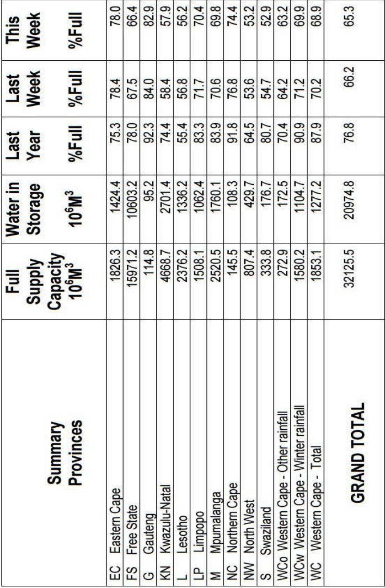
As is easily deduced from this chart, the water levels across all the provinces are ALL above 50%. The average water level across the country stands at 65.3%. Whilst we do concede that there may be a shortage of rain, we can hardly call these water reservoir levels a dearth or scarcity of water.
In fact, even the authorities have not called for major water restrictions. Yes, they are encouraging prudent usage of water and have suggested ways of saving water (factors which our beautiful Deen has prescribed centuries ago), but the fact of the matter is that even they do not deem the present situation dire or desperate! There are no limitations on water usage, which means that people can still legally waste water on hosing their cars and watering their driveways and lawns willy-nilly. Everyone is complaining of lack of rain, but there seems to be enough water yet for the authorities not to have restricted usage. What is the meaning of the stunt played out by the deviant 'ulama' in urging Salaatul Istisqaa?

SHAR`I PERSPECTIVE
In view of the above, let us see when the Shariah prescribes Salaatul Istisqaa:
"When there is no rain, and there are neither wells, rivers, etc., or if there are wells, rivers etc. but they are totally dry, or if they have water but there is insufficient water to satisfy the basic needs (of the people, animals and crops); that is, there is insufficient water to drink, give animals or for the crops, only then is Salaatul Istisqaa prescribed by the Shariah. If there is sufficient water (to satisfy the basic needs) then Salaatul Istisqaa is not prescribed.
'And according to the Shariah, seeking rain (Salaatul Istisqaa) is only (performed) under special circumstances, when there is severe need (severe shortage/non-existence of water), and the rain has been withheld; such that they do not have rivers, wells, reservoirs, etc. wherefrom they may drink, give their animals or water their crops. Or if there are these (sources of water) but they are insufficient to fulfil their basic needs.
If there is sufficient (water, albeit no rain), they should not make (Salaatul Istisqaa), as mentioned in Muheet.' [Raddul Muhtaar, vol.1, page 883]
When the situation is so dire, then Salaatul Istisqaa will be valid and permissible, because when there is no vegetation, then the animals will have no fodder and they will perish." [Fataawa Mahmoodiya, vol. 7, page 141]
"And Istisqaa is only performed in such places where there are no water reservoirs, rivers or wells, wherefrom people may drink, give their animals to drink or water their crops. Or if these (water sources) are available, but the water is insufficient.
If there are water reservoirs, rivers and wells, then they should not go out for Salaatul Istisqaa, because this is only performed at times of severe shortage and desperate need. This is recorded in Muheet."
[Fataawa Aalamgiri, vol. 1, page 394]
It is abundantly clear from the above that Salaatul Istisqaa is not prescribed under the present conditions in South Africa.
Allah Ta`ala states in the Qur`aan Majeed: "Corruption has appeared in the land and sea on account of what the hands of men have wrought, that He may make them taste a part of that which they have done, so that they may return." (Surah Room, Aayat 41)
The Ahaadith Shareef are replete with warnings that Allah Ta`ala will withhold rain and cause a scarcity of water when sin and transgression become rampant. The Kitaabs of the Shariah clearly state that a prerequisite to Salaatul Istisqaa, is repentance and reformation of evil ways. In fact, Salaatul Istisqaa is the last resort when water is depleted and all life is threatened. Salaatul Istisqaa is an earnest and desperate appeal to Allah Ta`ala, crying to Him that the people have remedied their ways and have sincerely repented, hence He should shower His Mercy.
In fact, it is stated in Fataawa Rahimiyyah that Salaatul Istisqaa will only be sincerely made when the situation is dire. If the appeal for rain is done half-heartedly (as will obviously be in the case when there is water available), then there is a great possibility that the people will return empty-handed from the Salaat. Begging for rain when there is water available, is in reality an act of ingratitude!

THIS BEGS THE QUESTION…
Why are the Ulama in all provinces calling for mass Salaatul Istisqaa? Are they not aware what the Kitaabs of Fiqh prescribe? Are they not literate enough to study these Kutub for themselves? Which religion are they following?
It is recorded in Fataawa Rahimiyyah that when water becomes scarce, then the Ulama should guide and advise the people from the Musaajid platforms and in the Jumuah Khutbah and also make dua to Allah Ta`ala during these occasions. Thereafter when water becomes scarcer, they should exhort the people to repent and reform their ways. Eventually, when water scarcity becomes life-threatening, they should advise the people to fast for three days and then on the fourth day they should go to the outskirts of the town and engage in Salaatul Istisqaa. The situation in our country has not even really truly reached the first level of water scarcity. Just look at the wastage of water in every Muslim home! Look at the wastage in the Musaajid wudhu khanas! Look at the wastage at the car-washers! Look just about everywhere and you will see wastage. How many of those who attend these pantomime Istisqaa Salaats are prepared to fast for three days to invite the Mercy of Allah Ta`ala? Never mind three days, how many are prepared to fast for a single day??? To show the faces to everyone and show the world we are praying for rain is easy, because it serves the purpose of satisfying the nafs and gratifying the lust for name and fame. Keeping fasts and making silent duas, go unnoticed, hence it does not appeal to the majority. Leave alone the masses, how many of these 'ulama' who shamelessly disregard the sanctity and importance of the Deen and Salaat by calling for Istisqaa, privately implore Allah Ta`ala for rain? How many of them save water in their personal capacities? How many of them abandon public sinning to invite the Mercy of Allah Ta`ala?
It is well-known that we waste more water just making instinjaa compared to what Nabi (sallallahu alaihi wasallam) and the Sahaabah (radhiallahu anhum) used for their Waajib ghusal! How many of us truly value the ni`mat of water enough to use a water jug when making wudhu? How many of us value water enough to curtail wastage in the multitudes of (unnecessary) showers we have weekly?
And yet, we are the same people who rush to perform Salaatul Istisqaa to show that we are doing our part to alleviate drought!!! What a bunch of hypocrites! Not only are the Salaatul Istisqaas that are being performed country-wide mock Salaats, they are a mockery to the Deen!

ISLAM HAS BECOME MALLEABLE AND INTERCHANGEABLE IN THE HANDS OF MISGUIDED
'Ulama'
Allah Ta`ala reminds us in the Qur`aan Majeed about the deviation of the Jews and Christians, more especially about their priests and rabbis, who changed the Deen to suit their desires and satisfy their nafs. The very same is happening amongst the Muslims today. The Deen is clear and explicit regarding the various acts of Ibadaat and yet the Ulama are the ones who alter and change the rules to suit their bloated egos. There are many examples – Loud Thikr in the Musaajid, loud and lengthy duas after the Fardh Salaats, mass I`tikaafs, Yaseen Khatams in the Musaajid, Durood programs in the Musaajid, Musjid 'Open days', Musjid opening ceremonies, singing anasheed in the Musaajid, etc., etc. All these ostensibly 'deeni' activities have no truck with the true Deen. Nabi (sallallahu alaihi wasallam), the Sahaabah (radhiallahu anhum), Tabieen and Tab-e-Tabieen (rahmatullahi alaihim), and all the Ulama and Fuqahaa of the past never indulged in these bid`ahs. Very recently the Qunoot-e-Naazilah has been a target of abuse by the so-called 'ulama'. The latest addition to the list is Salaatul Istisqaa.

DEENI TERMINOLOGY HAS BECOME A COVER-UP FOR THEIR SHENANIGANS
The 'ulama' hijack the Deeni terminologies and dupe the ignorant masses into believing that they are following the Deen. The so-called 'Islamic banking' has found acceptance amongst the masses because of the few Arabic words used in describing their riba transactions. The 'ulama' hijack words like 'mudhaaraba', 'shirkat', 'Istisqaa', 'Qunoot Naazilah', 'Thikr', 'I`tikaaf', etc. and use these to create acts that are alien to Islam. It appears that they just read the headers in the Kitaabs and ignore the rules and laws that the Shariah prescribes when executing these Ibaadaat. The idea is to show the people that they are doing something 'deeni'. It is all part of a big cover-up for the shenanigans of the 'ulama' fraternity. There is the desperate need to cover-up the haraam public displays perpetrated by some 'ulama', in shifting people's focus from the real evil only to see what ostensibly appears as 'deeni' acts organised by the 'ulama'.

BENONI 3-DAY MOCKERY OF THE DEEN
Recently, some ignoramuses in Benoni arranged for a 3-day festival they dubbed 'Salaatul Istisqaa'. Firstly, as mentioned earlier, there is no Shar`i validity for performing Salaatul Istisqaa presently. And then as mentioned in all Fiqhi Kitaabs and the Ahaadith, Salaatul Istisqaa is to be performed on the outskirts of the town and not in the middle of the town!
Another pre-requisite to demonstrate the sincerity of Salaatul Istisqaa is that the participants should have sincerely repented for their sins and reformed their ways. Just go to the Benoni Madrasah and look at the flagrant Deeni transgressions! The very basic Qur`aanic injunction of Hijaab is being flouted. On the one hand they call the people to perform a Salaat, begging and crying to Allah Ta`ala for forgiveness and rain and on the very same day they return to their harems and orgies they dub a 'Madrasah'! What a load of hypocrisy!
They impress the poor gullible residents of the town with their crocodile tears, when the very Salaat and dua they are making is contrary to what the Shariah prescribes. Did any of these 'molvis' cry when their counterparts appear on Haraam television? Did any of them cry when they see mature girls and 'aapas' being prostituted in their 'madrasah'? Did they cry when they see women walking in and out of the 'jamiat' offices? Did they cry when they see 'ulama' publically intermingling with women? Did they cry when their 'jamiat' haraam radio station, prostitutes women on air?

TRUE DEENUL ISLAM IS BEING HIJACKED!
This hijacking of the Deen is so widespread that it has taken over the entire country. No Aalim speaks against the shenanigans of their 'fraternity'. No Aalim can think for himself and realise the deviation that the 'wannabes' propagate. When a big 'pope' amongst the 'ulama' decrees something, the others blindly follow. This is not hikmat, it is dhalaalat. The 'ulama' are the ones responsible for deviating the masses. Those Ulama who may have some perception of the Haqq, are too scared to speak out or revolt against the mudhilleen. They fear the people more than they do Allah Ta`ala. But then, most of them fear the termination of that much coveted job and measly salary at the end of the month, hence their silence in the face of Baatil!

RATHER PERFORM SALAATUL SHUKR
Notwithstanding our wanton disobedience to Allah Ta`ala and transgression of His Shariah, He has blessed us with an abundance of water. With the reservoir levels standing at over 60% full, and there being an abundance of water beneath the ground in many areas of our country, what have we to complain about? We should all daily engage in performing 2 Rakaats, individually, making shukr unto Allah Ta`ala for His Bounties. Our intelligence should dictate that we realise the signs of impending scarcity of water due to the shortage of rain, and immediately rectify our evil ways and turn to Him in sincere repentance. The last thing we need to do is invite Divine Wrath and Anger by belittling the Shariah with pantomime acts of self-aggrandisement.

TRUE SALAATUL ISTISQAA
During the era of Hadhrat Moosa (alaihi salaam), there was a shortage of water. Hadhrat Moosa (alaihi salaam) took the people out of the town for Salaatul Istisqaa. Allah Ta`ala revealed to Hadhrat Moosa (alaihi salaam) that the rain will be withheld because of the sin of one individual amongst the crowd. Hadhrat Moosa (alaihi salaam) announced this to the people and said that the guilty person should remove himself, since he is blocking the Divine Mercy. The man who realised that he was guilty, sincerely repented to Allah Ta`ala and immediately the rains fell.
During the time of Nabi (sallallahu alaihi wasallam), there was a drought and Nabi (sallallahu alaihi wasallam) made Salaatul Istisqaa. Before the people returned home, the once clear sky became cloudy and the rains fell.
These are not fairy tales, but lessons to be learnt. The same is possible today also. However, the situation has to be desperate. Only when there is a serious shortage of water, and people realise that their lives are hanging in the balance, will they genuinely repent and change their ways, in the hope of inviting Divine Mercy. There is nothing more sincere than the plea of a desperate person. Only when the situation becomes dire, will the people realise the folly of their ways and repent. In fact, only under such dire circumstances will change become a reality. When this change is effected and the people go out and make a sincere cry for rain, only then, will their cries be heard and when Allah Ta`ala sees their (genuine) helplessness and hopelessness, will He shower them with His Mercy. When the need is not real, the sincerity and the dua will be likewise.

SEEK A RULING IN YOUR HEART
Our plea is for every Muslim to seek a fatwa from his heart and reflect. How many of those who attended these pantomime Istisqaas are truly suffering thirst and suffering due to lack of rain? How many of you use water sparingly? How many of you forgo that non-Waajib shower because there is a scarcity of water? Is there truly a scarcity of water? By performing this mock Istisqaa, everyone feels content that they are doing their part in alleviating the need, and therefore return from the Istisqaa parade, only to return to their old ways of haraam and sin. We are almost certain that many of those who attended these mockeries of the Deen, did so without having headgear or proper Sunnat garb! We are almost certain that the majority of these mock 'musallees' stood in front of Allah Ta`ala with their trousers or kurtas hanging below their ankles. Many were probably bare-headed and /or clean-shaven. What a mockery! What a mockery!
Salaatul Istisqaa is a sacred and special act of Ibaadat that is executed when there is a severe drought and people are desperate. In this condition, the sincerity of the people engaging in the Salaat will be without ulterior motive and their cries to Allah Ta`ala will be genuine. When this Salaat is performed in the presence of water (an abundance of it at the moment, if we see the levels of the reservoirs) then it is a mockery of the Deen and the Shariah. This is an act of gross undermining of a sacred Shar`i act of Ibaadat. A Muslim does not wait for water to be scarce before he starts conserving and appreciating it. His entire life is practice on the Sunnat, which exhorts meticulous preservation of water resources. A Muslim does not wait for drought to mend his ways. His entire life is the Deen. A Muslim does not wait for a calamity before he repents.
The entire logic is lopsided – They say water is life, but what is life without obedience to Allah Ta`ala? Allah Ta`ala created water and this entire universe for our convenience whilst we have been created for His Ibaadat. If we carry out our duty, then everything else will fall into place. Water is part of the dunya and not the objective of our lives. Allah Ta`ala is our Objective. If we subject our lives to the Shariah and make Allah Ta`ala our objective then this dunya and its conveniences, including water, will be at our full disposal. If we are tested with a scarcity of water, then we ask and beg for it in the way shown to us by Nabi (sallallahu alaihi wasallam) and not in accordance to what we feel convenient to suit our nafs. Salaatul Istisqaa, like every other Ibaadat, has specific rules, laws and conditions. We can only hope to attract the Help and Mercy of Allah Ta`ala if we carry out each Ibaadat in the way He wants and not in any other way.
We make dua that Allah Ta`ala bless us with guidance to follow His Commands in the way shown to us by His beloved (sallallahu alaihi wasallam). May He save us from the evil of our nafs and shaitaan. Aameen!

MAKING A MOCKERY OF SALAATUL ISTISQA
Nowadays the Deen is utilized and mis-manipulated for nafsaani motives. The latest victim to suffer the fate of mockery is Salaatul Istisqa – The Dua/Salaat for rain. While this act of Ibaadat is Masnoon, it should be executed in the Masnoon method.
The Masnoon method of performing this Salaat is as follows:
"Salaatul Istisqaa" is the Salaat enjoined by the Shariah in the event of a drought. Istisqaa' means to petition for water. Salaatul Istisqaa' consists of two raka'ts and the method of performing it is as follows:
The entire Muslim community should gather on the out-skirts of the town in the veld. Everyone should put on simple garments and set out for the gathering-place on foot. Little children and old people should also go along. Not a single kaafir should be taken along. It is not permissible to permit the kuffaar to participate in this mo-mentous occasion. Two raka'ts will be performed in jamaa't. Salaatul Istisqaa' has neither Azaan nor Iqaamat. The Imaam will recite the Qiraa'at audibly (jahr). The Imaam will thereafter recite two Khutabhsas on the Day of Eid. After the Khutabhs the Imaam will stand and face the Qiblah. He will raise his hands and petition Allah Ta'ala for rain. All those present should also make dua for rain. This procedure of Salaat should be repeated for three consecutive days. Salaatul Istisqaa' should not be performed for more than three days.
• 'If after having performed Salaatul lstisqaa' on the first day, it rains, then too, complete the three days.

• It is best (mustahab) to fast on these three days.
• Drought is the effect of sin committed in abundance. It is a form of Allah's Punishment. Hence, during a drought everyone should resort to istighfaar and taubah in abundance and discharge whatever rights are unfulfilled or usurped, be such rights in regard to Allah Ta'ala, e.g. Salaat not performed, Zakaat not paid, or be these rights in respect to people, e.g. debt deliberately not paid, wealth of others usurped or taken in a haraam way, etc.
• • It is Sunnat for the Imaam to invert his chaadar (the outer sheet which he wears). i.e. he should turn the inside out. This is to be done while making the dua for the rain after the two Khutbahs have been recited.

(ALLAHUMMASQINAA GHAYTHAM MUGHITHAM MUREE-AM MUREE-AN-NAAFI-AN GHAIRA DHAAR-RIN AAJILAN
GHAYRA AAJILIN).
O Allah! Give us rain, abundant, wide-spread, producing herbage, benefiting without doing injury, in haste without delay.
A Musjid or the Musjid ground is not a valid venue for Istisqa. The mock eidgahs within the built-up areas are not valid Istisqa venues. Worse is a school ground and a sportsfield of fisq, fujoor and zina.
A couple of months ago, we had commented on a mock 'Istisqa' in Durban. We reproduce our article for the benefit of Muslims:

A MOCK 'SALAATUL ISTISQA'

QUESTIONS:
1) The KZN Jamiat is inviting the Muslim community of Durban to participate in Salaat ul Istisqaa which will be performed at the Orient School (either on the school sports ground or in the school hall - there is no Musjid at the school). A poster issued by the KZN Jamiat explaining the method of performing this Salaat states:
"The method of performing this Salaah is for the Imaam to lead the people to the outskirts of the town for this Salaah.
In places where this is not possible, the Masjid will suffice."
(I have attached the posters which were issued by the KZN Jamiat). The KZN Jamiat appears to be contradicting itself by inviting the Muslim community of Durban to participate in the performance of Salaat ul Istisqaa at the Orient School thereby bypassing the Musjid.
2) Should the Muslim community of Durban participate in the Salaat ul Istisqaa which will be performed at the Orient School?
3) Another poster issued by the Jamiat KZN states the following:
"At times when there is a severe shortage of water and people do not have enough water to sustain their basic needs of life, there is a special Salaah called Salaatul Istisqaa.
Currently there is municipal water available in Durban - normal supply which is above the basic needs of life (other areas in KZN are affected by municipal water restrictions). Should Salaat ul Istisqaa be performed now in apprehension of the fear that a drought will occur in the near future or should each city/ town only perform Salaat ul Istisqaa after the onset of the drought in each respective city/ town - i.e. after all the dams and rivers supplying the city/ town have dried up?"
(4) Is it permissible for a city/ town to perform Salaat ul Istisqaa on behalf of other cities/ towns? It appears that the Salaat ul Istisqaa which will be performed at the Orient School will be performed on behalf of all the areas in KZN which are facing water shortages. ANSWERS
(1) The 'salaatul istisqa' being organized at the Orient Kaafir school, is one of the worst mockeries being enacted. It is not permissible to participate in this mockery of the Deen.
It is a despicable publicity stunt which the Jamiat is enacting in the name of Islam. Among the signs of Qiyaamah according to the Hadith is that the 'amal of the Aakhirah will be used for the acquisition of the dunya'.
(2) The Muslim community of Durban should not participate in this mockery perpetrated in the name of the Deen. This is NEVER the occasion for Salaatul Istisqa nor is the Orient Kaafir School a halaal venue for Salaat. It is not permissible to perform even Jumuah Salaat in that venue.
(3) It is sad that the Jamiat has miserably failed to understand the meanings of water shortage and suffering. It is sadder that they display such a conspectus lack of the basic requisites for the permissibility of Salaatul Istisqa. If ever there is a dire need for Salaatul istisqa, it will be HARAAM to perform it in the Orient Kaafir School grounds.
(4) Currently there is no need for this Salaat in any area of Natal. It is stupid and bid'ah for Durban to perform Salaatul Istisqa if there is a drought in Kalahari Desert or in Stanger.

THE MOCK/PUBLICITY STUNT 'ISTISQA' OF THE NNB JAMIAT OF FORDSBURG
A Brother enquires:
Assalaamu alaykum Dear Hadhrat In Mayfair this Sunday the NNB JAMIAT are hosting Salaatul Istisqaah at a soccer ground venue.
Do we perform the Salaah there?
What I fail to understand is that the point of performing this Salaah is so that people may make Taubah and regret the their past actions in order to derive the mercy of Allah Ta'ala.
The Jamiat molvis are they prepared to come off the TV and radio?
Are they prepared to reform the corrupted ways of Sanha and the other Halaal organizations that are affiliated to them?
Is this another cheap publicity stunt by the NNB?
Please shed light for us in these times immense darkness filled with Nafsaaniyat of the Molvis.
May Allah Ta'ala save us.
Requesting Duas.
Jazak-Allah Was-salaam
(End of letter)
The guidelines stated by the NNB Jamiat are all valid and teachings of the Shariah. However, the very first requisite is to repent for sins. A fundamental of repentance is to pledge abstention from the sins in which we are indulging.
The NNB Jamiat's molvis are trapped in the kabeerah sins of television, carrion-halaalizing and kuffaar sport. These are just three of their public sins which are mentioned. As long as they indulge in these sins and refuse to abandon them, they are not fit to organize Salaatul Istisqa'. Their 'istisqa' will be a hollow publicity.
YES! It is an evil, haraam publicity stunt. It is not permissible to participate in this mock, insincere publicity 'istisqa' stunt organized by the fussaaq, fujjaar NO NAME BRAND JAMIAT molvis who display their ugly snouts on haraam television.
These evil fussaaq molvis are among the worst Mudhilleen about whom Rasulullah (sallallahu alayhi wasallam) expressed his profound fear for the Ummah:
"VERILY, I FEAR FOR MY UMMAH THE AIMMAH MUDHILLEEN.", I.E. THE MOLVIS AND SHEIKHS OF THE NNB JAMIAT ILK WHOSE PRIME PROFESSION HAS BECOME TO MISLEAD THE UMMAH.

'SALAATUL ISTISQA' STUNT-STYLE BY THE NNB JAMIAT STUNTERS
A layman's comments Please allow me to share my views on the Salaatul Istisqaa hype that South African Muslims are going on.
Muslims and South Africans are crying left right and centre for rain. Every conversation is about rain both Muslim and Non. This weekend Muslims want to perform the Salaatul Istisqaa throughout the country. I am no Aalim and can't say whether this is the correct time to perform the Salaat or not. My reason to doubt this is because I have seen people up in Africa quite comfortably live with far less water than we have in our current 'drought' situation. But besides this, I have a few points that I would like those who are running to perform this Salaat to ponder on.
My Points are:
- Just take a look in our homes before crying for water.
1. How many of us MUSLIMS have washing machines that can use as much as 150 litres of water for a full washing cycle? For how many years has this been going on in our homes without a care for the Ni'mat of water Allah Ta'ala has sent. A friend of mine once collected one and a half full dustbins of water from one days washing load of one of his tenants (a family of 4) who complained about the water bill. That's over 200litres of water just for washing clothes! 2. How many of us MUSLIMS have dishwashers in our homes. A family of 4 instead of each washing their own plate and cup will rather do a full wash and rinse in the machine for those 4 plates and cups. Why haven't we trained our children to wash their own dishes to save water. Not to mention the electricity these machines use.
3. How many of us MUSLIMS for years have been having a 5 minute shower daily (to beautify ourselves to go to our Kuffaar environment of work) with the water flowing at full pressure. How many of us MUSLIMS atleast shut the water off to scrub our bodies down or shampoo and then re-open to rinse? How many of us MUSLIMS have trained our children to do this? Have we forgotten how our fathers grew up? Have we forgotten the bucket system? Give a youngster of today a bucket and ask him to bath, he won't know where to start leave alone knowing about the Masaail of using a bucket. They are too used to letting the water flow!
4. How many of us MUSLIMS flush away up to 10 litres of water for our 250ml of urine? How many of our children have been trained to do the same? For how many years has this been going on?
5. How many of us MUSLIMS water our gardens daily not caring about the quantity of water being used. A hose pipe pours out 9 litres of water per minute. All this for the sake of beauty for our pleasure. How many years has this gone on for? Sprinkler systems set on a timer daily! Are we truly crying for water today?
6. How many of us MUSLIMS spend our Sundays washing our idol cars. One doesn't even have to speak about the amount of wastage in this exercise!
7. Take a look at our Wudhu Khaanas in our MUSJIDS. Stop and have a look at how fast those taps are open while we are making the IBAADAT of Wudhu. Just have a look before a Salaah and see how many of our MUSLIM brothers are having a conversation while the water is flowing! Are we truly concerned about water?
These are just a few outstanding examples of mass scale wastage of water that is coming from our South African MUSLIMS lives, there are many more if each of us sincerely analyse our daily lives. If we as MUSLIMS can't correct our usage of water how can we expect the rest of the country to do so.
Think deeply about this before trying to imitate the Saudis by performing Salaatul Istisqaa. The Muslims of South Africa are always looking for new projects, new exciting things, fancy Jalsas, Qiraat competitions, Islamic TV etc etc. They never want to get serious and think responsibly, they are way too childish in their brains. This is the consequence of too much wealth and the desire to follow the kuffar. They want to live flashy, extravagant, sporty, braai and Dubai lives and forget their place as Muslims in society. This Salaatul Istisqaa that everyone wants to perform this weekend is another one of their 'new exciting projects'. Half of the areas that are performing the Salaah are not even performing it for 3 days. Many are on sports fields and school grounds where all sorts of filth takes place. Many are not even properly on the outskirts of the towns. This just shows how sincere they are.
Allah Ta'ala has blessed us with an abundance of water for years on end and we openly and arrogantly wasted it. Now a little water gets held back and we pretend as if we are worried.
- Let not the day come when we all open our taps in our homes and nothing comes out.
- Let not the day come when that boy who was grown up under the shower has to rope up a bucket from a well to have a bath. - Let not the day come when we have to dig for water like our brothers up in Africa.
Then we will see how sincerely we will perform this Salaatul Istisqaa!
May Allah Ta'ala save us and help us to recognise our faults and get serious about being and living like true MUSLIMS.
(End of the layman's letter)

OUR COMMENTS
Whilst waste is a surely contributing factor for the invocation of Allah's Athaab (Punishment), the primary factor for drought – although there is no real drought yet affecting us – is the filth of fisq and fujoor in which the Muslim community is wallowing, and in which the ulama-e-soo' are the main culprits. These evil molvis and sheikhs have legalized almost every sin in the Book of Sins, from carrion to riba, from immodesty to zina.
The 'istisqa' hype is simply another publicity stunt by the aggrandizement-seekers of the NNB Jamiat. This is why they have published lists of towns where the mock 'istisqa' shows are being organized. The Muslim community's worst enemies are the villainous molvis and sheikhs of the NNB Jamiat, the MJC, Daarush Shaitaan and a recent member of the fraternity of evil jaahil 'scholars, the Jamiatul Juhala of Durban.
The roots and causes of the wickedness and immorality (fisq and fujoor) prevailing in the Muslim community are these jamaats of juhala ulama-e-soo'. Even the 'khaanqahs' of the day have clambered on board the wagon of fisq and fujoor. These morons have not seen suffering. They do not have the haziest idea of suffering and hardships. But when the calamity of Divine Punishment descends, then it will be too late to open up the blind eyes.
The morons are too stupid to understand that a fundamental precondition for valid Salaatul Istisqa' is Taubah which entails abandonment of the sins in which there is current involvement. The very same jaahil and fussaaq molvis who are organizing their mock 'istisqa' shows are indulging in television zina and videos. They halaalize and consume carrion. They organize kuffaar sport. Theyhalaalize haraam television, videos and pictures. They halaalize intermingling of sexes. They lure women out of their homes to participate in public programmes. They operate haraam 'counselling' services with women at the helm. They embezzle and misappropriate Zakaat and Lillaah funds. The list of their public acts of fisq and fujoor is indeed formidable.
They refuse to abandon these brazen haraam acts of transgression, yet they organize 'istisqa' shows. As long as the evil in the community is not remedied, the punishment of Allah Ta'ala will become incremental until it reaches its climax in the sudden and devastating elimination of the community. May Allah Ta'ala have mercy on us.

