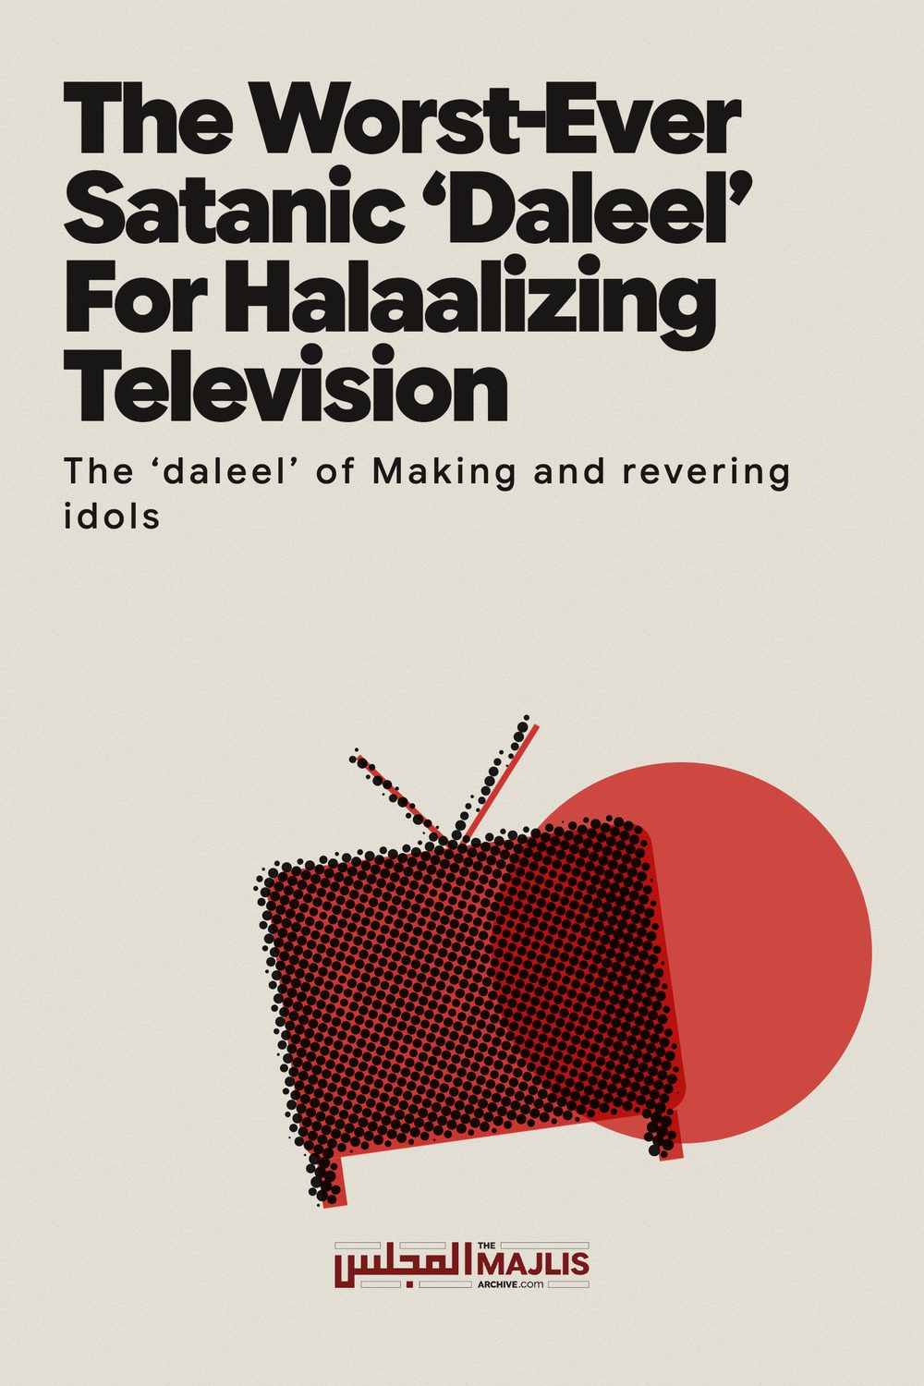

THE WORST-EVER SATANIC DALEEL FOR HALAALIZING TELEVISION
The Majlis · Voice of Islam
Mujlisul Ulama of South Africa

About this edition
This is a reproduction by The Majlis Archive (themajlisarchive.com) of a publication of The Majlis, Mujlisul Ulama of South Africa, made and published with their permission.
The PDF as The Majlis issued it is the original. This edition was read from that PDF's own structure and checked against it letter for letter; where the two differ, the PDF is correct.
Checked: 201 paragraphs, 0 differing; a second, independent PDF reader finds 100.0% of the PDF's words here.
Nothing has been reworded, added or removed.

By: The Majlis PO Box 3393 Port Elizabeth, 6056 South Africa

ABSOLUTELY MINDBOGGLING
A deviate Mufti of Pakistan who has lost the
Path of the Deen, in his endeavour to halaalize television claims that since idols are
'permissible', television too is permissible.
Indeed Shaitaan has urinated in his brains.
Not even the NNB morons nor the MJC morons nor the liberal Mufti Taqi nor any other zindeeq modernists have ever ventured that the satanism of making idols and statues of Muslim rulers is permissible.

THE SHARIAH IS THE QUR'AAN AND THE SUNNAH
"They take their ahbaar (rabbis/scholars) and their ruhbaan (monks/buzrugs) as gods besides Allah as well as Maseeh the son of Maryam."
(At-Taubah, Aayat 31)
When this Aayat of the Qur'aan Majeed was revealed, Hadhrat Adi Bin Haatim (Radhiyallahu anhu) who had been a Christian previously, said: "O Rasulullah (Sallallahu alayhi wasallam)! We never worshipped the ahbaar and ruhbaan."
He wanted the meaning of this Aayat. Rasulullah (Sallallahu alayhi wasallam) said: "While they did not (in reality) worship them, they considered halaal whatever their ahbaar and ruhbaan made halaal, and considered haraam whatever they made haraam."
Assuming that the understanding of the Pakistani mufti is correct in that the Maaliki Ulama of Spain had claimed that it was permissible, in fact mustahab to make idols and statues of the rulers and qaadhis and to mount these idols all over the country, then the aforementioned Aayat of the Qur'aan Majeed will apply to all those miserable souls who accept and follow such kufr and shirk. This was the satanic practice of Bani Israaeel, and this evil practice, in general, has been adopted by some molvis and others of this Ummah. They will fabricate baseless arguments cloaked with some silly 'deeni' veneer of a spurious kind to obfuscate the Truth and to misguide the ignorant masses.
Idols as daleel We have recently seen an article by a Mufti and which was published by Jaamiah Madaniah of Lahore, Pakistan halaalizing television on the basis of a shockingly stupid, haraam argument absolutely devoid of even a vestige of Shar'i substance. The basis on which the mufti structures his halaalization of television is the claim that the Ulama of Spain had permitted idols and statues of their rulers and government officials.
Every Muslim knows that any expediency or new development is incumbently reliant on a Shar'i basis for a ruling of permissibility or impermissibility. In the absence of Shar'i daleel, the opinion proffered will have no force of the Shariah regardless of the personality venturing the opinion unbacked by the dalaa-il of the Shariah.
The opinion of the Mufti of this Jaamiah is indeed unique for its stupidity and satanism. In addition to the spurious and stupid nature of the opinion, the fundamental basis tendered for permissibility of television is the hallucinated permissibility of stone statues/idols which he alleges that some Ulama of Spain had halaalized to appease and bootlick the rulers of the then corrupt Muslim regime of Spain.
Presenting an absolutely trash and baseless case for halaalizing television, the Mufti avers:
"….Every one aware of history knows that Muslims had ruled Spain for approximately 8 hundred years…….Gradually the former dignity and awe which the people had for the rulers disappeared from their hearts. The consequence of this decrease of awe for the rulers and judges was to abandon practicing the law resulting in social lawlessness. …….The Fuqaha and Ulama of that era decided that statues and idols of the rulers and judges be built and be mounted at vantage points on the main roads. The public seeing these statues and idols will then develop respect and awe for the rulers and judges and will thus be encouraged to become lawful. In the interests of the nation did they (the Ulama of Spain) issue this fatwa (of permissibility of idols and statues). Instead of decreeing making of idols haraam, they rendered it mandoob (mustahab), i.e. deserving of thawaab (reward)."
The mufti has baselessly and falsely attributed this kufr to the Maaliki Ulama. Nevertheless, we shall firstly refute this kufr drivel on the assumption which the mufti has stupidly made and falsely attributed to the Maaliki Ulama.
On this assumed trash, haraam satanic fatwa of the sheikhs of Spain some 8 centuries ago, does the miscreant mufti of Jaamiah Madaniyah proclaim television halaal. Truly, this type of rubbish is the effect of intellectual derangement produced by shaitaani manipulation.
He argues that the changing conditions demanded permissibility for these statues and idols. Therefore despite the Ulama being fully cognizant of the exceptionally grave prohibition of idols and pictures, they issued the fatwa of permissibility. On this basis does this errant Mufti who has recklessly failed to apply the Aql Allah Ta'ala has bestowed to him, claim that television is permissible for tableegh of the Deen.
Every such layman Muslim who may even be indulging in the filth of television provided he understands his sins, will be appalled at this kufr 'daleel' of this Mufti who has degenerated to the level of satanism to have halaalized idolatry on the satanically stupid idea of statues instilling honour, respect, fear and awe in the hearts of Muslims for their corrupt rulers – the rulers of Spain.
Awe and fear are attitudes which Allah Ta'ala creates and bestows to people. Awe cannot be acquired from haraam stone idols and statues. Rasulullah (Sallallahu alayhi wasallam) said about disobedient and rebellious Muslims:
"Allah Ta'ala will eliminate mahaabah (fear and awe) for you from the hearts of your enemy and instil fear (for them) in your hearts….."
The Fate of Muslims of Spain Everyone is aware of the fate of the Muslim rule of Spain. There is no community of the Ummah which was so deracinated and obliterated by Allah Ta'ala as were the Muslims of Spain. The Athaab of Allah Azza Wa Jal had utterly effaced Muslim rule in Spain. Not a Muslim was left to live in Spain after a reign of almost 8 centuries. It was their fisq, fujoor and kufr of which idolatry was the worse, that had brought the Punishment of Allah Azza Wa Jal to ultimately seal the doom of Muslim rule and Muslim presence in Spain.
The Muslim nation of Spain was brutally annihilated by the Christian kuffaar of Spain who Allah Ta'ala had subjugated to the Muslims for many centuries. When the disobedience of Muslims had transgressed beyond the point of no return to the level of the ulama halaalizing idolatry, Allah Ta'ala effaced that segment of the Muslim Ummah. The country was handed over to the Christians and the entire Muslim population was obliterated - brutally exterminated with the remnants being exiled to Northern Africa.
Now this mufti of Pakistan presents as his daleel for permissibility of television the satanic permissibility of idolatry of the Spanish ulama. He then ventures from one flapdoodle rubbish argument to the other in his abortive bid to justify the Spanish brand of idolatry as the basis and daleel for his hallucinated permissibility of television.
Utter Trash Hitherto, there has not been a single Muslim nor any Zindeeq nor any liberal molvi and sheikh such as Mufti Taqi, etc. who had ventured such trash as daleel as this errant mufti has ludicrously and satanically done. Not even a deviated modernist wallowing in fisq and fujoor will accept as valid that Spanish idolatry – idols and statues halaalized by some Spanish ulama can ever be a valid Shar'i basis for halaalization of television. While the deviates present flaccid arguments to justify television, no one has ever even hinted that idols and statues could ever be made halaal.

Hadhrat Umar (Radhiyallahu anhu)
The miscreant mufti of Pakistan in his stupid endeavour to justify the fatwa of permissibility of statues and idols, says:
"The lifestyle of Hadhrat Ameerul Mu'mineen Sayyiduna Umar Bin Khattaab (Radhiyallahu anhu) in Madinah was completely simple and inferior. Then when he went to Shaam, there he found Sayyiduna Muaawiyah bin Abi Sufyaan (Radhiyallahu anhu) who had maintained a distance between himself and the public. Curtains were arranged whereby the awaam (laity) was separated from the rulers. The mounts (horses) of the rulers were of a very high status and so was their dress which was gaudy (faakhirah). The style of government was that of kings."
Hadhrat Umar (Radhiyallahu anhu) did not prohibit Hadhrat Muaawiyah (Radhiyallahu anhu) from this royal style of governing and living. Commenting on this attitude of Hadhrat Umar (Radhiyallahu anhu), the miscreant says: "The meaning was that seeing the conditions, he (Hadhrat Muaawiyah) should do what he deems appropriate."
Now this is the mufti's daleel for permissibility of idolatry. If the prevailing political conditions had constrained Hadhrat Muaawiyah (Radhiyallahu anhu) to adopt his royal style and for Hadhrat Umar (Radhiyallahu anhu) not to prohibit him, by what stretch of Imaani logic could this constitute a basis for permitting the evil and satanism of shirk for which every Nabi of Allah Ta'ala was raised? Idols are the very antithesis of Tauheed regardless of the intention and purpose for which the idols are constructed.
Whatever the lifestyle of Hadhrat Muaawiyah (Radhiyallahu anhu) was, it was not haraam. It was within the bounds of the Shariah. He did not descend into the dregs of haraam, kufr and shirk to uphold his lifestyle. Lack of simplicity while in conflict with Zuhd (abstinence), is not haraam. For some valid reasons, a royal lifestyle is permissible.
There was political expediency for Hadhrat Umar (Radhiyallahu anhu) adopting a neutral position on this occasion. On the occasion of taking possession of the City of Jerusalem, when Hadhrat Umar (Radhiyallahu anhu) saw some Sahaabah without their simple Madinah style dress, he pelted them with stones, and he exclaimed: "We are a nation whom Allah has elevated with Islam." On this occasion he did not tolerate the changed style of the Sahaabah. Whatever the case may be, the essential factor is that the lifestyle of Hadhrat Muaawiyah (Radhiyallahu anhu) was not haraam. It is only satanic derangement of the mind that presents Hadhrat Muaawiyah's royal lifestyle as a daleel for halaalizing idolatry, then cite this idolatry as daleel for halaalizing television. Only a putrefied brain degenerates to such a ridiculously satanic level. How can a mufti halaalize the worst haraam act on the basis of a halaal act?
Their second bunkum daleel Regressing deeper into his rot of intellectual derangement, the mufti says:
"These Fuqaha (of Spain) cited Taraaweeh Salaat as their second daleel for making statues and idols. This Salaat was also performed during the time of Rasulullah (Sallallahu alayhi wasallam) and in the era of Khalifah Sayyiduna Abu Bakr (Radhiyallahu anhu). However, with the passage of time during the Faaruqi era all the people performed it in Jamaat. Similarly, in the initial era (of Spanish rule) there was no need to mount statues and idols in the roads. However, since there is now a need in our era, we have adopted it."
Intelligence and Knowledge are not requisites for rejecting this exceptionally moronic argument. How can the performance of Taraaweeh in Jamaat ever be a daleel for idolatry – for making idols and mounting the satanic rubbish all over the country? The changing circumstances did not induce Hadhrat Umar (Radhiyallahu anhu) to introduce any haraam act or to halaalize any haraam. Arranging for Taraaweeh to be performed in Jamaat was not a change from haraam to halaal or of halaal to haraam.
Rasulullah (Sallallahu alayhi wasallam) had described the Sunnah of his Khulafa as being his own Sunnah. Thus, the format of the acts of Ibaadat instituted by Hadhrat Umar (Radhiyallahu anhu) was also part of the Sunnah of our Nabi (Sallallahu alayhi wasallam). And, whatever it may be, it never was haraam – it never was kufr and shirk – it never violated any Command of the Shariah substantiated by Dalaa-il-Qat'iyyah. It was pure Ibaadat. Only brains vermiculated by shaitaani urine understand a resemblance between pure Ibaadat and gross shirk –the worst shirk of idolatry.

Their third rubbish daleel The misguided Mufti then says:
"Then they (the Ulama of Spain) presented also a third daleel (for justifying the idols). They said that Hadhrat Umar (Radhiyallahu anhu) himself ate only bread of cornflour and salt. However, since he knew that all people will not be able to adhere to such austerity, he ordered mutton of half a goat daily for his officials. (he did this) because he knew that if the masses see that the rulers consuming just bread and salt, the awe of the rulers will be extinguished from their hearts."
Something is drastically amiss with the thinking of this miserable Mufti who has displayed such blatant temerity and brazen jahaalat in his effort to halaalize idols, then on the basis of such stupid satanic halaalization argue the permissibility of television.
Every Muslim, be he an ignoramus, will mock at this absolutely corrupt 'daleel' presented by a mufti whose brains have exploded into a mass of satanic incongruities. What is the affinity between the austere diet of bread/salt and the construction of idols? How can the consumption of mutton create awe in the hearts of the masses for the rulers. This convoluted satanic stupidity displays the abject collapse of the thinking ability of the mufti. It was in fact the austerity and simplicity of Hadhrat Umar (Radhiyallahu anhu) which had created awe and fear in the heart of the Christian emperor's envoy, and it also instilled awe and fear into the hearts of the emperors themselves.
Hadhrat Umar (Radhiyallahu anhu) did not impose his personal Taqwa on others. Despite his garments consisting of numerous patches, such simplicity never detracted from the awe and dignity which Allah Ta'ala had bestowed to him and to all the Sahaabah. While the Ummah has to emulate the Sahaabah, the errant mufti and the ulama of Spain sought to gain honour and respect from the ways of the mushrikeen and idolaters.
The miscreant mufti has miserably failed to present even a single incident or fatwa of a Sahaabi or of any of the Aimmah Mujtahideen to show that an explicit haraam act was transformed into halaal for the acquisition of awe, honour and dignity. The fossilization of the brains of the halaalizers of idolatry were incapable of understanding the meaning and purport of the Qur'aanic Aayat:
"He (Allah) grants honour to whomever He wills, and He disgraces whomever He wills. In His Hand is all goodness. Verily, He has power over all things."
Therefore, their malfunctioning intellectual and spiritual faculties constrained them to search for awe, honour, respect and dignity in the stone filth which they constructed with their own hands. Thus, they cast themselves into the same degenerate rotten ebb of shirk as did the mushrikeen and all idolaters. Since their idol-making and idol-worship abolished their right to respect and power, Allah Ta'ala eradicated Muslim rule and handed Spain to the Christian kuffaar/mushrikeen.
It is this same malady which has convoluted the brains of the miscreant mufti who could not find even a straw to clutch on for halaalizing television. He was therefore constrained to stupidly proffer the absolutely untenable example of Taraaweeh Salaat and the salt and bread diet of Hadhrat Umar (Radhiyallahu anhu) to justify the idol-making and to proffer it as the basis of halaalizing television.
The Alleged idol-halaalizing ulama of Spain Proceeding with his drivel and trash, the mufti states:
"The Fuqaha-e-Kiraam who presented arguments in favour of production of statues and making idols were not mediocre muftis or faqeehs. They were of the status of Imaam Quraafi and Imaam Shaatibi."
Assuming that the rubbish stated by this miscreant mufti is true, then suffice for the dismissal of this ludicrous 'daleel' is the Qur'aanic Aayat:
"They take their ahbaar (rabbis/scholars) and their ruhbaan (monks/buzrugs) as gods besides Allah as well as Maseeh the son of Maryam."
(At-Taubah, Aayat 31)
Regardless of who the halaalizer of idolatry was or may be (as alleged by the mufti), and regardless of their status, we do not appoint them as gods. For us the Qur'aan and the Sunnah suffice. The Qur'aan is the Furqaan – the Divine Law which separates baatil from Haqq. We are not in need of stupid, satanic 'daleels' which halaalize idols when the Furqaan of Allah Ta'ala and the Sunnah of Rasulullah (Sallallahu alayhi wasallam) unequivocally brand idols to be the worst of all crimes. It was for the eradication of idols that Rasulullah (Sallallahu alayhi wasallam) was sent by Allah Azza Wa Jal as His greatest and final Nabi.
Now this wayward mufti who has lost the Path –Siratul Mustaqeem – wants Muslims to believe that idolatry has suddenly become 'Sunnah' of the Mustahab category.
NB We are refuting this specific claim, namely, that the Ulama of Spain had halaalized idolatry, on the momentary assumption that the attribution of this falsehood to the Ulama of Spain has been correctly made by the miscreant mufti of Pakistan. The factual rebuttal of this falsehood shall be made later in the ensuing pages, Insha-Allah.
Acceptance of the idol satanism is precisely the abolition of Islam. One who believes in the permissibility of idols, not only permissibility, but to respect and revere the satanic idols, is not a Muslim even if he is a great scholar, Aalim, Mufti, Faqeeh, Allaamah, etc., etc. He has become an agent of Iblees, knowingly or unknowingly. The fact remains that he is an agent of Iblees. His Salaat, Saum, Hajj, Zakaat, etc., etc., are all unacceptable. His 'ibaadat' is a mirage devoid of Shar'i reality.
When the pivot of Islam – the Mission of Rasulullah (Sallallahu alayhi wasallam) and of all the Ambiyaa (Alayhimus salaam) – was the destruction of idols and shirk, the vile views of scholars who had grievously erred and slipped into unthinkable deviation must incumbently be assigned to the trash bin. Do we submit to the view of men who halaalize idols or to the command of the Qur'aan to destroy idols?
The miscreant mufti has to produce daleel from the Qur'aan, the Sunnah and the Aimmah-e-Mujtahideen of Khairul Quroon to substantiate his absolutely corrupt shaitaani idea of permissibility of idol production and mounting statues throughout the country for the masses to admire, respect and honour, in fact worship.
Assuming that the mufti has correctly understood what the Ulama of Spain had said, then the errors and obscure views of the Ulama have to be incumbently discarded, not cited as daleel. Allaamah Abdul Wahhaab Sha'raani as well as other Ulama and Fuqaha said: "He who seeks daleel from the nawaadir of the Ulama has made his exit from Islam."
An act or practice acquires a ruling based on Shar'i daleel, not on the basis of rubbish, trash and kufr disgorged by some Ulama regardless of their status. The reality is that the Ulama of Spain had never said that idol and statues are permissible. They have been stupidly slandered by the miscreant mufti who has miserably failed to understand the Arabic texts of the kitaabs from which he had cited.
Iblees, the father of Shirk/Idolatry The very first being who had made idols was Iblees. The initial rationale for idol-making was only to revere and respect the persons whose idols had been made.
The idols were made of pious men who were Auliya. The seeds of shirk planted in the hearts of people by shaitaan were reverence and respect for the idols by their followers. Then Iblees made the idols. In the first phase, they only paid respects to the idols and derived solace. The next generation commenced actual worship.
The names of the idols such as Wadd, Suwaa', Yaghooth, Nasr, etc. were the names of Buzrugs who flourished after Nabi Aadam (Alayhis salaam). Shaitaan had constructed idols in the images of these Buzrug. The original purpose of the idols as understood by the followers was to derive comfort merely looking at and respecting the idols. Gradually shaitaan succeeded in his plot of entrenching idolatry in the people.
The ludicrousness and villainy of the miscreant who halaalizes idols are mindboggling. A practice (idols) which Rasulullah (Sallallahu alayhi wasallam) described to be the worst and for which the severest punishment in the Hereafter has been sounded, is described as 'mustahab' by this mufti of Pakistan. In addition to abandoning Amr Bil Ma'roof Nahy Anil Munkar, he aggravates his villainy of transgression by following in the footsteps of the ulama of Bani Israaeel, haalizing acts which Allah Allah Azza Wa Jal had categorically prohibited. Idolatry has become 'mustahab'! What a travesty and mockery of the Deen! And that too, enacted by Ulama!
The miscreant mufti of Pakistan has not proffered even a vestige of a Shar'i daleel for bolstering his rubbish idea of kufr. For total lack of Shar'i daleel, he resorted to Iblees for aid. Then Iblees inspired him to base his halaalization of television on the hallucinated basis of idols being permissible.
Changing Circumstances The argument of the miscreant mufti is that when circumstances change, the laws of the Shariah also change. Earlier fatwas should be amended, reviewed or discarded to suit the prevailing circumstances.
While a fatwa could be reviewed in the light of prevailing circumstances and factors, Islam cannot be abolished. Islam and its fundamental doctrines and tenets are not the products of fatwas issued by Ulama. Islam is the product of Wahi –Revelation from Allah Ta'ala. The Beliefs and fundamental tenets of Islam are not the effects of the fataawa of Ulama.
The Meanings of Tauheed, Salaat, Zakaat, Saum, Hajj, etc. cannot and will not change to accommodate changing circumstances and the vicissitudes of life. Expediencies and new developments for which there are no explicit decrees in the Qur'aan and Sunnah will be determined on the basis of principles which the Aimmah Mujtahideen had formulated from the Qur'aan and Sunnah.
Cancelling or abolishing an explicit belief or tenet of Islam has never been a principle of the Shariah. Yes, it is a principle of Iblees, and the miscreant ulama have based their halaalization of idolatry on this Ibleesi principle.
The elimination of idolatry which necessitated the destruction of idols and the prohibition of making idols was the ACTUAL mission of all the Ambiya (Alayhimus salaam). But now we find muftis with convoluted brains - convoluted by shaitanai manipulation – striking at the very Foundations of Islam. They have discerned with their deranged brains the need to elevate idol-making to the status of the Sunnah, hence they even classified this shaitaaniyat as 'mustahab'.
Now it should be quite simple to understand why Rasulullah (sallallahu alayhi wasallam) "feared the deviate ulama more than even Dajjaal", and why our Nabi (Sallalalhu alayhi wasallam) branded these mudhilleen Ibleesi scholars as "the worst of the people under the canopy of the sky - people from who fitnah will emerge".
THE ULAMA OF ANDALUS (SPAIN) AND THEIR ALLEGED HALAALIZATION OF IDOLS AND STATUES
The miscreant mufti of Pakistan has structured his entire rubbish case in favour of television on the basis of his hallucination of the Ulama of Spain having halaalized statues and idols of their rulers and officials of the state. He has alleged that the Ulama of the Maaliki Math-hab had elevated idol-making to the status of Mustahab due to the changing circumstances.
Almost 8 centuries have passed since the time of Imaam Al-Quraafi (Rahmatullah alayh) and Imaam Shaatibi (Rahmatullah alayh) wrote their kitaabs from which the miscreant mufti quotes. In these 8 centuries, not a single Aalim of any Math-hab had understood from the statements of these two Fuqaha that making idols is halaal. This misguided, lost Pakistani mufti is the very first fellow in 8 centuries who has ventured this absolutely ludicrous slander which he attributes to these two illustrious Maaliki Fuqaha.
The mufti presented texts from these senior Maaliki Fuqaha to bolster his stupid and baatil claim. Despite being a so-called senior mufti, he has shockingly mistranslated the Arabic texts to suit his agenda, namely halaalization of television.
The reality is that there is not a single Maaliki Faqeeh nor any Faqeeh of any other Math-hab who has ever halaalized idols and statues. There is complete unanimity (Ijmaa') of all Four Math-habs on the prohibition of idols/statues. There is not a single Maaliki Faqeeh who had maintained that due to changing circumstances in Spain, idol-making and mounting statues of the rulers is permissible, leave alone being Mustahab.
The text which the mufti has so egregiously mistranslated is:
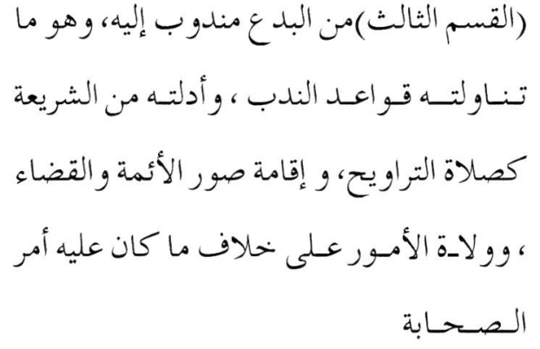
His translation of this text is:
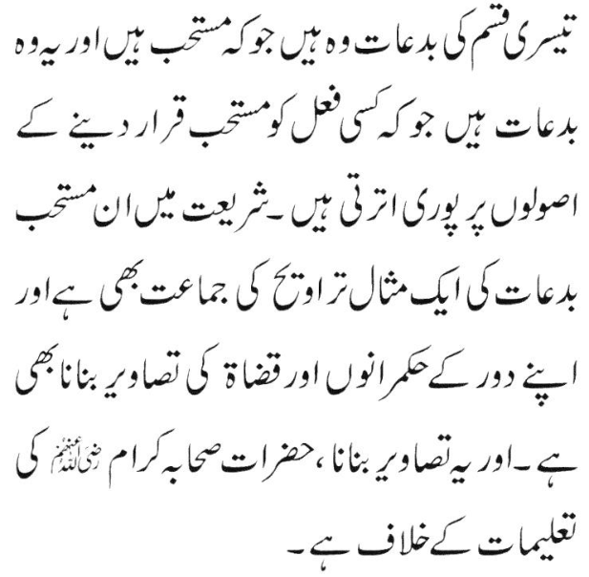
English translation of his Urdu translation:
"The third kind of bid'ah which is Mustahab… such as Taraaweeh Jamaat and making pictures of their rulers and judges although this picture-making is in conflict with the teachings of the Sahaabah…..
The mufti of Pakistan has grievously erred in his translation. The meaning of iqaamatis suwaril aimmah is NOT 'making pictures of the rulers and judges'.
Expanding on his hideously erroneous understanding, the mufti progresses from 'pictures' to 'idols and statues'. Thus he says:
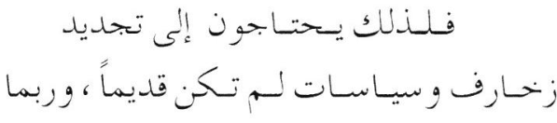
His Urdu translation is:
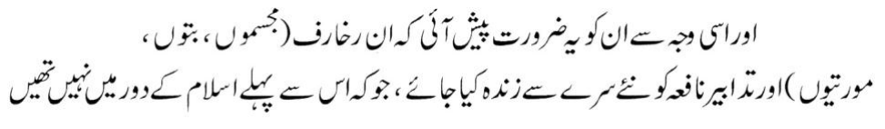
English translation ""For this reason they were confronted with the need originate anew rakhaarif (statues, idols and pictures) and schemes which did not exist in the Islamic era before this (but had existed during the age of kufr)……"
Degenerating further into his egregrious error, the mufti claims that not only pictures, but statues and idols are also permissible, in fact Mustahab, due to changing circumstances.
The capital, stupid and kufr error of the mufti is that instead of zakhaarif, he reads the word as rakaahrif. Then he commits the brutal abortion of translating this nonsensically hallucinated term to mean "statues, idols and pictures."
The word in the quoted text of Al-Quraafi is zakhaarif which means ways of adornments, embellishments, styles of adornment, etc. It does not mean statues, idols and pictures. Neither in the Kitaab of Al-Quraafi nor in any of the Maalikli kutub of the Ulama of Spain is there any reference to statues, idols and pictures. From whence did this mufti dig up the term rakhaarif? There is no such word in Arabic nor in Urdu.
Zakhaarif does not mean idol-making, idols, statues and pictures as the lost mufti seeks to convey. All types of embellishment, adornment and beautifying, whether with ornaments, garments, decorative materials, painting, pictures, etc., etc. are described as zakhaarif. Confirming this fact, the Qur'aan Majeed states: "If it was not for (the fact) of people becoming a single community (of kuffaar), We would have made roofs of silver for the kuffaar, as well as staircases (of silver) on which they could climb.
And, We would have made doors (of silver) for their houses and couches on which they may recline.
And (We would also have made these of) gold…"
(Az-Zukhruf, 33, 34, 35)
Here, these Aayaat are cited not to present their tafseer. The point is to show that the Qur'aan Majeed describes gold, silver, etc. embellishments with the term zukhruf. In fact the Surah is titled Az-Zukhruf. The word itself NEVER means idol-making, idols, statues and picture. It simply means embellishments / decorations / adornments regardless of the methods of adornment.
But the wayward mufti who has lost his Imaani bearings has committed chicanery of the worst kind by slandering the illustrious Fuqaha of the Maaliki Math-hab, alleging that they had halaalized statues and idol-making. He has struck at the very roots of the Deen with idolatry in the satanic attempt to halaalize television. In so doing he has secured for himself an elevated status in the hierarchy of the shayaateen and tawaagheet.
Then he commits the very same blunder most stupidly by attributing it to the illustrious Maaliki Faqih, Shaatibi. He cites the following text of Shaatibi:
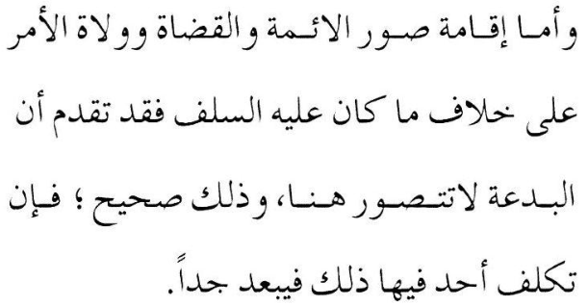
His Urdu translation is
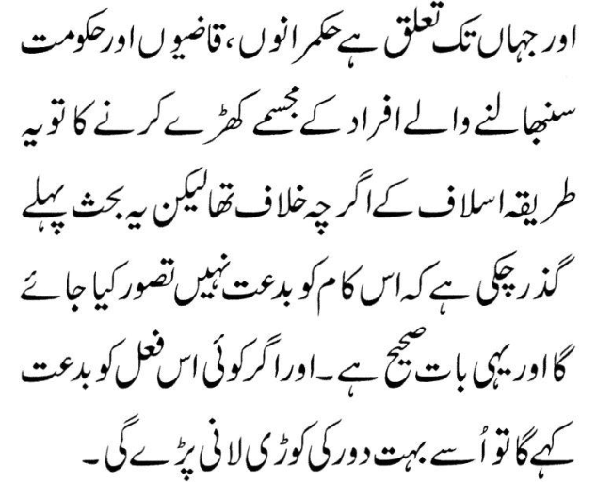
The English translation of his Urdu is:
"Regarding the rulers, judges and the officials of the government, despite mounting statues being in conflict with the way of the Aslaaf, nevertheless, it has already been explained before that this act cannot be said to be bid'at, and this is correct."
The correct translation of Shaatibi's statement is:
"Regarding the images of the Qaadhis and rulers which are in conflict with the way of the Salaf, it has already been explained that bid'ah does not feature here."
The gigantic blunder of the mufti is that he has understood the word suwar to mean idols and statues. However, in the context of the discussion and exposition of the classes of Bid'ah categorized by some Ulama, Quraafi and Shaatibi use this term to mean the outward, physical appearances – the ways of attire. What they said was that due to the changing circumstances, the austere and simple dress and lifestyle of the Sahaabah was not adequate to instil awe in the hearts of the masses for their rulers. Due to the changing circumstances, it was permissible for the rulers to lead a life of pomp, style and luxury to enhance their image.
While we do not agree with even this conclusion, it is not a subject of the current dissertation. We shall therefore not delve on this topic. At this juncture it suffices to say that the Pakistani mufti has stupidly portrayed himself with this major gaffe.
To crown his stupidity or deceit, the mufti conveniently or ignorantly overlooked or concealed the explanation of suwar presented by Shaatibi. Explaining the meaning, Shaatibi comments:
"From the examples mentioned by Al-Quraafi, is Iqaamatu suwaril Aimmah … This is not from the category of bid'ah in any way. Firstly, in regard to tajammul (embellishment/adornment) for persons of status and rank, it (tajammul) is desirable. Rasulullah (Sallallahu alayhi wasallam) had a special dress for tajammul (which he would don when meeting) the delegations."
The statement Iqaamatu suwaril Aimmah means enhancing the images of the rulers by means of dress, mounts, etc. It never ever meant idols and statues.
Thus it should be clear that the term suwar in the context of engendering honour and respect for the rulers as used by Al-Quraafi, refers to external appearances and ways of adornment, etc. It NEVER means statues, idols and pictures. It only means the abstract image of the rulers.
The term zakhaarif does not mean statues and idols as the mufti stupidly claims. This error is indeed appalling in the extreme. The notoriety of what he was disgorging never occurred to him. He did not halt momentarily to reflect and understand that his satanic attempt to halaalize idols and statues is in fact idolatry. Not a single Muslim, not even modernist of the zindeeq class, had ever attempted to halaalize idols and statues. There is absolute Ijma' on the prohibition of idols.
Although we do not agree with Al-Quraafi regarding the advice to adopt appearances and ways of adornment and embellishment for cultivating honour and respect and for instilling awe in the hearts of the masses, this issue is a topic for another dissertation. It suffices here to say that Al-Quraafi never said or meant that statues and idols are permissible and Mustahab for cultivating honour.
The mufti has also failed to understand the negation of bid'ah stated by Shaatibi who authored a commentary on Al-Quraafi's kitaab. While Al-Quraafi had categorized Bid'ah into five classes, Shaatibi refuted the validity of this classification, saying that it is a baseless fabrication.
According to Al-Quraafi, adoption of splendour in dress and ways is bid'ah, but a good bid'ah. He classified it as Mandoob which is the third class of the five classes of Bid'ah. Refuting this classification, Shaatibi said: "Bid'ah is not be understood here." In other words, he explained that it was superfluous and erroneous for Al-Quraafi to classify adornment/embellishment as a good, permissible bid'ah, giving it the designation of Mandoob. And the reason for this superfluity of Al-
Quraafi is the simple fact that Rasulullah (Sallallahu alayhi wasallam) possessed a suit of garments with which he donned for delegations.
In other words, there was no need for Al-Quraafi to say that adornment/embellishment is a Mandoob Bid'ah. It is simply permissible and even Sunnah. The classification of Bid'ah for it is an error. This fact has not been understood by the Pakistani mufti. Shaatibi was merely discussing and refuting the validity of the five classes of Bid'ah stated by Al-Quraafi on the basis of his Ustaadh Al-Izz Bin Abdus Salaam who was the first to have formulated this classification.
Furthermore, the mufti has also wrongly stated the definition of mandoob. The citation he presents states: 'Mandoob is an act for which one will be rewarded if done, and punished for omitting it.' This is incorrect. Abstention from mandoob is not a punishable offence.
Commenting on Al-Quraafi's classification, Shaatibi said:
"This classification (of bid'ah into five classes) is a fabrication for which there is no Shar'i daleel. On the contrary, it is rebutted….." Then he proceeds with his refutation. There is absolutely nothing in Imaam Shaatibi's commentary and refutation of Al-Quraafi's classification of bid'ah to support the rubbish idolatry ideology of the Pakistani mufti. However, since it is not directly related to our refutation of the Pakistani mufti's stupidity, there is no need at this juncture to traverse Shaatibi's refutation of Al-Quraafi.
Explaining the meaning of Iqaamatu suwaril Aimmah, the Annotater says:
"By Iqaamatu suwaril Aimmah Quraafi means attajammul (embellishment/adornment) of dress, beautifying appearance and establishing hijaab (i.e. separation between the rulers and the masses), and such other ways by which the rules and qaadhis could distinguish themselves from the laeity - such ways which did not exist during the first century."
Thus the Pakistani mufti has structured his television case on a pure figment of his imagination which in turn is based on his gross error and gaffe. He has miserably failed to understand the meaning of the Arabic texts from which he quoted.
Imaam Al-Quraafi (Rahmatullah alayh), far very far from what the moron mufti says, unequivocally said that statues and idols are haraam by the Ijma' of the Ummah. Not a single Faqeeh of any math-hab had ever posited a contrary view.

STATUES AND IDOLS – WHAT THE MAALIKI FUQAHA SAY
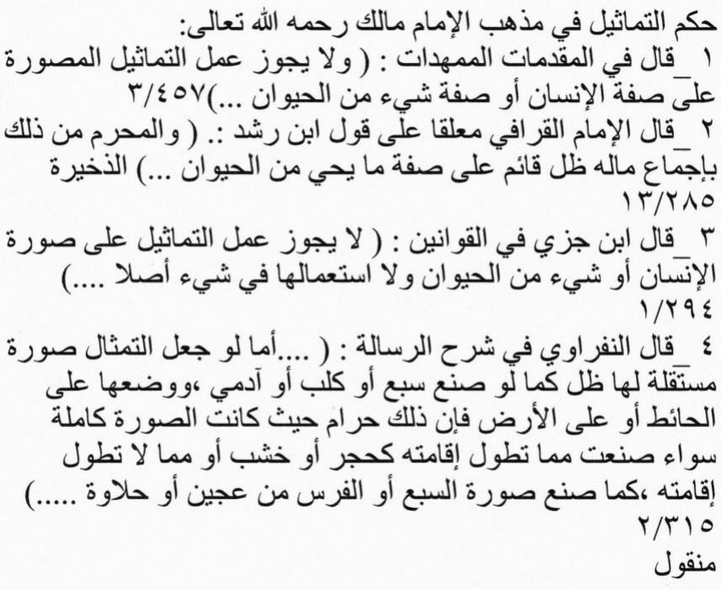
All the Maaliki Fuqaha, including Imaam Al-Quraafi as well as all the Fuqaha of all Math-habs say that there is IJMA' (CONSENSUS) that statues and idols are HARAAM. There is no dissenting view whatsoever.
From the above Arabic texts, we single out the statement of Imaam Al-Quraafi for the edification of the convoluted brains of the miscreant moron mufti. Imaam Al-Quraafi said:
"Making idols which have shadows (i.e. three dimensional) is HARAAM by Ijma'….."
But more than fourteen centuries after Rasulullah (Sallallahu alayhi wasallam) had categorically announced the Prohibition of pictures, idols and idolatry, a moron mufti claims that making idols and statues of the rulers to promote dignity and awe for them is permissible.
The deviant mufti totally confused and misguided by shaitaan did not for a moment reflect on the action of Rasulullah (Sallallahu alayhi wasallam) on the day when Makkah was conquered. Rasulullah (Sallallahu alayhi wasallam) had refused to enter the sacred Baitullaah – the Ka'bah – solely because the walls of the Ka'bah and the interior were decorated with the embellishments (zakhaarif) of idols and paintings of pagan deities. Only after the Ka'bah was cleansed from all zakhaarif of shirk and kufr did our Nabi (Sallallahu alayhi wasallam) enter. Now comes the agent of Iblees to revive idolatry for the sake of halaalizing television.

THE GAFFE AND CAPITAL BLUNDERS OF THE DEVIANT MUDHIEL MUFTI IN A NUTSHELL
(1) The errant mufti of Pakistan, contrary to what is expected from a Mufti of Haqq, firstly determined for himself an objective. Being a deviated liberal / modernist, his objective was to halaalize television which is haraam according to the consensus of the Ulama-e-Haqq. Thus his search was not for the Truth. His nafsaani desire was to legalize and halaalize television by hook or crook. This evil motive constrained him to lapse into gaffes and blunders.
(2) For the attainment of this satanic objective, he required dalaa-il (proofs of the Shariah). His scanning the Qur'aan, the Ahaadith and the Kutub of the Fuqaha produced not a single daleel for the achievement of his objective which Iblees had whispered to him.
(3) After miserably failing to procure even a vestige or a shred of daleel from the Shariah's sources of Law, he stumbled on to the Kitaabs of the Maaliki Ulama, Imaam Al-Quraafi (Rahmatullah alayh) and Imaam Shaatibi (Rahmatullah alayh) of the 7th Islamic century.
(4) In the kitaabs of these two Aalims, the miscreant fellow stumbled on the following texts:
(a) Suwar: Iqaamatus suwarul aimmah (b) Zakhaarif: Yahtaajuna ilaa tajdeedi zakhaarifa..
Then he committed the unforgivable gaffe which emboldened him into blundering to structure his satanic case on the basis of his gaffe.
(5) His Gaffe: He translated both (a) and (b) to mean pictures, statues and idols while both Al-Quraafi and Shaatibi never said nor intended these terms to be pictures and idols. And, no Aalim since the era of these two Maaliki Imaams had ever even suggested what the deviate mufti has frauded on the advice of Iblees.
(6) Compounding his satanic gaffe, the mufti in his Urdu translation translated zakhaarif (which is with a zaa), as rakhaarif (with a raa). Then degenerating further in his puddle of confusion and satanism, he explains that rakhaarif means statues, idols and pictures. Firstly, there is no such word as rakhaarif in Arabic. Secondly, if he seeks to wriggle out of his shaitaaniyat by saying that the missing dot on the raa is a typographical error, then too he will fail to wriggle out because he has translated the word to mean statues, idols and pictures whereas zakhaarif does not mean this.
(7) Having miserably failed to find even a vestige of daleel for halaalizing haraam television, he resorted with egregious stupidity and shaitaaniyat to commit the unforgivable blunder of assigning a kufr meaning to what some Maaliki Ulama said seven hundred years after Rasulullah (Sallallahu alayhi wasallam).

SPAIN – THE DESTRUCTION OF MUSLIM RULE
Much has been written about the 'glory' of Muslim rule in Spain. While Muslims had ruled Spain for several centuries, it cannot be said that genuine Shariah Law had prevailed. It was a regime of worldly pomp and splendour which had made Muslims completely oblivious of the Aakhirat which was furthest from their minds. The pomp, splendour, wealth, comforts and luxuries of the dunya had made them totally oblivious of the objective of man's temporary sojourn on this ephemeral worldly abode.
They ignored this objective stated in many Aayaat of the Qur'aan: "The life of this world is but play and amusement whilst the Abode of the Aakhirat is best for those who have Taqwa. What! Have you no intelligence?" Yes, the Muslims of Spain lacked intelligence, hence they sowed the seeds of their decline and destruction from the very inception of their rule.
While Spain was a province of the Islamic Empire during the tenure of the Khilaafate of Bani Umayyah, it broke away in the year 128 Hijri when the Abbaasi Khilaafate replaced the reign of Bani Umayya.
In 138 Hijri, Abdur Rahmaan, the grandson of the tenth Khalifah, Hishaam of the Umayyah Dynasty, managed to escape from the clutches of Bani Abbaas. He reached Spain and established his own Khilaafate. He established the Spanish City of Qurtuba (Cordova) as the Seat and capital of his Khilaafate. This Khilaafate remained with great pomp and splendour in the Bani Umayyah until 422 Hijri (288 years). Entire Spain was ruled by Bani Umayyah during this period.
After the demise of the Umayyah Khilaafate established by Abdur Rahmaan, Spain became a splintered Muslim land where about a dozen miniature khilaafates were established all engaging in internecine warfare against one other.
Taking advantage of the internecine warfare of the Muslims, the Christians allied themselves with the different Muslim factions to give greater impetus to the process which was sapping the power of the Muslims. Ultimately, the Muslim miniature countries were rendered impotent. The Christians took power and brutally pillaged, plundered and expelled all Muslims from Spain.
There is no other land from which Muslims and Islam were so thoroughly destroyed and extinguished as was the case in Spain. Muslims themselves had brought their own downfall and elimination by their insane plunge into the pomp and splendour the world had to offer. The consequence of their insane love for the dunya is depicted in the following Hadith. Rasulullah (Sallallahu alayhi wasallam) said:
"Most certainly, Allah will eliminate from the hearts of your enemies fear for you, and He will instil in you wahan." A Sahaabi asked: "O Rasulullah! What is Wahan?" Rasulullah (Sallallahu alayhi wasallam) said: "Love of the dunya and dislike for Maut." The Muslims of Spain forgot about Maut and the Aakhirat, and indulged insanely in the pursuit of the dunya.
The evil worldly pursuit had degenerated to the extent that their Ulama had halaalized the construction of statues of the royalty for placement in public places. Their rationale was that such statues of the rulers would instil honour and awe for the rulers in the hearts of the masses. This was the low and rotten ebb of satanism to which they had sunk. Shirk and Kufr was legalized and halaalized on a basis and a 'daleel' which is expected of only an insane man.
When such villainy became acceptable and the statues were proudly displayed in public for Muslims to worship, then the Wrath of Allah Azza Wa Jal settled on that unfortunate land of Muslims. Allah Ta'ala uprooted every vestige of Muslims and their rule from Spain.
"Say: O Allah! You are the King of all dominion. You grant Mulk (land and power) to whomever You will, and You snatch away Mulk from whomever You will. You give honour to whomever You will, and you disgrace whomever you will. All goodness is in Your power.
Verily, You are powerful over all things." (Aal-e-Imraan, Aayat 26)

SPAIN-ANDALUS – THE CLASSICAL EXAMPLE OF DIVINE APPREHENSION
"When We intend to destroy a qaryah (city, town or country), We command its affluent people (i.e. grant them rope and respite to plunge headlong in their evil and villainy).
Then the decree (of punishment) becomes established for it. Then We utterly destroy (and flatten) it."
(Qur'aan)
And so was Spain flattened and destroyed, and this Land of Muslims, which had basked for centuries in worldly 'glory and splendour', was reduced to ashes and rubble, and made barren by Christian fire and butchery which only some unbiased Christian westerners graphically describe, and which bring Muslims to shed futile tears of no avail.

SPAIN – THE SEEDS OF DESTRUCTION
"Do you construct palaces as if you will be living forever (on earth)?" (Qur'aan)
A Sample Of A Seed Of Destruction Four miles from the City of Qurtuba (Cordova), on Mount Al-Uroos, Sultan Abdur Rahmaan had constructed a most 'glorious' palace which he named after his beloved slave girl, 'Az-Zahra'. This is a veritable city, not merely a building of pomp and splendour. Az-Zahra should not be mistaken and understood to be a slave in the popular meaning of the term. She was not a slave doing menial labour in some kitchen. On the contrary, thousands of servants were at her beck and call. She was a veritable queen of queens. The Sultan was captivated by her, and it was for her sake that he built this palace which is better known as Medinatuz Zahra (the City of Zahra).
This palace was completed in 25 years. Within the limits of its compound lived many thousands of soldiers and workers. Its fortified walls had 15,000 massive and powerful gates. The length of this palace was 4 miles and its breadth 3 miles. For 25 years, daily 10,000 artisans and labourers, and 4000 camels and mules worked in the construction of this palace. The palace was constructed on 4316 massive pillars which were of a variety of precious stones. Some of the pillars were sent as gifts by the Christian kings of France, Constantinople and other European countries who sought the favour of the Sultan.
Two wonderfully constructed fountains were established in the palace. The bigger of the two was so adorned with gold-plating, giving the impression that the entire fountain was made of gold.
'Beautiful' (satanic in terms of Islam) statues of humans were constructed in this fountain as part of the decorations.
The smaller fountain was built with green marble stone which was acquired from Syria. Twelve water outlets in the form of animals and birds built with precious stones and studded with diamonds, etc., from whose mouths and beaks water constantly gushed were erected at this fountain. Even European historians who had seen these fountains conceded that words could not do justice to the beauty and wonder of these constructions.
One section of the palace was known as Qasrul Khulafa' (The Palace of the Khulafa). History books authored by westerners should be read to understand the splendour of this section. It will suffice to give an idea to mention that this section of the palace alone had 13,750 servants. From these, 6,314 were in the constant service of the queen of queen, Zahra, the beloved slave girl of Sultan Abdur Rahmaan.
Daily 12,000 loaves of bread would be fed to the exotic fish in the Pond of Zahra.
Besides Qasruz Zahra (the Palace of Zahra), there were also other palaces such as Qasrul Ma'shooq (The Palace of the Beloved One), Qasrus Suroor (The Palace of Happiness), Qasrut Taaj (The Palace of The Crown), Qasrud Damishq (The Palace of Damascus), etc., etc., which were all unique. There was nothing on earth to match the embellishment and adornment of these palaces.
The Sultans of Spain had emulated Shaddaad who had attempted to build 'jannat' to vie with the Jannat the Nabi of the time had spoken of. These Sultans sought happiness and pleasure on earth completely oblivious of Maut and the Aakhirat. Not a single one of their herd of palace ulama had advised them about the impending evil and of the disastrous consequences which would follow in the wake of this insane pursuit of the dunya – a pursuit which had made them oblivious of Allah Ta'ala.
When the Sultan first visited the palace with his beloved Az-Zahra, on seeing the huge form of the black mountain in the background of the palace, she commented: "This palace is like a beloved sweetheart in the grips of an ugly man." The Sultan immediately issued orders for the mountain to be demolished and its very roots be uprooted. To satisfy his beloved one, he was prepared, like Iblees, to stand as an adversary to Allah Azza Wa Jal. Imaam Ghazaali (Rahmatullah alayh) said that when a man is trapped in love with a woman, then 80% of his brain cells become inoperative. Finally when the wise men of the palace explained that it was an impossible task and that only Allah Ta'ala could destroy the huge mountain, the Sultan came to his senses. Nevertheless, he issued orders for transforming the entire mountain into a massive orchard of fig trees, almond trees, pomegranates, flowers, etc. The mountain was soon transformed into a 'garden of paradise'.
Thus, the Muslims themselves planted the seeds of their future destruction in Spain by courting the Wrath of Allah Azza wa jal. They had forgotten about Allah Ta'ala and the Deen. Their ulama, instead of admonishing and advising the Sultans, totally abandoned Amr Bil Ma'roof Nahyi Anil Munkar. On the contrary, they fabricated fatwas to halaalize the evil and the shirk of statues in the same way as the molvis of this era have halaalized pictures of animate objects, digital pictures and television.
All of this satanism culminated in the final destruction of Muslim rule and the forcible conversion to Christianity and the expulsion of every single Muslim from Spain. "You (O Allah!) grant honour to whomever You will, and You humiliate whomever You will." (Qur'aan)
Allah Ta'ala snatched away Spain from the Muslims and handed it over to His kuffaar Ibaad (servants), the Christians. Allah is Independent and Unique.

