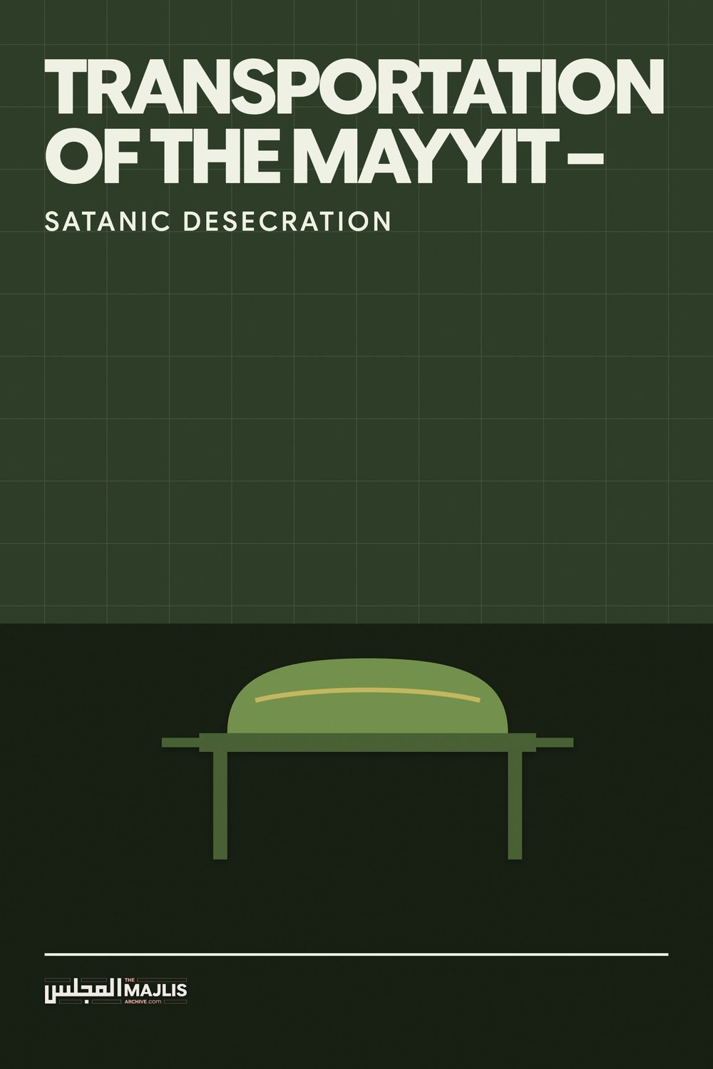

TRANSPORTATION OF THE MAYYIT
The Majlis · Voice of Islam
Mujlisul Ulama of South Africa

About this edition
This is a reproduction by The Majlis Archive (themajlisarchive.com) of a publication of The Majlis, Mujlisul Ulama of South Africa, made and published with their permission.
The PDF as The Majlis issued it is the original. This edition was read from that PDF's own structure and checked against it letter for letter; where the two differ, the PDF is correct.
Checked: 143 paragraphs, 0 differing; a second, independent PDF reader finds 99.9% of the PDF's words here.
Nothing has been reworded, added or removed.

By:
Mujlisul Ulama of S.A.
Port Elizabeth, 6056

South Africa

QUESTION
Would Moulana please clarify and comment on the issue of the burial of Hazrat Moulana Hafeez Makki who passed away today (16 January 2017) in Pietermaritzburg (May Allah reward him with the highest stage in Jannah). Janazah Salaah was performed in Pietermaritzburg but the body has been arranged to be flown to Makkah Mukarramah for burial in the Holy City. This arrangement has appeared strange to many, including some Ulema. Apart from the Islamic imperative in respect of expeditious burial, there is the substantial transportation cost factor of the body, which is clearly wasteful under the circumstances. Would Moulana please elaborate. Is this jaa-iz?

ANSWER
How can the plethora of shaitaaniyat and haraam acts associated with transportation of a body from one country to another ever be jaa-iz (permissible)? Without the need for plunging in the Fiqhi technical issues, the heart of a Mu'min will spontaneously issue the correct fatwa. Rasulullah (Sallallahu alayhi wasallam) said: "Seek a fatwa from your heart."
Allah Ta'ala says in the Qur'aan Majeed: "No person knows in which land he will die." This event is only in the Knowledge of Allah Azza Wa Jal. Allah Ta'ala had decreed that the honourable Marhoom Maulana who had resided for many decades in Makkah Muazzamah, should die in South Africa. Therefore, he embarked on the flight to South Africa. On reaching South Africa, Malakul Maut arrived to take his soul. Thus, the land Allah Ta'ala had decreed for his death was South Africa. It was therefore Waajib to bury him in the place where he had died.
However, in the shaitaani attempt which is being implemented and which is attended by a host of haraam acts, those in charge of the Marhoom's body, have satanically schemed to thwart Allah's Will, and to load the body like chattel most dishonourably to be shipped to Saudi Arabia. Since this dunya is the testing ground for Haqq and baatil, Allah Ta'ala allows freedom to act whether in a halaal or haraam way. The recompense will be meted out in the Aakhirat.
If concerned Muslims had prior awareness of the evil arrangement of transporting the body, they should not have joined the Janaazah Salaat. It is not permissible to participate in even a lawful act if such act will be followed up with haraam. Thus, it is not permissible for the Imaam of the Musjid or the Ulama to perform a Nikah in the Musjid if the nikah will be followed by a haraam wedding reception as is the incumbent practice in our community.
The attempt to thwart Allah Ta'ala's Shariat, entails evil, disgusting process of haraam acts perpetrated in utter desecration of the Marhoom's body. The Shariah commands utmost respect for the mayyit. There is a host of masaa-il attached to the Ghusl, Kafan, Janaazah and burial service. All such masaa-il are intended for the respect of the mayyit who is being despatched from this mundane realm on his journey into Barzakh.
The villains who have plotted to desecrate the body of the honourable mayyit, have violated every sacred mas'alah in Allah's Shariah pertaining to the mayyit. They have shown flagrant disregard for the Shariah and for the mayyit. To gratify their corrupt motives and nafsaaniyat, they have ignored the interests and welfare of the Mayyit.
If it was the Divine Plan for the Maulana Saheb to be buried in Makkah Muazzamah, Allah Ta'ala would not have sent him out of the country. It would not have occurred to the Maulana Saheb on the verge of his Maut to have taken a flight to South Africa. His Maut in South Africa is the clearest evidence for the Divine Will. But, as part of the worldly test and trial, Allah Ta'ala does not compel His Will to prevail. He leaves the choice to the people who have to face the trial and make decisions to conform with the Divine Will.
Rasulullah (Sallallahu alayhi wasallam) commanded: "Make haste with the Janaazah. If the mayyit was pious, then the abode to which you are sending him is better (than the place where he is). If he was impious, then get rid of him from your shoulders."
Every jaahil Muslim is aware of the Islamic method pertaining to the mayyit. He has to be buried where he dies and as expeditiously as possible. His body may not be unnecessarily transported even from one town to another town, even if acts of desecration are not committed. When the transportation necessitates mutilation and desecration of the mayyit, the prohibition of transportation is vastly magnified. Let us now examine the vile, satanic acts of desecration to which the villains have subjected the Body of Hadhrat Maulana Abdul Hafiz Makki (Rahmatullah alayh).
(1) In flagrant violation of the Shariah, the burial is being delayed a couple of days.
(2) The body is transported away from the abode where Allah Ta'ala took his soul and the place desired by Allah Ta'ala for the burial of the mayyit.
(3) Burial should follow immediately after the Janaazah Salaat. This requisite has been totally ignored. All the Janaazah and Dafan rites ordered by Allah Ta'ala are discarded. Thus, the mayyit is deprived of the benefits and barkat of the sacred rituals the Shariat has ordained for the respect and comfort of the mayyit.
(4) Maulana Makki's body was shoved into a kuffaar mortuary among the najis kuffaar bodies. Instead of the mayyit being reposed in a Taahir (Paak) Qabr in the Sunnah way, it has been assigned to a kuffaar mortuary to lay disgustingly among kuffaar amwaat. This is the 'respect' and 'love' which the wayward, miscreant mureeds and others have for their Shaikh.
(5) Instead of abiding by the Sunnah of Rasulullah (Sallallahu Alayhi wasallam) and Allah's Shariah of immediate Dafan (burial), the 'sunnah' of Fir'oun and the Mushrik Faraa-in (Pharoahs) of Egypt of bygone times is adopted. That is, they subjected the body of Hadhrat Maulana Abdul Hafiz to the kuffar act of embalming. And, what does this vile process entail? Insha-Allah, a detailed exposition shall be presented later in this article.
(6) Briefly, embalming entails disgusting mutilation of the body. The kafan is violated. The mayyit is disrespectfully opened up by the kaafir surgeon. The body is cut and mutilated. It is disembowelled and injected with haraam, najis chemical poisons. It is embalmed in similar fashion as Fir'oun was embalmed. The whole brutal, disgusting shaitaani embalming procedure shall be described later, Insha-Allah.
(7) When ghusl is given to the mayyit, the satr is covered. It is haraam to look at the mayyit's satr and to leave it uncovered during ghusl. But when the mayyit is subjected to mutilation by the surgeon in preparation for embalming, it is totally denuded – made naked – stripped of the kafan, and laid bare for the perpetration of disgusting desecration. Is this evil sacrilege committed on the body of the Marhoom Maulana Sahib tolerable to his mureeds who are guilty of this villainy?
(8) After the mayyit has been embalmed in kuffaar style, wrapped dishonourably in plastic, sealed and enclosed in a box/coffin as if it is chattel, it is subjected to the indignities of being loaded like chattel, custom checks, security checks, then loaded like cargo in the plane. Instead of the mayyit being carried with honour and respect by Muslim hands and persons engaging in Thikrullah whilst carrying aloft the Janaazah, the villains subjected the Maulana to the disgusting indignity of being loaded like cargo and to be shoved among the cargo in a plane. Let them hang themselves and perish in their shame if they do have any haya and Imaani Aql.
(9) The villains, true to shaitaani form, became "ikhwaanush shayaateen" (brothers of the devils), in Qur'aanic terms, to squander a minimum of R50,600 for the transportation costs. What they spent on mortuary and other attendant expenditure is unknown to us. If these unfortunate persons responsible for all of this haraam sacrilege and disgusting desecration had ikhlaas and if they had genuine devotion and concern for their Shaikh, they would have contributed this large sum of money towards the procurement of acts of Thawaab-e-Jaariyah for Maulana Hafiz (Rahmatullah alayh). But, shaitaan has convoluted their brains and has adorned for them the multitude of haraam acts they are guilty of.
(10) On arrival in Saudi Arabia, there will most assuredly be further delay, possible assignment into a mortuary and further cargo-type indignities to the mayyit. We are not aware what exactly the mayyit will be subjected to in Saudi Arabia.
What has been gained by subjecting the Mayyit to so much haraam and disgusting acts? Who has benefited? What is the haal (state) of the Mayyit who has been subjected to disgusting mutilation and desecration. Has the Mayyit benefited or harmed by the wholesale discardance of the entire Shar'i process of kafan and dafan? The villains need to reflect and understand the grave injustice they have inflicted on their Shaikh. We complain to Allah Azza Wa Jal for the wholesale rape, pillage and plunder of the Shariat committed by those who advertise themselves as Deeni personnel.
Those responsible for the sacrilege, desecration and injustice inflicted on the body of Hadhrat Maulana Abdul Hafiz (Rahmatullah alayh) should not attempt to justify their grotesquely haraam act with the view of permissibility of transporting the body held by a small minority of Fuqaha. Even in this minority view there is absolutely no vindication for the disgusting treatment to which the body of Maulana Abdul Hafiz (Rahmatullah alayh) has been subjected to by his followers who love to advertise themselves as his devotees.
The permissibility view is restricted to transporting the body – only transportation – without the grotesque, haraam, disgusting procedure to which the body is subjected in this day. The permissibility view of some Fuqaha centuries ago may not be cited in justification of the disgusting desecration which has been perpetrated on the body of the Mayyit.
It is distressful and painful to know that at this very moment whist we are writing this Naseehat the body of Hadhrat Maulana Abdul Hafiz (Rahmatullah alayh) is lying in a filthy kuffaar mortuary amidst najis kuffaar bodies, or being mutilated for embalming and cargo-treatment. The hearts of the villains are dead. Their brains are stultified, totally lacking in the ability of cognitive understanding. The degree of the imperviousness or hardness of their hearts is shockingly lamentable. They have failed to understand the obvious desecration they would be committing on the body of their Shaikh by transporting it back to Saudi Arabia.
The possible excuse for justifying the haraam desecration may be cited as the wishes/insistence of the family to transport the body to Saudi Arabia. In the Shariah this justification is baseless. It is not permissible to satisfy the haraam wishes of the family. Such haraam desires have to be incumbently ignored and the Shariah's commands be obeyed. The local mureedeen or whoever else who are in charge of the Mayyit should have proceeded with the immediate dafan without taking into consideration the wishes of the family. Pleasing people in defiance of Allah's Commands is haraam. There is no valid justification for the unacceptable and massive haraam perpetration of those who had commuted the sacrilege to the Mayyit.

THE GROTESQUE EMBALMING PROCESS
Modern day international shipment of corpse causes change in the composition and nature of the dead body. The international shipment of corpse requires body embalming. The embalming process entails at least three kinds of embalming.
1: Arterial Embalming.
This involves arterial injection of embalming fluids. The fluids are injected through an artery and the blood is drained through a vein. The embalming fluids penetrate all parts of the body including the tissues, muscles, organs and even the skin. The tubes are inserted through the artery and the vein so that each body vessel receives the tube to facilitate fluid injection and blood drainage. All the blood is drained into the gutter and replaced with embalming fluids.
The embalmer injects almost 1 gallon of fluid for every 50 pounds of body weight. For example a body of 200 pounds receives at least 4 gallons of embalming fluids. After completion of arterial injection and complete blood drainage, the arterial and jugular tubes are removed, the incisions are sutured, the vessels are tied closed and sealed with a special chemical.
2: Cavity Embalming.
The fluids inside the abdomen and thoracic cavities and organs are sucked through a suction machine. All the body organs are pierced and punctured to drain the fluids out of them through suction.
3: Surface Embalming.
It applies embalming fluids to the skin and tissues to make them hard and protected from decomposition.
The typical embalming fluid is made up of a mixture of formaldehyde, methanol and other solvents including ethanol. The formaldehyde content generally ranges from 5 to 29 percent and the ethanol content may range from 9 to 56 percent.
Formaldehyde's systematic name is methanol as it is mainly consisted of methanol ingredients. "Methanol, also known as methyl alcohol, wood alcohol, wood naphtha or wood spirits, is the simplest alcohol, and is a light, volatile, colourless, flammable liquid with a distinctive odour very similar to, but slightly sweeter than, that of ethanol (drinking alcohol)."
Nowadays, Muslims too, in emulation of the kuffaar, resort to the savage practice of transporting the bodies of deceased relatives abroad for burial. The bodies are legally required to be embalmed. The mayyit as has been explained above, is subjected to following evil, and grotesque process of mutilation and desecration. It is hoped that the information will, Insha-Allah, open the eyes of Muslims and induce in them an understanding of the barbarism to which they will be subjecting their beloved and honourable amwaat (deceased) if they resort to this disgustingly haraam process of desecrating the mayyit.
Embalming Embalming is a process to preserve bodies from the time of death until they can be buried or cremated. Embalming is required when a body is taken out of the country.

THE SHAITAANI PROCESS
(1) The body is placed on stainless steel or porcelain table, then washed with a germicide-insecticideolfactant. The insides of the nose and mouth are swabbed with the solution.
(2) Rigor mortis (stiffness) is relieved by massage. Sometimes tendons and muscles are cut in order to place the body in a more natural pose if limbs are distorted by disease, e.g., arthritis.
(3) Facial features are set by putting cotton in the nose, eye caps below the eyelids, a mouth former in the mouth, and cotton or gauze in the throat to absorb purging fluids. The mouth is then tied shut with wire or sutures.
(4) Arterial embalming is begun by injecting embalming fluid into an artery while the blood is drained from a nearby vein or from the heart. The two gallons or so needed is usually a mixture of formaldehyde or other chemical and water. In the case of certain cancers, some diabetic conditions, or because of the drugs used prior to death. If body deterioration has commenced, a stronger or waterless solution is used for better body preservation. Chemicals are also injected by syringe into other areas of the body. (Namely via anal and vaginal apertures, etc.)
(5) During the second part of the embalming process, viz. cavity embalming, a trocar - a long, pointed, metal tube attached to a suction hose - is inserted close to the navel. The embalmer uses it to puncture the stomach, bladder, large intestines, and lungs. Gas and fluids are withdrawn before cavity fluid (a stronger mix of formaldehyde) is injected into the torso.
(6) The anus and vagina are packed with cotton or gauze to prevent seepage.
While every aspect and step of this haraam barbaric process is disgusting, this item No.6, is the epitome of the satanism to which the mureeds and others have subjected the body of Hadhrat Maulana Abdul Hafiz Makki (Rahmatullah alayh). We urge these villain handlers of the Mayyit to fear Allah Ta'ala and to reflect on this unspeakable indignity inflicted on their Shaikh's body, and for which they must assume full responsibility here and on the Day of Qiyaamah. Ruminate on the picture of the Mayyit and the unspeakable indignity of the kuffaar handling his body, denuding him of the kafan, barbarically inserting filth into his Satr-e-Ghaleez, and making the Heavens shed tears. After being apprized of this sub- barbaric act of satanism, will the villainous mureeds of Hadhrat Makki be able to sleep peacefully? Drown yourselves in shame, O thou villains and barbarians!
(7) Incisions and holes made in the body are sewn closed or filled with trocar "buttons." The body is shrouded and placed in the casket. The Masnoon kafan with which the mureeds soothed their conscience, labouring under the shaitaani misconception of having discharged their obligation to their Hadhrat, is discarded as dirt.

Chemicals Used
(a) Typical embalming fluid contains a mixture of formaldehyde, methanol, ethanol, and other solvents. The formaldehyde content generally ranges from 5 to 35 percent and the ethanol content may range from 9 to 56 percent.
(b) Ethanol, also known as ethyl alcohol, drinking alcohol which is Coke and soft drink alcohol, or grain alcohol, is a flammable, colourless, slightly toxic chemical compound, and is best known as the alcohol found in alcoholic beverages, which the Maajin muftis halaalize.
(c) An alcoholic beverage is a drink containing ethanol. And, this is the intoxicating ingredient used in all concentrates and soft drinks.

FOR REFLECTION
Human bodies transported abroad by plane are treated no different from normal cargo. The following incident should be some food for the fossilized brains of those who have subjected the body of their Hadhrat to a process of systematic and revolting desecration.

ALERT: OR Tambo flights delayed after coffin with human remains 'leaked'
2016-11-28 17:02 - Louzel Lombard Steyn:
Cape Town - Several flights at OR Tambo International Airport have been delayed after a coffin carrying human remains was dropped when off-loaded from a flight from Lusaka, South African political figure and motivational speaker Zelda la Grange reported.
UPDATE: SAA flight delays and the 'leaking' coffin
The author of Good Morning, Mr Mandela tweeted from OR Tambo International saying "Flights delayed on ORT because someone dropped a coffin being offloaded from Lusaka which contained human remains."
A later tweet read, "Ok LEAKAGE from coffin. The entire aircraft has to be decontaminated. Says the captain. SO gross. Nevermind the delay."
La Grange, who was scheduled for departure on a South African Airways flight, told Traveller24 there were notices of delays on several notice boards in the airport terminal. The SAA flight was delayed until 17:00 on Monday, 28 November.
One confused Tweeter, @NicoleV_01, replied to La Grange's original tweet saying, "Things aren't making sense. My mother flew in from Lusaka and now she and about 10 other people can't get their luggage".
She told Traveller24 that her mother's suitcase was "still in quarantine".
La Grange responded on Twitter saying, "As I understand, the coffin leaked on the luggage. On both flights".

EMBALMNG – THE HANDIWORK OF IBLEES
It is essential for the family, mureeds and khulafa of Hadhrat Maulana Abdul Hafiz Makki, in particular, and for all Muslims in general, to understand that embalming corpses is the handiwork of Iblees. It is a satanic art imparted to humans by Shaitaan. The first known humans on which this satanic art was practised were the mushrik Pharoahs of Egypt whose bodies were mummified for preservation in consonance with some of their corrupt beliefs of shirk.
Atheists in the western world had also directed that their bodies should be preserved by means of embalming. The founder of communism, the atheist Lenin's body was also embalmed and preserved and is still on display to this day.
"For over 90 years, communist leader Vladimir Lenin's body has been on view in a mausoleum in Moscow's Red Square. Preserving his corpse takes regular upkeep. Over the years, a special team of anatomists, surgeons and biochemists has replaced Lenin's lashes with fake ones, created artificial skin grafts to fill in decaying spots, re-sculptured his nose and other body parts, and replaced the original subcutaneous fat with a compound of paraffin, glycerin and carotene......." (Laura Yan)
The shaitaaniyat with which the villains have inflicted the body of their Hadhrat is absolutely deplorable and revolting. Whilst the Mayyit had to be honourably sent on his journey into Barzakh, these barbarian guardians of Hadhrat Makki's body deemed it proper to satanize the Mayyit regardless of what Allah Ta'ala has ordained and commanded. If they sincerely apply their minds to the ahkaam relevant to the mayyit from the moment of a person's death, they will not fail to understand the great honour Allah Ta'ala has commanded for even a faasiq-faajir Muslim.
Allah Ta'ala says in the Qur'aan Majeed: "Verily, We have ennobled the Son of Aadam (Human Beings)........and We have granted them great status above numerous beings We have created."
When the Rooh departs from its physical body, this very lifeless body which will soon decompose and disintegrate in the Qabr, is offered the highest honour and respect. If the eyes are open, they should be quickly closed before rigor mortis sets in. The hands should be placed straight on the sides. The big toes of both legs should be lightly tied with ribbon to prevent the legs remaining apart. The body should be covered with a sheet, and immediate preparation should be made for its ghusl.
The ghusl is a respectable process to be effected with dignity. The Shariah stipulates that excessively hot water should not be used. Now, what for? It is after all, a lifeless, soulless body which will decompose and disintegrate. But, Allah Azza Wa Jal has commanded that the material body which was the receptacle of the celestial soul which is not the subject of physical death, and which Soul had given the Pledge of Tauheed long before it made the material body its home, be honoured and respected. The celestial Soul maintains a link with its Body immediately after its extraction. It remains hovering above in close proximity until its return to its body for the Questioning by Munkar and Nakeer.
Now, O you villains who have desecrated and disgraced the Body of your Hadhrat! Ponder and hang your heads in shame! Think of the terrible pain and anguish you have inflicted on the Rooh of your Hadhrat – his Rooh witnessing and crying over the desecration being perpetrated on his Body at the behest of those who were supposed to have been his mureeds and khaas khaadims.
This human body is perfumed and honourably draped with several shrouds known as the Kafan. The Mayyit is then honourably placed on the Janaazah base. Females in the state of haidh and those in the state of janaabat are not supposed to be in proximity of the Mayyit. But the mureeds of Hadhrat Makki (Rahmatullah alayh) dumped his Body in a kuffaar mortuary among the najis bodies of kuffaar. Then it was loaded like chattel along with other cargo.
Then the Mayyit is further honoured with the Janaazah Salaat, carried aloft with utmost respect on the shoulders of the Mu'mineen, following a Masnoon pattern. The Body is honourably lowered in the Qabr, honourably placed in the Lahd to prevent even the pure sand falling on it, and to distinguish it from dead animals which are simply cast in a pit and sand thrown directly on their bodies.
Then the Qabr is respectfully filled with sand, and Dua of Maghfirat is made at the graveside. This is the lofty state of honour which Allah Ta'ala has commanded for the Muslim Mayyit. But, the mureeds of Hadhrat Maulana Hafiz Makki (Rahmatullah alayh) have disgracefully and revoltingly violated every single act of this honourable process ordained by Allah Ta'ala. They committed the dastard sacrilege of rejecting the Shariat's process to subject the Mayyit of their Hadhrat to the grotesque process of desecration described in this discussion.
In addition to the numerous sacrilegious acts of satanism inflicted on the Hadhrat's Body, the actual burial has been delayed for almost three days, that is, if the Saudis will be burying the Mayyit immediately on its arrival. What protocols and delay will be applicable to the Mayyit in Saudi Arabia are unknown to us.
The disgusting treatment to which the Body of Hadhrat Maulana Abdul Hafiz Makki (Rahmatullah alayh) has been subjected to with the active connivance of his mureeds and others is by far worse than the treatment of animals being prepared for preservation and display by taxidermists. Even dead animals are not subjected to the sacrilegious treatment which has been inflicted on the Hadhrat's Mayyit. The revulsion which genuine Muslims suffer on account of such abominable desecration cannot be translated and conveyed adequately in words.

THE LAMENT OF INNUMERABLE MUSLIMS
Echoing the concern, revulsion and grief of most Muslims over the dastardly haraam acts committed regarding the Janaazah of Hadhrat Maulana Abdul Hafiz Makki (Rahmatullah alayh), a Brother who participated in the Janaazah Salaat, writes:
"Assalaamualaikum
Respected Hazrat Moulana.
I write with concern. Sadly we experienced the loss of Hazrat Moulana Abdul Hafiz Makki (Rahmatullah alayh). I had received a message that the janazah will be at the Mountain Rise Musjid in Pietermaritzburg and the burial will be in Makkah Sharif. When I received the message I thought this is probably a hoax as this won't happen with an Aalim. When I reached the Musjid, an announcement was made that the janazah will be at 9:15 pm, but no mention at all about the burial. This is when I realised that the message was not a hoax.
Many people in the Musjid were also talking about this as it is contrary to what we were thought. A person should be buried closest to the place of passing away.
Also it was announced that the Janaazah Salaat would be outside the Musjid in the Sehn area. However, after Esha Salaah, due to crowds I suppose, some negotiations were going on with a few ulama and muftis and the janazah was brought into the Musjid half way approximately. This was most disturbing. Then due to the crowd it was brought further till about four or five saffs approximately from the front of the Musjid. Being inside the Musjid I couldn't get out.
I knew that janazah should not be performed in the Musjid, but shockingly it seems the rules changed due to crowds. Is this how rulings change to accommodate people? Despite so many ulama and muftis that we hear in bayaans and majaalis from all the time, I was amazed or rather shocked as it seems like 'senior' ulama and muftis are involved in doing things in an impermissible way. What will the masses be doing soon? Also does it mean if the person is a buzurg then rulings in deen change?
Please comment and enlighten us as it seems as Haq is not what is the objective today.
May ALLAH SUBHANU WATALLA, guide us all and make us amongst those who will come onto Siraat-e-Mustaqeem and follow shariat as ALLAH SUBHANU WATALLA wishes and NABI Sallallahu alaihi wassallam taught us. Jazakumullah.
(End of Letter)

OUR COMMENT
We have discussed the entire haraam episode and scenario in this booklet. It should adequately answer your concern and the concerns of the other Muslims who have viewed with revulsion what had transpired.
The Laws of the Shariat are immutable and constant. No one, not even the greatest Buzrug is exempted from the Shariat. The muftis and molvis who had participated in the haraam activities are "dumb shayaateen". They betray the Deen with their participation and condonation of the flagrant haraam misdeeds which have been perpetrated.
It is not permissible according to the Hanafi Math-hab to bring the Janaazah into the Musjid proper. It was not permissible to have joined in the Janaazah Salaat conducted inside the Musjid proper. Most of the evils in the community must be attributed to the ulama-e-soo' who always condone the miseeds and haraam activities of the masses. The objective of the molvis is no longer the Deen. It is glaringly the dunya. Hubb-e-Dunya (Love of the world) and Hubb-e-Jah (Love of filthy name and fame) have destroyed the molvis and in the wake of their destruction have they ruined the Akhlaaq and Imaan of the masses.

FATWA OF THE FIQH COUNCIL OF NORTH
AMERICA » Prohibition of Dead Body's Transportation
Prohibition of Dead Body's Transportation (NOTE: We reproduce here the Fatwa of the Fiqh Council of North America for its worth. We are not aware of the Islamic bonafides of the Fiqh Council of North America. However, since the Fatwa is valid in terms of the Shariah, we include it in our discussion. –(Mujlisul Ulama)
Islamic Rulings: Fataawah
AUTHOR: Dr. Zulfiqar Ali Shah
The Prophet (SAW) never moved a dead body from one location to another; he buried the person in the graveyard of the locality where the person died. He never transported the dead bodies to Makkah or Madinah even if the person/persons passed away just a few miles away from these holy places. This was the practical model followed by the Sahabah (RA) during the time of the Four Rightly Guided Caliphs. There is not a single Hadith, Propehtic report or a reported incident in which Prophet (SAW) either allowed or approved transportation of a dead body from one location to another for any reason or purpose. That is why the majority of Muslim jurists prohibit the transportation of a corpse from the place of its death to another for burial purposes except for a very strong Shara'i' reason being the fear of the grave's desecration, violation of corpse's dignity due to enmity or fear of defilement due to natural disasters such as flooding.
The minority of Jurists who have permitted transportation of corpse from one place to another have allowed it only under stringent conditions, they have maintained it must be done for genuine Shara'i' reasons. They have also stipulated that transportation is permitted only if in the process the essence, construction, composition and nature of the body is not changed. Honouring the dead body and its dignified burial is a fundamental Islamic obligation and in no way or form is permitted any harm, disrespect or damage to the natural composition and construction of the body before burial. This group of scholars argues that Sa'ad bin Waqqas and Sa'eed bin Zaid (RA) both died in al-A'qeeq, ten miles away from Madinah, and were transported to Madinah for burial. This is reported by Imam Malik in his hadith book Muwatta.
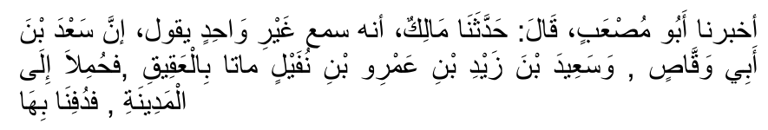
Transportation of corpses from al-A'qeeq to al-Madinah did neither cause much delay nor any change to composition of the dead bodies.
On the other hand, modern day international shipment of corpse does cause change in the composition and nature of the dead body. The international shipment of corpse requires body embalming. The embalming process entails at least three kinds of embalming. 1: Arterial Embalming. This involves arterial injection of embalming fluids. The fluids are injected through an artery and the blood is drained through a vein. The embalming fluids penetrate all parts of the body including the tissues, muscles, organs and even the skin. The tubes are inserted through the artery and the vein so that each body vessel receives the tube to facilitate fluid injection and blood drainage. All the blood is drained into the gutter and replaced with embalming fluids. The embalmer injects almost 1 gallon of fluid for every 50 pounds of body weight. For example a body of 200 pounds receives at least 4 gallons of embalming fluids. After completion of arterial injection and complete blood drainage, the arterial and jugular tubes are removed, the incisions are sutured, the vessels are tied closed and sealed with a special chemical. 2: Cavity Embalming. The fluids inside the abdomen and thoracic cavities and organs are sucked through a suction machine. All the body organs are pierced and punctured to drain the fluids out of them through suction. 3: Surface Embalming. It applies embalming fluids to the skin and tissues to make them hard and protected from decomposition.
The typical embalming fluid is made up of a mixture of formaldehyde, methanol and other solvents including ethanol. The formaldehyde content generally ranges from 5 to 29 percent and the ethanol content may range from 9 to 56 percent. Formaldehyde's systematic name is methanol as it is mainly consisted of methanol ingredients. "Methanol, also known as methyl alcohol, wood alcohol, wood naphtha or wood spirits, is the simplest alcohol, and is a light, volatile, colorless, flammable liquid with a distinctive odor very similar to, but slightly sweeter than, that of ethanol (drinking alcohol)."
While "Ethanol, also called ethyl alcohol, pure alcohol, grain alcohol, or drinking alcohol, is a volatile, flammable, colorless liquid. A psychoactive drug and one of the oldest recreational drugs known, ethanol produces a state known as alcohol intoxication when consumed. Best known as the type of alcohol found in alcoholic beverages, it is also used in thermometers, as a solvent, and as a fuel. In common usage, it is often referred to simply as alcohol or spirits."
Islamically, just the embalming process itself is extremely problematic rest aside the infusion of embalming fluids saturated with alcohol throughout the body and complete drainage of the bodily blood and fluids which were part and parcel of the physical construction of the human person. The process of incision, injection of gallons of external fluids mainly consisting of alcohol, puncturing of almost all body organs, suction of internal body fluids and injection of external alcoholic fluids into all organs, complete drainage of body blood into the sewer system and hardening of the tissues and skin, all of them are detrimental to the wellbeing of the dead body and must be considered as against the dignity of the corpse except in an extraordinary situation warranting such radical steps for genuine Shar'ai' reasons. (There can never be any 'extraordinary situation' to warrant the grotesque desecration entailed by the satanic process of embalming –Mujlisul Ulama) This is in addition to delays in burial and un-necessary expenditure of thousands of dollars. The Prophet (SAW) was emphatic when he said:
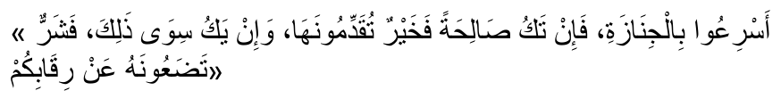
"Hasten to bury the corpse; for if it was righteous then you are sending it off to its welfare; and if it was otherwise then you are putting off a liability from your necks." (Narrated by al-Bukhari)
The report in Sahih Muslim is very similar. It emphasizes the same fact.
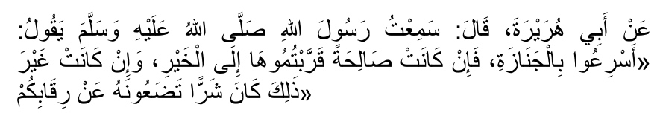
Imam al-Qurtubi, Qadi 'Iyadh, Ibn Hazm and many other renowned jurists have argued that the hadith requires a quick funeral and a quick burial. They substantiate their view point with other Ahadith such as the ones reported by Abu Dawud and al-Tabaraani. Abu Dawud reports that the Prophet (SAW) commanded: "It is not appropriate to hold back the corpse (from burial) while keeping it among the family."
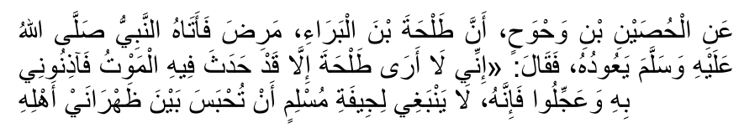
Al-Tabaraani reports that the Prophet (SAW) said: "Do not withhold the dead body and hasten to take it to its grave. Let al-Fatiha be recited from its head side and the ending verses of Surah al-Baqarah from the feet side."
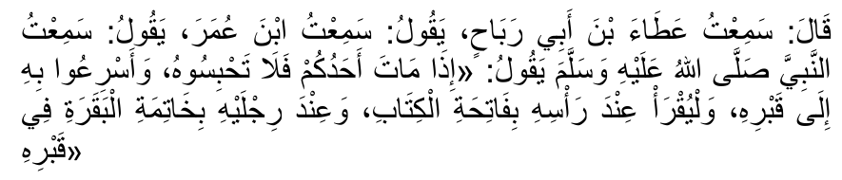
Therefore, burial of dead bodies in the graveyard of the city/place they die in as quickly as possible is a practical Sunnah (and Waajib act of the Sunnah – Mujlisul Ulama). Corpses must not be transported to far away destinations except in a very rare, extraordinary situation where Islamic burial is not possible or corpse dignity is feared to be compromised.
Rasulullah (Sallallahu alayhi wasallam) said:
"When the Janaazah is ready (for burial), and the men load it on their shoulders, then if it was a Saalih (Pious) person, it says: '(Make haste)and send me forth. And, if it was an impious person, it (the mayyit) wails to its family: 'Alas! Where are you going with it (the Janaazah)?' Everything hears its (wailing) voice except Insaan (human beings). If man was able to hear (the wailing), he would fall down unconscious."
AN ADDITIONAL SACRILEGE TO THE MAYYIT IS THAT IS HAS JUST BEEN ANNOUNCED THAT THE BURIAL WILL TAKE PLACE ONLY AFTER 9 P.M, THURSDAY NIGHT 19TH JANUARY 2017 – THAT IS ALMOST FOUR DAYS AFTER THE HADHRAT'S MAUT. Inna Lillaahi wa inna ilayhi raajoon

