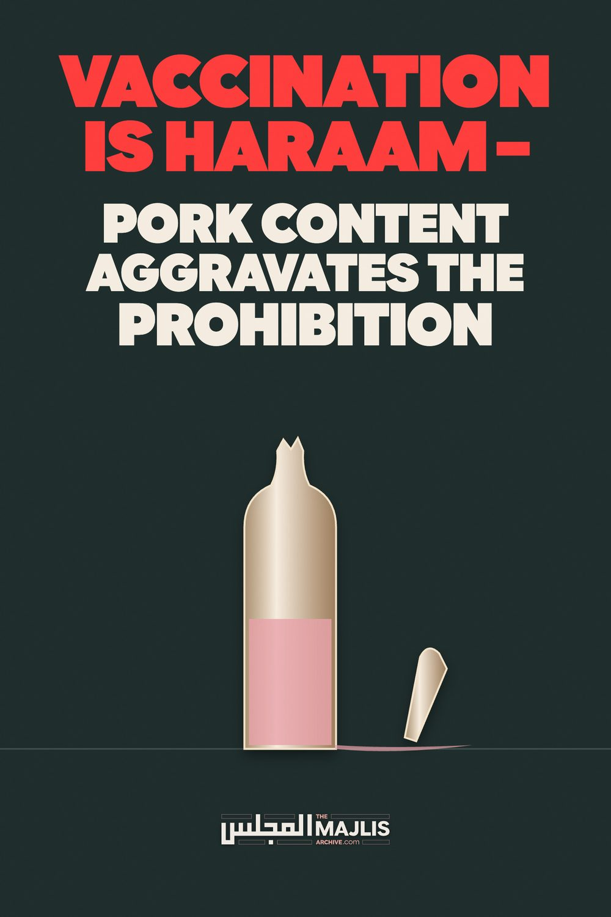

VACCINATION IS HARAAM - PORK CONTENT AGGRAVATES THE PROHIBITION
The Majlis · Voice of Islam
Mujlisul Ulama of South Africa

About this edition
This is a reproduction by The Majlis Archive (themajlisarchive.com) of a publication of The Majlis, Mujlisul Ulama of South Africa, made and published with their permission.
The PDF as The Majlis issued it is the original. This edition was read from that PDF's own structure and checked against it letter for letter; where the two differ, the PDF is correct.
Checked: 49 paragraphs, 0 differing; a second, independent PDF reader finds 100.0% of the PDF's words here.
Nothing has been reworded, added or removed.

PUBLISHED BY: MUJLISUL ULAMA OF S.A. PO Box 3393
Port Elizabeth, 6056 South Africa

VACCINATION IS HARAAM
Coming out in defence of the vaccine with pork content, the jaahil so-called 'Islamic' Medical Association of S.A., is labouring to set itself up as an Islamic authority capable of issuing fatwas on matters of Deeni import. We are certain that many of these chaps on this jaahil association of western bootlickers are deficient in the basic masaa-il of even Istinja.
The article of this deviate group of doctors currently issued in defence of the pork vaccine is a perfect specimen of shaitaani zukhrufal qaul (deceptive statements satanically adorned). Regarding such embellished statements of satanism, the Qur'aan Majeed states:
"Thus, have We made for every Nabi human shayaateen and jinn shayaateen as enemies. They (these human and jinn devils) whisper (satanically) embellished statements
(and ideas) to one another. And, if your Rabb had so willed, they would not have been able of this. Therefore, leave them and that (falsehood) which they fraud."
(Aayat 112, Al-Anaam)
Since the brains of these westernized doctors are fitted in a western straitjacket of kufr culture which is the effect of their western education, they disgorge whatever rubbish has been vomited into their systems by their western masters.
Thousands of pages of articles have been published by western medical experts to prove beyond doubt the grave dangers of the filth and poison known as vaccines. These bootlicking so-called Muslim doctors have miserably failed to rationally and scientifically disprove the evidences advanced by their opposition. They are only capable of regurgitating what has been vomited into their mouths and brains by their atheist educators.
Aggravating their jahaalat is their contumacious audacity of posing as Muftis of the Shariah.
Whilst disease prevention is necessary, this goal may not be pursued in haraam ways. Rasulullah (Sallallahu alayhi wasallam) debunking this haraam stupidity of these juhala doctors, said: "Verily, Allah has not created the shifa' (cure) of my Ummah in substances which have been made haraam for them." The decision (stupid fatwa) taken by the so-called 'Islamic' Organization for Medical Sciences – another western bootlicking entity – is baatil. Muslims do not worship moron 'legal scholars' who are out to appease western palates and who resort to bootlicking. Muslims are not allowed to worship scholars. The decision of the scholars in 1995 on the issue of pig ingredients is baatil – baseless, false and in conflict with the Shariah. Such flotsam 'fatwas' are not needed by the Ummah.
The claim by the juhala IMASA that "vaccination is an important component that assists in the facilitation of public health", is a palpable canard. There exists a deluge, nay, deluges, of medical evidences to debunk this stupid and unscientific claim made by the bootlicking Muslim doctors. They only know how to disgorge what they had lapped up from their kuffaar masters. They are incapable of conducting independent research in even the medical field which is supposed to be their preserve. All the research which thoroughly debunks the claims of the efficacy of vaccination has been accomplished by non-Muslim experts whose brains are not welded to the Satanist priests of the western medical establishment.
We have published hundreds of pages of such evidence of the experts. Far from vaccines protecting people as claimed by IMASA, these harmful and filthy substances destroy the health of millions of people. The sole motivation underlying the cruel vaccine and vaccination racket is monetary gain.
The claim that vaccination has eliminated numerous serious diseases globally is another satanic canard. Study the writings of the opposition medical experts to understand the villainy and satanism which underlay this whole shaitaani project.
Endeavouring to project an image of juridical authority in Deeni terms, the juhala doctors group flaunts Arabic terminology such as hifz al-din (preservation of religion), hifz al-nafs (preservation of life), etc. In mentioning these terms they are making a mockery of themselves. They have succeeded in only portraying their jahaalat. They mention these terms as Maqasid al-Shariah (objectives of Islamic law), yet they are lamentably ignorant of even the meaning of the Shariah. The Shariah is the Qur'aan and the Sunnah, and the primary Maqsad (Objective) of the Shariah is not what these juhala believe. The Primary Objective of the Sharia is mentioned with clarity in the Qur'aan Majeed: "I have not created jinn and man except that they worship
Me."
The other issues which they have hallucinated as the Maqaasid have no relationship to the Primary Objective for which Allah Ta'ala has created us. Any secondary objective may not be pursued in ways which are in conflict with the Shariah.
The objective of Hifzud Deen (Protection of the Deen) has absolutely no truck with the haraam filth and poison of vaccination. The only way of protecting and preserving the Deen is by practical implementation of every facet of the Shariah and Sunnah. The Deen cannot be preserved by bootlicking kuffaar wallowing in spiritual and physical janaabat. Practical implementation with its primary agency of Amr Bil Ma'roof Nahy Anil Munkar, is the only way of preserving the purity of the Deen. But these juhala, introduce this issue in their stupid discussion pertaining to the filth and poison of vaccination.
Their jahaalat is stupendous and shockingly lamentable, for they claim: "Interestingly, vaccination fulfils all the above five objectives of the Shariah."
Shaitaan has truly whispered his embellished ideas of satanism into their brains. They are out to make the Shariah a handmaid of the filthy and haraam cult of vaccination – a cult invented to fleece the peoples of the world of their wealth. Allah Ta'ala is well aware of these jaahil mudhilleen who present shaitaani zukhrufal qaul to dupe and mislead the ignorant masses. Among the mudhilleen are two categories: (1) the ulama-e-soo', and (2) the juhala-e-soo'. IMASA falls within this second class of mudhilleen. With its zandaqah these IMASA juhala zanaadeeq portray themselves as authorities of the Shariah.
But, regarding such miscreants, Allah Ta'ala says in the Qur'aan Majeed:
"Those who dispute in Our Aayaat (Laws/Ahkaam) will come to know that for them there is no escape (from Jahannam)"
Soon will they understand the fate of their dabbling in the domain of the Deen without possessing the requisite qualifications. Their medical qualifications are flotsam in terms of the Shariah. Such mundane qualifications preclude intrusion into the sacred precincts of Allah's Shariah. Their dubious medical 'expertise' is bereft of Shar'i substance. Whilst they hallucinate of their 'greatness' based on their medical profession, the Qur'aan Majeed denouncing them proclaims:
"Whatever you (O IMASA and your ilk!) have been given is something meagre of this worldly life, and that which is by Allah is better and more enduring for those who have Imaan, and on their Rabb do they have tawakkul."
(Aayat 35 and 36, Ash-Shuraa)
It is the height of absurdity to believe that the filth and poison of vaccination fulfil the objective of preserving the Shariah. Brains vermiculated by shaitaani manipulation are capable of proffering such ridiculous absurdities.
The contention that vaccination preserves life is another shaitaani deception. Firstly, a massive deluge of expert evidence – evidence tendered by western medical experts – refutes and debunks this stupid contention. And, IMASA and its ilk are impotent in the glare of this evidence, hence they have hitherto miserably failed to rationally, medically and scientifically refute the evidence. Their sole capability is restricted to regurgitation of the rubbish they have acquired at the feet of their atheist western masters from whom they acquired their medical qualifications.
The claim that vaccination preserves human progeny is another ludicrous shaitaani deception. The evidence belies this absurd claim. Hifz-e-Nasl (preservation of progeny) is not possible by the adoption of haraam ways and means of satanism. These very entities who bootlick the west, promote the destruction of Nasl with their advocacy of birth control which is raised on the premises of disbelief in the Razzaaqiyat (Providence) of Allah Azza Wa Jal. Therefore, they promote infanticide- the murder of babies – which they dub 'abortion'. Their brains and souls have been corrupted and satanized by the touch of Iblees. Yet these juhala shamelessly proclaim the stupidity of the filth and poison of vaccination as protecting the human race.
Whilst the evidence has proven that vaccination casts the brain into disequilibrium, the jaahil IMASA advertising its jahl-e-murakkab proclaims that this filth and poison preserves Aql. They display shocking ignorance of the realities of the Deen, of the demands of the Shariah and the goals of the Aakhirah.
The other shaitaani myth propagated by the priests of the kufr medical cult is that the filth and poison of vaccination preserve wealth. Their jahl is indeed colossal. The vaccine trade siphons billions of dollars annually from the people on whom the oppressive governments impose the satanic policy of immunization. Only the ill-gotten wealth of the devils of the pharmaceutical companies is preserved by vaccination. The process of amassing wealth at the expense of destroying the health of humanity has been satanically designed by the Yahood who are in control of this evil system which has been injected into the brains of the medical establishment of the west.
IMASA either is bereft of Imaan or extremely deficient in Imaan, hence it contends that vaccination has "reduced mortality". In other words, vaccination has prolonged life, prevented Maut and thwarted Hadhrat Israaeel (Alayhis salaam). By this theory of kufr, IMASA implies the rejection of Allah's declaration in the Qur'aan Majeed: "No person will die except with the permission of Allah at the appointed time."
No amount of medical treatment, least of all the injection of poison and filth, will stave off Maut. Maut arrives with precision the very second ordained by Allah Azza Wa Jal. But IMASA having its brains fitted in a straightjacket of atheistic origin is capable of disgorging only the theories of kufr which had been vomited into its brains by its kuffaar masters.
In the matter of medical treatment, it is imperative for Muslims to understand that medicine – valid, halaal medicine – will cure only by the decree of Allah Azza Wa Jal, hence Nabi Ibraaheem (Alayhis salaam) said: "When I am sick, then He cures me." It is not the medicine which cures just as it is not the shop, the factory or the farm which feeds. The minimum Waajib degree of tawakkul for the masses is to harness the material and worldly means and agencies within the confines of the Shariah. It is Waajib to give a wide berth to Haraam and Mushtabah. Inclining to the filth and poison of the western medical cult is the effect of gross Imaani deficiency.
Islam does not tolerate the injection of filth and disease into the human body. This injection of filth and poison into the body is haraam regardless of any perceived benefits. The perceived benefits are shaitaani hallucinations. The Shariah does not condone haraam substances for medical treatment. The prohibition is greatly emphasized with regard to people who are healthy and free of disease. The devils of immunization inject filth and poison into healthy people in anticipation of them contracting future diseases. This is the ta'leem of Iblees.
Our advice for IMASA is that they restrict their propagation of haraam within the parameters and narrow confines of their profession. They should not perpetrate the kufr offence of encroaching into the domain of the Shariah for which they are unqualified. The attempt to encroach on the Shariah is motivated by a false and base nafsaani desire. We have a divine Shariah to follow. Allah Ta'ala commands:
"Then We have established you on a Shariah regarding (all) issues. Therefore, follow it and do not follow the base desires of those who do not know (i.e. the juhala). Verily, they cannot make you independent of Allah (i.e. they cannot benefit you against Allah's commands) in any way whatever. Verily, the zaalimeen (oppressors) are friends to one another whilst Allah is the Friend of the Muttaqeen." (Aayat 18 and 19, Al-Jaathiyah).
The juhala and the kuffaar cannot benefit Muslims in any way whatsoever with their satanism of vaccination. On the contrary, they augment the very diseases which they claim to be treating. IMASA is incapable of seeing beyond the narrow confines of the kufr ta'leem and tarbiyat acquired from their western masters. About such juhala, the Qur'aan states:
"That is the limit of their knowledge. Verily, your Rabb is more aware of the one who deviates from His Path, and verily, He is more aware of the one who attains guidance." (Aayat 30, An-Najm)
We have available the following booklets on the evils and harms of vaccination:
1) Vaccination The Devils Medicine 2) Vaccination 3) Islam, Vaccines and Health 4) The Horrifying, Criminal and Grotesque Vaccination
Plots 5) The Filth – The Poison – The Damage Of The
Vaccination Fraud

