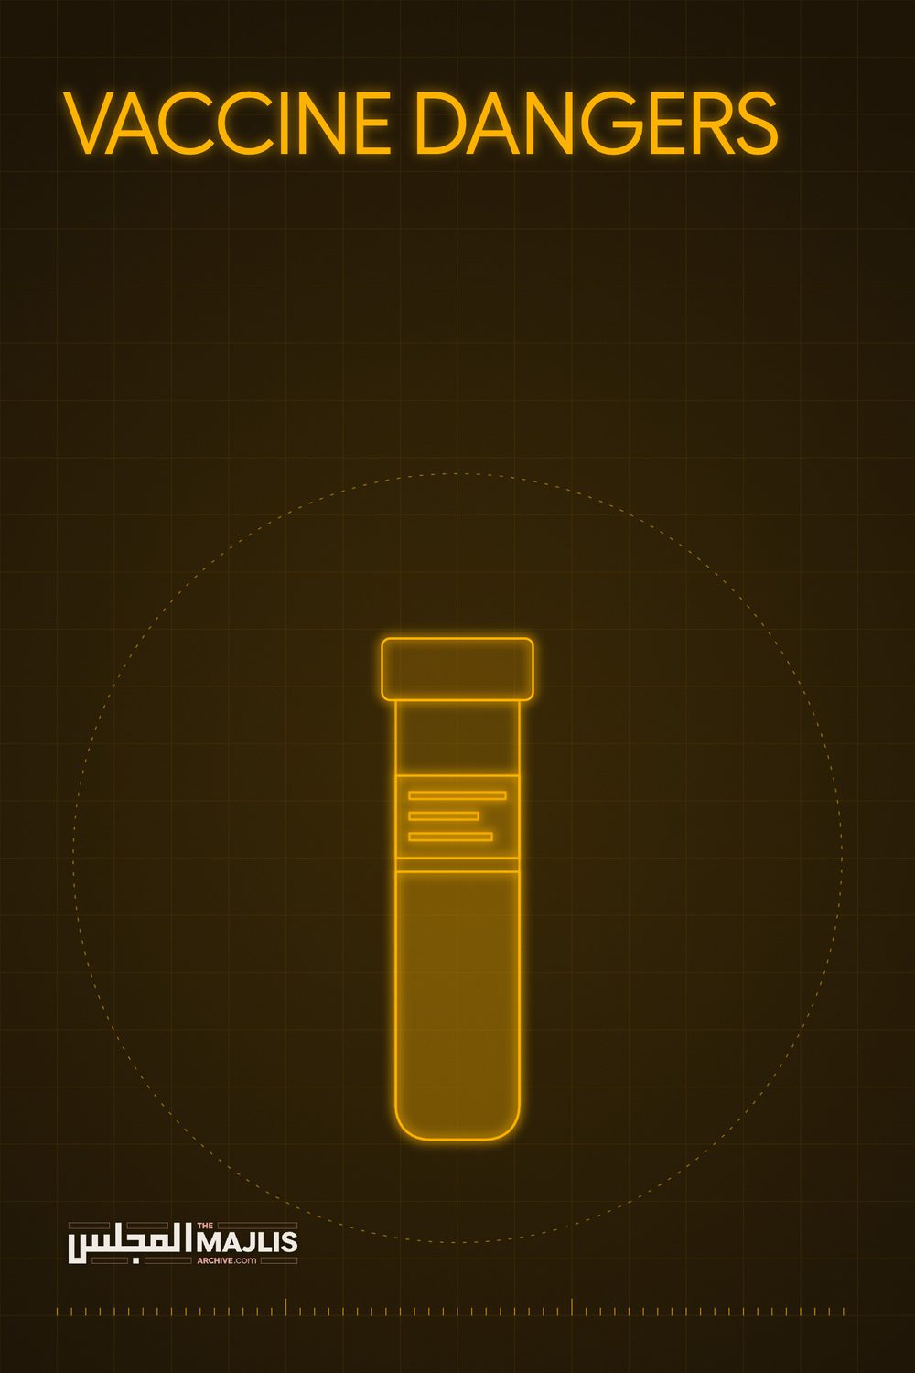

VACCINE DANGERS
The Majlis · Voice of Islam
Mujlisul Ulama of South Africa

About this edition
This is a reproduction by The Majlis Archive (themajlisarchive.com) of a publication of The Majlis, Mujlisul Ulama of South Africa, made and published with their permission.
The PDF as The Majlis issued it is the original. This edition was read from that PDF's own structure and checked against it letter for letter; where the two differ, the PDF is correct.
Checked: 31 paragraphs, 0 differing; a second, independent PDF reader finds 100.0% of the PDF's words here.
Nothing has been reworded, added or removed.

Published by: The Majlis PO Box 3393, Port Elizabeth, 6056 South Africa
Blasting Bill Gates and claiming Covid vaccine contains Satanic microchips gets Mexican cardinal censored by Facebook
17 Jan, 2021 11:14 © REUTERS/Dado Ruvic; Creative Commons/ stillwellmike A Mexican cardinal has been censored by Facebook after claiming that the Covid-19 pandemic is part of a "new world order plot" and saying vaccines against the disease contain satanic microchips.
Cardinal Juan Sandoval Iniguez claimed in a video on the social media platform that vaccines to combat the spread of the coronavirus contain "the mark of the beast."
In a video titled 'Plot of a new world order', which was released on January 12, the 87-year-old claimed that the pandemic will continue for several more years.
"This pandemic won't end in a month or two months, perhaps not this year, perhaps not in three, four, five, six years. That's what these men want," he said.
ALSO ON RT.COM13 Israelis suffer FACIAL PARALYSIS after taking Pfizer Covid jab, amid influx of reports detailing adverse effects
Sandoval went on to blast Bill Gates, saying the Microsoft founder has given himself the attributes of a "prophet" by forecasting the outbreak of deadly diseases.
"It turns out, coincidentally, that a laboratory in Atlanta, of which Bill Games is a benefactor, has a strain of smallpox, so we are prepared for this new pandemic," he said.
Facebook quickly censored the post, making the video inaccessible and adding a warning that read: "This publication repeats information about COVID-19, which independent fact checkers indicated is false."
Sandoval served as archbishop of Guadalajara for 17 years before retiring in 2011. He said that the goal of the plot was to establish a single world government with a single army, economy, and religion, which will not be Christian.
The archdiocese posted the video on its website along with a story about its removal. "Cardinal Juan Sandoval denounced the imposition of a new world order, hours later his video was censored," it said in a Facebook post.
Sandoval was part of the papal conclaves that elected Pope Benedict XVI and Pope Francis. The National Catholic Reporter said he has "detoured into conspiracies throughout the pandemic".
Think your friends would be interested? Share this story!
23 Norway Deaths Prove COVID-19 Vaccine is Downright Dangerous and Deadly Posted on January 15, 2021 by State of the Nation "Serious Consequences" –
Norway Sounds Alarm After
23 Die Following Pfizer
Vaccine
ZeroHedge.com Norway health authorities are reporting COVID-19 vaccine news of monumental importance at a moment the US is rushing to get an initial some 30 million doses into the arms of the elderly and those with chronic health conditions: sick patients over 80 are particularly at risk for devastating side effects.
Thus for this vulnerable demographic which is currently first in line in North America, the "cure" could be worse than the disease. Bloomberg notes that it's "the most cautious statement yet from a European health authority" regarding potential adverse vaccine health risks.
"For those with the most severe frailty, even relatively mild vaccine side effects can have serious consequences," the Norwegian Institute of Public Health said.
The health authority said further in its most blunt statement cautioning against a policy of a blanket promotion of the vaccine for all:
"For those who have a very short remaining life span anyway, the benefit of the vaccine may be marginal or irrelevant."
This comes after a handful of global cases, including an elderly patient in France, where a recipient died within hours of receiving their first-round of the vaccine. Thus far Norway says it has administered doses to up to 33,000 people, including the elderly, but are already finding it "too risky" for the terminally ill and people over 80 that are in frail condition. Given only 33,000 injected so far, the reported death count is already staggering and is causing officials to sound the alarm:
Norwegian officials said 23 people had died in the country a short time after receiving their first dose of the vaccine. Of those deaths, 13 have so far been autopsied, with the results suggesting that common side effects may have contributed to severe reactions in frail, elderly people, according to the Norwegian Medicines Agency.
But despite the warnings being featured prominently at the end of this week in Bloomberg and multiple other mainstream publications, again we doubt this will do anything in terms of putting the brakes on the rushed vaccine rollout in the US where it's precisely the elderly, frail, and those prone to persistent health conditions that are being urged on by state and federal policies to be first in line.
Meanwhile, Bloomberg had this to say of the most common vaccine brands in Norway and the West: Representatives for Pfizer and BioNTech didn't immediately respond to requests for comment.
The Pfizer-BioNTech vaccine approved late last year has been used most broadly, with a similar shot from Moderna Inc. approved earlier this month also now being administered.
Norway initiated its COVID-19 vaccinations last month on the heels of the Pfizer/BioNTech vaccine receiving approval by the European Medicines Agency. Norway's infections are approaching 60,000 out of total population of 5.3 million, including over 500 deaths. Many skeptics in Europe and the US still have severe reservations about the vaccines, even as big pharma and governments continually insist they are completely safe.
___ https://www.zerohedge.com/covid-19/norway-sounds-alarm-over-vaccine-risks-elderly-frail-after-23-deaths

