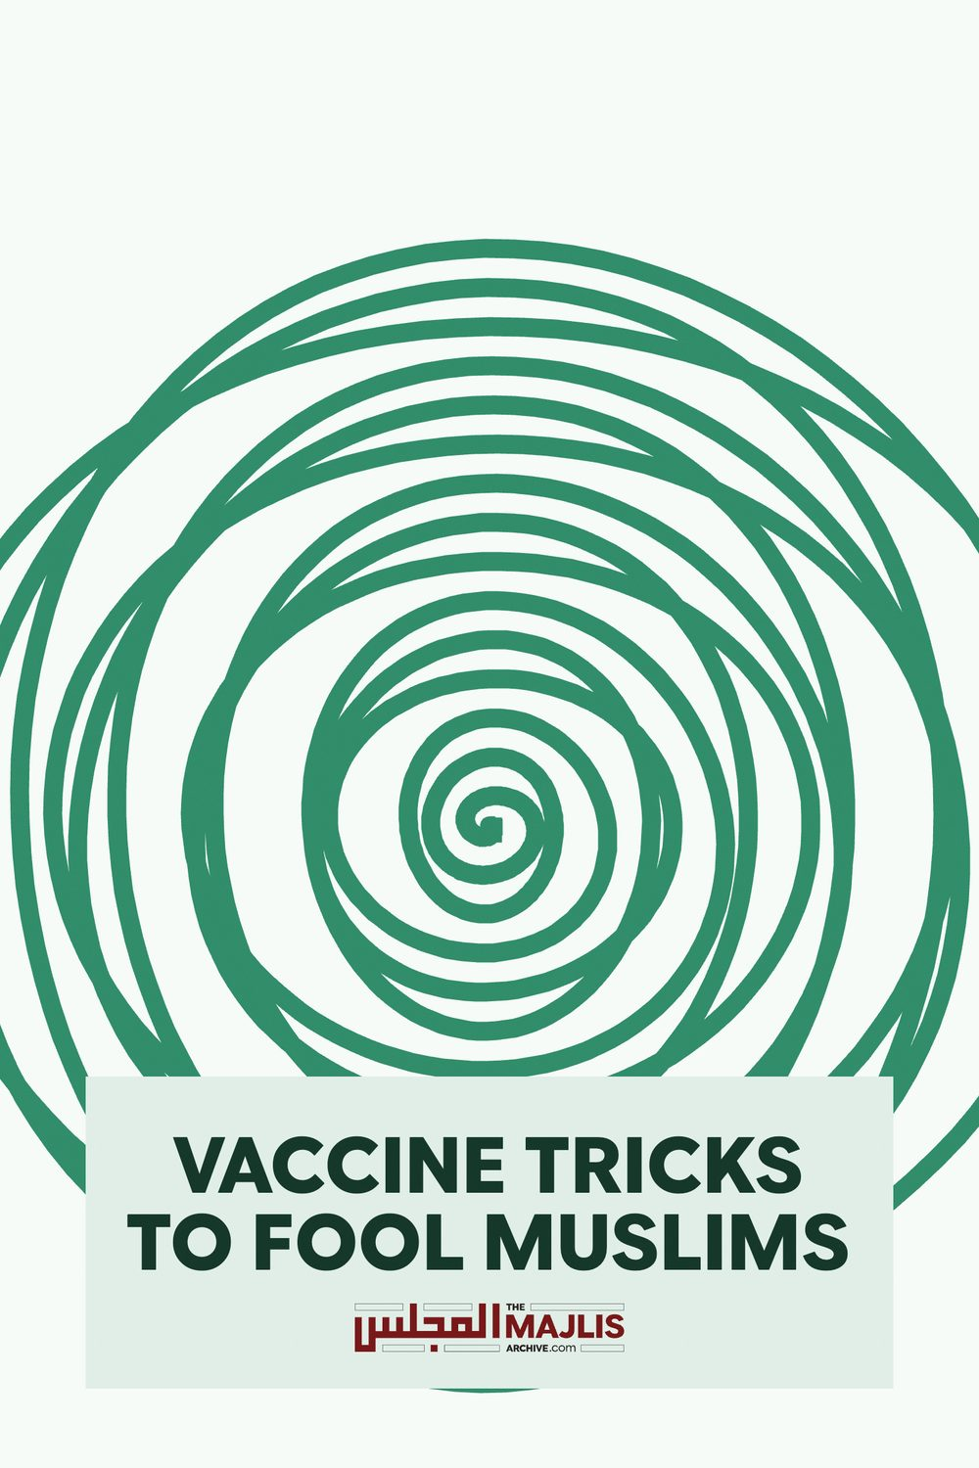

Vaccine Tricks to fool Muslims
The Majlis · Voice of Islam
Mujlisul Ulama of South Africa

About this edition
This is a reproduction by The Majlis Archive (themajlisarchive.com) of a publication of The Majlis, Mujlisul Ulama of South Africa, made and published with their permission.
The PDF as The Majlis issued it is the original. This edition was read from that PDF's own structure and checked against it letter for letter; where the two differ, the PDF is correct.
Checked: 125 paragraphs, 0 differing; a second, independent PDF reader finds 100.0% of the PDF's words here.
Nothing has been reworded, added or removed.

Mujlisul Ulama of S. A. P.O. Box 3393 Port Elizabeth
6056, South Africa
By Muslim Health Watch & The Majlisul Ulama. 1st March 2018.
Did You Know?
We are being fooled into taking harmful Vaccines and Polio Drops that may contain filth and impurities from aborted foetus, animal blood, baby foreskin, cow, dog, monkey, pig, homosexuals blood and more!
Many substances may be forbidden to Muslims, Christians, Jews, Hindus and vegans, but clever sales tricks can fool you into injecting these impurities into your little child and baby.
Don't be caught out!
Vaccines May Contain Filth and Haraam.
Vaccines may contain filthy and impure substances from animals and humans, like cancer cells, cows blood & gelatine, dog kidney, infected homosexuals blood, monkey kidney, pigs blood & gelatine, pus from diseased animals and humans, plus many more! Vaccines may also contain many toxic substances like aluminium, antibiotics, abortion drugs, anti-fertility drugs, aspartame, heavy metals, mercury, MSG, polysorbate, sorbitol, and many more!
Vaccines have been linked to nearly every disease we see today like autism, autoimmune disease, cancer, cot death, infertility, neurological disease, sterility and death. Worse still, new diseases never seen before, continue to increase as more and more vaccines are injected into our innocent little babies and children.
Would You Knowingly Inject These Substances Into Your Child?
If the people really understood what was in a vaccine, it would be very difficult to sell harmful vaccines and polio drops to the public masses. To overcome this problem, many clever methods may be used that completely fool and confuse the Muslims, doctors and even religious scholars into supporting vaccination!
Incorrect Medical Knowledge.
Vaccination is based on a long-discredited theory that stimulation of antibodies in the human body equals protection from disease. This theory has not only failed to be proved, but has been repeatedly disproved by many world doctors and scientists. Drug companies have infiltrated and seized control over the entire healthcare system, medical schools, medical journals, hospitals, clinics and local pharmacy. Doctors are slowly conditioned and groomed into promoting a treatment that only targets symptoms, but does not cure. Patients are locked into a kind of slavery, requiring ongoing medical treatment, and vaccines cause further disease, securing future profits!
Hidden Substances.
Many substances in vaccines may be hidden or disguised because they are forbidden to Muslims, Christians, Jews, Hindus, Vegetarians and Vegans, or linked to cancer, infertility, sterility, disease and death!
Vaccine substances may be legally hidden by the following methods and more…Trade secrets, patent rights, disclaimers on changes in raw materials and supplies, substances added but not intended as ingredients, and insane regulations that allow substances below a certain level to disappear from the list completely. Thimerosal free vaccines that actually contain mercury are still being injected globally.
Medical Study Fraud.
Medical studies may be funded by vaccine companies and the results pre-ordained, biased or false. See Vaccine safety tips and tricks, by Neil Z. Miller, and Why most published research findings are false, by John P. A. loannidis.
Polio Renamed.
Many disease like polio were never really wiped out. To hide vaccine failure, governments and doctors may simply rename diseases. Polio may now be diagnosed as acute flaccid paralysis, Guillain-Barre Syndrome, meningitis and more. Smallpox may be diagnosed as monkey pox and other diseases are renamed as such.
Epidemics Caused By Vaccines.
Epidemics like polio are caused by vaccines. Instead of halting the program, governments say they now need to continue vaccinating to control the new epidemic. This illogical decision spreads polio & paralysis further!
Misleading Graphs. (Designed to Sell Vaccines).
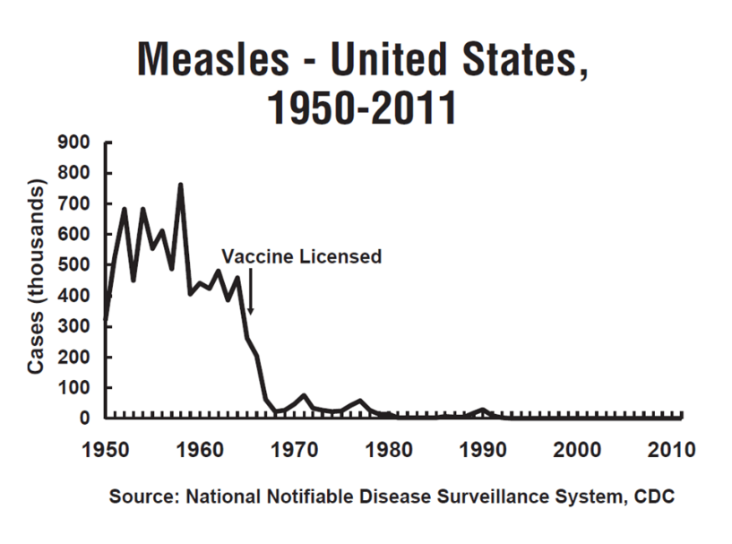
CDC Graph.
The above graph is a typical short term graph used by the CDC, WHO, governments and supporters of mass vaccination. The data points start immediately before the vaccine was introduced, making it appear that the vaccine wiped out measles. But data before 1950 is withheld because it shows a clearer picture, and would not convince anybody into taking the vaccine!
This graph is very inaccurate, but sells vaccines! It also shows cases of measles, not deaths, and fails to give enough information needed to make an intelligent and informed decision on vaccine efficacy. A true picture of measles cases can never be obtained for many reasons including the following...
• Cases of measles may be easily misdiagnosed. • Thousands of patients do not report in to their doctor or hospital.
This same type of graph is used in Australia, UK, USA and globally to sell vaccines for various diseases. Even though it is highly inaccurate, it is promoted and relied upon by the vaccine companies, governments, medical schools, regulatory bodies, healthcare professionals and the sickness industry. Sickness makes big money!
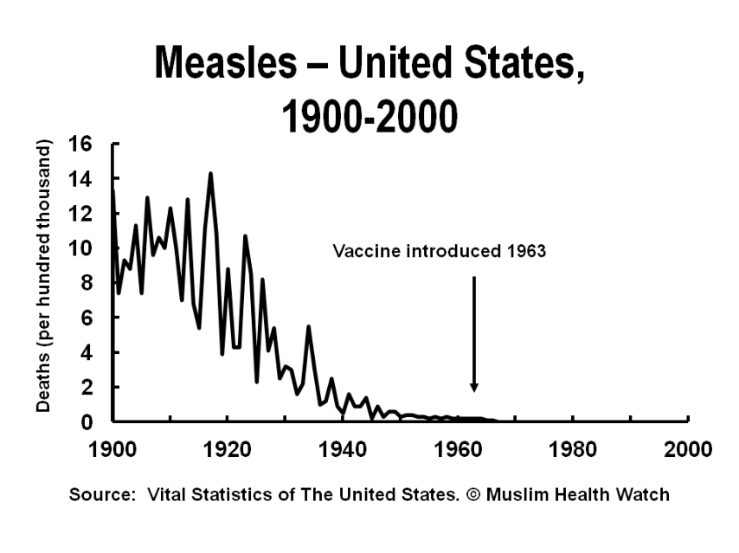
Muslim Health Watch Graph.
The above graph is a long term graph by Muslim Health Watch. The data points start well before the vaccine was introduced, and clearly show that the vaccine did not wipe out measles. Measles declined well before the vaccine was introduced and is said to be due to things like improvements in sanitation and living conditions.
This graph is very accurate, but does not sell vaccines!
It also shows actual death rates from measles clearly. Understand well that deaths from measles were nearly zero before any vaccines were introduced! It is very strange why so much money is wasted in vaccinating millions globally against diseases that kill so few, and that vaccines are actually causing and spreading new diseases. Instead, this money could be better spent on improved sanitation, sewerage systems, clean water and pure food supplies in the third world!
For more long term graphs showing that vaccines did not wipe out any disease globally, see the following...
• Muslim Health Watch: www.muslimhealthwatch.org • Dissolving Illusions: www.dissolvingillusions.com • Vaccination Dilemma: www.vaccinationdilemma.com
Halaal Label Fraud.
Many Muslim doctors are cashing in on so called halaal vaccines. But halaal vaccines will never exist because vaccines do not protect against any disease. They actually cause and spread old and new diseases.
Impure Substance Undergoes Change.
Incorrect fatwas may be issued saying that an impure substance has undergone change. Pig and cow gelatine are examples that may remain impure say new fatwas.
Invalid Fatwas.
All previous fatwas supporting vaccination may be invalid because nobody fully knows what is really in any vaccine, or how vaccines work, not even the manufacturers, according to a UK high court judge.
Bullying Tactics.
Hospital staff are programmed to push vaccines onto newly born infants, when parents are highly emotional and easily coerced, using scare tactics, lies and deceit! Parents are not given any correct information on vaccines or allowed any time to research and think about it, resulting in a hasty decision. Parents who dare to question vaccination are humiliated and made to feel inferior by ignorant doctors who know nothing about vaccines, only what they have been told by the vaccine salesman.
Vaccines: Get the Full Story.
By Muslim Health Watch & The Majlisul Ulama. 1st September 2017.
Nicola Antonucci MD, David Ayoub MD, Nancy Turner Banks MD, Timur Baruti MD, Danny Beard DC, Russell Blaylock MD, Fred Bloem MD, Laura Bridgman FNP ND, Kelly Brogan MD, Sarah Buckley MD, Rashid Buttar DO, Harold Buttram MD, Lisa Cantrell RN, Lua Català Ferrer MD, Jennifer Craig PhD BSN MA, Robert Davidson MD PhD, Ana de Leo MD, Carlos deQuero Kops MD, Carolyn Dean MD ND, Mayer Eisenstein MD JD MPH, Todd M. Elsner DC, Jorge Esteves MD, Edward "Ted" Fogarty MD, Jack Forbush DO, Milani Gabriele CRNA RN, Sheila Gibson MD BSc, Mike Godfrey MBBS, Isaac Golden ND, Gary Goldman PhD, Garry Gordon MD DO MD(H), Doug Graham DC, Boyd Haley PhD, Gayl Hamilton MD, Linda Hegstrand MD PhD, James Howenstine MD, Suzanne Humphries MD, Belén Igual Diaz MD, Philip Incao MD, Joyce Johnson ND, A. Majid Katme MBBCh DPM, Tedd Koren DC, Alexander Kotok MD PhD, Eneko Landaburu MD, Luc Lemaire DC, Janet Levatin MD, Thomas Levy MD JD, Stephen L'Hommedieu DC, Paul Maher MD MPH, Andrew Maniotis PhD, Steve Marini PhD DC, Juan Manuel Martínez Méndez MD, Sue McIntosh MD, Richard Moskowitz MD, Sheri Nakken RN MA, Christiane Northrup MD, Amber Passini MD, Ronald Peters MD MPH, Jean Pilette MD, Pat Rattigan ND, Zoltan Rona MD MSc, Chaim Rosenthal MD, Robert Rowen MD, Máximo Sandín PhD, Len Saputo MD, Michael Schachter MD, Viera Scheibner PhD, Penelope Shar MD, Bruce Shelton MD MD(H), Debbi Silverman MD, Kenneth "KP" Stoller MD, Terri Su MD, Didier Tarte MD, Leigh Ann Tatnall RN, Adiel Tel-Oren MD DC, Sherri Tenpenny DO, Renee Tocco DC, Demetra Vagias MD ND, Franco Verzella MD, Julian Whitaker MD, Ronald Whitmont MD, Betty Wood MD, Eduardo Ángel Yahbes MD.
The above signatories represent a spectrum that includes pediatricians, family physicians, brain surgeons, and professors of pathology, chemistry, biology and immunology. All have independently researched the real science and have come to the conclusions you will read about in this document...
Ever Wonder Why... Doctors Can't Find the Cause for Many Diseases?
It's because they are conditioned to ignore the relationship between illness and vaccines. These are some of the diseases that have documented associations with vaccines:
• Allergies. • Arthritis. • Asthma. • Autism. • Acid reflux requiring an infant to take proton pump inhibitors, which have many side effects.
• Cancer. • Diabetes (infant and childhood).
• Eczema. • Kidney disease. • Miscarriages. • Long list of neurological and autoimmune diseases. • Sudden Infant Death Syndrome (SIDS). • And many, many more.
These Are Some Known Vaccine Side Effects, Documented in Medical Literature and/or in Package Inserts:
• Arthritis, bleeding disorders, blood clots, heart attacks, sepsis, ear infections.
• Fainting (with reports of broken bones). • Kidney failure requiring dialysis. • Seizures /epilepsy. • Severe allergic reactions, such as hives and anaphylaxis. • Sudden death. • Many common diagnoses given for hospital admissions. • The National Vaccine Injury Compensation Program, has awarded more than $1.2 billion in damages to children and adults injured by vaccines.
Autism is Associated with Vaccines.
• Autism was rare until the mass vaccination programs were accelerated in 1991, with the introduction of the hepatitis B vaccine and the HiB (meningitis) vaccine. Tens of thousands of parents will attest that autism appeared in their children very soon after they were given these, and other vaccines.
Drug Companies, Insurance Companies & the Medical System Get Rich When You Get Sick.
• Vaccines do not give life-long immunity, which means booster shots are recommended.
• Each booster shot increases the risk of more side effects. • Vaccine side effects can make you sick for the rest of your life. Conveniently, there are many drugs to treat the side effects caused by vaccines.
• In the U.S., neither drug companies nor doctors can be sued when something bad happens from a vaccination. Both are protected by the 1986 National Child Vaccine Injury Act. This law, signed into effect by then-president Ronald Reagan decreed: "No vaccine manufacturer shall be liable in a civil action for damages arising from a vaccine-related injury or death." (Public Law 99-660).
Many Doctors and Health Care Practitioners Do Not Get Vaccinated and Do Not Vaccinate Their Children. Why Not?
• They know vaccines are not proven to be safe or effective. • They know vaccines contain dangerous substances. • They know vaccines cause serious health problems. • They have treated patients with serious side effects from vaccines.
The Only People Who Benefit From Being Healthy are You and Those You Care About.
• Drug companies have infiltrated and seized control over the entire healthcare system, including medical schools, medical journals, hospitals, clinics and the local pharmacy. A doctor's very livelihood thus depends on blind faith, without questioning any aspect of any vaccination. Even when obvious evidence of vaccine damage occurs right before a doctor's eyes, s/he is usually unwilling to consider a vaccine as the cause. Though uncorrupted science and medicine support rejection of vaccines, doing so can be considered professional career suicide. The signatories to this document boldly risk this end for the safety of you and your child.
• Hospitals benefit financially from hospitalizations and tests. • Drug companies make billions of dollars from vaccines. • Drug companies make tens of billions of dollars from drugs given to treat side effects and life-time illnesses caused by vaccines.
• Vaccines are the backbone of the medical system. Without vaccines, healthcare costs would go down because we would have a healthier overall society. We have exchanged chicken pox for autism, flu for asthma, ear infections for diabetes. The list goes on and on. In the zeal to eliminate a shortlist of relatively benign microbes, we have traded temporary illnesses for pervasive, life-long diseases, disorders, dysfunctions and disabilities.
How Many Vaccines Are There?
• If U.S. children receive all doses of all vaccines, they are injected with up to 35 shots that contain 113 different kinds of disease particles, 59 different chemicals, four types of animal cells/DNA, human DNA from aborted fetal tissue and human albumin.
• If you think you don't have to worry about vaccines because your children are older, think again. There are at least 20 more vaccines currently in the development pipeline for release in the next few years, mostly targeting adolescents and adults.
Some Vaccine Ingredients: How is it Possible That Vaccines Will Not be Harmful to Your Health?
• Stray viruses and bacteria from the animal cell cultures that vaccines are made in.
• Mercury, a well-documented neurotoxin, is still in the multi-dose flu vaccines throughout the world. Trace amounts remain in several other vaccines.
• Aluminum, a poison that can cause bone, bone marrow and brain degeneration.
• Animal cells from monkeys, dog kidneys, chickens, cows, and humans.
• Formaldehyde (embalming fluid), known carcinogen. • Polysorbate 80, known to cause infertility in female mice and testicular atrophy in male mice.
• Gelatin, from pigs and cows, known to cause anaphylactic reactions, is found in large quantities in the MMR, chickenpox and shingles vaccines.
• Monosodium glutamate (MSG) in inhaled flu vaccines, known to cause metabolic disturbances (e.g. diabetes), seizures & other neurologic disorders.
Conflicts of Interest.
• The same people who make rules and recommendations about vaccination profit from vaccine sales. For example, Dr. Julie Gerberding, who was in charge of the CDC for eight years, is now the President of Merck Vaccines. Dr. Paul Offit, a member of the Advisory Committee on Immunization Practice (ACIP), developed and patented his own vaccine.
• According to the CDC, the average U.S. 10-doctor pediatric group has over $100,000 of vaccine inventory in their office to sell. These doctors make money from office visits, from giving your children vaccines, and also from follow up office visits for assessing reactions.
Vaccine Exemptions in the U.S.
• You do have the right to refuse. Use it. • Your child does not have to be vaccinated to attend public school.
To Have Vibrant Health, You Will Need to Take the Initiative to Learn Some New Things.
• Babies are born with powerful, natural defenses. If this were not so, all would die shortly after birth. Enormous cascades of complex immune processes start with the first cry. This needs to occur naturally, without the interruption caused by the injections of toxic substances.
• Learn that the primary keys to health are good nutrition, pure water, adequate sleep, routine exercise and happiness.
• Health cannot come through a needle. • You have no control over the outcome of a vaccination.
Source of Article.
• From an article, Vaccines. Get the Full Story. By the
International Medical Council on Vaccination. • For the full article, visit www.vaccinationcouncil.org
Fatwas on All Vaccines and Polio Drops.
• Pig and Cow Gelatine may not undergo a complete change and remain impure, say scholars including the Majlisul Ulama and Mufti Muhammad Taqi Uthmani.
• Vaccination is haraam. Majlisul Ulama. • Vaccination even on the assumption that the vaccine is free of haraam ingredients is haraam. UUCSA.
• It is permissible not to go for a Fardh Haj if one cannot avoid the injection of filth and poison into one's body. It is not permissible to perform Umrah and Nafl Haj if one cannot avoid the vaccination. It is haraam to take vaccination. Jamiatul Ulemaa Gauteng.
• More Fatwas on Vaccines & Hajj on websites below.
All Previous Vaccine Fatwas Invalid?
All previous fatwas supporting vaccination are invalid, as nobody knows what is in a vaccine, even the vaccine manufacturers. Reports say in 1993, a high court judge in the UK decided it was impossible to know the exact contents of vaccines and that science had no idea what the cocktail of chemicals, contaminants and heavy metals contained in vaccines could do to the human body, or why they would work to prevent disease. It is impossible for any scholar to rule in favour of any vaccine, when nobody knows what is in them!
More Information on Vaccines and Health. • The International Medical Council on Vaccination at www.vaccinationcoucil.org • Muslim Health Watch at www.muslimhealtwatch.org • See our leaflets titled, Vaccines. Get the Full Story, The Truth
About Vaccines, Vaccine Tricks to Fool Muslims, Vaccines May Ruin Your Hajj & Umrah.
Vaccination Research by Muslim Scholars.
For fatwas & information on vaccines, visit the only Islamic body to have extensively researched and written on vaccination, free from all vested interests. The Majlisul Ulama at www.themajlis.co.za
What Must Muslims Do?
• Learn more about vaccines. Start by visiting the International Medical Council on Vaccination. www.vaccinationcouncil.org
• Petition the Ministry of Hajj against compulsory vaccination. Keep our Hajj and Umrah pure and safe!
• Share this information with family, friends, mosques & muftis.
The Safe Choice is to Say No to Vaccines!
Muslim Health Watch, The Majlisul Ulama & the International Medical Council on Vaccination are asking for an urgent and open, scientific, medical debate on Vaccines & Vaccination. Thousands of western websites now expose and oppose the many harms, damage and death from vaccines, unknown to most doctors and the public at large.

