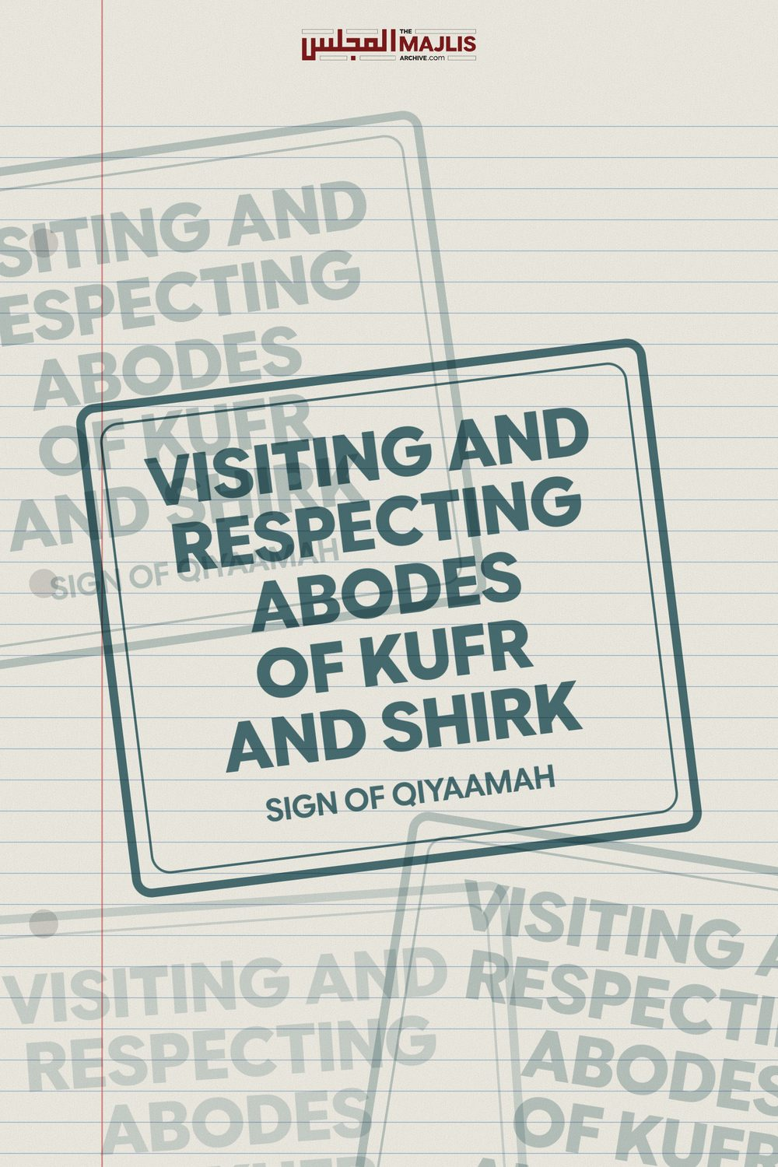

VISITING AND RESPECTING ABODES OF KUFR AND SHIRK
The Majlis · Voice of Islam
Mujlisul Ulama of South Africa

About this edition
This is a reproduction by The Majlis Archive (themajlisarchive.com) of a publication of The Majlis, Mujlisul Ulama of South Africa, made and published with their permission.
The PDF as The Majlis issued it is the original. This edition was read from that PDF's own structure and checked against it letter for letter; where the two differ, the PDF is correct.
Checked: 74 paragraphs, 0 differing; a second, independent PDF reader finds 100.0% of the PDF's words here.
Nothing has been reworded, added or removed.

By: The Majlis PO Box 3393 Port Elizabeth, 6056 South Africa
Abodes of kufr and shirk Worship are Mal-oon and maghdoob And Waajibul ihaanat (Places for disgracing)

IN THE ABODE OF SHIRK AND KUFR "ALLAH DOES NOT FORGIVE THAT SHIRK BE COMMITTED WITH HIM."
(Qur'aan)
"…About the matter you disgorged with your tongues and with your mouths and you said such (vile drivel) about which you have no knowledge whilst you thought it to be trivial, but in reality by Allah it is (exceptionally)
grave."
(An-Noor, Aayat 15)
Question Kindly find the transcription of a clip of a South African mufti currently residing in the UK which was made recently here in South Africa in one of his talks (about two days ago). This clip has been going viral and people are under the impression that it is permissible to visit churches. Is it permissible to go into churches and respect such places? Please comment.

THE TRANSCRIPT
"When I was in Cairo, I stayed for a year in Cairo. In Cairo there's a place called Misr-al-Qadeemah. In Misr-al-Qadeemah is the mosque of Amr ibn al-Aas (Radiyallahu Ta'ala Anhu). Abdullah ibn Amr ibn al-Aas also a Sahabi, is buried there. So, we actually went to see the mosque. There's a whole lot of gold Coptic churches. So, I told my wife lets go into the church, I want to see how it is. They pray in Arabic. When we went there, we took out our shoes as a custom of us when we enter a holy place. So, the woman ran to us: "No! no! You don't have to take off your shoes". I told her - we call them Sittah, Sittah means sister- we have to take out our shoes. This is a place of worship. We went back little bit. She realized we not just coming there to admire the architecture. We just want to see your place of worship, nothing more. There was no other niyyat, no other ulterior motive. So, we take off our shoes. Me and my wife went inside, we saw the church whatever it was. When we went out, we just wanted to see it, we went back home. It's the respect that we show..."
(End of the Molvi's ramble)
"What? Do you search honour from them?
Izzat belongs to only Allah." (Qur'aan)

ANSWER AND COMMENT
This unfortunate Molvi is a victim of the spiritual contagious disease of kufr/shirk which is a plague in which most of the U.K. molvis and sheikhs are trapped. Thus his visit to the church of Iblees is in consonance with the interfaith ideology adopted by the bootlicking UK priests and pundits masquerading as 'ulama'.
The Mashaaikh have said: "Imaan is suspended between fear and hope." No one knows what the morrow holds for him/her, be he the Junaid or the Raabiah of the age. The Molvi had grievously erred. In the process of his visit to the citadel of kufr and shirk, he perpetrated a number of major infractions - sins and crimes. Whilst his infraction is of immense gravity, it is not at all surprising, especially since the Molvi is residing in the U.K.
Physical diseases such as Covid and the myriad of other maladies, according to the Shariah are not contagious. But moral and spiritual diseases are extremely contagious according to Rasulullah (Sallallahu alayhi wasallam). One of the worst spiritual diseases in the U.K. is the kufr of interfaith. The Muslim masses of the U.K. in general, but the Molvis of the U.K. in particular, are afflicted with the interfaith disease which has outrageously and scandalously spread in the Muslim community of that Darul Harb.
Attending churches and kuffaar functions in general has become somewhat of a norm in the U.K. Thus the Molvi mentioned in the question appears to be a victim of the contagious interfaith kufr disease sweeping the U.K. Hence, despite the gravity and Imaani ruinous consequence of the matter of visiting and respecting churches and temples as illustrated by the Molvi, he believes it trivial and acceptable by whatever stretch of Ibleesi logic he has hallucinated in justification of his villainy. The likes of him come fully within the purview of the Qur'aanic stricture:
"…..About the matter you disgorged with your tongues and with your mouths you said such (vile drivel) about which you have no knowledge whilst you thought it to be trivial, but in reality by Allah it is (exceptionally) grave."
(An-Noor, Aayat 15)
Of the range of infractions of the Shariah perpetrated by him, his worst crime was to enter a venue of shirk and kufr. The church is an abode on which the La'nat of Allah Azza Wa Jal constantly rains down. How can a Mu'min yearn to visit and see an abode of kufr and shirk? Nothing – nothing is more abhorrent to Allah Azza Wa Jal than shirk and kufr.
If the Molvi has a correct understanding of the demands of Imaan, it may be salubrious for him to know that the Fuqaha have ruled that if a Christian asks a Muslim for the direction to the church and he (the Muslim) indicates with his hand or tongue the direction, then his act will be kufr. It is kufr because he facilitates and aids a person in the commission of the most abhorrent crime against Allah Azza Wa Jal, namely shirk/kufr. To show even a kaafir the abode of shirk and kufr is ridha bil kufr (to be pleased with kufr) and I'aanat alal Ma'siyat (aiding the perpetration of sin).
What should now be understood and concluded from the vile misdeed of the Molvi who had entered, honoured and respected the abode of shirk and kufr? He had purred pleasure on his sight-seeing tour to impress, flatter and bootlick the Mushrikeen. Regardless of his intention as proclaimed by him, we can state with a degree of certitude that in both the zaahiri and baatini dimensions of Imaan and the Shariah, he has grievously and grossly erred. Regardless of any good intention he may have had for venturing into the Mal-oon abode, it will not be any extenuating factor in the Divine Court of Allah Ta'ala in view of the flagrant violation of the Code of the Zaahiri Shariah to which even the Nabi (Sallallahu alayhi wasallam) is bound.
It is not permissible to even visit places which were annihilated and destroyed by the Athaab of Allah Azza Wa Jal such as the Dead Sea region where the nation of homosexuals was obliterated with the Chastisement of Allah Azza Wa Jal. The desire to see and visit Mal-oon and Maghdoob places stems from deficiency of Imaan. Imaan actually abhors all such places on which the La'nat of Allah Azza Wa Jal settles.
When the Arsh of Allah Ta'ala shudders if even a Muslim faasiq is respected, how much greater will be the evil and sin for respecting an abode of shirk/kufr? But this Molvi, for displaying respect of the place of kufr, removed his shoes thereby equating it to a Musjid. We remove our shoes when entering the Musjid. But this Molvi despite the kaafirah caretaker discouraging him, went ahead with his respect and honour for the abode of shirk/kufr by removing his shoes. Just whose example was he emulating in this act? It was certainly an inspiration of Iblees.
Places of kufr/shirk deserve ihaanat (to be disgraced), not respected. The Molvi, conceding his respect for kufr and shirk said: "It is the respect we show." In other words, deep down in his heart he respects their kufr and shirk worship, hence he respected the shaitaani abode by removing his shoes. What else did he do? Did he perhaps recite the dua which we recite when entering the Musjid? This question is not farfetched. He had removed his shoes which is among the aadaab we show for the Musjid. Then we recite the dua. If the church deserved one adab, then perhaps the Molvi had also recited the Masnoon dua.
In the Musjid there are Malaaikah. In the church there are shayaateen. The shayaateen love kufr, shirk and people in the state of janaabat. These are found in a church, not in a Musjid.
The Molvi said: "When we went there, we took out our shoes as a custom of us when we enter a holy place." He has clearly elevated the abode of shirk and kufr to the Houses of Allah Ta'ala, the Musaajid. His statement conveys with clarity that the church of kufr/shirk is a holy place whilst in reality it is a Mal-oon abode.
Enamoured by the worldly glitter of gold, the Molvi said: "There's a whole lot of gold Coptic churches, so I told my wife let's go into the church." But Allah Ta'ala says in the Qur'aan Majeed:
"Never drag your eyes to the glittering provisions of this worldly life We have given to the different groups among them to test them therein. The provision of your Rabb (in Jannat) is best and most enduring.
(Taa-haa, Aayat 131)
The false glitter of the gold and architecture of the dunya lured the Molvi into the abode of kufr and shirk and induced him to enter with honour and respect, and to equate the citadel of kufr/shirk with the Musaajid of Allah Ta'ala.
Another major sin of the Molvi was taking his wife into the abode of shirk / kufr. When it is not permissible for a woman to go to even the Musjid for Fardh Salaat, by what logic did the Molvi take his wife to a temple in which the La'nat of Allah Ta'ala rains down constantly? He furthermore acted like a dayyooth by exposing his wife to the kuffaar inside and outside the church.
Compounding his crimes, he interacted with ghair mahram kaafiraat. His presence brought the female caretaker running towards him to forbid him from removing his shoes. This haraam encounter was the consequence of his haraam entry into the church.
His statement: "This is a place of worship.", uttered in respect is a clear expression of ridha bil kufr. It is indeed a 'place of worship' where Iblees is worshipped. The deities of the kuffaar of all hues and ideologies are the shayaateen. The founder of every religion, ideology of kufr, shirk and atheism is Iblees. In fact it was Iblees who originated the variety of cults in the Ummah such as Shi'ism, Murjiyyah, Qadriyyah, Mu'taziliyyah, Qadiani'sm, etc. So the Molvi went to respect the house of Iblees wherein he found it necessary to express pleasure at what he saw of their false gold glitter.
This Molvi should understand well the great disservice he has rendered Islam and the Ummah by having visited the Abode of Iblees, and then by his publicizing his act of villainy. He has given further impetus to the interfaith devils in our midst such as Reverend Abraham Bham, Solomon Ghandi and the MJC Munaafiq, Murtadd molvis who participated in the Christian candlelight prayer service in the church. He should search his heart and apply his brains in an endeavour to understand the harm he has inflicted on Islam and the Ummah, with his church attendance, regardless of his intention of not being there to worship Iblees. The fact that he respected the house of Iblees and constrained even his wife to publicly participate in his villainy of shirk and kufr, has ruined his Imaan and his wife's Imaan.
It is now imperative for the Molvi to publicly recant and make Taubah. His recalcitration of the bounds of the Shariah in the manner he has acquitted himself has negated his Imaan in terms of the Shariah. He is therefore required to publicly announce his Taubah, renew his Imaan and also his Nikah.
Rasulullah (Sallallahu alayhi wasallam) had predicted that among the signs of Qiyaamah will be cross-worship and idol-worship by professed Muslims. How can this be possible? How will Muslims ever worship the cross of trinity shirk and resort to idolatry? The fast-moving events of this era have answered what were conundrums just a few years ago.
As for the shirk of cross-worship, Egypt and the UK Muslims are in the forefront. Decades ago, to curry favour with the Christian Copts, a large Christian cross was placed in the Mihraab of the Musjid of Al-Azhar which has been transformed into a university of Iblees. In recent years, molvis and sheikhs have roped in innumerable ignorant Muslims into the kufr shirk ideology. In the UK a supposedly orthodox molvi allowed a Christian priest to preach his kufr and to disparage the Qur'aan Majeed from the mimbar of his Musjid.
As for idolatry, Rasulullah (Sallallahu alayhi wasallam) said that the women of the Arab tribe of Daus will gyrate around idols. The moron, bootlicking rulers of the West's backyard principalities such as Gulf States, have already initiated the process of idol worship. The biggest and most expensive Hindu temple has recently been constructed in one of these miserable puppet states. The ruler's representative even went into the Hindu temple and prayed in front of their idol.
'Muslims' are participating in the interfaith kufr movement all over the world. Then we have the ilk of this Molvi who goes into the church and publicizing his respect for the house of shaitaan and for the worship of the mushrikeen. It will be salutary for the Molvi to call to mind the refusal of Rasulullah (Sallallahu alayhi wasallam) to enter the Holiest Abode on earth, namely the Ka'bah, on the occasion of the Conquest of Makkah. Rasulullah (Sallallahu alayhi wasallam) had refrained from entering the Ka'bah which at that time had housed hundreds of idols. Hadhrat Ali (Radhiyallahu anhu) was despatched to destroy all the idols and to purify the Ka'bah. Only thereafter did our Nabi (Sallallahu alayhi wasallam) enter.
Idols, kufr and shirk associated with idolatry, are mal-oon. How is it possible for a Mu'min to enter such a vile abode and offer respect to it? Does he not know what the Qur'aan Majeed says about the shirk of trinity?
"Verily, those who said: 'Verily Allah is the third of three (gods –trinity)' have committed kufr (have disbelieved). There is no deity but Allah, The One.
If they do not desist from (the villainy of shirk) they say, then most certainly the painful punishment will befall those of them who disbelieve."
(Al-Maaidah, Aayat 73)
The kufr and shirk of the Christian doctrine of trinity is worse than the shirk of Hindu idolatry. While the Hindus revere their idols just as the pagan Arabs had revered their idols, they do not believe that the idols of stone made with their own hands were gods. But the Christians believe that Nabi Isaa (Alayhis salaam) is god and also one third of godhood. It is this shirk which is worshipped in Christian churches – the abodes which the Molvi respects, visits and honours.
Shaitaan is a cunning ustaadh. He operates stealthily, spreading his snare by imperceptible degrees. In this manner he gradually desensitizes the Imaani inhibitions for fisq, fujoor, kufr and shirk. We have thus reached the level of accepting kufr and shirk and elevating it to the status of Islam – all in the name of a satanic concept of tolerance and harmony.
Remember well that the objective of Islam is not harmony with kufr and shirk. The mission of all the Ambiyaa (Alayhimus salaam) was nothing but the deracination of kufr and shirk, and this sacred objective is attainable only by means of conflict. Allah Ta'ala has created this dunya to be the arena of conflict – conflict between Haqq and Baatil – conflict between Imaan and Kufr.
While the molvi purrs respect for the Christian abode of trinity, kufr and shirk, Rasulullah (Sallallahu alayhi wasallam) denouncing Christians said to a delegation of 70 Christians:
"How can you claim to be Muslims when you ascribe children to Allah, worship the cross and eat pork?"
They had deceptively claimed to be 'muslims'. Rasulullah (Sallallahu alayhi wasallam) did not respect the visiting delegation of Christians. He stated categorically that they were speaking 'LIES.' Then on his Dying Bed, our Nabi (Sallallahu alayhi wasallam) ordered the Sahaabah: "Expel the Yahood and Nasaara from the Arabian Peninsula."
All the talk pertaining to harmony and tolerance of kufr and baatil is pure shaitaaniyat which the Qur'aan Majeed terms zukhruful qawl – satanically adorned statements designed to deceive. The Molvi's justification for his respect for the abode of kufr and by extension for his respect and acceptance of the kufr and shirk of trinity of the Christian kuffaar is the inspiration of Iblees.
"And worship your Rabb until there comes to you Yaqeen (i.e. Maut)."
(Qur'aan)
May Allah Ta'ala save us all from the evils of our nafs and the snares of Iblees.

