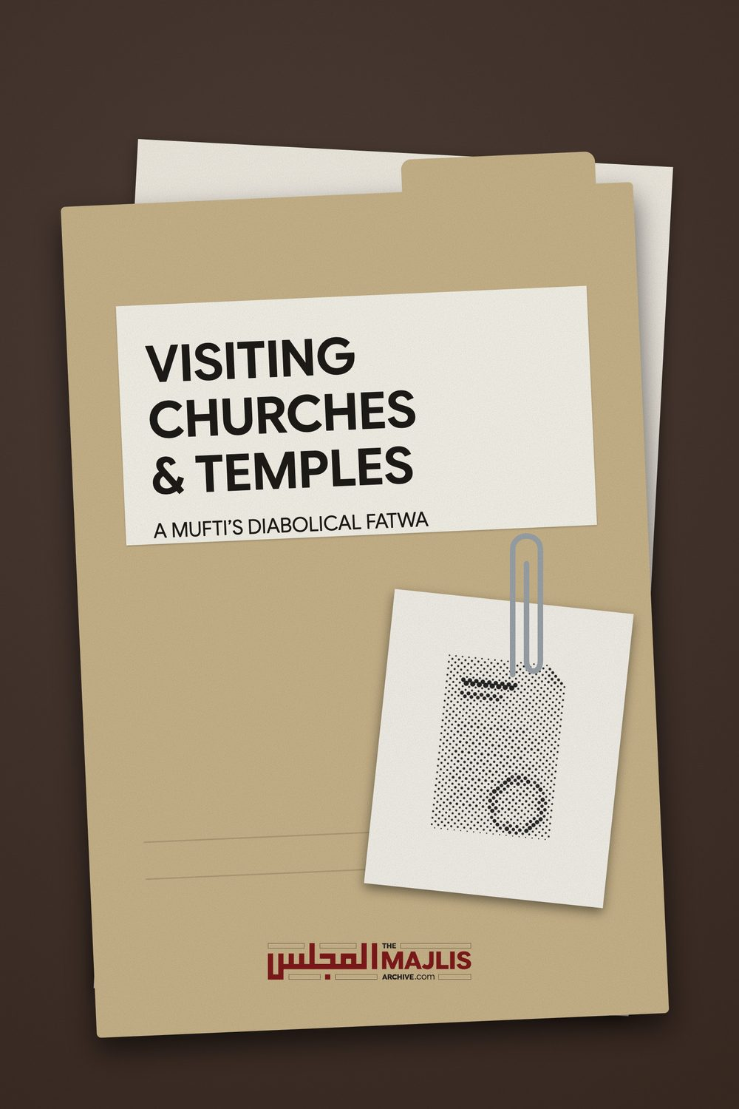

VISITING CHURCHES AND TEMPLES
The Majlis · Voice of Islam
Mujlisul Ulama of South Africa

About this edition
This is a reproduction by The Majlis Archive (themajlisarchive.com) of a publication of The Majlis, Mujlisul Ulama of South Africa, made and published with their permission.
The PDF as The Majlis issued it is the original. This edition was read from that PDF's own structure and checked against it letter for letter; where the two differ, the PDF is correct.
Checked: 189 paragraphs, 0 differing; a second, independent PDF reader finds 100.0% of the PDF's words here.
Nothing has been reworded, added or removed.

VISITING CHURCHES & TEMPLES A MUFTI'S DIABOLICAL FATWA

MUJLISUL ULAMA OF S.A. PO BOX 3393 PORT ELIZABETH SOUTH AFRICA

VISITING CHURCHES & TEMPLES
Question According to Fataawa Darul Uloom Zakariyya it is permissible to enter churches for a need (dhuroorat). However, according to The Majlis it is not permissible. Please comment.
Answer The Mufti of Darul Uloom Zakariyya said that entry is permissible if there is a dhuroorat. He also mentioned that it is Makrooh. A dhuroorat renders permissible a haraam act, even consuming pork.
It appears that the Mufti Sahib is a supporter of the kufr interfaith movement. The question posed to him is:
"An Aalim of the Deen went into a church to attend some interfaith meeting…"
It was in response to this question that the Mufti couched his fatwa in terms to convey the idea that participating in interfaith programmes is 'dhuroorat' (a dire need). It is clear that the Mufti lacks understanding of the interfaith plot of the Yahood and Nasaara, hence he believes that interfaith being a dhuroorat justifies entering into the abode of the devils – the abode of shirk and kufr – the abodes on which descends the La'nat of Allah Azza Wa Jal. Furthermore, almost every haraam act could be rendered permissible on the basis of a dire need (dhuroorat), hence it is highly improper and deceptive for a mufti to introduce this factor when there is absolutely no need for it. The molvi chap who had entered the church had not done so to merely attend a meeting. He actively engaged in prayer with the priests of kufr and shirk, sitting under a dozen crosses.
Although the Mufti had commenced his fatwa cautiously, he lapsed into a zigzag trajectory citing several episodes to dilute and even negate his own fatwa. There was no need for the zigzag trajectory especially in view of the interfaith curse. The obligation of a Mufti is to guide the masses, not to confuse them and not to open up avenues of fitnah which threaten not only the akhlaaq of Muslims, but even their Imaan.
The example of the Reverend Cross or Reverend Abraham Bham is more than adequate to convince sincere Muslims of the impermissibility of unnecessarily entering and visiting churches. In the furtherance of the interfaith plot Reverend Cross who professes to be a Muslim prayed under 12 crosses alongside the priests of shirk and kufr in the church. How can this ever be permissible?
Nothing is more abhorrent for Allah Ta'ala than shirk. The Qur'aan is replete with Aayaat emphasising the abhorrence of Allah Ta'ala for shirk. The Qur'aan even states explicitly that there is no forgiveness for shirk.
"Verily, Allah does not forgive that shirk be committed with Him while He forgives all sins besides it (shirk)."
(An-Nisaa', Aayat 48)
A church is where the unforgivable sin of shirk is committed.
A Mufti should be farsighted. He should understand the implications of his fatwa. He should not acquit himself as if he is teaching students in a madrasah. The technicalities and obscurities should be restricted to academic circles, not advertised to cause the masses to fall into confusion and to eke out advantage for the commission of haraam.
The zigzag trajectory of the Mufti Sahib is extremely confusing, especially for ordinary Muslims, and it provides gratification for the interfaith satanic rubbish interfaithers lurking in the folds of the community.
In his effort to dilute his own fatwa, the Mufti says that Makrooh in the context does not mean Makrooh Tahrimi. Indeed he has committed a grievous error. His spurious averment is extremely harmful for ordinary Muslims. In Al-Bahrur Raaiq is mentioned: "It is obvious that it is Tahrimi." That is: It is Makrooh Tahrimi to enter a church.
Ignoring the Fataawa of the Fuqaha, this Mufti dug out obscure episodes of which the Fuqaha were aware, but which they did not utilize as does this Mufti for legalizing entry into churches and temples. Shaami states:
"…..It (the church) is the abode of the shayaateen, hence Salaat in the churches and temples of the kuffaar is not permissible (i.e. Makrooh Tahrimi), and that is because it is the abode of the devils as the Shaafis have explicitly said…. In Al-Bahr in Kitaabud Da'wa it is said: 'Oaths shall not be taken in their (i.e. kuffaar's) places of worship. In At-Taataarkhaaniyah it is said: 'It is Makrooh (i.e. Tahrimi) for a Muslim to enter a synagogue or a church. It is Makrooh because these places are the gathering places of the shayaateen…
It is obvious that Makrooh means Tahrimi because the meaning of the term when stated by them (the Fuqaha) unrestrictively is Tahrimi. Verily, the fatwa has been issued to effect of Ta'zeer (whipping) the Muslim who frequents a synagogue with the Yahood."
This is also mentioned in the other authoritative Kutub such as Al-Fataawal Hindiyyah, etc.
The entry into churches by the conquering Sahaabah may not be utilized as a basis for permissibility to visit churches and temples which are the abodes of the shayaateen and on which the La'nat of Allah Ta'ala settles. How is it possible that visiting such abominable abodes of shirk could be Makrooh Tanzihi as the Mufti alleges in stark conflict with the ruling of the Fuqaha?
The Fuqaha were well aware of such episodes, nevertheless, they did not utilize these episodes for a basis to produce permissibility as did the Mufti. Whatever reasons the conquering Sahaabah had, were of political nature dictated by valid circumstances. They did not enter churches for interfaith meetings stemming from some satanic 'abraham accord' plot.
How can it ever be permissible to visit the abodes of the Shayaateen and the abodes on which the Curse of Allah Azza Wa Jal settles? A Mu'min need not be a mufti to understand the Divine Abhorrence for shirk and its headquarters, viz. churches and temples. The following factors are more than adequate for comprehending this mas'alah in the context of Divine Abhorrence:
(a) There is no greater and more abhorrent sin by Allah Ta'ala than shirk. Shirk is worse than murder, adultery, riba, liquor, etc., etc.
(b) The very first and primary focus of all the Ambiyaa (Alayhimus salaam) was the elimination of shirk.
(c) Allah Azza Wa Jal has stated several times in the Qur'aan Majeed that He forgives all sins, but shirk.
(d) Hadhrat Nabi Ibraaheem (Alayhis salaam) entered the temple of idolatry with an axe and destroyed all the idols. This indeed was a real dhuroorat which permitted entry into the temple. He decapitated all the idols which were left sprawling on the ground. Thus, the Divine Abhorrence for shirk is quite manifest.
(e) Churches, temples, synagogues and the like are the abodes of the Shayaateen.
(f) These abodes of shirk and kufr are Mal-oon and Mabghoodh. The Curse and Wrath of Allah Azza Wa Jal perpetually settle on these abodes of shirk.
(g) On the Conquest of Makkah, Rasulullah (Sallallahu alayhi wasallam) refused to enter the Ka'bah which until that time was treated as a temple of idolatry. It was filled with idols and pictures. Rasulullah (Sallallahu alayhi wasallam) instructed Hadhrat Ali (Radhiyallahu anhu) to first destroy all the idols and to efface all the pictures on the walls. Only thereafter our Nabi (Sallallahu alayhi wasallam) entered.
This entry of Hadhrat Ali (Radhiyallahu anhu) was dictated by dhuroorat (a real, dire need). Entering in the abodes of the shayaateen to participate in a haraam, kufr, shirk interfaith session is never ever a dhuroorat as the Mufti has egregiously misunderstood. On the contrary interfaith is an evil plot of the Yahood and Nasaara to eliminate Islam. But the Mufti believes that participating in interfaith meetings is a dhuroorat. Indeed it is a miserable commentary on the understanding of the Mufti.
(h) Even locations where the Athaab of Allah Ta'ala had settled are forbidden for Muslims. Thus, it is haraam to visit places such as the Dead Sea locality where the nation of Nabi Loot (Alayhis salaam) was destroyed because of their homosexuality. Other vile places such as the region where the Aad and Thamood were annihilated are also not permissible for Muslims. Such places are constantly accursed. The La'nat of Allah Azza Wa Jal settles perpetually and permanently on these abodes.
Now how can it ever be permissible for Muslims to visit the abhorrent abodes of the Shayaateen? The following salubrious episode of one of the greatest Taabieen, Hadhrat Saeed Bin Jubair (Rahmatullah alayh) illustrates the abhorrence of the true Mu'min for the abhorrent abode of the shayaateen.

THE CAPTIVITY OF HADHRAT SAEED BIN JUBAIR
The notorious tyrant Hajjaaj Bin Yusuf of Iraq sent his police to arrest Hadhrat Saeed Bin Jubair (rahmatullah alayh). By this time the tyrant had already slaughtered 120,000 Muslims among whom were numerous Sahaabah. Hadhrat Saeed was taken into custody from Makkah Muakarramah. Along the journey to Iraq, at nightfall, the party halted for the night at a place in close proximity to a Christian church. The priest from the church came out and warned them of a lion and lioness which roamed around the precincts late at night. He proposed that they spend the night in the church.
While the policemen happily accepted the offer, Hadhrat Saeed (rahmatullah alayh) said: "I shall not enter in the premises of a Mushrik. Allah suffices for me."
Late at night while Hadhrat Saeed Bin Jubair was engaging in Salaat, the lioness appeared and stood nearby observing the scene. When Hadhrat Saeed went into Sajdah, the lioness gently licked his feet. Soon the male lion appeared and stood nearby as if on guard. Meanwhile the Christian priest was struck by wonder viewing this miraculous scene. The policemen too were astonished. The priest embraced Islam. Although the policemen expressed their profound regret, they were overwhelmed by the fear of Hajjaaj. Finally they delivered Hadhrat Saeed Bin Jubair to Hajjaaj.
After a lengthy interrogation and fearless response by Hadhrat Saeed Bin Jubair (rahmatullah alayh), he was put to death. Just prior to his death, Hadhrat Jubair supplicated to Allah Ta'ala: "O Allah! After me, do not allow Hajjaaj power to kill anyone." This Dua was accepted. For as long as Hajjaaj lived thereafter, he was unable to kill anyone. He died in great agony. After the murder of Hadhrat Saeed, Hajjaaj lamented that every night when he wanted to sleep, an apparition of Hadhrat Saeed Bin Jubair (rahmatullah alayh) would appear and violently tug his legs. Thus perished the tyrant suffering and deranged by fear.
Despite there being a valid need (Dhuroorat), Hadhrat Saeed Bin Jbair (Radhiyallahu anhu) did not avail himself of the concession. This was on account of his abhorrence for the abode of the Shayaateen – the abode of shirk – the abode of Divine Abhorrence. Apart from the lofty stage of Hadhrat Saeed's Taqwa, which most people are unable to emulate, the reason for his abhorrence is confirmed, viz., it is not permissible to enter into the places of worship of the kuffaar.
The Mufti has ingeniously proffered some episodes of Sahaabah entering churches to eke out permissibility for an act which is clearly haraam in terms of the Shariah. It should be understood that the issue of Dhuroorat (dire/real need) is not being disputed. The Mufti had ingeniously crafted his fatwa to condone and support the Reverend Abraham/Reverend Cross and also perhaps the swami molvis of Jamiat Juhala Hind of India who visit Hindu/Sikh temples wherein they are constrained to respect the idols of the mushrikeen. There was no dhuroorat to constrain permissibility. The miscreant chap went to the church to participate in the pernicious interfaith plot. Then he was constrained to pray under a dozen crosses together with a priest and swami.
If someone asks: 'Is it permissible to consume liquor and to eat pork?', what is the Mufti supposed to answer? It will only be a mufti' who is a fraud who will answer that if there is a dhuroorat then it is permissible. Then he proceeds to present a stack of episodes pertaining to starving persons having consumed pork and to some persons who drank wine because they were dying of thirst.
The simple answer is that wine and pork are haraam. There is no need for cunningly presenting confusion and misleading people with the dhuroorat argument. The Reverend of the Cross went into the church to commit shirk. There was no dhuroorat constraining him to go into the abode of the shayaateen.
The fatwa of the Mufti has rendered a great and a treacherous disservice to the Ummah, especially at this time when the interfaith kufr is on the increase. The attempt of the Mufti to justify free entry into the abodes of the shayaateen is indeed mind-boggling. His endeavour to justify and support Reverend Cross is extremely ingenious and haraam.
Instead of citing the example and command of Rasulullah (Sallallahu alayhi wasallam) and of Hadhrat Umar (Radhiyallahu anhu), the Mufti dug out some obscure episodes in his spurious bid to support Reverend Abraham Bham. On the occasion of the conquest of Makkah, Rasulullah (Sallallahu alayhi wasallam) refused to enter even the Ka'bah. Hadhrat Abdullah Ibn Abbaas (Radhiyallahu anhu) narrates:
"When Rasulullah (Sallallahu alayhi wasallam) saw the pictures in the Bait (Ka'bah), he did not enter. He ordered that the pictures be eliminated." (Bukhaari)
Rasulullah (Sallallahu alayhi wasallam) entered only after the pictures were effaced and the idols removed and destroyed.
In Umdatul Qaari, it is mentioned: "The reason for not entering their churches is the pictures therein." In fact, another reason emphasizing the prohibition is that churches/temples are the abodes of the Shayaateen. Another more important reason applicable to our current age is the danger it constitutes for the Imaan of people, especially converts who are already accustomed to worshipping in churches/temples.
Hadhrat Umar Bin Khattaab (Radhiyallahu anhu) said to a Christian leader of Shaam who had invited him for meals: "Verily, we do not enter your churches because of the pictures therein." (I'laamus Saajid) Thus, pictures, idols and shayaateen are the very basis for the Prohibition.
Al-Ustuwaani narrated that this statement of Hadhrat Umar (Radhiyallahu anhu) is in the category of "Marfoo' because in reality its meaning is: 'We have been prohibited from entering churches.' The one who has prohibited is the illustrious Nabi (sallallahu alayhi wasallam), not anyone else. Thus, the statement of a Sahaabi: "We do not do this, etc." is in fact in the Hukm of Marfoo' because it is not the effect of (personal) opinion. There is no scope for (personal) opinion in this matter. The prohibition demands Karaahat."
(Asluz Zuraari)
Marfoo': That is the hukm is by the directive of Rasulullah (Sallallahu alayhi wasallam).
The Sahaabah were conquerors. They had to assess the lands and the people they invaded and captured. One of the episodes proffered by the Mufti pertains to a church which the Sahaabah had converted into a military barracks. Their entry into churches was due to political expediency. They had a dhuroorat. No one is disputing concession when there is dhuroorat. Even today dhuroorat will be availed off for permissibility. But currently our discussion does not relate to dhuroorat which the Mufti has ingeniously introduced to craft out permissibility for Reverend Abraham Cross Bham. Interfaith, far from being a need is an evil plot against Islam.
It is therefore, not only futile, but treacherous and chicanery to proffer some anecdotes of the Conquering Sahaabah for the extravasation of permissibility for an act for which there exists explicit textual prohibition of the Sahaabah and the Fuqaha. It is like moronically arguing and 'proving' that pork and liquor are halaal on the basis of dhuroorat. The factor of dhuroorat is invoked only when there is a dire need. But interfaith!!!!!!
The need is to take into account the normal way and attitude of the Sahaabah based on the directive of Rasulullah (Sallallahu alayhi wasallam) to ascertain the ruling. For this, there exist adequate Nusoos for establishing the Prohibition.
Even Ibn Taimiyyah who is the Imaam of the Salafis, who did not subscribe to any Math-hab, said regarding churches/temples:
"…Because they (churches) are the abodes of kufr and the places of the shayaateen, it is Makrooh (Tahrimi) to perform Salaat in churches just as it is Makrooh to perform Salaat in places where the shayaateen gather.
…The Math-hab (Hambali) of the majority of the Ashaab (i.e. Fuqaha of the Math-hab) is that Salaat is Makrooh (in churches). In fact the Abomination (Karaahat) applies to entry into every place where there are pictures. Thus the prohibition of Salaat therein is more emphasized than entering."
Hadhrat Ali (Radhiyallahu anhu) said: "Verily, my Beloved (i.e. Rasulullah – Sallallahu alayhi wasallam) forbade me from performing Salaat in a graveyard and in the land of Baabil, for verily it is Mal-oonah (accursed)."
Churches are also mal-oon (accursed). It is therefore not permissible to enter such abodes without valid reason.
Rasulullah (Sallallahu alayhi wasallam) had also forbidden camping or staying for some time in all such places on which the La'nat and Punishment of Allah Ta'ala had settled. On the occasion of the Battle of Tabook, the Sahaabah passed by the place where the Thamood had been eliminated by the punishment of Allah Ta'ala. Water from this place was used in flour to bake bread. When Rasulullah (Sallallahu alayhi wasallam,) was informed that this place was accursed, he ordered that the flour be thrown away, and they quickly departed from the mal-oon place. This further confirms that Muslims should not enter the mal-oon temples of the kuffaar.
The deception perpetrated by the Mufti is the introduction of his own idea into the question. While the question was simply a query regarding a molvi going to the church to participate in a shaitaani interfaith meeting, the Mufti Sahib read dhuroorat into the question. He was supposed to have answered the question as it was posed, and not promote his own idea. He had crafted his answer in vindication of the haraam participation of Reverend Abraham Cross Bham in the haraam interfaith exercise of the kuffaar.
In these times of fitnah, the Imaan of most people dangles on a thread. They are on the precipice of destruction as Allah Ta'ala says in the Qur'aan Majeed:
"You were on the precipice of an abyss of fire then He saved you from it. Thus does Allah explain for you His Aayaat so that you may be guided."
(Aal-e-Imraan, Aayat 103)
There are numerous converts to Islam as well as innumerable born Muslims whose Imaan dangles on threads. The state of their Imaan is pathetic in the extreme. In fact, the state of even the Imaan of many molvis and sheikhs of this age is deplorable in the extreme. These people of weak Imaan have no qualms in going to churches and temples and even participating in the kufr prayers and customs of the abodes of the shayaateen.
We are speaking on the basis of practical experience. Some do not see anything amiss in walking around the holy Hindu fire and chanting shirki incantations during a wedding ceremony. Some go to the church to pay their respects to a deceased kaafir friend and his relatives. Some go to the church because the deceased happens to be their kaafir mother/father. Miserable molvis and sheikhs go to the temples and churches to participate in the shaitaani interfaith plot. Some attend the church because the wife happens to be a Christian. She had not embraced Islam. Some molvi/sheikh drunk with jahaalat had informed her husband that it was permissible to marry a Christian woman. In the process the man of weak Imaan becomes a semi-Christian which in terms of the Shariah is Irtidaad. Furthermore, the children follow the Christian mother, attend the church, eat haraam and act like the kuffaar in the style of their mother while the jaahil dayyooth husband's mouth is welded.
A Mufti is supposed to have his finger on the pulse of the community. His office and status require that he should acquit himself with wisdom and take into account the prevailing circumstances, then issue fatwas in the best interests of the Imaan and Akhlaaq of the community. Alas! Most muftis of this age of fitnah are bereft of wisdom and far-sightedness because they are spiritually bankrupt. They have no Taqwa. They suffer from the maladies of hubb-e-maal (love for wealth) and hubbe jah (love for name/fame). Thus do they mislead Muslims, taking them far away from Allah Ta'ala.
Regardng such molvis and sheikhs, Rasulullah (Sallallahu alayhi wasallam) said:
"I fear most for my Ummah the aimmah
(molvis/sheikhs) who are
Mudhilleen (they mislead Muslims, taking them to
Jahannam)."

DISPELLING THE HAZE AND CONFUSION
The Mufti has confused the simple Prohibition of entering/visiting churches and temples by introducing episodes of the Sahaabah who had entered churches. An explicit command issued by the Shariah may not be cancelled or argued away with isolated episodes occasioned by valid need.
There exists an abundance of Nusoos prohibiting entry to churches. These have already been mentioned in the aforegoing pages. Emphasizing the prohibition are many other factors which have also been discussed.
Regarding some Sahaabah having entered churches, it should be understood that the Sahaabah were not the resident Muslim community in the territories they had invaded and conquered. The Sahaabah were not tourists. They did not go to the churches for any sight-seeing, merrymaking, interfaith dialogue, etc. The Sahaabah were conquerors. They entered the lands of the kuffaar as Mujaahideen Fi Sabeelillah. Their mission was I'laa–e-Kalimatullaah. They waged Jihad not as a defensive exercise but to conquer the lands, to subjugate the kuffaar and to present Tauheed to them. The Sahaabah waged their Jihad wars to plant the Standard of Islam on the hilltops of the world.
In the process of Jihad, they entered the churches to establish their domination; to use the church premises for their needs; to investigate what was taking place, etc. Churches were used as even barracks by the Sahaabah. Churches were also transformed into Musaajid. Among the terms of safety and peace granted to the Christians were that:
• They should leave the doors of their churches open for Muslims.
• Muslims may enter at will whenever they deemed it necessary.
• New churches will not be built. • Dilapidated churches will not be renovated. • Spies will not be allowed inside churches. • Church bells will not be sounded. • Crosses will not be raised on churches. • They will not raise their voices in prayer in their churches.
Even the churches were held in subjugation by the Sahaabah. The Sahaabah were troops who had valid reasons for entering and subjugating churches. No one in this day has the right to cite these episodes of the Sahaabah to justify their respect, honour and bootlicking for priests and churches when they visit these abodes of the shayaateen. What analogy is there between the entry into churches of the Sahaabah and the entry of a moron molvi who honours the cross and worships inside the church?
When Rasulullah (Sallallahu alayhi wasallam) could not tolerate Hadhrat Umar (Radhiyallahu anhu) reading the Tauraah, how is it possible to tolerate Muslims going to churches, sitting there with respect thereby honouring the pictures and statues of shirk? Is there any comparison between the perfect Imaan of Hadhrat Umar (Radhiyallahu anhu) and the extremely defective Imaan of Muslims of this day whose Imaan dangles by threads? Narrating this incident, the following appears in Musnad Imaam Ahmad:
"Rasulullah (Sallallahu alayhi wasallam) said reprimandingly to Umar and others like him (who were reading or may read the scriptures of the Yahood and Nasaara): 'Do you want to be cast into confusion regarding your Deen by acquiring knowledge from other books and from (sources) other than your Nabi, just as the Yahood and Nasaara had done? They cast the Kitaab of Allah behind their backs and followed the ahwaa (vain and haraam desires of the nafs) of their scholars and saints.
When it is not permissible to show even a non-Muslim the direction of the church/temple, how can it ever be permissible to enter with respect and reverence a church and offer ostensible obeisance therein? In Fataawa Hindiyyah it is explicitly mentioned that it is kufr to show a kaafir the direction to the church/temple.
The Mufti should consult his conscience and ask himself: Just what business does a Muslim today have in a church or a temple? What precisely motivates a person who professes to be a Mu'min to go into a church? What business does he have in the abode of shirk and shayaateen? The Sahaabah had their valid causes for going into churches. They entered churches to assert their domination. They did not pay respects, homage and pray in front of crosses. On the contrary they ordered their Christian subjects (Zimmis) to pray silently even inside their churches. They were not allowed to ring their church bells. They had to tolerate whatever actions Muslims deemed appropriate to commit inside the churches.
The Sahaabah had conquered the lands of the enemies. They had to ensure that the churches were not being utilized to plot schemes against the Muslims. Thus, the Christians were ordered to leave open the doors of the churches at all times.
That the Mufti could understand Reverend Abraham Bham's praying in the church under 12 crosses to be dhuroorat defies credulity and boggles the mind. By what stretch of Imaani Aql can sareeh kufr voluntarily committed be interpreted to be dhuroorat? Something is gravely amiss in the comprehension of reality by the Mufti Sahib.
A dhuroorat (valid need) was the action of Nabi Ibraaheem (Alayhis salaam). He entered the temple of the mushrikeen with an axe and decapitated the idols of shirk. He did not pray in front of the idols. Now if any Muslim possesses such Imaan, then his entry into a church/temple would be applauded. He will be following the Sunnah of Nabi Ibraaheem (Alayhis salaam). Far from ever attempting to emulate Nabi Ibraaheem (alayhis salaam), Muslims who today visit churches and temples are bootlickers suffering from the disease of hypocrisy. Regarding these bootlickers, the Qur'aan states:
"You will see those in whose hearts is a disease (of kufr and nifaaq) racing among them, saying: 'We fear that some misfortune may befall us."
(Al-Maaidah, Aayat 52)
The Mufti's zigzag fatwa is designed to accommodate the bootlickers who enter and visit churches. It is devoid of Shar'i substance. Instead of guiding Muslims, the Mufti opens an avenue of grievous fitnah which can efface even the Imaan of Muslims.

IS THIS KUFR A DHUROORAT?
The Reverend's picture
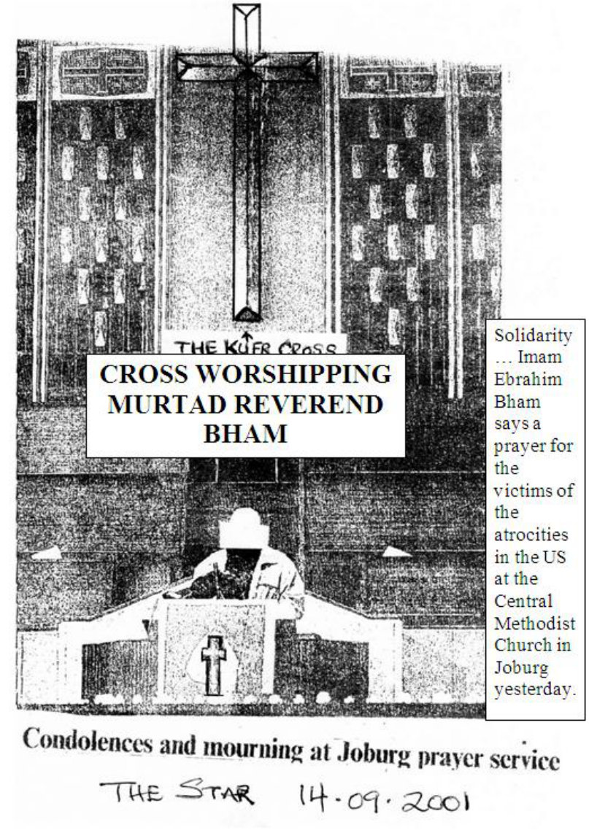
What analogy is there between the kufr entry into the church and obeisance of Reverend Abraham Bham worshipping the Cross, and the domineering entry of the conquering Sahaabah? On what basis has the Mufti hallucinated a dhuroorat for today's Muslims who enter churches/temples with their bootlicking attitude to acquit themselves with respect and reverence in the abodes of shirk and shayaateen? Despite there being absolutely no basis for imagining a need, the Mufti compounding his egregious blunder proceeded in a zigzag trajectory to baselessly introduce the Sahaabah to deceptively extravasate some semblance of 'daleel' for his conspicuously erroneous fatwa.
Sultan Mahmood Ghaznawai entered the great Hindu temple of idolatry. But his dhuroorat justified his entry. He entered to smash the idols in emulation of Nabi Ibraaheem (alayhis salaam). But Muslims who visit churches and temples today conduct themselves repulsively by acting in diametric contradiction of the stance of the Sahaabah.
The conclusion is quite simple. The Sahaabah entered as conquerors and dictated terms which the kuffaar had to observe even in their churches whereas today's Muslims who visit churches do so as bootlickers, hence they are constrained to respect and portray reverence for all the artefacts of kufr and shirk in churches such as crosses, pictures, etc.
One UK molvi who visited a church commented: "When we went there, we took out our shoes as a custom of us when we enter a holy place." His brains are fossilized with kufr. Thus, he found it valid to elevate the abode of shirk and shayaateen to the lofty status of a Musjid. The Musjid is the abode of the Malaaikah whereas the church is the abode of the shayaateen- the abode where the worst belief of shirk is given practical expression.
In India, some swami 'molvis' of the Jamiatul Juhala Hind, also visit Hindu temples of idolatry to pay their respects. Inside the temples they have to portray reverence for the idols. Yet the mission of all the Ambiya was to destroy every vestige of idolatry and shirk.
In Dubai the murtad ruler went a multitude of steps further in offering obeisance to the idols of shirk. He, his wife and some other moron murtaddeen stood in worship mode in front of the main Hindu idol with trays of 'holy' food on their heads as offerings for the idols. To what lower levels of rijs can Muslims stoop? Can such shirk be justified on the basis of the entry into churches of the Conquering Sahaabah?
In this age, Muslims who enter churches and temples are constrained to enter submissively. They have to display respect and reverence for all the artefacts of shirk and kufr. If prayers are in progress, the Muslim inmates sit silently with respect. Such respect is to honour shirk. There is no greater abhorrence for Allah Azza Wa Jal than shirk. Churches are the factories of shirk and kufr.
The Muslim who goes into a church emerges, at the minimum, with emaciated Imaan. Perhaps he emerges with effaced Imaan without him even realizing the magnitude of the calamity which has befallen him.
Coexistence and living harmoniously with non-Muslim neighbours do not require visiting their churches and temples. For them is the message of Surah Kaafiroon:
"For you is your religion and for us is our religion."

WAS TARIQ JAMEEL'S VISIT TO THE SIKH TEMPLE A DHUROORAT?
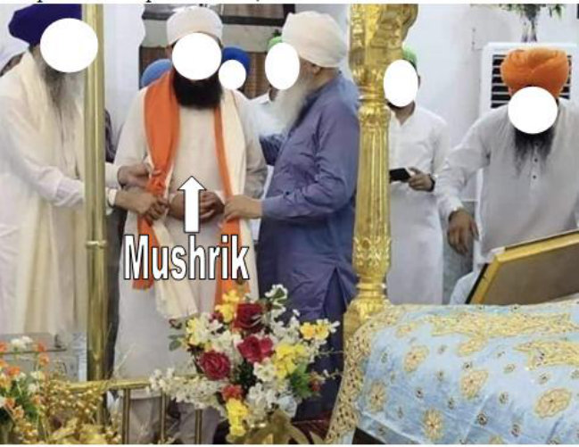

Press report LAHORE:
Renowned religious scholar Maulana Tariq Jameel came under criticism on social media platforms on Sunday, a day after his visit to a Sikh religious site in Kartarpur, the Gurdwara Darbar Sahib.
A delegation of religious scholars also accompanied Maulana Tariq Jameel during the visit to Kartarpur Sahib on Saturday. They were received by the head granthi of Gurdwara Sahib, Sardar Gobind Singh, Punjab Assembly Member Sardar Ramesh Singh Arora and others.
Maulana Tariq Jameel was also given a briefing regarding Kartarpur. He was told that Baba Guru Nanak, the founder of the Sikh religion had spent the last 18 years of his life and that he taught monotheism instead of idolatry.
He was told that Baba Guru Nanak was a proponent of humanity and brotherhood.
The administration of Gurdwara Sahib gave him gifts, including Saropa and Kirpan.
During his visit, the religious scholar also met and interacted with the Sikh pilgrims, who had come to their holy site. Speaking on the occasion, Maulana Tariq Jameel said that Islam teaches respect for the rights of minorities and their sanctities.
"Kartarpur is the corridor of peace," he said. "Minorities in Pakistan enjoy full religious freedom."
However, the visit drew criticism on social media as the pictures were shared on various platforms.
https:/ /tribune.com.pk/story/ 2378629/ 1 (End of Report)
Our Comment This vile Rascal is scheduled to darken the shores of South Africa. How can Muslims who profess belief in Tauhid ever sink to the gutter kufr level of listening to the satanically adorned talks of this Munaafiq enemy of Islam? Those who have invited him and those who will be hosting this shaitaan in human form will lose their Imaan.
It is haraam to participate in the talks of this Mushrik, Munaafiq and Murtad. No longer has he any vestige of shame for the Ummah, hence he so audaciously and flagrantly attended the ceremony of shirk and kufr in the Sikh temple. The rubbish molvis who had accompanied him to the temple of shirk have also lost their Imaan.
This kufr/shirk attitude of Tariq Jameel is a common factor in all molvis who participate in the kufr interfaith religion of Iblees. It is time that these mushrik scoundrels, shave their beards, derobe themselves and don the garb of the mushrikeen priests, sadhus, pundits, swamis and the like.
Now that Tariq Jameel's shirk and kufr are no longer concealed, it is not permissible to allow the scoundrel in the Musjid to perform Salaat. If his hosts want him to be a Muslim, they should pressurize the shaitaan to resort to public Taubah to renew his Imaan.
This Tariq Jameel character and his likes such as Reverend Abraham Bham, Sooliman Moolla, Menk and others all come within the purview of the Qur'aanic Aayat:
Thus, have We appointed for every Nabi, human and jinn devils (shayaateen) who whisper to one another satanically adorned statements (zukhruful qawl) for deceiving."
(Al-An'aam, Aayat 112)
WAS THE PRAYING OF THESE MURTAD BOGUS 'SHEIKHS' IN THE CHRISTIAN CHURCH DICTATED BY DHUROORAT?
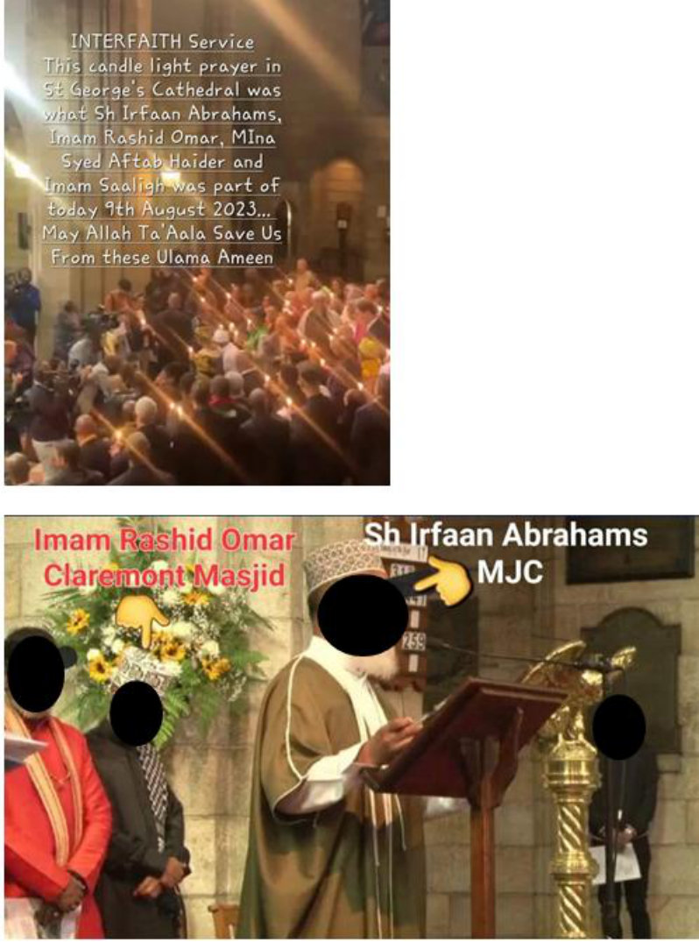
Question What does our Shariah say about MJC sheikhs and Imaams participating in interfaith prayers in a Christian church?
On 9th August 2023 Sheikh Irfaan Abrahams, Imam Rashid Omar, the Shiah Aftab Haider and Imaam Saaligh were at St.George's Cathredral in Cape Town taking part in a candle light interfaith prayer service. Please comment.

OUR COMMENT AND ANSWER
Every Muslim, be he/she a moron, as long as his/her Imaan is intact will readily understand that these miserable characters masquerading as sheikhs, imams and muslims are in fact MURTADDEEN of the worst order.
They had conducted themselves exactly like the kuffaar Nasaara. They are under the perpetual La'nat of Allah Azza Wa Jal. Salaat behind such characters whose nifaaq and irtidaad have been conspicuously portrayed by themselves, is never valid.
The participation of the Shiah fellow is quite understandable. Since he is not a Muslim, the issue of irtidaad does not apply to him just as it does not apply to the Christian participants. They are all of the same feather. All of them are Hasabu Jahannam (Fuel of Jahannam).
But the other characters who claim to be Muslims are in reality Munaafiqeen whose kufr is concealed in their hearts. Their participation in the prayer services of kuffaar makes manifest their hidden kufr.
All of these munaafiqeen and murtaddeen are signs of Qiyaamah. That they will be on the increase as Qiyaamah approaches, has been predicted by Rasulullah (Sallallahu alayhi wasallam). Muslims must expect this type of fitnah to be incremental with each passing day. Beware of them. They will rob you of your Imaam then you too will become Hasabu Jahannam.

IS THIS PRAYING INSIDE A CHRISTIAN CHURCH BY A 'MUSLIM' A DHUROORAT?
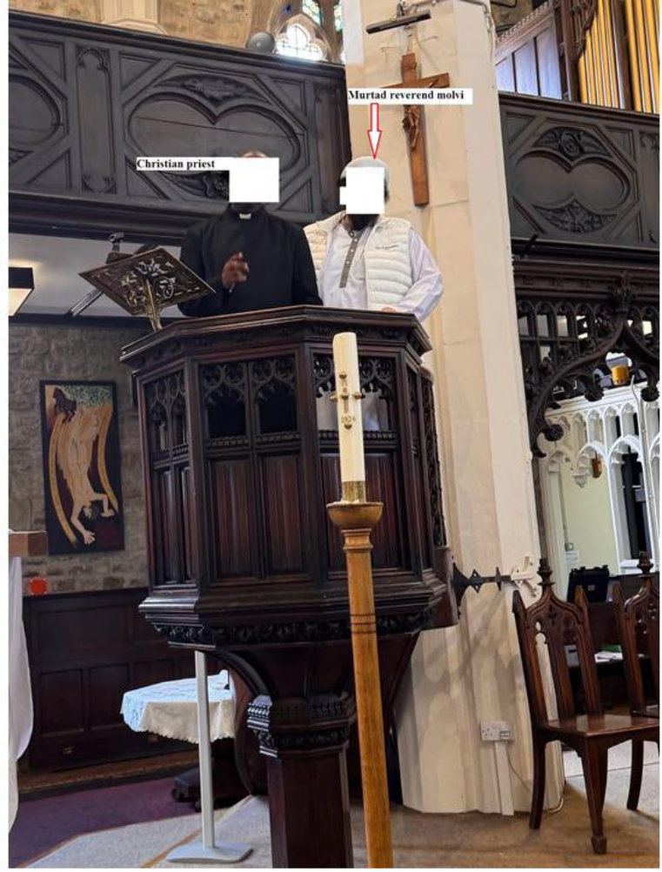
A Brother from the UK writes: ASSALAMU ALAIKUM
01 Dhul Hijjah 1447 / 18 May 2026
Respected Mufti Saheb
It appears that the Athaab of Allah Ta'ala upon the miscreant, treacherous and rebellious UK Muslim community is not just on the horizon, it edges closer and closer whilst the community remains engrossed in open disobedience of Allah Ta'ala.
If the rot amongst the Mullahs is anything to go by, what hope remains for the laity?
In recent weeks we have had a prominent UK Mullah congratulate and celebrate a Sikh Vaisakhi Festival as it was passing by his Masjid (Image Attached). The dishonourable Mullah said,
'We on behalf of Indian Muslim Association congratulate our Sikh brothers who are celebrating Vaisakhi. This is a festival of unity, love, caring and sharing. It is our pleasure on behalf of Indian Muslim Association to greet and congratulate them as they go past and offer them some gifts. I am honoured that we have with us our (female) Member of Parliament to join us in these celebrations.'
This thoroughly dishonourable Mullah then proceeded to meet and greet the Sikh procession.
In another instance, a Mullah posted a photo of himself smiling and joking with a christian priest inside a church altar (Image photo attached).
How long will it be before Kuffar demand access to Masajid to carry out similar reciprocal stunts?
That Muslims are required to live as good neighbours is denied by nobody. What need is there to willingly participate in Kuffar festivals and to bootlick them?
Ironically, it is these same Mullahs and their bootlickers who end up antagonising the Kuffar with their provocative behaviour.
They chant the Adhan in soccer stadiums, display Durood Shareef in predominantly Kuffar areas, hold mass provocative 'Iftars' in public spaces and march like transvestites on 'Pro-Palestinian' demonstrations; antagonising and infuriating the Kuffar in the process.
In recent UK elections, the Anti-Islam Reform party have topped the polls and only a few days ago, a mass Anti-Muslim rally was held in London attended by around half a million Kuffar where the slogans of 'Remove Islam' and 'They must all leave' were openly chanted and cheered on by thousands of attendees.
These are clear warnings for this miscreant community about what lies ahead.
UK Mullahs (and their bootlickers) remain as deaf, dumb and blind observers to this chaos, more interested in their Mock 'Umrah' holidays and 'Islaahi Programmes', in the process having their grubby eyes and hands on the purses and lingerie of Muslim Ladies.
The same Mullahs who were vocal during the Convid Scamdemic are now satanically silent.
Our situation appears to be similar to what the Muslims of Bosnia faced during the early 1990s. Unless we change course rapidly and repent sincerely to Allah Ta'ala, we face a wipeout in the UK that could dwarf the Bosnian Genocide.
(End of letter)
Rasulullah (Sallallahu alayhi wasallam) said that an age will dawn when "the worst of mankind under the canopy of the sky will be the ulama". This "worst kind" of murtad molvis is on a rapid increase all over the world, with the UK leading in the field of molvi irtidaad.
When the Guillotine of Divine Chastisement finally falls on the community, Muslims should not wail and moan. The Athaab of Allah Azza Wa Jal is a fact of certitude. The molvies have transgressed beyond all bounds of villainy, fisq, fujoor and kufr. Muslims should understand and remember:
"You will not find a change for the Sunnah (of Allah's
Athaab)." (Qur'aan)
In the temples and churches of shirk and kufr they lost whatever little Imaan they may have had. What dhuroorat did the Mufti discern in these visits to the temples and churches to constrain him to issue his corrupt fatwa? There is absolutely no dhuroorat for Muslims to enter churches and temples. They visit the abodes of the shayaateen at the peril of destroying and eliminating their Imaan.

