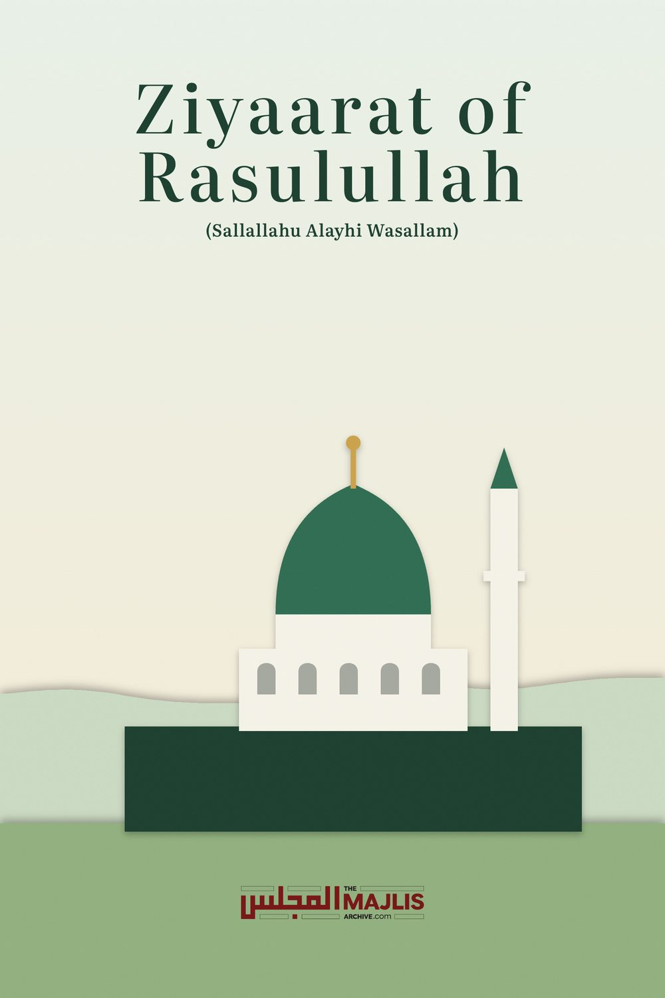

Ziyaarat of Rasulullah (Sallallahu Alayhi Wasallam)
The Majlis · Voice of Islam
Mujlisul Ulama of South Africa

About this edition
This is a reproduction by The Majlis Archive (themajlisarchive.com) of a publication of The Majlis, Mujlisul Ulama of South Africa, made and published with their permission.
The PDF as The Majlis issued it is the original. This edition was read from that PDF's own structure and checked against it letter for letter; where the two differ, the PDF is correct.
Checked: 101 paragraphs, 0 differing; a second, independent PDF reader finds 97.1% of the PDF's words here.
Nothing has been reworded, added or removed.

Ziyaarat of Rasulullah (Sallallahu Alayhi Wasallam)
By:
Mujlisul Ulama of S.A
Port Elizabeth South Africa


INTRODUCTION
Ziyaarat or presenting yourself in the Sacred Court of Rasulullah (Sallallahu Alayhi Wasallam) at Madinah Munawwarah is indeed among the greatest blessings and fortunes. Whoever is blessed with the opportunity of making Ziyaarat of Nabi-e-Kareem (Sallallahu Alayhi Wasallam) should have an understanding of the tremendous significance and the wonderful fortune of this Sacred Visit. A windfall of the greatest thawaab has come his way. He must, therefore, acquire the maximum benefit from this golden opportunity which Allah Ta'ala has bestowed on him.
Many people, due to lack of knowledge, lack of proper understanding of the importance of the Ziyaarat or through negligence ruin this great chance of gaining the great and wonderful spiritual benefits and thawaab attendant to the Ziyaarat. It is for this reason that the publication of this booklet has become expedient. May Allah Ta'ala accept this small service and may he fill our hearts with the true love of Rasulullah (Sallallahu Alayhi Wasallam) – a love which will manifest itself in our practical life in the assertion and dominance of the Sunnah of Rasulullah (Sallallahu Alayhi Wasallam).
MUJLISUL ULAMA OF SOUTH AFRICA
Port Elizabeth,6056
South Africa

Rasulullah (Sallallahu Alayhi Wasallam) said:
"My shafaa'at (intercession) is waajib (obligatory) for the one who visits my grave."
"Verily, he who made Hajj and refrained from visiting me (i.e. my Qabar), has rendered me an injustice."
Ziyaarat of Rasulullah's (Sallallahu Alayhi Wasallam) holy Qabar (grave) is the highest of Mustahab acts. Therefore, those who proceed for Hajj should consider it incumbent upon themselves to make the Ziyaarat. In order to understand the importance and significance of the journey to Madinah Munawwarah, it is necessary to cite some Ahadith of Rasulullah (Sallallahu Alayhi Wasallam). As long as the significance, sanctity and importance of Madinah Munawwarah are not embedded in the heart, the visitor will not be in the position to correctly discharge the rights of the Sacred Visit to the Holy City.
Rasulullah (Sallallahu Alayhi Wasallam) said:
1. "The la'nat (curse) of Allah, of the Malaaikah and of all creation descends on a person who introduces a bid'ah (innovation) in Madinah or gives refuge to a bid'ati (innovator) in Madinah. Neither the Fardh nor Nafl (acts of Ibaadat) of such a person is accepted".
2. "I will be the intercessor for the Mu'min who patiently bears the hardships and hunger (which he may encounter) in Madinah."
3. "I was commanded to make Hijrat (migrate) to a city which overwhelms all cities. Madinah Munawwarah drives away evil people like a furnace purifies steel."
4. "He who deceives the people of Madinah will recede into insignificance like salt is dissolved by water." 5. "Among the lands of Islam, the very last city to be destroyed will be Madinah."
Numerous Ahadith regarding the sanctity, significance and excellence of Madinah Tayyibah have been narrated. In the Ahadith it has been said that in the sands of Madinah Tayyibah is a cure for every disease. Hadhrat Shaikh Abdul Haqq Muhaddith Dehliwi (Rahmatullah alayh) said:
"When I was in Madinah Tayyibah my feet were swollen. I used the blessed sand as treatment (for my ailment). Within a few days I was cured."
In view of the sanctity and significance of Madinah Tayyibah, it is essential to respect and honour the people of Madinah. Regarding the inhabitants of Madinah Tayyibah, Nabi-e-Kareem (Sallallahu Alayhi Wasallam) said: "My Ummah should protect the honour and dignity of my neighbours. My Ummah must not be deficient in fulfilling their rights. Overlook their faults as long as they abstain from major sins. He who protects their honour, I shall be his witness on the Day of Qiyaamah."
Those who disrespect the people of Madinah or quarrel with them, should digest the following warning of Rasulullah (Sallallahu Alayhi Wasallam):
"He who dishonors the people of Madinah will be given to drink from Teenatul Khabal."
Teenatul Khabel is a pond in Jahannum where the blood, evil fluids and impurities of the inmates of the Fire will accumulate.
"He who frightens the people of Madinah is like a person who frightens me. Neither his Fardh nor his Nafl if accepted."
From the few statements of Rasulullah (Sallallahu Alayhi Wasallam), which we have cited above, you will be able to understand the holiness and greatness of Madinah Munawwarah and its inhabitants. You have, therefore, to regard your opportunity to visit the sacred city and the Sacred Raudhah (Grave) of Rasulullah (Sallallahu Alayhi Wasallam) as a great fortune. You must, therefore, spend every moment of your time in Madinah Tayyibah constructively so as to obtain maximum benefit and Thawaab. In the pursuit of the wonderful rewards of the Ziyaarat it is imperative that you diligently guard your heart, tongue and limbs. Abstain totally from all evil, futile and nonsensical acts and discussions. Speak only when necessary.

ZIYAARAT OF THE SACRED QABAR
Although it is permissible to render the Ziyaarat before or after Hajj, the following course is best:
a. If the Hajj is Fardh, it is best to make Ziyaarat after completing the Hajj. b. If it is a nafl Hajj, it will be the same if Ziyaarat is made before or after Hajj. c. Those who approach Makkah Mukarramah from the direction of Madinah Tayyibah, should render the
Ziyaarat before Hajj.
The visitor must constantly remind himself that he is not on a holiday tour. This is no ordinary visit. He is on a holy journey and is, therefore, bound to observe all rules, respects and etiquettes of the sacred visit. He must at no time indulge in any act or discussion which despoils or detracts from the sacredness and thawaab of the holy visit.

THE NIYYAT
When about to set out for the journey to Madinah Tayyibah make niyyat (that is, form an intention of Ziyaarat of Raudha-e-Aqdas (the Holiest Grave) as well as niyyat of Musjid-e-Nabawi. This form of niyyat is best.

EN ROUTE TO MADINAH TAYYIBAH
Along the journey to Madinah Tayyibah recite Durood Shareef in abundance. In fact, spend all available time, other than the time engaged in Fardh acts, reciting Durood Shareef. In this way endeavor to imbue eagerness and enthusiasm in your heart for the Ziyaarat.
On your way to Madinah Tayyibah visit all the holy places which you pass by. Perform Salaat in those Musjids which are specifically related to Rasulullah (Sallallahu Alayhi Wasallam) and the Sahaabah (Radhiallahu anhum). Drink of the waters of the holy wells which you locate along the road to Madinah Tayyibah.
As you near Madinah Tayyibah, increase your recitation of Durood Shareef. Endeavor to imbue in your heart love and fervor for the Ziyaarat. If you are unable to induce such feelings physically in your heart, then at least attempt to create such a mental state. Rasulullah (Sallallahu Alayhi Wasallam) must be foremost in your mind.
When your gaze first falls on the trees and buildings of Madinah Tayyibah, recite Durood Shareef much and make dua. It is best to dismount from the vehicle and walk on foot, if this is possible. It is best to proceed barefooted and shedding tears.
When you reach the boundary of Madinah Tayyibah, recite Durood Shareef and the following dua:
If possible, take ghusl before entering the City. If this is not possible, take ghusl after having entered the City. If for some reason, this too is not possible, make wudhu. But, ghusl is afdhal (best) Don Clean garments and if possible, new garments.
As you enter the City Gates, recite:
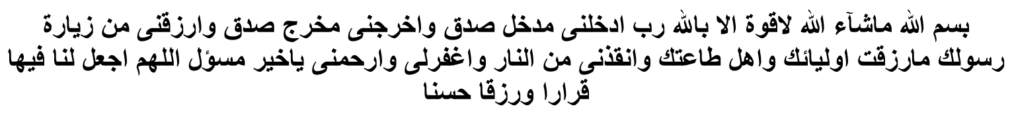

INSIDE MADINAH TAYYIBAH
When your gaze falls on the sacred Green Dome, contemplate its sanctity and nobility. This is the holiest place. After having entered the City, endeavor to firstly enter Musjid Nabawi. It is best for women to make the Ziyaarat during the night.
Enter Musjid Nabawi with your right foot and with utmost humility and reverence. As you enter, recite:
You may enter Musjid Nabawi from any entrance you wish. However, it is of greater merit to enter through the entrance known as Baabul Jibraeel.
Inside the Musjid perform two raka'ts Tahyatul Musjid in the area known as Raudhah. This is the area between the Mimbar and the Holy Grave of Rasulullah (Sallallahu Alayhi Wasallam). In the first raka't recite Surah Qul Yaa Ayyuhal kaafiroon after Surah Faatihah. In the second raka't, after Surah Faatihah, recite Surah Qul Huwallahu Ahad. Speaking on the significance of the area known as the Raudhah, Rasulullah (Sallallahu Alayhi Wasallam) said:
"Between my home and my Mimbar is a Garden of the Gardens of Jannat."
Although it is afdhal (best and of greater merit) to perform the two raka'ts Tahyatul Musjid in the Mihraab of Nabi (Sallallahu Alayhi Wasallam), you may perform it anywhere in the Raudhah, wherever you find place. After this Salaat, engage in Hamd, Thana and Shukr. Thereafter, make dua for the acceptance of your Ziyaarat. Then, again perform two raka'ts Saalatush Shukr which is Salaat performed in gratitude to Allah Ta'ala for having blessed you with the great favour of Ziyaarat.
If at the time of entry into the Musjid, Jamaa't of Fardh Salaat has begun or there is fear of your Salaat becoming Qadah, then perform the Fardh Salaat. In this case do not engage in Tahyatul Musjid. Your Tahyatul Musjid will be incorporated into the Fardh Salaat. By joining in the Fardh Salaat, Tahyatul Musjid will be rendered as well.

THE WAY OF RECITING SALAAM AT THE HOLY RAUDHAH (GRAVE)
After Tahyatul Musjid, proceed to the Sacred Qabr of Rasulullah (Sallallahu Alayhi Wasallam) with much reverence, humility, eagerness and respect. Banish all affairs and thoughts of the world from your heart and mind, and brace yourself for your presence in the Court of the Leader of mankind, our beloved Rasulullah (Sallallahu Alayhi Wasallam).
Stand about a metre from the pillar which is located at the corner of the wall at the head-side of the Holy Qabar. Stand with your back towards the Qiblah an move slightly to the left so that you directly face the Holiest of Faces. Do not cast your gaze all over the show. Adopt an attitude of utmost respect and awe. It is not respectful to cast the gaze all over. Do not do anything disrespectful. Do not stand very close to the Holy Qabar.
Do not touch the wire-mesh enclosure. Do not kiss nor make Sajdah. While standing there picture in your mind that Rasulullah (Sallallahu Alayhi Wasallam) is reclining, facing the Qiblah inside the Holy Qabar and that he is listening to the Salaams which are being recited.
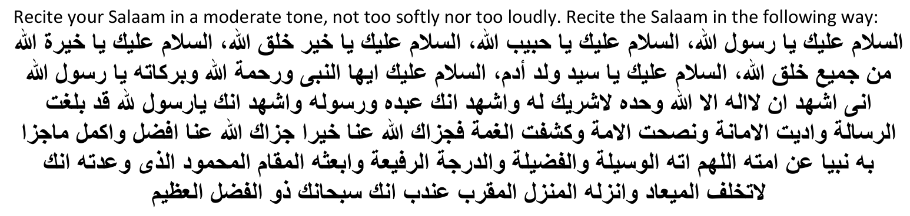
After the Salaam make dua, invoking the Waseelah (agency) of Rasulullah (Sallallahu Alayhi Wasallam), i.e. make your dua to Allah Ta'ala, asking Him (Allah Ta'ala) to accept your dua through the Waseelah of Nabi-e-Kareem (Sallallahu Alayhi Wasallam). Make a request for the Shafaa'at (Intercession of Rasulullah (Sallallahu Alayhi Wasallam)in the following way:
It is not compulsory to recite the above Salaam formula. You may recite any other form of Salaam as you wish. If one cannot remember any long form of Salaam, recite whatever you can remember of it. The minimum requirement for Salaam is to say:

Salaam upon you, O Rasulullah!
If someone had requested you to convey their Salaams to Rasulullah (Sallallahu Alayhi Wasallam), do so. After you have recited your own Salaams, convey the Salaams of the one who had requested you, in the following way:
Rabb.
While conveying the Salaams of the person who had requested you, recite his name after the word من (mien) which appears in the Arabic Salaam, above.
If several people had asked you to convey their Salaams, do so in the following manner:
Salaam upon you, O Rasulullah, from all those who had requested me to convey Salaams to you.
On the right side of the Holy Qabar of Rasulullah (Sallallahu Alayhi Wasallam) is the Qabar of Hadhrat Abu Bakr Siddique (radhiallahu anhu). Move slightly to the right and while standing in line with the holy face of Hadhrat Abu Bakr, recite Salaam on him in the following way:
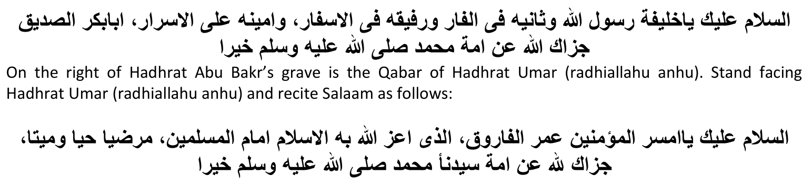
You are at liberty to recite lengthier or shorter formulae of Salaams.
According to some Ulama, after completing the Salaam on Hadhrat Umar (radhiallahu anhu), one should move to a position between the two graves of these two Khulafa of Rasulullah (Sallallahu Alayhi Wasallam) and renew the Salaam as follows:

Thereafter, face the Holy Qabar of Rasulullah (Sallallahu Alayhi Wasallam) and once again renew the recitation of Salaam on Rasulullah (Sallallahu Alayhi Wasallam). Then recite Hamd and Thana; then Durood Shareef and make dua to Allah Ta'ala, invoking the Waseelah of Rasulullah (Sallallahu Alayhi Wasallam). Again request for Rasulullah (Sallallahu Alayhi Wasallam)'s Shafaa'at. When making dua, raise both hands. Your dua should be for yourself, parents, Mashaaikh, family, relatives, friends and for all Muslims in general. After the Salaam, it is best to say as follows:

After having made the Ziyaarat, go to the pillar known as the Pillar of Abi Lubaabah. Perform two raka'ts Nafl Salaat there and make dua. Then come into the area known as Raudhah and perform Nafl Salaat in any quantity you wish. However, do not perform any Salaat if it is a Makrooh time. Recite Durood Shareef here in abundance and make dua.
Thereafter proceed to the Mimbar; place your hands on it; recite Durood Shareef and make dua. Then go to the pillar known as the Pillar of Hanaanah. Make dua and recite Istighfaar. Do the same at the other pillars. After this, return to your place of residence.
Consider the time you have available in Madinah Tayyibah as a golden opportunity. Spend most of your time in Musjid Nabawi. When in the Musjid, make niyyat for I'tikaaf. Nafl I'tikaaf is of any duration. Even one minute Nafl I'tikaaf is valid. Therefore, whenever you are inside the Musjid make niyyat of I'tikaaf. Endeavor to make khatm of the Qur'aan Shareef in the Musjid.
Give Sadqah to the poor according to your means. Honour and respect the poor, the Caretakers of the Holy Places and all the inhabitants of Madinah Tayyibah. Treat them with respect. Deal with them with love and kindness. In honouring them you are honouring and pleasing Rasulullah (Sallallahu Alayhi Wasallam). Even if they are perhaps unjust or unkind with you, bear it with patience. Do not quarrel and dispute. When buying and selling with them, make the niyyat of aiding them. Such a niyyat merits Thawaab.
Endeavor to be present at Musjid Nabawi five times daily. Ensure that your back is not towards the Holy Grave, whether you are performing Salaat or not. Whenever you pass by the Holy Qabar, recite Salaams, even if it be a short Salaam and even if you happen to be outside the Musjid.

OTHER PLACES OF ZIYAARAT
It is Mustahab to also visit the Qabrastaan (cemetery) known as Jannatul Baqi where the graves of the Sahaabah-e-Kiraam and of members of Rasulullah's (Sallallahu Alayhi Wasallam) Family are. Make a point of visiting the Qabar of Sayyudush Shuhada (The Leader of Martyrs, Hadhrat Humzah (radhiallahu anhu).
Visit Musjid Quba as well as other Musjids. Visit the holy wells and drink of their water.

YOUR DEPARTURE
After you have completed all Ziyaarat and when you intend to depart, do so from Musjid Nabawi after performing Salaam and making dua. If possible, perform your departing Salaat of two raka'ts Nafl on or near to the Musalla of Rasulullah (Sallallahu Alayhi Wasallam). If this not possible, perform it wherever place is available in the Musjid. After this Salaat proceed to the Sacred Raudhah (Grave) of Rasulullah (Sallallahu Alayhi Wasallam). Recite Salaams on Rasulullah (Sallallahu Alayhi Wasallam). After Salaam, make dua in all earnestness. Your dua should cover all Deeni as well as worldly needs and wishes. Make dua for yourself, family, relatives and all Muslims. Make dua for the acceptance of your Ibaadat and for steadfastness on the Deen. Make dua for a death on Imaan and for a safe return home.
Among the signs of the acceptance of one's efforts and Ibaadat is the ready flow of tears. If you are unable to shed tears, recite such dua which induce tenderness in the heart and make an attempt to shed some tears. With a heart stricken with grief and sorrow at the impending separation, take your leave. Do not move backwards when leaving because such action is exclusive for the Ka'bah. Depart in sadness giving Sadqah to the poor of Madinah Tayyibah liberally. While reciting the duas of safar (journey) walk away. Take along with you some dates and water of the seven wells as tabarrukaat.
If your remember, do include the author and publishers of this booklet in your duas at the Sacred Places.

Printed by: As Saadiqeen Islamic Centre (A.S.I.C)
www.assaadiqeen@gmail.co.za
Web: www.asic-sa.co.za

